

**Rosemary Insurance Policy**

**Application**

**Group 21**

ZC Mayisela - 42024897

TI Masiteng – 37862154

KM Mahlalela – 47321784

N Mahlambi 42469163

KXP Molete_ 46142797

TO Tsokolibane – 44920490

Contents

Physical Data Model 4

Database Schema 5

Physical Process Model 6

SQL – Database Creation 7

Policyholder Table 7

Policy Table 7

Claim Table 8

Payment Table 8

Users Table 9

Maintaing all the tables 9

Maintaing Policeholder Form: 9

Maintaining the Payments Form: 11

Maintaining the Policies Form: 12

Querying the Database 14

Login form: 14

Maintaining Payment Form: 14

Maintaining Policies Form: 14

Maintaining Policyholder Form: 14

Maintain Claim Form: 14

Report Form: 15

Maintaining a Child Entity: 16

Reports Generated 18

User Manual 20

End-User Installation Guide for Rosemary Insurance App 20

System Installation 20

ADMIN OVERVIEW 22

AGENT OVERVIEW 26

CLIENT OVERVIEW 29

Detail Dairy 31

# Physical Data Model

# Database Schema

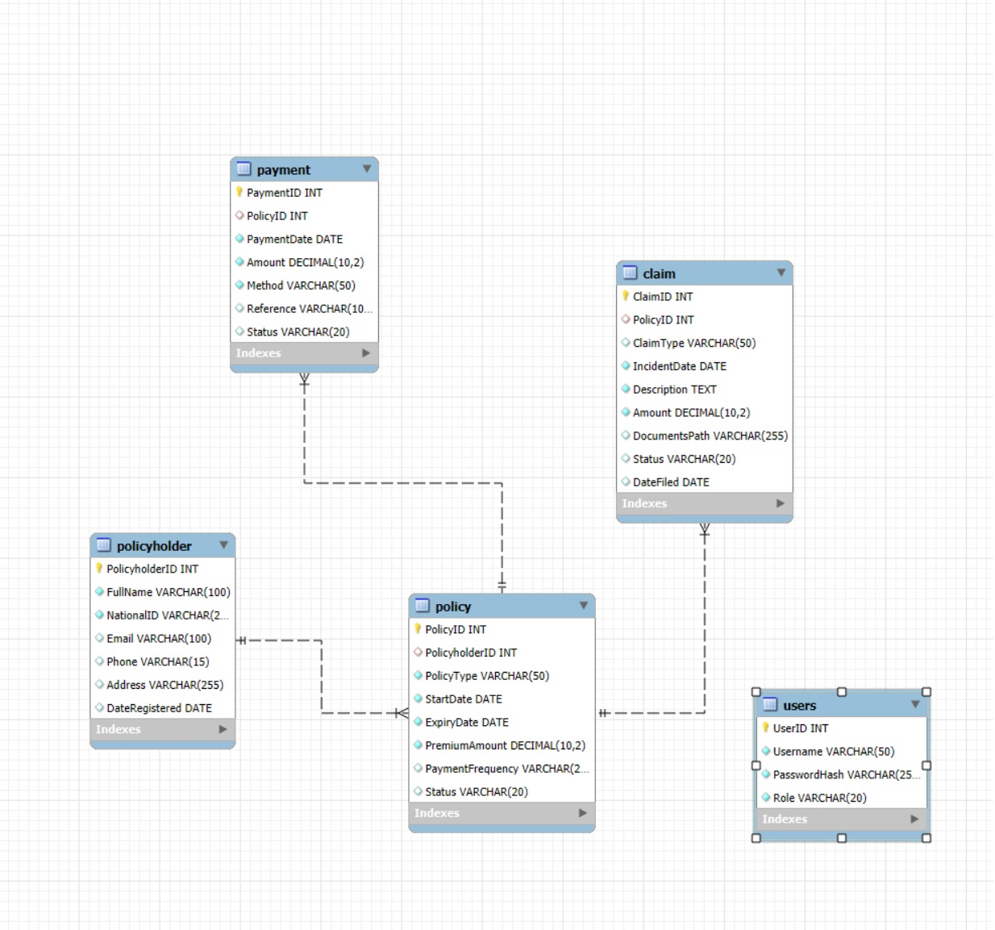

# Physical Process Model

# SQL – Database Creation

ROSEMARY INSURANCE DATABASE

## Policyholder Table

CREATE TABLE policyholder (

PolicyholderID INT AUTO_INCREMENT PRIMARY KEY,

FullName VARCHAR(100) NOT NULL,

NationalID VARCHAR(20) UNIQUE NOT NULL,

Email VARCHAR(100),

Phone VARCHAR(15),

Address VARCHAR(255),

DateRegistered DATE DEFAULT CURRENT_DATE

);

## Policy Table

CREATE TABLE policy (

PolicyID INT AUTO_INCREMENT PRIMARY KEY,

PolicyholderID INT,

PolicyType VARCHAR(50) NOT NULL,

StartDate DATE NOT NULL,

ExpiryDate DATE NOT NULL,

PremiumAmount DECIMAL(10,2) NOT NULL,

PaymentFrequency VARCHAR(20) CHECK (PaymentFrequency IN ('Monthly', 'Quarterly', 'Yearly')),

Status VARCHAR(20) DEFAULT 'Active',

FOREIGN KEY (PolicyholderID) REFERENCES policyholder(PolicyholderID)

ON DELETE CASCADE ON UPDATE CASCADE

);

## Claim Table

CREATE TABLE claim (

ClaimID INT AUTO_INCREMENT PRIMARY KEY,

PolicyID INT,

ClaimType VARCHAR(50),

IncidentDate DATE NOT NULL,

Description TEXT NOT NULL,

Amount DECIMAL(10,2) NOT NULL,

DocumentsPath VARCHAR(255),

Status VARCHAR(20) DEFAULT 'Pending',

DateFiled DATE DEFAULT CURRENT_DATE,

FOREIGN KEY (PolicyID) REFERENCES policy(PolicyID)

ON DELETE CASCADE ON UPDATE CASCADE

);

## Payment Table

CREATE TABLE payment (

PaymentID INT AUTO_INCREMENT PRIMARY KEY,

PolicyID INT,

PaymentDate DATE NOT NULL,

Amount DECIMAL(10,2) NOT NULL,

Method VARCHAR(50) NOT NULL,

Reference VARCHAR(100),

Status VARCHAR(20) DEFAULT 'Paid',

FOREIGN KEY (PolicyID) REFERENCES policy(PolicyID)

ON DELETE CASCADE ON UPDATE CASCADE

);

## Users Table

CREATE TABLE Users (

UserID INT AUTO_INCREMENT PRIMARY KEY,

Username VARCHAR(50) UNIQUE NOT NULL,

PasswordHash VARCHAR(255) NOT NULL,

Role VARCHAR(20) NOT NULL CHECK (Role IN ('Admin', 'Agent', 'Client'))

);

# Maintaing all the tables

## Maintaing Policeholder Form:

## Maintaining the Payments Form:

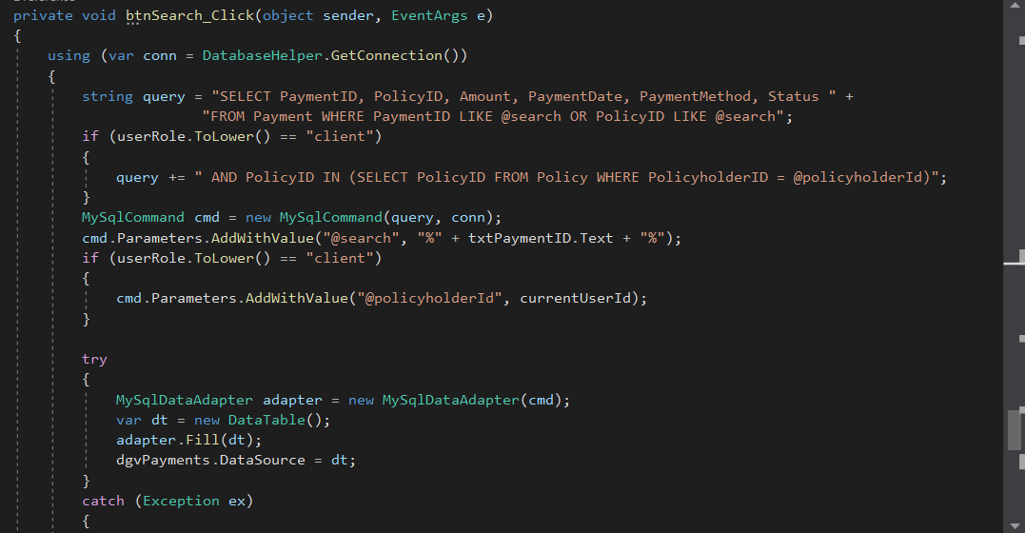

## Maintaining the Policies Form:

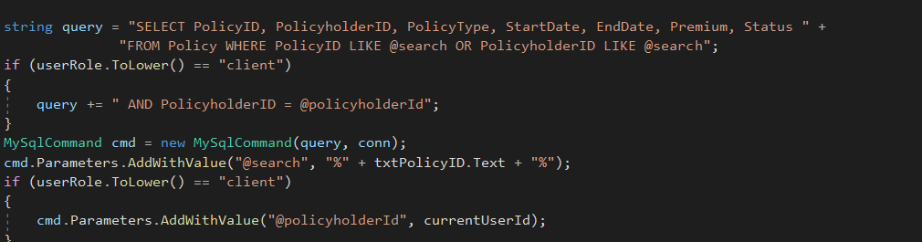

# Querying the Database

## Login form:

## Maintaining Payment Form:

## Maintaining Policies Form:

## Maintaining Policyholder Form:

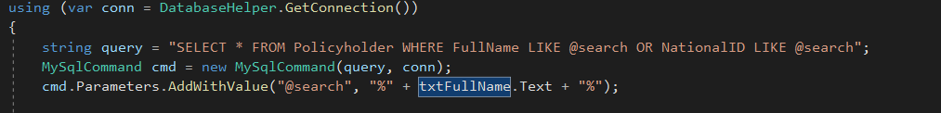

## Maintain Claim Form:

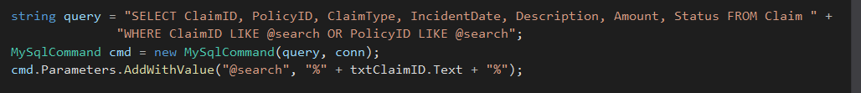

# Report Form:



# Maintaining a Child Entity:

# Reports Generated

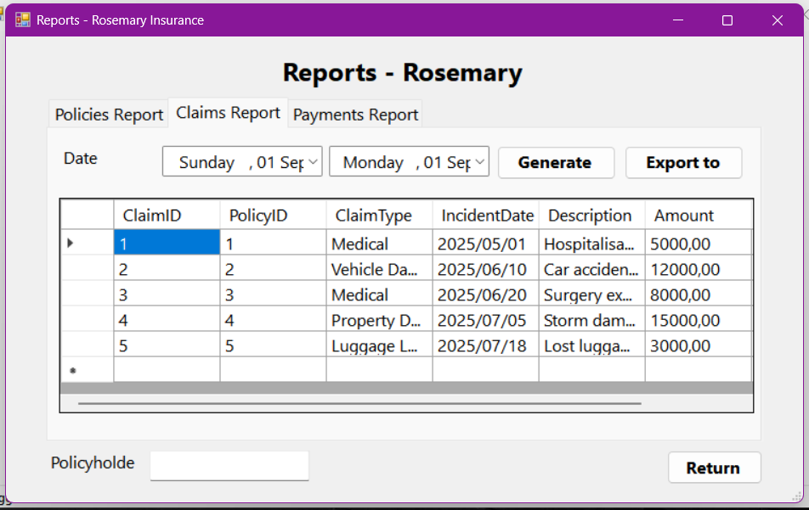

Figure 1: Claims Report

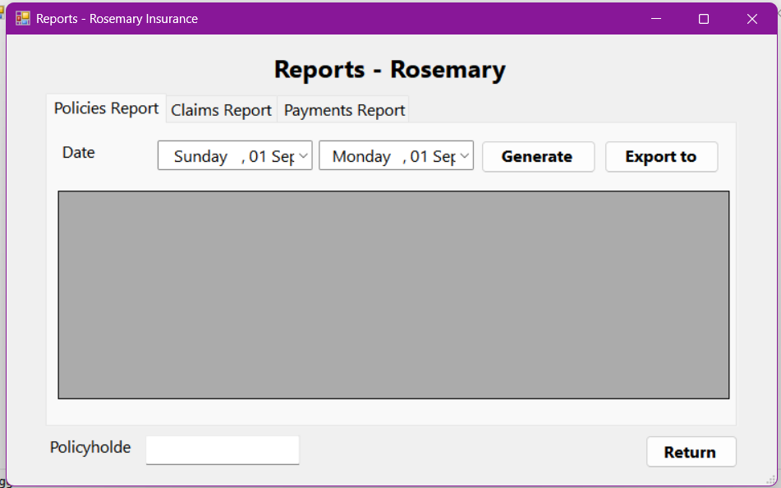

Figure 2: Policies Report

Figure 3: Payment Report

# User Manual

Rosemary Insurance Policy Application

## End-User Installation Guide for Rosemary Insurance App

#### Pre-Requisites (Technical Requirements):

* CPU: Quad-core 2.4 GHz or higher
* RAM: 8GB minimum (16GB recommended)
* Storage: SSD, 100GB+
* OS: Windows Server 2019 or later
* .NET Framework 4.8 – can be downloaded from Microsoft
* Display resolution with a minimum 1366 x 768(WXGA)

## System Installation

#### Installation Process:

1. Download the application.
2. Save it to your local machine.
3. Locate the file in your Downloads folder.
4. Make sure all files are present (including .exe)
5. Unzip the file.
6. Double-click the file to begin.
7. Extract the folder where you downloaded it.
8. Click Run if a Windows Security warning appears.
9. Follow the on-screen instruction in the Setup Wizard.
10. Wait for installation.

#### After Installation:

After the installation has completed, a desktop shortcut named Rosemary Insurance will be created.

Double-click the shortcut to launch the application.

#### Run the Application

* Log in using credentials.
* Upon successful login, you will be redirected to the home page.

## ADMIN OVERVIEW

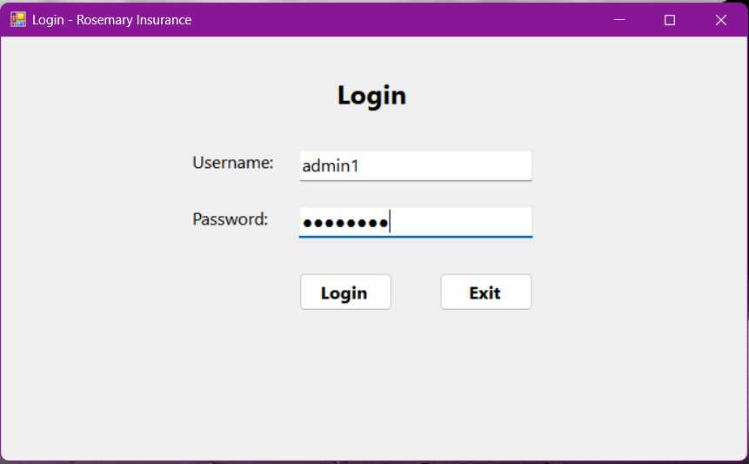

* On the Login Page, enter your admin username and password.
* Press Login (If credentials are correct, the system opens the Home Page with the Admin Dashboard.)

* The Home Page is the control center. From here, admins can see stats, navigate menus and perform admin tasks.

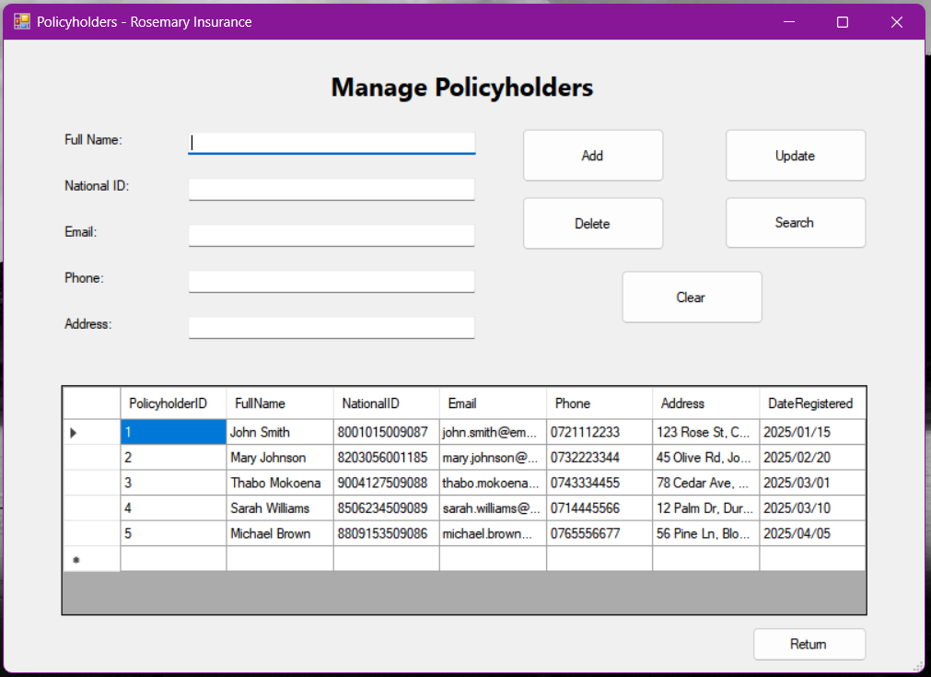

* From the menu, when you select Policyholders. As Admin, you can add,update,delete,search,clear policyholders.

* When you click Policies, you will get options to choose from including file, Update, Add, Search, Clearing policies.

* Selecting claims from the Home page allows the admin to file, update,delete,search,clear, and return button to the home page.

* Clicking Reports, will show available reports(policies, claims, payments).

## AGENT OVERVIEW

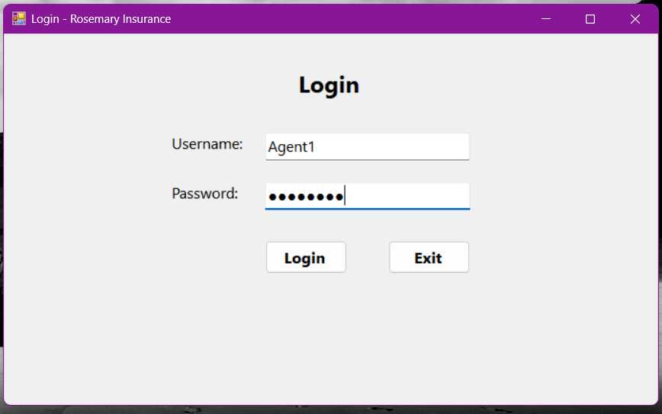

* On the login screen, enter your Agent username and password.
* Click Login.

* On your home page you will get buttons that are only available for agents.

* Add, update, search, clear the policyholders on the Manage Policyholders page.

* On the Claims page you will find claims submitted by clients and you will be able to file, update,search, clear the claims.

* On the Payments page, agents can record, update, search payments made by clients.

CLIENT OVERVIEW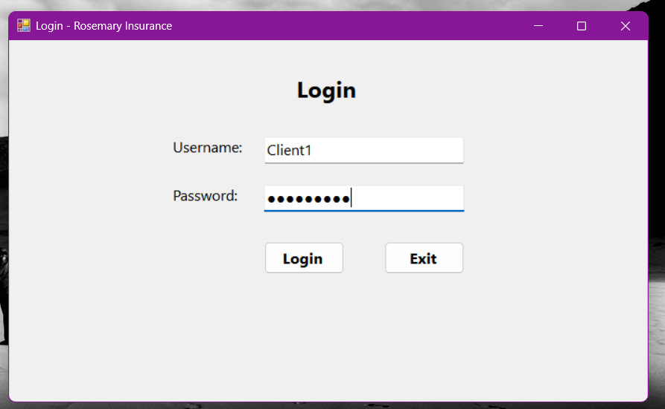

* After putting in your details, click Login.

* Clients will only have access to policies, claims, payments buttons. They can make claims and payments.

* When you click Policies, you can view search and view your policies.

* Clicking my claims, you can file for a new policy or search active policy or click return, to return to home page.

* Click Payments to make a payment. Click Search button to view payment information.

# Detail Dairy