ELEC 3300 Project Summary Sheet

This is a ONE Page Summary Sheet, Content more than 1 page will be deleted.

All the fonts used in this Sheet should be in Times New Roman at 12 points

|  |  |
| --- | --- |
| Group Number | 8 |
| Project Title | Pet Feed |
| Name of Student 1 | CHA, Seunghwan |
| Name of Student 2 | JEON, Sanghyun |

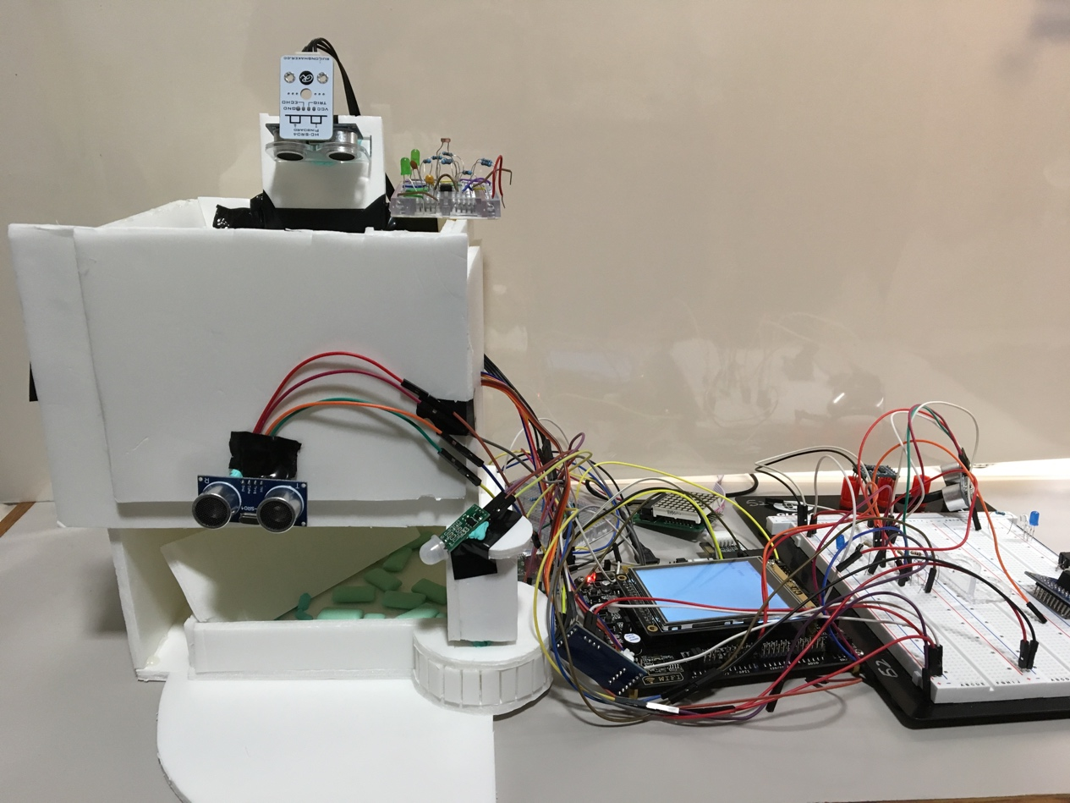Please attach ONE photo of your project here

HC-SR04

LDR

Motors

Buzzer

LCD

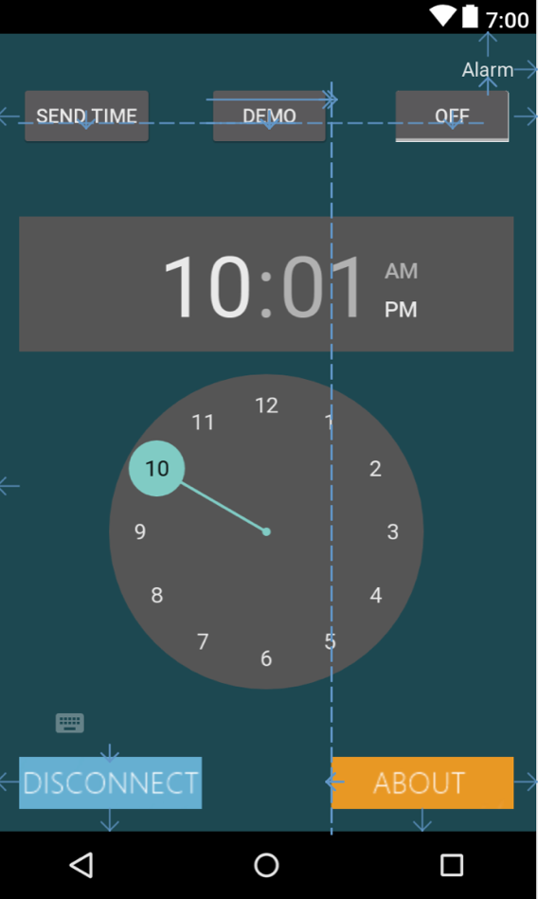

Android App: Sets Time

PIR

Please list the functions of your project in point form

* Used USART protocol and Bluetooth module (HC-05) to communicate with android device
* User-friendly mobile application to set the time for food dispense at user input time
* RTC to accurately measure the current time and perform given tasks at given time
* Food is dispensed by rotating stepper motor and servo motor. Different PWMs were calculated to set the rotation of servo motor and to turn the buzzer on.
* Use of ultrasonic sensor (HC-SR04), PIR sensor (HC-SR505) to detect the pet and response to change of surroundings (turn off buzzer when pet is nearby).
* LDR to detect movement of hand to dispense the food (light intensity changes as hand moves over LDR).
* LCD to display current amount of food (in percentage).
* External button/switch to open/close food plate and to control LDR hand detecting function.
* Properly measured and designed an efficient structure for the safe dispense and sturdy architecture.