Pre-requisite:
- User have the hierarchical data in the Google Sheet
- User connected the datasheet using Google Connector
- User is trying to use Sunburst charts/ Nested Donut charts

Goal:
This is a step-by-step higher-level map to create Nested Donut chart
Nested Donut is created by adding individual donuts and merging them using a hierarchical relationship

Steps:
- Go to Add a chart -> Pie-> Donut chart
For our example, this is our Outer Donut (Phone Models)

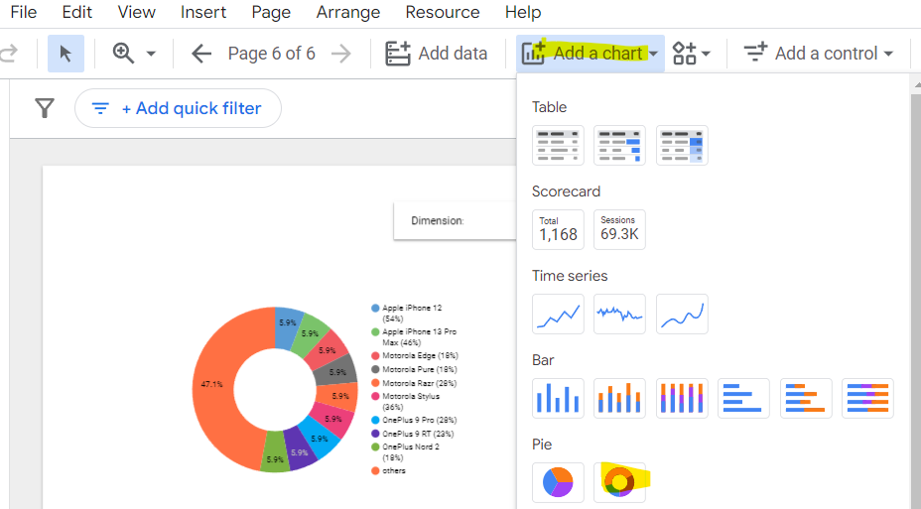

- Add a calculated field
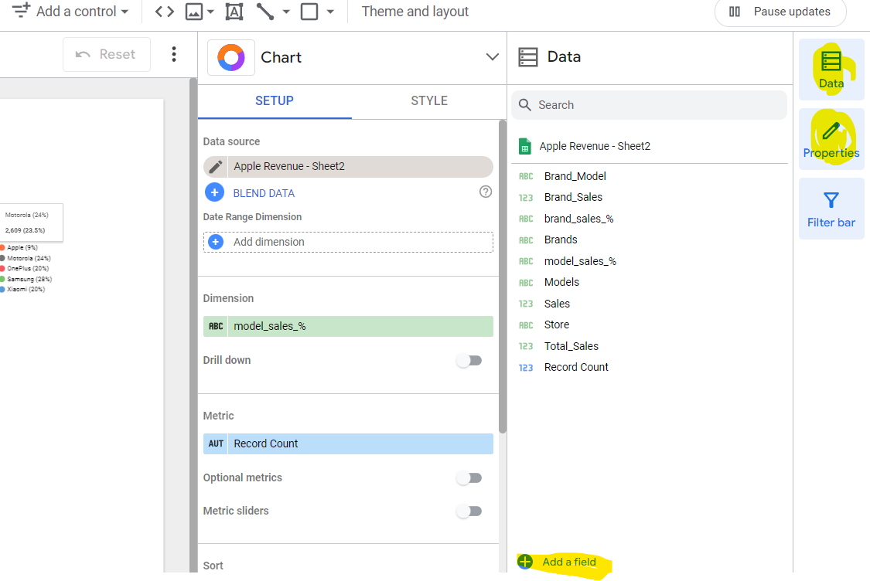

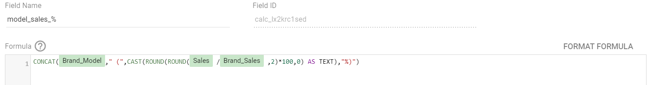

Here, we are concatenating Brand Models and the % calculation and to establish the relationship between Brand and Model. For example, OnePlus 9 Pro(28%), Apple iPhone 12(54%). You can view the picture in the 3rd point below.

Please click the SAVE button and DONE button to create the calculated field after typing the formula

You can now see the new calculated field in the list of fields.
Note: The field name should be changed based on the data.

- Use that column as Dimension for Outer Donut chart
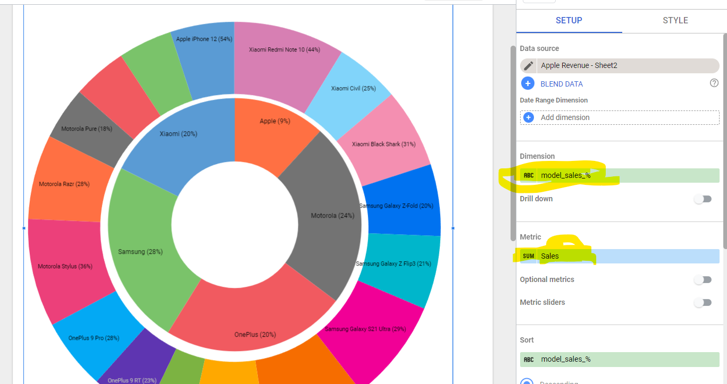

Now, outer donut chart is completed..

- You can follow the same steps for Inner Donut chart.
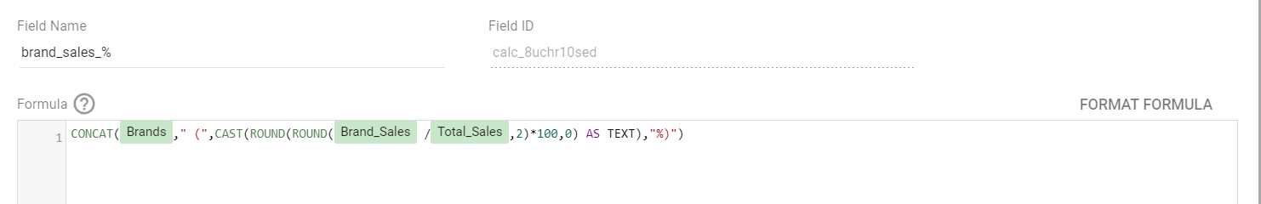

This formula for creating a new calculated field for Inner Donut chart.
This formula concatenates Brands with %, so that each slice would be named as: Apple (9%), Samsung (28%)
Note: The field name should be changed based on the data.

- Now, after enabling Cross-Filtering for both donuts (Inner and Outer), you can check the relationship by clicking on one of the sectors from Inner Donut chart, it will give the associated sectors from Outer Donuts.

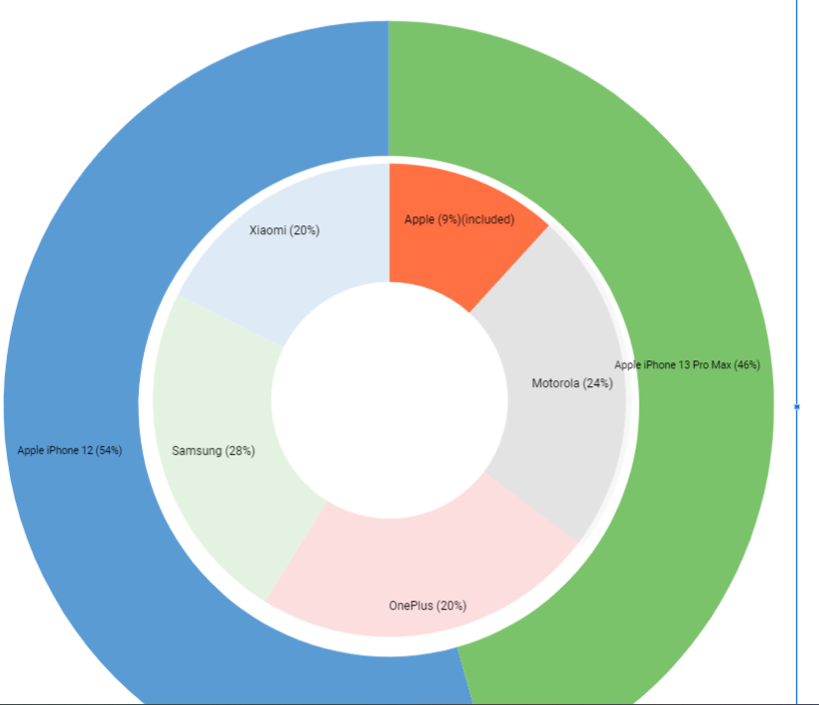

In this example, Inner Donut (Apple) is selected, it gives the respective Apple Models from Outer Donut chart.

- Similarly, we can create multi-level/ nested Donut charts by applying this technique and establishing the relationship.

DONUT STYLING POINTS:

- While creating multi-level/ nested donuts, use the Style option from the right-side.
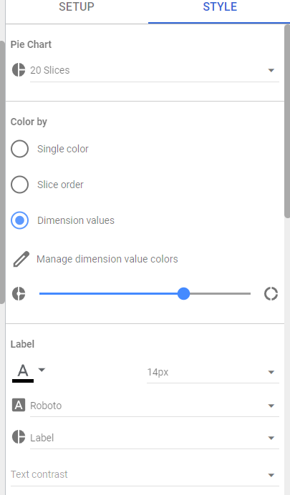

We can use maximum of 20 slices for each Donut.
We can choose to Label for each slice.

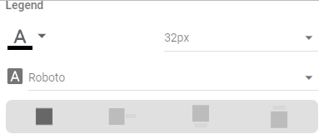

We can also remove the Legend, by selecting the “No Legend” option from the picture above.

Similarly, we can follow the same styling options based on our data for other donuts.

