

MC12G MC12T

VHF, dual-channel digital capacitive sensing chip



# Overview

MC12G and MC12T are highly integrated dual-channel capacitive sensing chips. The chip measures the single-ended capacitance to ground and is directly connected to the measured capacitance plate. Connected, through very high frequency resonance excitation and solution to measure the micro capacitance variety. The excitation frequency is configurable in the range of 10~100MHz, and its frequency measurement output is a 16-bit digital signal, and the corresponding maximum resolution of capacitive sensing is 0.5ff. The chip adopts a fully digital design, and its functional configuration and data reading and writing support I2C communication rates up to 1MHz; it has a built-in low-noise power management module LDO, which can adapt to a wide input voltage range. In addition, the chip also integrates a temperature sensing circuit that can be used to perform temperature compensation and other temperature sensing scenarios.

Capacitive sensing realizes detection of different objects through cooperation with detection electrodes. Dielectric detection of materials is a low power consumption, low cost and high resolution non-contact detection technology. Compared with the traditional RC oscillation touch capacitor structure, MC12G and MC12T adopt the very high frequency LC resonance method, which makes the electric field intensity penetrate better. chip frequency meter. The calculation is fully digitally output through the internal digital signal processing unit, and a variety of The working mode can be flexibly configured. MC12T has a simplified SOP8 pinout for low-cost dual-channel capacitance detection. MC12G is a small QFN16 package that provides more comprehensive internal chip control.

Compared with similar products at home and abroad, MC12G and MC12T have wider capacitive excitation frequency, longer non-contact measurement performance, and wider working voltage range, more flexible reference frequency and working mode configuration set. The chip has both a temperature sensing signal for temperature compensation, independent. The dual-channel measurement circuit can compensate for each other's reference and can also be configured to automatically alarm logic. Small-sized, low-cost chips can be widely used in smart home appliance liquid level, proximity, touch and other scenarios can also be used for industrial special inspections such as automotive oil, water immersion sensing, food testing, soil moisture content, etc. test scenario.

# Characteristics

Capacitance measurement range: 0~150pF

Temperature range: -55℃~+125℃

Frequency range: 10MHz~100MHz

Effective resolution: up to 15bit

Supply voltage range: 2.0V~5.5V

Conversion time: 1~100ms (configurable)

Measure peak current: 1.3~8.3mA (configurable)

Sleep mode current: 50nA

Shutdown mode current: 40nA

# Application

Smart home appliance liquid level

Industrial water tank level

Car oil level

Food moisture content analysis

Soil moisture content analysis

Proximity detection

Touch sensing

**Product Information**

|  |  |  |
| --- | --- | --- |
| **Model** | **Encapsulation** | **Size** |
| MC12G | QFN16 | 3.0*3.0*0.75mm |
| MC12T | SOP8 | 4.9*3.9*1.6mm |

Contents

1. Overview 1

2. Characteristics 1

3. Application 1

4. Package pin description 4

4.1. MC12G package pin diagram (QFN16) 4

4.2. MC12T package pin diagram (SOP8) 5

5. Electrical specifications 5

5.1. Absolute Maximum Ratings 5

5.2. ESD Level 5

5.3. Electrical characteristics 6

5.4. i2c interface timing1 7

6. Detailed description 8

6.1. Overview 8

6.2. System block diagram 8

6.3. Characteristic description 9

6.3.1. Clock system 9

6.3.2. Channel conversion 10

6.3.2.1. Conversion mode 10

6.3.2.2. Data format and reading 11

6.3.2.3. Conversion time 11

6.3.3. Capacitance calculation 13

6.3.4. Drive current 13

6.3.5. Alarm function and INTB 14

6.3.6. Resistance voltage 14

6.3.7. Status Register 15

6.3.8. Temperature Measurement 15

6.4. Functional Mode 15

6.4.1. Power on and start 15

6.4.2. Conversion Mode 15

6.4.3. Sleep Mode 15

6.4.4. Shutdown Mode 16

6.4.5. Software Reset 16

6.5. i2c Programming 16

6.5.1. i2c Address selection 16

6.5.2. i2c Interface data format 16

6.6. Register description 18

6.6.1. Register list 18

6.6.2. DATA_CH0_MSB, DATA_CH0_LSB 18

6.6.3. DATA_CH1_MSB, DATA_CH1_LSB 19

6.6.4. RCNT_CH0_MSB, RCNT_CH0_LSB 19

6.6.5. RCNT_CH1_MSB, RCNT_CH1_LSB 19

6.6.6. SCNT_CH0 19

6.6.7. SCNT_CH1 20

6.6.8. FIN_DIV_CH0 20

6.6.9. FREF_DIV_CH0 20

6.6.10. FIN_DIV_CH1 21

6.6.11. FREF_DIV_CH1 21

6.6.12. STATUS 21

6.6.13. TH_MSB, TH_LSB 22

6.6.14. TL_MSB, TL_LSB 22

6.6.15. CFG 22

6.6.16. Channel Enable 23

6.6.17. RESET 23

6.6.18. DRIVE_IC_CH0, DRIVE_IC_CH1 23

6.6.19. VC_SEL 24

6.6.20. Glitch filter 24

6.6.21. DEVICE_ID_MSB, DEVICE_ID_LSB 24

7. Application and implementation 25

7.1. Typical application circuit 25

7.2. Typical application examples 27

7.3. Inductor self-resonant frequency 27

8. Encapsulation 28

8.1. MC12G QFN16 3.0*3.0*0.75mm 28

8.2. MC12T SOP8 4.9*3.9*1.6mm 29

# Package pin description

# MC12G package pin diagram (QFN16)

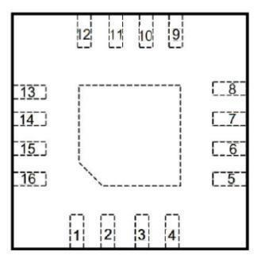front perspective view

|  |  |  |  |
| --- | --- | --- | --- |
| Pin Number | Pin Name | Type | Description |
| 1 | SCL | I | i2c clock line |
| 2 | SDA | I/O | i2c data line |
| 3 | CLKIN | I | external count clock  (GND needs to be connected when selecting the internal clock) |
| 4 | ADDR | I | i2c address line |
| 5 | INTB | O | Interrupt signal output, active low level |
| 6 | SD | I | Stop mode enable signal |
| 7 | VDD | P | Power Supply |
| 8 | GND | G | Ground |
| 9 | C0A | A | Channel 0 capacitor input terminal |
| 10 | C0B | A | Channel 0 capacitor input terminal |
| 11 | C1A | A | Channel 1 capacitor input terminal |
| 12 | C1B | A | Channel 1 capacitor input terminal |
| 13 | VC | A | Internal reference voltage |
| 14 | VT | A | Negative temperature coefficient voltage |
| 15 | NC | - | Not connected |
| 16 | NC | - | Not connected |

Note 1: I represents input, O represents output, P represents power supply, G represents ground, and A represents analog signal.

Note 2: During circuit design, the thermal pad can be suspended or grounded.

# MC12T package pin diagram (SOP8)

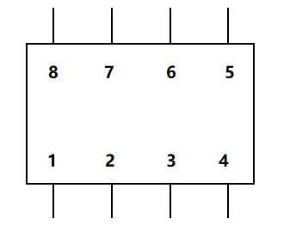

top view

|  |  |  |  |
| --- | --- | --- | --- |
| Pin Number | Pin Name | Type | Description |
| 1 | VT | A | negative temperature coefficient voltage |
| 2 | SCL | I | I2C clock line |
| 3 | SDA | I/O | I2C data line |
| 4 | VDD | P | power supply |
| 5 | GND | G | land |
| 6 | C0 | A | Channel 0 capacitor input terminal |
| 7 | C1 | A | Channel 1 capacitor input terminal |
| 8 | VC | A | Internal reference voltage |

Note: I represents input, O represents output, P represents power supply, G represents ground, and A represents analog signal.

# Electrical specifications

# Absolute Maximum Ratings

|  |  |  |  |  |
| --- | --- | --- | --- | --- |
|  | project | minimum value | maximum value | unit |
| VDD | Supply voltage range | - 0.3 | 6.0 | V |
| Vi | Pin voltage | - 0.3 | VDD | V |
| TJ | Junction temperature | - 55 | 125 | ℃ |
| Tstg | storage temperature | - 55 | 125 | ℃ |

Note: The above are limit parameters. This specification does not apply to the functional operation of the device in environments beyond these limit conditions. Long-term exposure to this extreme environment can affect device reliability.

# ESD Level

|  |  |  |  |
| --- | --- | --- | --- |
|  | project | numerical value | unit |
|  | Human-body model(HBM) | ±8000 | V |
| VESD Electrostatic Discharge | Charged-device model(CDM) | ±750 | V |

# Electrical characteristics

Unless otherwise specified, the data conditions in the table are T=25℃, VDD=5V.

|  |  |  |  |  |  |  |
| --- | --- | --- | --- | --- | --- | --- |
|  | Parameter | Test Conditions | Minimum Value | Typical value | Maximum Value | Unit |
| Power consumption | | | | | | |
| VDD | voltage | T = -55℃ to 125℃ | 2.0 |  | 5.5 | V |
| IDD | Measure peak current(1) |  | 1.3 | 3.7 | 8.3 | mA |
| IDDCST | Continuous conversion standby current(2) |  |  | 75 |  | uA |
| IDDSL | Sleep mode current(3) |  |  | 0.05 |  | uA |
| ISD | Stop mode current(3) |  |  | 0.04 |  | uA |
| Capacitive Sensing | | | | | | |
| CSENSORMAX | Maximum measured capacitance | L=150nH, fSENSOR=30MHz |  | 150 |  | pF |
| CC0A/C1A | Pin parasitic capacitance |  |  | 2 |  | pF |
| ENOB | Effective resolution |  |  |  | 15 | Bits |
|  |  |  |  |  |  |  |
| fcs | Channel sampling rate |  | 0.01 |  | 1 | kSPS |
| Oscillator | | | | | | |
| fSENSOR | Oscillator frequency range | T = -55℃to 125℃ | 10 |  | 100 | MHz |
| ISENSORMAX | Oscillator drive current |  | 0.5 | 3.0 | 8.0 | mA |
| Internal clock | | | | | | |
| fINTCLK | Internal clock frequency |  | 2.3 | 2.4 | 2.5 | MHz |
| TCF_INT_U | Internal clock temperature drift coefficient | T=20℃to 125℃ |  | - 700 |  | ppm/℃ |
| T = -55℃to 20℃ |  | 800 |  | ppm/℃ |
| External clock | | | | | | |
| fCLKIN | external clock frequency | T = -55℃to 125℃ | 0.1 |  | 50 | MHz |
| CLKINDUTY | External clock duty cycle |  | 40% |  | 60% |  |
| VCLKIN_HI | External clock high threshold |  | 0.7*VDD |  |  | V |
| VCLKIN_LO | External clock low threshold |  |  |  | 0.3*VDD | V |

Note 1: Peak current is measured and represents the current during conversion when configured in single conversion and continuous conversion modes. Note 2: Continuous conversion standby current indicates the current during non-conversion when configured in continuous conversion mode. Note 3: The current flowing into the SDA and SCL pins during I2C reading and writing is not included.

# i2c interface timing1

|  |  |  |  |  |  |  |
| --- | --- | --- | --- | --- | --- | --- |
| Parameter | Symbol | Standard Mode | | Quick Mode | | Unit |
| Minimum Value | Maximum Value | Minimum Value | Maximum Value |
| SCL Frequency | fSCL | 0 | 400 | 0 | 1000 | kHz |
| SCL low level time | tLOW | 1300 | - | 620 | - | ns |
| SCL high level time | tHIGH | 600 | - | 220 | - | ns |
| Duration of SCL high level after SDA is pulled low during start or restart | tHD;STA | 400 | - | 260 | - | Ns |
| The time interval from when SCL is pulled low to when SDA data changes | tHD;DAT | 0 | 0.9 | 0 | - | µs |
| The time interval from when SDA data becomes stable to when SCL is pulled high | tSU:DAT | 100 | - | 150 | - | ns |
| The high level holding time of SCL before SDA is pulled low during restart | tSU;STA | 400 | - | 260 | - | ns |
| The time interval from when SCL is pulled high to when SDA is pulled high during stop | tSU:STO | 400 | - | 260 | - | ns |
| The interval between start and stop | tBUF | 1300 | - | 500 | - | ns |
| SCL/SDA rising edge time required | tRC | 20+ 0.1Cb2 | 1000 | 20+ 0.1Cb2 | 120 | ns |
| SCL/SDA falling edge time required | tFC | 20+ 0.1Cb2 | 300 | 20+ 0.1Cb2 | 120 | ns |

1. All values are based on VIHmin and VILmax
2. Cb=total capacitance of I2C bus.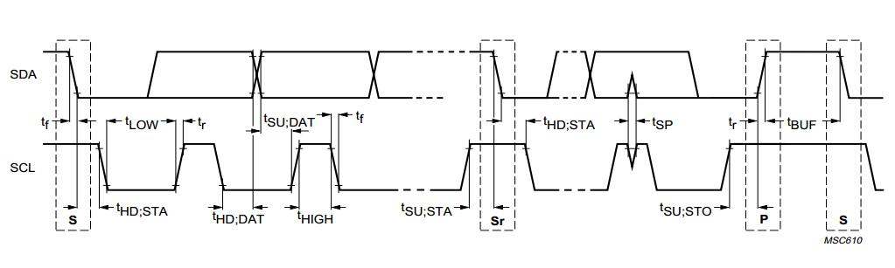

Figure 5.4 I2C timing parameters

# Detailed description

# Overview

MC12G and MC12T are high-precision, multi-channel capacitance conditioning chips suitable for a variety of capacitance sensing applications. Compared with the traditional switched capacitor structure, MC12G and MC12T adopt the LC resonance method for capacitance measurement. The narrow-band characteristics of the LC oscillator enable MC12G and MC12T to have lower noise levels and are less susceptible to external interference.

When the capacitance of the LC resonant tank changes, the resonant frequency of the circuit will also change. Based on this principle, MC12G, MC12T operate y measuring the oscillation frequency and outputting a data proportional to the frequency. From this data, the capacitance value can be calculated.

# System block diagram

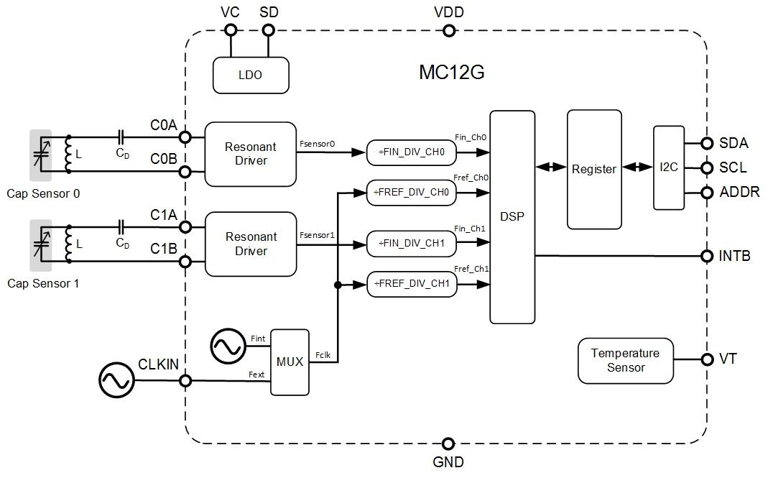

*Figure 6.2-1 MC12G system block diagram*

*Figure 6.2-2 MC12T system block diagram*

These diagrams are the system block diagrams of MC12G and MC12T respectively, including LDO power management, resonant driver circuit (Resonant Driver), and frequency divider (Divider) , internal clock (Fint), digital frequency calculation (DSP), register (Register), Temperature Sensor, I2C interface and other functional modules. The resonant drive circuit of MC12G and MC12T and the external LC form an active oscillation, which sends the output signal to the digital logic circuit to measure and digitize the signal frequency of the sensor rate(fSENSOR) . For MC12G, the C0B/C1B pin is connected to GND internally through the sensor. Digital logic uses a reference frequency (fCLK) to measure the signal frequency f of the sensor SENSOR. fCLK from chip clock or external clock. The I2C interface is used for communication between the chip and the MCU. By measuring the VT pin voltage at the MCU end, the ambient temperature can be indirectly measured for temperature compensation. For MC12G, by controlling the SD pin, the chip can be shut down to reduce system power consumption; at the same time, the INTB pin can output an alarm status bit or a conversion completion flag signal according to the configuration.

# Characteristic description

# Clock system

According to the MC12G and MC12T system block diagram, fCLK, fIN and fREF are three important clock signals. According to the register configuration, fCLK can select the internal clock or the external clock (MC12T can only select the internal clock). The reference clock fREF is obtained by dividing fCLK. For high-precision applications, it is recommended to choose an external clock with high precision and high stability. The internal clock is more suitable for applications with low cost and moderate accuracy requirements. The measured signal clock fIN is obtained by dividing the frequency of the sensor resonance signal fSENSOR. In order to ensure correct measurement results, the clock frequencies of fREF and fIN need to meet the following conditions:

For most effective resolution of the measurement, the ratio of fREF to fIN should be as close as possible to 2.5. The most significant number of digits is 15 bits. The following table is the clock configuration related register definition.

|  |  |  |  |  |
| --- | --- | --- | --- | --- |
| Channel | Clock | Registers and addresses | Bit | Description |
| 0,1 | fCLK | CFG, 0x1F | REF_CLK_SEL | b0: Select internal clock  b1: Select external clock |
| 0 | fREF0 | FREF_DIV_CH0, 0x12 | CH0_FREF_DIV[7:0] | b00000000-b11111111 = values 0 to 255 |
| 1 | fREF1 | FREF_DIV_CH1, 0x14 | CH1_FREF_DIV[7:0] | b00000000-b11111111 = values 0 to 255 |
| 0 | fIN0 | FIN_DIV_CH0, 0x11 | CH0_FIN_DIV[3:0] | b0000-b0111 = value 0 to 7  b1000-b1111 = value 8 |
| 1 | fIN1 | FIN_DIV_CH1, 0x13 | CH1_FIN_DIV[3:0] | b0000-b0111 = value 0 to 7  b1000-b1111 = value 8 |

# Channel conversion

# Conversion mode

By setting the channel enable bit, you can choose to enable single-channel or multi-channel conversion. When selecting multi-channel conversion, channel 0 is started first, then channel 1, and the switching time between the two channels is ≤10us. The following table is the configuration channel related register definition.

|  |  |  |  |
| --- | --- | --- | --- |
| Channel | Registers and addresses | Bit | Description |
| 0 | CH_EN, 0x20 | CH0_EN | b0: Close channel 0  b1: Open channel 0 |
| 1 | CH_EN, 0x20 | CH1_EN | b0: Close channel 1  b1: Open channel 1 |

By setting the CFG register, the sensor's working mode can be configured, including single conversion, continuous conversion, stop conversion, and the measurement time interval of continuous conversion mode. The following table is the definition of registers related to working mode configuration.

|  |  |  |  |
| --- | --- | --- | --- |
| Mode | Registers and addresses | Bit | illustrate |
| Single  /Continuous | CFG, 0x1F | OS, SD | b00: Continuous conversion mode, the time interval is determined by the value of CR[2:0]. When changing the continuous conversion mode, conversion must be stopped first.  b01: Stop conversion.  b10: Same as b00.  b11: Single conversion mode.  After setting the flag, the chip will automatically stop after one conversion. After the conversion is completed, OS and SD automatically change to b01. |
| Collected per second  Number of samples  (MPS) | CFG, 0x1F | CR[2:0] | b000: Convert once every 60s  b001: Convert once every 30s  b010: Convert once every 10s  b011: Convert once every 5 seconds  b100: Convert once every 2s  b101: Convert once in 1s  b110: Convert once in 0.5s  b111: Convert once in 0.25s |

It should be noted that in order to ensure the correctness of the converted data, the following two points must be followed when modifying the register configuration:

1. To switch from continuous conversion mode to single conversion mode, you must first send a stop conversion command, and then send a single conversion command.
2. During the sensor measurement conversion process, do not modify any conversion-related register configuration. If you need to modify the configuration parameters, you need to stop the conversion first, make sure the conversion is stopped, then modify the configuration parameters and restart the conversion.

# Data format and reading

The sensor measures the ratio between the divided frequency of each channel signal and the divided frequency of the reference clock, expressed in a 16-bit data format:

The data results of channel conversion will be stored in the following corresponding registers:

|  |  |  |  |
| --- | --- | --- | --- |
| Channel | Registers and addresses | Bit | Description |
| 0 | DATA_CH0_MSB, 0x00 | DATA0[15:8] | Channel 0 converts the upper 8 bits of data |
| DATA_CH0_LSB, 0x01 | DATA0[7:0] | Channel 0 converts the lower 8 bits of data |
| 1 | DATA_CH1_MSB, 0x02 | DATA1[15:8] | Channel 1 converts the upper 8 bits of data |
| DATA_CH1_LSB, 0x03 | DATA1[7:0] | Channel 1 conversion data lower 8 bits |

It should be noted that in order to ensure the accuracy of the converted data, the I2C reading of DATAx must be performed during the non-conversion period of the sensor. The specific method is:

i. In single conversion mode, I2C reading of DATAx needs to be performed after the conversion is completed.

ii. In continuous conversion mode, you need to stop conversion first, execute I2C to read DATAx, and then restart continuous conversion.

# Conversion time

The figure below is the timing diagram in single conversion mode when single channel and dual channel are selected. Among them, TCV is the total single-channel single conversion time, TSCIt is the channel switching time (<10us).

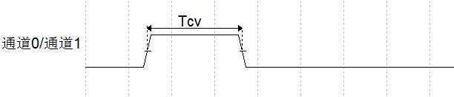

Channel 0/  
Channel 1

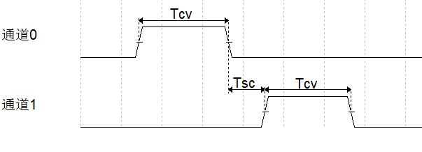

Channel 0/  
Channel 1

The figure below is the timing diagram in continuous conversion mode when single channel and dual channel are selected. Among them, TPER is the measurement period of continuous conversion mode, TCV is the total single-channel single conversion time, TSC is the channel switching time (<10us).



Channel 0/  
Channel 1

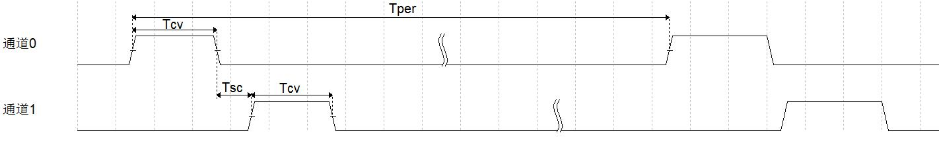

Channel 0/  
Channel 1

To ensure that continuous conversion mode works properly, TPER and TCV. The following constraints need to be satisfied:

1. Single channel measurement,
2. Dual channel measurement,

TCV including start-up time TSTART, establishment time TSET, counting time TCNT, and the delay time TDELAY.

TSTART indicates the stabilization time of the internal reference voltage, and is fixed at 200us. Channel establishment time TSET indicates the initial stabilization time of the oscillation signal establishment, which is defined by the following registers:

|  |  |  |  |
| --- | --- | --- | --- |
| Channel | Registers and addresses | Bit | Description |
| 0 | SCNT_CH0, 0x0E | SCNT0[7:0] | Channel 0 setup time |
| 1 | SCNT_CH1, 0x0F | SCNT1[7:0] | Channel 1 setup time |

The calculation formula for TSET is:

In order to ensure sufficient time for channel signal establishment, TCNT ≥ 100us should be set. When using the internal clock as fCLK:

* Setting SCNT_CHx to 0x0F corresponds to TSET being 100us and
* Setting SCNT_CHx to 0xFF corresponds to TSET being 1.7ms

The counting time of the channel TCNT represents the time for fREFx to count pulses to fINx, which is defined in the following table:

|  |  |  |  |
| --- | --- | --- | --- |
| Channel | Registers and addresses | Bit | Description |
| 0 | RCNT_CH0_MSB, 0x08 | RCNT0[15:8] | Channel 0 counting time high 8 bits |
| RCNT_CH0_LSB, 0x09 | RCNT0[7:0] | Channel 0 counting time low 8 bits |
| 1 | RCNT_CH0_MSB, 0x0A | RCNT1[15:8] | Channel 1 counting time high 8 bits |
| RCNT_CH0_LSB, 0x0B | RCNT1[7:0] | Channel 1 counting time low 8 bits |

The calculation formula for TCNT is:

The calculation formula for TDELAY is:

Therefore, the conversion time TCV is calculated by:

# Capacitance calculation

The calculation formula of LC resonant frequency is:

Therefore, the measured capacitance CSENSOR can be calculated as follows:

CF Expressed with CSENSOR the sum of the total parallel capacitances to ground, CF can be expanded and expressed as:

In the above formula, each capacitor represents:

CD is an off-chip DC blocking capacitor, placed between the resonance point and the C0A/C1A pin (see section 6.2.1-2);

CP is the total ground capacitance of the C0A/C1A pin inside the sensor, with a typical value of 52pF;

CPCB is the total ground capacitance of the C0A/C1A pin on the PCB, with a typical value of 2pF.

fSENSORx can be calculated using DATAx as follows:

# Drive current

Two-channel oscillator drive current IDRIVE can be configured to different values, defined by the following registers.

|  |  |  |  |
| --- | --- | --- | --- |
| Channel | Registers and addresses | Bit | illustrate |
| 0 | DRIVE_I_CH0, 0x23 | I0[3:0] | Set the single channel drive current value.  b0000-b1111: 0.5mA to 8mA, LSB=0.5mA |
| 1 | DRIVE_I_CH1, 0x24 | I1[3:0] |

In order to ensure that the oscillator can start up successfully, the driving current IDRIVE needs to be greater than a certain threshold, the threshold size is the same as CSENSOR, CD ,CP. It is related to the capacitor network formed and the Q value of the inductor L. Generally speaking, the greater the driving current, the stronger the channel's oscillation ability and the greater the oscillation amplitude. For larger measured capacitance CSENSOR, and the inductor L with a low Q value needs to increase the drive current to ensure the channel starts to oscillate.

# Alarm function and INTB

MC12G and MC12T have alarm function. The alarm threshold includes trigger threshold TH and release threshold TL, which are defined by the following registers. Both TH and TL are 16 bits, which is the same number of bits as DATA_CHx.

|  |  |  |  |
| --- | --- | --- | --- |
| Threshold | Registers and addresses | Bit | Description |
| Alarm trigger | TH_MSB, 0x19 | TH[15:8] | When DATA_CHx > TH, ALERT_CHx in the STATUS register is set to 1 |
| TH_LSB, 0x1A | TH[7:0] |
| Alarm stop | TL_MSB, 0x1B | TL[15:8] | When DATA_CHx<TL, ALERT_CHx in the STATUS register is set to 0 |
| TL_LSB, 0x1C | TL[7:0] |

When the conversion is completed, the alarm state is triggered when the following conditions are met:

After the alarm status is triggered, ALERT_CHx in the status register is set to 1, and the INTB pin output level changes from high to low (only applicable toMC12G). In order to ensure that the alarm function is turned on, when setting the TH and TL threshold parameters that TH > TL.

When the alarm status is triggered, there are 4 implementation methods to clear the alarm status:

* 1. Read channel conversion data through I2C, this method is limited to single conversion mode and stop mode.
  2. Perform a channel conversion and satisfy DATA_CHx < TL
  3. Enable software reset function.
  4. Pull the SD pin high.

For MC12G, the INTB pin can output the alarm status bit of channel 0 or channel 1, which is active at low level. After the alarm condition is cleared, the INTB pin returns to high level. In addition, the INTB pin can also be configured to output the conversion completion flag of channel 0 or channel 1. INTB functionality is defined by the following registers.

|  |  |  |  |
| --- | --- | --- | --- |
| Channel | Registers and addresses | Bit | Description |
| 0,1 | CFG, 0x1F | INTB_EN | b0: INTB pin output enable. |
| b1: INTB pin output is not enabled. |
| 0,1 | CFG, 0x1F | INTB_MODE | b0: INTB pin output alarm status bit, active low level. |
| b1: INTB pin output conversion completion flag bit, active low level. |
| 0,1 | CH_EN, 0x20 | INTB_CH | b0: INTB pin outputs the alarm status or conversion completion flag of channel 0. |
| b1: The INTB pin outputs the alarm status or conversion completion flag of channel 1. |

# Resistance voltage

Both MC12G and MC12T can adapt to different VDD voltages. According to different VDD voltage conditions, the internal reference voltage value (VC pin voltage) is changed by configuring the VC_SEL register, so that the sensor can achieve optimal performance.

|  |  |  |  |
| --- | --- | --- | --- |
| Channel | Registers and addresses | Bit | Description |
| 0,1 | VC_SEL, 0x23 | VC | b00: Reference voltage 2.5V |
| b01: Reference voltage 3.0V |
| b10: Reference voltage 1.8V |
| b11: Reference voltage 2.0V |

In actual application, it is recommended to configure according to the following two points:

1. When 2.5V < VDD < 5.5V (VDD is between 2.5V and 5.5V), configure the reference voltage to 2.5V (default value).
2. When 2V < VDD < 2.5V (VDD is between 2.0V and 2.5V), configure the reference voltage to 2.0V

# Status Register

The status register can reflect whether the measurement data of MC12G and MC12T overflows, whether the conversion is completed, and the alarm status.

|  |  |  |  |
| --- | --- | --- | --- |
| Channel | Registers and addresses | Bit | Description |
| 0 | STATUS, 0x17 | OF_CH0 | b0: Channel 0 data does not overflow  b1: Channel 0 data overflow |
| 1 | STATUS, 0x17 | OF_CH1 | b0: Channel 1 data does not overflow  b1: Channel 1 data overflow |
| 0 | STATUS, 0x17 | DRDY_CH0 | b0: Channel 0 conversion is not completed  b1: Channel 0 conversion completed |
| 1 | STATUS, 0x17 | DRDY_CH1 | b0: Channel 1 conversion is not completed  b1: Channel 1 conversion completed |
| 0 | STATUS, 0x17 | ALERT_CH0 | b0: Channel 0 does not trigger the alarm  b1: Channel 0 triggers alarm |
| 1 | STATUS, 0x17 | ALERT_CH1 | b0: Channel 1 does not trigger the alarm  b1: Channel 1 triggers alarm |

# Temperature Measurement

MC12G, MC12T provide a negative temperature coefficient voltage VT, output to the VT pin, is used to roughly evaluate the temperature. VT Voltage measurement requires the use of an external ADC for sampling, and the conventional 10-bit precision ADC built into the MCU can meet the needs. Temperature value T can be calculated with this calculation:

Where VT is the voltage value measured by ADC, in mV; K is the temperature coefficient, the default value is -560.0℃/V; TC is the temperature correction value, the default value is 386.3℃. Users can also choose to calibrate the K and TC parameters themselves.

# Functional Mode

# Power on and start

MC12G and MC12T will automatically enter continuous conversion mode after power-on. Users can send a stop conversion command through I2C to put the chip into sleep mode, and then perform operations including parameter modification, single conversion, continuous conversion, etc.

# Conversion Mode

The conversion modes of MC12G and MC12T are divided into single conversion mode and continuous conversion mode, which are configured through the CFG register. For details, see Chapter 6.3.2.

# Sleep Mode

MC12G and MC12T will automatically enter sleep mode (low power consumption mode) after each execution of I2C command operation. When the host sends a valid I2C command, MC12G and MC12T will automatically wake up and perform corresponding operations. It should be noted that in continuous conversion mode, MC12G and MC12T will not enter sleep mode after each conversion is completed.

# Shutdown Mode

The external SD pin of MC12G is used to initiate hardware shutdown (Shutdown). When the SD pin is pulled high, the chip function is completely shut down and i2c cannot be accessed. After the SD pin changes from low to high, the chip recovery time is <20us.

# Software Reset

MC12G and MC12T provide software reset function. By writing 0x7A to the reset register, the software reset function is started, the sensor returns to the initial power-on state, all registers return to their default values, and the chip recovery time is <20us.

|  |  |  |  |
| --- | --- | --- | --- |
| Channel | Registers and addresses | Bit | Description |
| 0,1 | RESET, 0x22 | RESET[7:0] | b01111010 : Start the software reset and the sensor returns to the initial state after power-on, and all registers are restored to default values. |

# i2c Programming

The MCU accesses the control and data registers of MC12G and MC12T through the i2c interface. The SDA and SCL pins integrate spike suppression circuitry to reduce the impact of bus noise. MC12G and MC12T support i2c communication rate of 400KHz. The data SDA and clock SCL of the i2c interface are connected to the corresponding ports of the host processor respectively, and passed through the pull-up resistor RP. Connected to VDD, the read and write control of each node chip is realized through the host computer software. According to the actual application, the address of the slave device can be set through the value of pin ADDR.

# i2c Address selection

MC12G can realize different i2c addresses through different connection methods of ADDR pin. The specific corresponding relationship is:

|  |  |
| --- | --- |
| ADDR connection method | i2c address |
| Connect to GND | 0x68 |
| Connect to VDD | 0x69 |
| Connect to SDA | 0x6A |
| Connect to SCL | 0x6B |

The I2C address of MC12T is fixed at 0x69. The MC12G development board PCB is also fixed at 0x69.

# i2c Interface data format

Typical I2C bus operation is defined as follows:

Bus Idle: SDA and SCL both remain high.

Start data transfer: When SCL is high, a change in SDA state (from high to low) indicates a start condition. Every data transfer begins with a start condition.

Stop data transfer: When SCL is high, the change of SDA state (from low level to high level) indicates the stop state. Each data transfer is terminated by a repeated start or stop condition.

Data transfer: The number of data bytes transferred between start and stop conditions is unlimited and is determined by the master device. The receiver acknowledges the data transmission.

Response: Each receiving slave device must generate a response signal when being addressed. The slave must acknowledge by stabilizing SDA low during the high period of the acknowledge clock pulse. On the master side, the data transfer is terminated by the master not acknowledging the last byte transmitted by the slave.

For read i2c operations, the master sends the i2c slave address and write flag bit. The slave acknowledges, then the master sends the register it wishes to read. The slave acknowledges this. The master sends a bus re-start and sends the i2c slave address and the read bit. The slave acknowledges and then sends the contents of the register. Once this is complete, the master sends a negative-acknowledgement (NACK) and a bus stop.

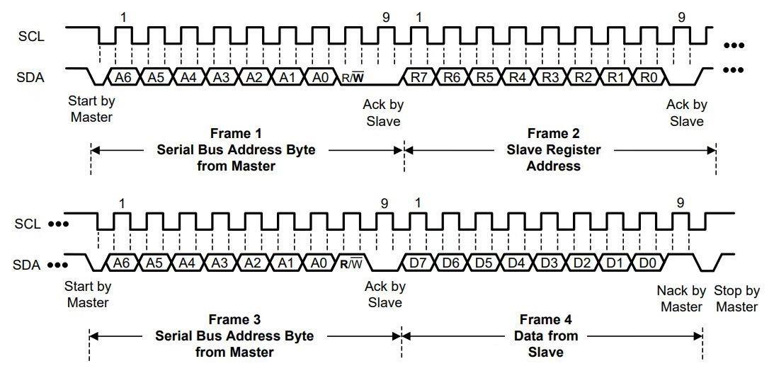

For i2c write operations, the master will send a start bus event, then send the i2c address of the slave, accompanied by the write flag. The slave will ack this and the master will send the register address it wishes to write to. The slave will ack this and the master will send the data it wishes to put in the register. Once this is acknowledged by the slave, the master will send a bus stop event.

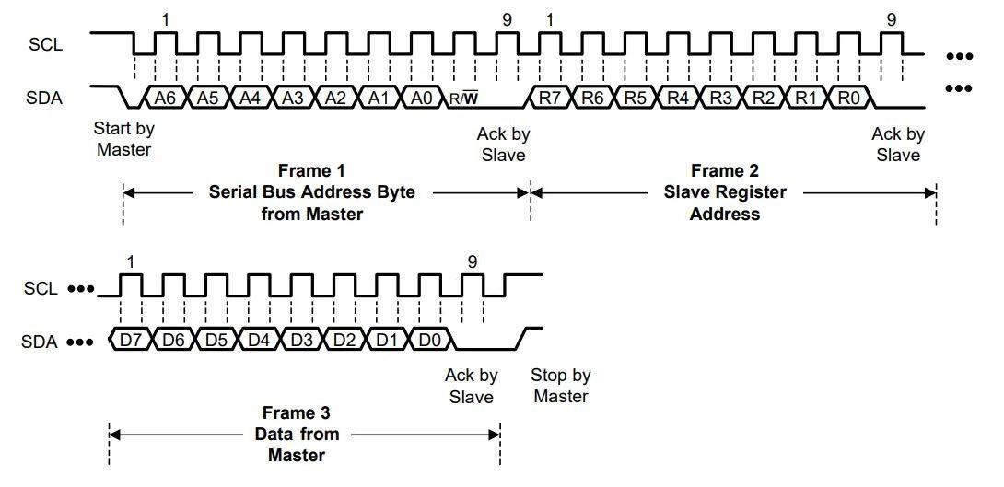

# Register description

# Register list

The registers of MC12G and MC12T include three categories: read-write, read-only, and write-only. The default value represents the value in the initial state of the sensor when it is powered on. Below is a list of all registers.

|  |  |  |  |
| --- | --- | --- | --- |
| Address | Name | Default Value | Description |
| 0x00 | DATA_CH0_MSB | 0x00 | Channel 0 conversion data, read only |
| 0x01 | DATA_CH0_LSB | 0x00 |
| 0x02 | DATA_CH1_MSB | 0x00 | Channel 1 conversion data, read only |
| 0x03 | DATA_CH1_LSB | 0x00 |
| 0x08 | RCNT_CH0_MSB | 0x40 | Channel 0 counting time |
| 0x09 | RCNT_CH0_LSB | 0x00 |
| 0x0A | RCNT_CH1_MSB | 0x40 | Channel 1 counting time |
| 0x0B | RCNT_CH1_LSB | 0x00 |
| 0x0E | SCNT_CH0 | 0x20 | Channel 0 setup time |
| 0x0F | SCNT_CH1 | 0x20 | Channel 1 setup time |
| 0x11 | FIN_DIV_CH0 | 0x70 | Channel 0 oscillation signal frequency division |
| 0x12 | FREF_DIV_CH0 | 0x00 | Channel 0 reference clock divider |
| 0x13 | FIN_DIV_CH1 | 0x70 | Channel 1 oscillation signal frequency division |
| 0x14 | FREF_DIV_CH1 | 0x00 | Channel 1 reference clock divider |
| 0x17 | STATUS | 0x00 | Status bits, read only |
| 0x19 | TH_MSB | 0x20 | Single channel alarm trigger threshold |
| 0x1A | TH_LSB | 0x00 |
| 0x1B | TL_MSB | 0x10 | Single channel alarm release threshold |
| 0x1C | TL_LSB | 0x00 |
| 0x1F | CFG | 0x54 | Channel conversion and INTB function configuration |
| 0x20 | CH_EN | 0xC0 | Channel selection configuration |
| 0x22 | RESET | 0x00 | Reset function, write only |
| 0x23 | DRIVE_I_CH0 | 0x50 | Channel 0 drive current |
| 0x24 | DRIVE_I_CH1 | 0x50 | Channel 1 drive current |
| 0x30 | VC_SEL | 0x00 | VC voltage configuration |
| 0x33 | GLITCH_FILTER_EN | 0x01 | Anti-glitch filter |
| 0x7E | CHIP_ID_MSB | 0x01 | Chip ID, read only |
| 0x7F | CHIP_ID_LSB | 0x20 |

# DATA_CH0_MSB, DATA_CH0_LSB

|  |  |  |  |  |  |  |  |  |
| --- | --- | --- | --- | --- | --- | --- | --- | --- |
| Register | Bit7 | Bit6 | Bit5 | Bit4 | Bit3 | Bit2 | Bit1 | Bit0 |
| 0x00 | DATA0 | | | | | | | |
| 0x01 | DATA0 | | | | | | | |

|  |  |  |  |  |
| --- | --- | --- | --- | --- |
| Bit | Scope | Operation | Default Value | Description |
| 7:0 | DATA0[15:8] | Read Only | 0000 0000 | The two byte registers can be used to obtain a 16 bit conversion data of channel 0 |
| 7:0 | DATA0[7:0] | Read Only | 0000 0000 |

# DATA_CH1_MSB, DATA_CH1_LSB

|  |  |  |  |  |  |  |  |  |
| --- | --- | --- | --- | --- | --- | --- | --- | --- |
| Register | Bit7 | Bit6 | Bit5 | Bit4 | Bit3 | Bit2 | Bit1 | Bit0 |
| 0x02 | DATA1 | | | | | | | |
| 0x03 | DATA1 | | | | | | | |

|  |  |  |  |  |
| --- | --- | --- | --- | --- |
| Bit | Scope | Operation | Default Value | Description |
| 7:0 | DATA1[15:8] | Read Write | 0000 0000 | The two byte registers can be used to obtain a 16 bit conversion data of channel 1 |
| 7:0 | DATA1[7:0] | Read Write | 0000 0000 |

# RCNT_CH0_MSB, RCNT_CH0_LSB

|  |  |  |  |  |  |  |  |  |
| --- | --- | --- | --- | --- | --- | --- | --- | --- |
| Register | Bit7 | Bit6 | Bit5 | Bit4 | Bit3 | Bit2 | Bit1 | Bit0 |
| 0x08 | RCNT0 | | | | | | | |
| 0x09 | RCNT0 | | | | | | | |

|  |  |  |  |  |
| --- | --- | --- | --- | --- |
| Bit | Scope | Operation | Default Value | Description |
| 7:0 | RCNT0[15:8] | Read Write | 0000 0000 | The two byte registers can be used to obtain a 16 bit counting rate of channel 0. |
| 7:0 | RCNT0[7:0] | Read Write | 0000 0000 |

# RCNT_CH1_MSB, RCNT_CH1_LSB

|  |  |  |  |  |  |  |  |  |
| --- | --- | --- | --- | --- | --- | --- | --- | --- |
| Register | Bit7 | Bit6 | Bit5 | Bit4 | Bit3 | Bit2 | Bit1 | Bit0 |
| 0x0A | RCNT1 | | | | | | | |
| 0x0B | RCNT1 | | | | | | | |

|  |  |  |  |  |
| --- | --- | --- | --- | --- |
| Bit | Scope | Operation | Default Value | Description |
| 7:0 | RCNT1[15:8] | Read Write | 0000 0000 | The two byte registers can be used to obtain a 16 bit counting rate of channel 1. |
| 7:0 | RCNT1[7:0] | Read Write | 0000 0000 |

# SCNT_CH0

|  |  |  |  |  |  |  |  |  |
| --- | --- | --- | --- | --- | --- | --- | --- | --- |
| Register | Bit7 | Bit6 | Bit5 | Bit4 | Bit3 | Bit2 | Bit1 | Bit0 |
| 0x0E | SCNT0 | | | | | | | |

|  |  |  |  |  |
| --- | --- | --- | --- | --- |
| Bit | Scope | Operation | Default Value | Description |
| 7:0 | SCNT0[7:0] | Read Write | 0010 0000 | Set the channel 0 settling time. |

# SCNT_CH1

|  |  |  |  |  |  |  |  |  |
| --- | --- | --- | --- | --- | --- | --- | --- | --- |
| Register | Bit7 | Bit6 | Bit5 | Bit4 | Bit3 | Bit2 | Bit1 | Bit0 |
| 0x0F | SCNT1 | | | | | | | |

|  |  |  |  |  |
| --- | --- | --- | --- | --- |
| Bit | Scope | Operation | Default Value | Description |
| 7:0 | SCNT1[7:0] | Read Write | 0010 0000 | Set the channel 1 settling time. |

# FIN_DIV_CH0

|  |  |  |  |  |  |  |  |  |
| --- | --- | --- | --- | --- | --- | --- | --- | --- |
| Register | Bit7 | Bit6 | Bit5 | Bit4 | Bit3 | Bit2 | Bit1 | Bit0 |
| 0x11 | CH0_FIN_DIV | | | | RSV | | | |

|  |  |  |  |  |
| --- | --- | --- | --- | --- |
| Bit | Scope | Operation | Default Value | Description |
| 7:4 | CH0_FIN_DIV [3:0] | Read Write | 0111 | Set the oscillation signal frequency division ratio of channel 0  0000: No frequency division  0001: Frequency division by 2  0010: Frequency division by 4  0011: Frequency division by 8  0100: Frequency division by 16  0101: Frequency division by 32  0110: Frequency division by 64  0111: Frequency division by 128 [Default]  1xxx: Frequency division by 256 |
| 3:0 | RSV [3:0] | Read Write | 0000 | Reserved bit, can only write 0 |

# FREF_DIV_CH0

|  |  |  |  |  |  |  |  |  |
| --- | --- | --- | --- | --- | --- | --- | --- | --- |
| Register | Bit7 | Bit6 | Bit5 | Bit4 | Bit3 | Bit2 | Bit1 | Bit0 |
| 0x12 | CH0_FREF_DIV | | | | | | | |

|  |  |  |  |  |
| --- | --- | --- | --- | --- |
| Bit | Scope | Operation | Default Value | Description |
| 7:0 | CH0_FREF_DIV [7:0] | Read Write | 0000 0000 | Set the reference clock division ratio of channel 0, 8-bit value 1 to 256. |

# FIN_DIV_CH1

|  |  |  |  |  |  |  |  |  |
| --- | --- | --- | --- | --- | --- | --- | --- | --- |
| Register | Bit7 | Bit6 | Bit5 | Bit4 | Bit3 | Bit2 | Bit1 | Bit0 |
| 0x13 | CH1_FIN_DIV | | | | RSV | | | |

|  |  |  |  |  |
| --- | --- | --- | --- | --- |
| Bit | Scope | Operation | Default Value | Description |
| 7:4 | CH1_FIN_DIV [3:0] | Read Write | 0111 | Set the oscillation signal frequency division ratio of channel 1  0000: No frequency division  0001: Frequency division by 2  0010: Frequency division by 4  0011: Frequency division by 8  0100: Frequency division by 16  0101: Frequency division by 32  0110: Frequency division by 64  0111: Frequency division by 128 [Default]  1xxx: Frequency division by 256 |
| 3:0 | RSV [3:0] | Read Write | 0000 | Reserved bit, can only write 0 |

# FREF_DIV_CH1

|  |  |  |  |  |  |  |  |  |
| --- | --- | --- | --- | --- | --- | --- | --- | --- |
| Register | Bit7 | Bit6 | Bit5 | Bit4 | Bit3 | Bit2 | Bit1 | Bit0 |
| 0x14 | CH1_FREF_DIV | | | | | | | |

|  |  |  |  |  |
| --- | --- | --- | --- | --- |
| Bit | Scope | Operation | Default Value | Description |
| 7:0 | CH1_FREF_DIV [7:0] | Read Write | 0000 0000 | Set the reference clock division ratio of channel 0, 8-bit value 1 to 256. |

# STATUS

|  |  |  |  |  |  |  |  |  |
| --- | --- | --- | --- | --- | --- | --- | --- | --- |
| Register | Bit7 | Bit6 | Bit5 | Bit4 | Bit3 | Bit2 | Bit1 | Bit0 |
| 0x17 | OF_CH1 | OF_CH0 | DRDY_CH1 | DRDY_CH0 | RSV | | ALERT_CH1 | ALERT_CH0 |

|  |  |  |  |  |
| --- | --- | --- | --- | --- |
| Bit | Scope | Operation | Default Value | Description |
| 7 | OF_CH1 | Read Only | 0 | DATA_CH1 overflow flag, read data is cleared. |
| 6 | OF_CH0 | Read Only | 0 | DATA_CH0 overflow flag, read data is cleared. |
| 5 | DRDY_CH1 | Read Only | 0 | Channel 1 conversion completed, read data cleared. |
| 4 | DRDY_CH0 | Read Only | 0 | Channel 0 conversion completed, read data cleared. |
| 3:2 | RSV | Read Only | 00 | Reserved Bits |
| 1 | ALERT_CH1 | Read Only | 0 | Channel 1 alarm trigger status bit, read register to clear. |
| 0 | ALERT_CH1 | Read Only | 0 | Channel 0 alarm trigger status bit, read data to clear |

# TH_MSB, TH_LSB

|  |  |  |  |  |  |  |  |  |
| --- | --- | --- | --- | --- | --- | --- | --- | --- |
| Register | Bit7 | Bit6 | Bit5 | Bit4 | Bit3 | Bit2 | Bit1 | Bit0 |
| 0x19 | TH_MSB | | | | | | | |
| 0x1A | TH_LSB | | | | | | | |

|  |  |  |  |  |
| --- | --- | --- | --- | --- |
| Bit | Scope | Operation | Default Value | Description |
| 7:0 | TH[15:8] | Read Write | 0100 0000 | Constitute 16bit data contains the single-channel alarm triggering threshold.  After the channel conversion is completed, when DATA_CHx > TH, the alarm status bit ALERT_CHx is set to 1. |
| 7:0 | TH[7:0] | Read Write | 0000 0000 |

# TL_MSB, TL_LSB

|  |  |  |  |  |  |  |  |  |
| --- | --- | --- | --- | --- | --- | --- | --- | --- |
| Register | Bit7 | Bit6 | Bit5 | Bit4 | Bit3 | Bit2 | Bit1 | Bit0 |
| 0x1B | TL_MSB | | | | | | | |
| 0x1C | TL_LSB | | | | | | | |

|  |  |  |  |  |
| --- | --- | --- | --- | --- |
| Bit | Scope | Operation | Default Value | Description |
| 7:0 | TH[15:8] | Read Write | 0010 0000 | Constitute 16bit data contains the single-channel alarm reset threshold.  After the channel conversion is completed, when DATA_CHx < TL, the alarm status bit ALERT_CHx is set to 0. |
| 7:0 | TH[7:0] | Read Write | 0000 0000 |

# CFG

|  |  |  |  |  |  |  |  |  |
| --- | --- | --- | --- | --- | --- | --- | --- | --- |
| Register | Bit7 | Bit6 | Bit5 | Bit4 | Bit3 | Bit2 | Bit1 | Bit0 |
| 0x1F | REF_CLK_SEL | INTB_EN | INTB_MODE | CR | | | SD | OS |

|  |  |  |  |  |
| --- | --- | --- | --- | --- |
| Bit | Scope | Operation | Default Value | Description |
| 7 | REF_CLK_SEL | Read Write | 0 | Reference Clock to use:  0: Internal Clock [Default]  1: External Clock |
| 6 | INTB_EN | Read Write | 1 | INTB pin is 0 (disabled) or 1 (enabled) |
| 5 | INTB_MODE | Read Write | 0 | Which event triggers INTB:  0: Threshold alarm triggers.  1: Conversion complete triggers. |
| 4:2 | CR | Read Write | 101 | The time interval between consecutive conversion modes:  000: Convert once every 60s  001: Convert once every 30 seconds  010: Convert once every 10 seconds  011: Convert once every 5 seconds  100: Convert once in 2s  101: Conversion once per 1s  110: Convert once in 0.5s  111: Convert once in 0.25s |
| 1 | OS | Read Write | 0 | Set channel conversion mode  00: Continuous conversion  01: Stop conversion  10: Continuous conversion (actually sets 00)  11: Single conversion |
| 0 | SD | Read Write | 0 |

# Channel Enable

|  |  |  |  |  |  |  |  |  |
| --- | --- | --- | --- | --- | --- | --- | --- | --- |
| Register | Bit7 | Bit6 | Bit5 | Bit4 | Bit3 | Bit2 | Bit1 | Bit0 |
| 0x20 | CH1_EN | CH0_EN | RSV | | | | | INTB_CH |

|  |  |  |  |  |
| --- | --- | --- | --- | --- |
| Bit | Scope | Operation | Default Value | Description |
| 7 | CH1_EN | Read Write | 1 | Channel 1 is enabled (1) or disabled (0) |
| 6 | CH0_EN | Read Write | 1 | Channel 0 is enabled (1) or disabled (0) |
| 5:1 | RSV | Read Write | 00000 | Reserved (must be all zeros) |
| 0 | INTB_CH | Read Write | 0 | INTB port output selection  0: Output the status information of Channel 0  1: Output the status information of Channel 1 |

# RESET

|  |  |  |  |  |  |  |  |  |
| --- | --- | --- | --- | --- | --- | --- | --- | --- |
| Register | Bit7 | Bit6 | Bit5 | Bit4 | Bit3 | Bit2 | Bit1 | Bit0 |
| 0x22 | RESET | | | | | | | |

|  |  |  |  |  |
| --- | --- | --- | --- | --- |
| Bit | Scope | Operation | Default Value | Description |
| 7:0 | RESET[7:0] | Write | 0000 0000 | 0111 1010: Start software reset, the chip returns to the initial power-on state, and all registers return to their default values.  Any other value:  Always 0000 0000 when read. |

# DRIVE_IC_CH0, DRIVE_IC_CH1

|  |  |  |  |  |  |  |  |  |
| --- | --- | --- | --- | --- | --- | --- | --- | --- |
| Register | Bit7 | Bit6 | Bit5 | Bit4 | Bit3 | Bit2 | Bit1 | Bit0 |
| 0x22 | I_CH0 | | | | RSV | | | |
| 0x24 | I_CH1 | | | | RSV | | | |

|  |  |  |  |  |  |
| --- | --- | --- | --- | --- | --- |
| Bit | Scope | Operation | Default Value | Description | |
| 7:4 | I_CH0[0:3]  I_CH1[0:3] | Read Write | I_CH0: 0101  I_CH1: 0101 | Set the drive current of channel CH0 or CH1 | |
| 0000: 0.5mA  0001: 1.0mA  0010: 1.5mA  0011: 2.0mA  0100: 2.5mA  0101: 3.0mA  0110: 3.5mA  0111: 4.0mA | 1000: 4.5mA  1001: 5.0mA  1010: 5.5mA  1011: 6.0mA  1100: 6.5mA  1101: 7.0mA  1110: 7.5mA  1111: 8.0mA |
| 3:0 | RSV | Read Write | 0000 | Reserved bits, must be 0. | |

# VC_SEL

|  |  |  |  |  |  |  |  |  |
| --- | --- | --- | --- | --- | --- | --- | --- | --- |
| Register | Bit7 | Bit6 | Bit5 | Bit4 | Bit3 | Bit2 | Bit1 | Bit0 |
| 0x30 | RSV | | | | VC | | RSV | |

|  |  |  |  |  |
| --- | --- | --- | --- | --- |
| Bit | Scope | Operation | Default Value | Description |
| 7:4 | RSV | Read Write | 0000 | Reserved bits, must be 0. |
| 3:2 | VC | Read Write | 00 | Set reference voltage  00: 2.5V [Default]  01: 3.0V  10: 1.8V  11: 2.0V |
| 1:0 | RSV | Read Write | 00 | Reserved bits, must be 0. |

# Glitch filter

|  |  |  |  |  |  |  |  |  |
| --- | --- | --- | --- | --- | --- | --- | --- | --- |
| Register | Bit7 | Bit6 | Bit5 | Bit4 | Bit3 | Bit2 | Bit1 | Bit0 |
| 0x33 | RSV | | | | | | | FILTER_EN |

|  |  |  |  |  |
| --- | --- | --- | --- | --- |
| Bit | Scope | Operation | Default Value | Description |
| 7:1 | RSV | Read Write | 0000 000 | Reserved bits, must be 0. |
| 0 | FILTER_EN | Read Write | 1 | Anti-glitch filter enabled  0: Turn off the anti-peak filter  1: Turn on the anti-peak filter [Default] |

# DEVICE_ID_MSB, DEVICE_ID_LSB

|  |  |  |  |  |  |  |  |  |
| --- | --- | --- | --- | --- | --- | --- | --- | --- |
| Register | Bit7 | Bit6 | Bit5 | Bit4 | Bit3 | Bit2 | Bit1 | Bit0 |
| 0x7E | DEVICE_ID_MSB | | | | | | | |
| 0x7F | DEVICE_ID_LSB | | | | | | | |

|  |  |  |  |  |
| --- | --- | --- | --- | --- |
| Bit | Scope | Operation | Default Value | Description |
| 7:0 | DEVICE_ID_MSB[15:8] | Read Only | 0000 0001 | The two byte registers can be used to obtain a the device’s chip identification number  eg. 0x0120 |
| 7:0 | DEVICE_ID_LSB[7:0] | Read Only | 0010 0000 |

# Application and implementation

# Typical application circuit

MC12G and MC12T need to build an LC resonant cavity circuit off-chip. CSENSOR in the picture below is the measured capacitance, and L is the resonant inductance. After the conversion is completed, the MCU reads the chip's data DATA_CHx and calculates CSENSOR according to the formula in Chapter 6.3.3. The VT signal is inversely proportional to the temperature. Referring to the formula in Chapter 6.3.8, the temperature value can be calculated. The VT value can be read using an analogue pin on the MCU.

In addition to the above application modes, the MC12G can also be used as a capacitive switch. After powering on, the sensor will automatically enter continuous conversion mode and measure once per second. When DATA_CH0 exceeds the alarm trigger threshold (TH Register), the INTB pin will automatically output the alarm flag. When the data is below the alarm reset threshold (TL Register), the INTB pin will automatically clear the alarm flag.

MC12G supports two connection methods of the capacitor under test: for double-electrode detection scenarios, one end of the capacitor under test is connected to the C0A/C1A pin, and the other end is connected to the C0B/C1B pin. The C0B/C1B pin is connected to GND through the inside of the sensor, as shown in the figure. As shown in 7.1-1.

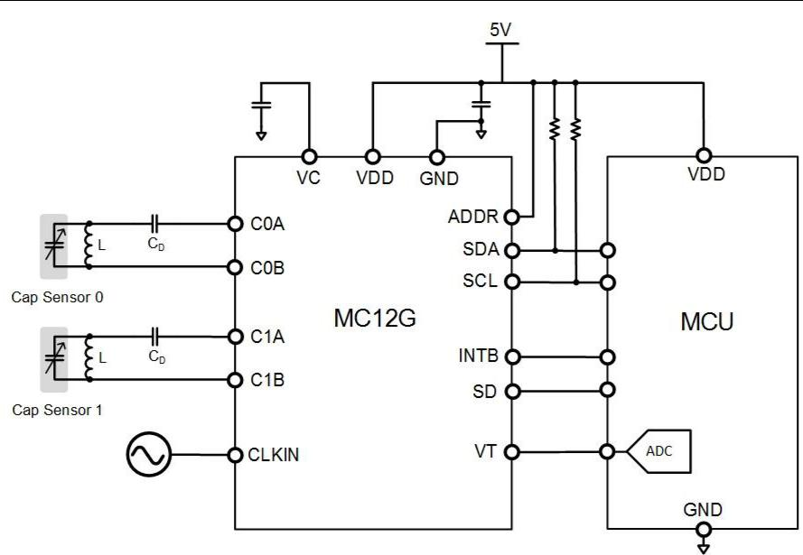

Figure 7.1-1 MC12G typical application circuit diagram: double electrode detection

For single-ended detection scenarios, the positive terminal of the capacitor under test is connected to the inductor L, and the negative terminal is connected to GND, as shown in Figure 7.1-2. In order for the sensor to enter a low-power state during non-conversion, the CLKIN pin needs to be held low.

Figure 7.1-2 MC12G typical application circuit diagram: single electrode detection

MC12T only supports the positive terminal of the capacitor under test to be connected to the inductor L, and the negative terminal to GND, as shown in Figure 7.1-3.

Figure 7.1-3 MC12T typical application circuit diagram: single electrode detection

For MC12G and MC12T, the recommended external capacitor value for the VC pin is 4.7nF.

# Typical application examples

Scenario:

* Single-channel application requires 100 samples/second.
* Conversion time TCV=10ms
* Inductor: 1uH
* CD: 100pF.
* C0A chip internal parasitic capacitance to ground CP = 51.5pF
* C0A PCB parasitic capacitance CPCB = 2pF.

In this way, with CSENSOR The sum of the total parallel capacitances to ground CF for:

Then calculate the maximum oscillation frequency through the LC resonance formula:

This frequency is the maximum oscillation frequency, when using CSENSOR. When connected to a circuit, the oscillation frequency will decrease. Select the internal 2.4MHz clock of the chip for counting. The configuration process of each related register is as follows:

* Configure channel 0 conversion and configure the CH_EN register to 0x40 (enable channel 0, disable channel 1, disable INTB triggering).
* Configure the chip to use the internal clock for counting: Set bit 7 of the CFG register to 0.
* To ensure accuracy, fREF is recommended to meet the conditions:

fCLK=2.4MHz, select CH0_FREF_DIV=0, CH0_FIN_DIV=7, which can meet the above conditions. Therefore, configure the FREF_CH0_DIV register to 0x00 and the FIN_CH0_DIV register to 0x70.

To ensure that the oscillator can start and control the oscillation amplitude, the driving current can be configured as 3mA by setting the DRIVE_I_CH0 register to 0x50. If it still fails to start, increase the drive current value and re-test.

To ensure sufficient setup time, take TSET0 ≥ 100us, by configuring the SCNT_CH0 register to 0x0F, so that the actual TSET0=100us.

* Calculate counting time TCNT:

According to the configuration in the previous steps, fREF0=2.4MHz. Therefore, RCNT0=23760, the maximum resolution is >13 bit. Configure the RCNT_CH0_MSB register to 0x5A and the RCNT_CH0_LSB register to 0xF0.

For MC12G, if you want to use the interrupt signal output by the INTB pin, you need to set bit 6 of the CFG register to 1 and bit 0 to 0, so that INTB can output the comparison result of the converted data, and the comparison thresholds are stored in the TH_MSB / TH_LSB registers. and TL_MSB/TL_LSB registers.

# Inductor self-resonant frequency

The inductor itself has parasitic capacitance, corresponding to a specific self-resonant frequency. In order to avoid entering the self-resonant state, it is recommended that the oscillation signal frequency fSENSOR < 0.8 x fSR.

# Encapsulation

# MC12G QFN16 3.0*3.0*0.75mm

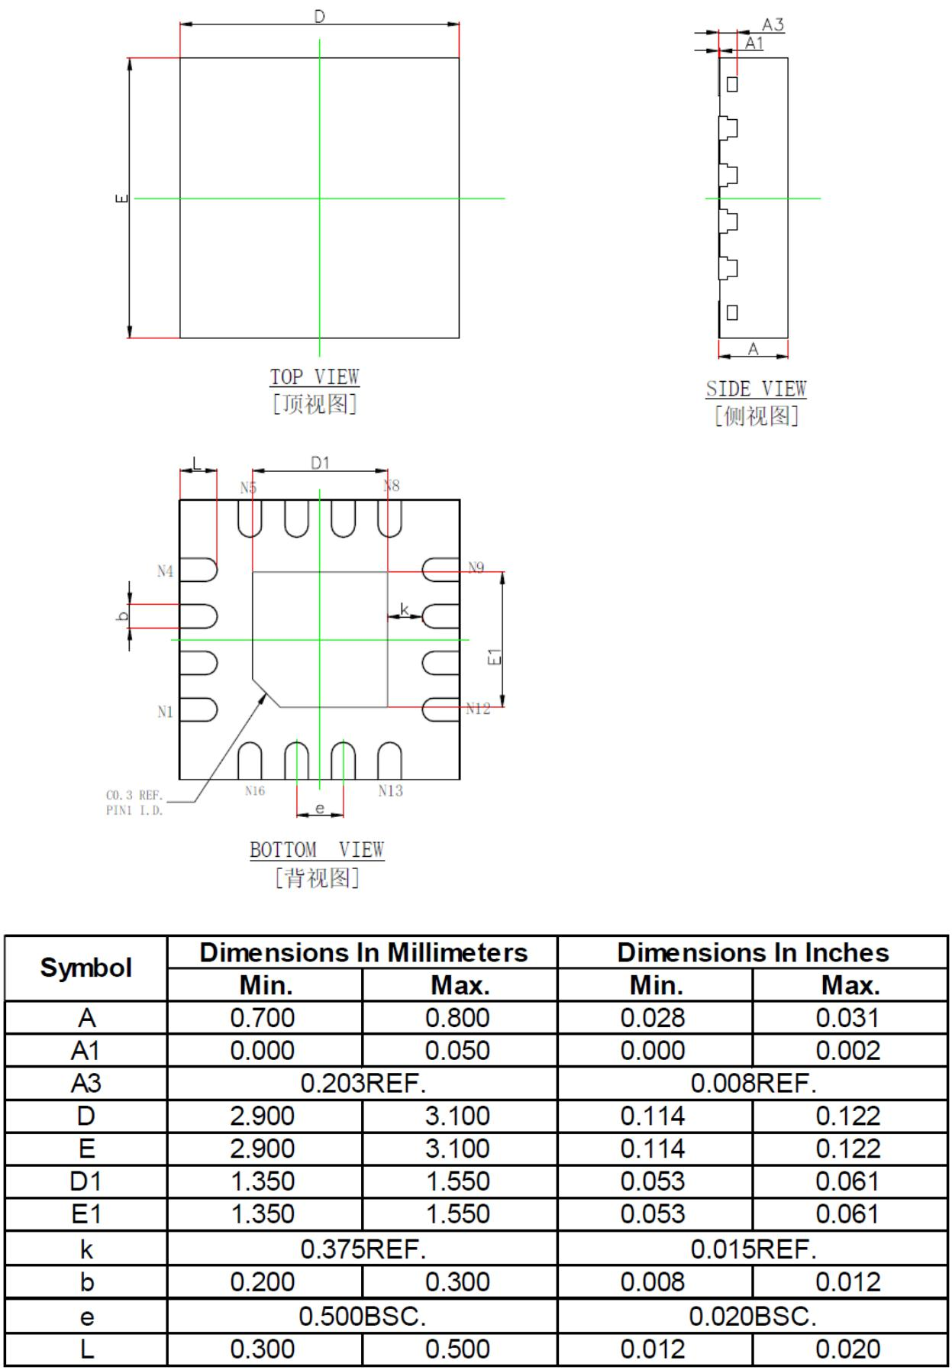

# MC12T SOP8 4.9*3.9*1.6mm

