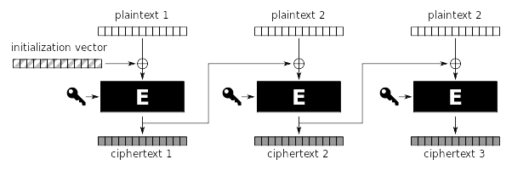
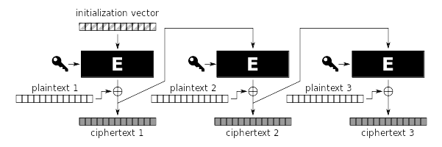
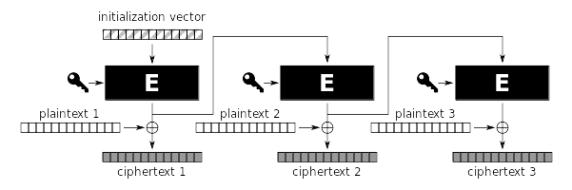
Cipher Block Chaining mode (CBC)

Output FeedBack mode (OFB)

Cipher FeedBack mode (CFB)
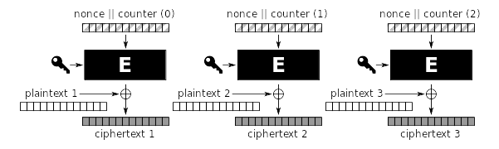
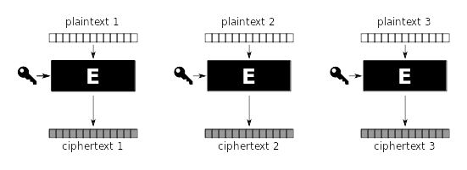
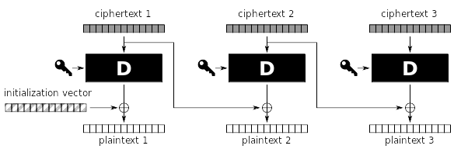
CounTeR mode (CTR)
A

Electronic Code Book mode (ECB)

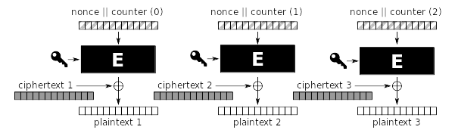
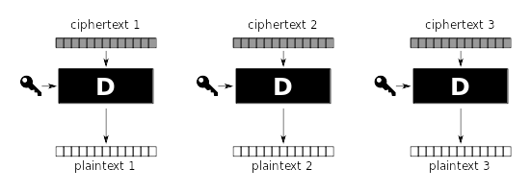
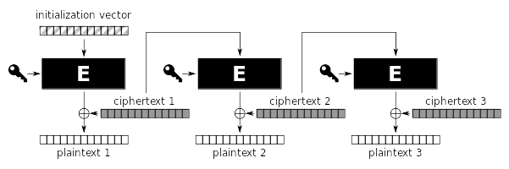
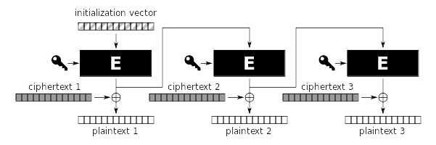
C
D
B
E
Use case:
You are submiting electronic voting ballot
(exactly 3 bytes).

Use case:
You want to add privacy
to instant messaging application.

Use case:
The customer wants the configuration of the program you develop to be saved in an encrypted form.

Use case:
You need to encrypt huge file backups.

Use case:
You need to encrypt the outgoing stream of video.

Use case:
You are adding encryption capabilities to new chips embedded into parking gate remote controls.
Feature 1:
The encryption process can be parallelised easily.

Feature 1:
The encryption process can be parallelised easily.

Feature 2:
The change in 1 ciphertext block
causes 1 corrupted plaintext block.

Feature 2:
The change in 1 ciphertext block
causes 1 corrupted plaintext block.

Feature 2:
The change in 1 ciphertext block
causes 1 corrupted plaintext block.

Feature 3:
The change in 1 ciphertext block
causes 2 corrupted plaintext blocks.

Feature 3:
The change in 1 ciphertext block
causes 2 corrupted plaintext blocks.
Feature 4:
Encrypting the same plaintexts
produces the same ciphertexts.

Feature 5:
Encryption/decryption can be accelerated
by precomputation.

Feature 5:
Encryption/decryption can be accelerated
by precomputation.

------------- extra ½ page (and ½ next page) ------------

Feature 4:
Encrypting the same plaintexts
produces the same ciphertexts.

Feature 5:
Encryption/decryption can be accelerated
by precomputation.

Feature 5:
Encryption/decryption can be accelerated
by precomputation.
Feature 6 (bonus):
The plaintext block is corrupted predictably.
(predictability = changing some bits in ciphertext
causes changes in the same positions in plaintext)

Feature 6 (bonus):
The plaintext block is corrupted predictably.
(predictability = changing some bits in ciphertext
causes changes in the same positions in plaintext)

Feature 6 (bonus):
The plaintext block is corrupted predictably.
(predictability = changing some bits in ciphertext
causes changes in the same positions in plaintext)

Feature 6 (bonus):
The plaintext block is corrupted predictably.
(predictability = changing some bits in ciphertext
causes changes in the same positions in plaintext)

Feature 6 (bonus):
The plaintext block is corrupted predictably.
(predictability = changing some bits in ciphertext
causes changes in the same positions in plaintext)

Feature 6 (bonus):
The plaintext block is corrupted predictably.
(predictability = changing some bits in ciphertext
causes changes in the same positions in plaintext)
Feature 6 (bonus):
The plaintext block is corrupted predictably.
(predictability = changing some bits in ciphertext
causes changes in the same positions in plaintext)

Feature 7 (bonus):
The plaintext block is corrupted UNpredictably.
(unpredictability = changing some bits in ciphertext
causes random changes in plaintext)

Feature 7 (bonus):
The plaintext block is corrupted UNpredictably.
(unpredictability = changing some bits in ciphertext
causes random changes in plaintext)

Feature 7 (bonus):
The plaintext block is corrupted UNpredictably.
(unpredictability = changing some bits in ciphertext
causes random changes in plaintext)

Feature 8 (bonus):
Block synchronization is required.
(e.g. getting ciphertext blocks 1, 2, 4, 5, 6, … and thinking it’s
1, 2, 3, 4, 5, … causes ALL remaining plaintext to be unreadable)

Feature 8 (bonus):
Block synchronization is required.
(e.g. getting ciphertext blocks 1, 2, 4, 5, 6, … and thinking it’s
1, 2, 3, 4, 5, … causes ALL remaining plaintext to be unreadable)

