Fetching Data

Michael Borck

Table of contents

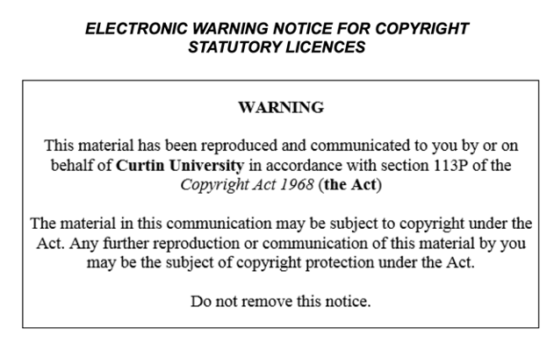

# Today

* Emphasise the importance of understanding APIs and data fetching in Python
* Highlight the skills that will be learned in this session, such as:
  + Fetching data using the OpenWeatherMap API
  + Parsing JSON data
  + Handling errors

# Live Coding - Fetching Data

* Demonstrate how to use the requests library to fetch data from the OpenWeatherMap API
* Introduce the concept of HTTP requests and responses
* Show how to handle errors and exceptions in Python

# Parsing JSON Data

* Introduce the concept of JSON data and how it is used to represent data
* Demonstrate how to use the json library to parse JSON data in Python
* Highlight the importance of data parsing and how it is used in the weather dashboard project

# Error Handling

* Introduce the concept of error handling in Python and its importance
* Demonstrate how to use try-except blocks to handle errors in Python
* Highlight the importance of error handling in the weather dashboard project

# Breakout Room Activity

* Emphasise the importance of teamwork and collaboration in the project
* Encourage students to work together to fetch and parse data for different cities

# Demo and Discussion

* Demonstrate how to use the fetched data to create a basic weather dashboard
* Encourage students to share their findings and discuss challenges

# Q&A and Wrap-Up

* Address any questions and provide additional tips
* Emphasize the importance of practicing and experimenting with the concepts learned in the session

# Homework*

* Assign homework that reinforces the concepts learned in the session
* Encourage students to experiment with different APIs and data fetching techniques