Welcome

Michael Borck

Table of contents

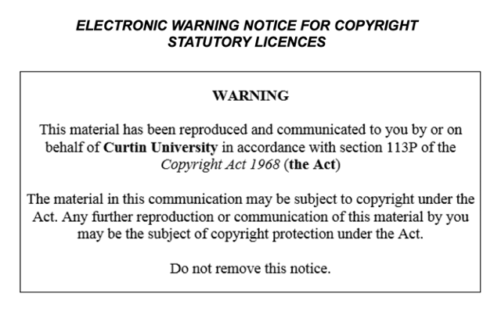

# Today

– Introduce the course and project goals. – Set up the development environment. • Activities: – Overview of the weather dashboard project. – Install Python, Jupyter, and necessary libraries. – Basic Git commands: clone, commit, push.

# Introduction to the Course

* Welcome and course overview
* Introduction to the WeatherVista project

# Demo of Completed WeatherVista Dashboard (20 minutes) • Show the completed dashboard

* Highlight key features and functionalities

# Setting Up Development Environment (30 minutes)

* Walkthrough installation of Python, Jupyter, and necessary libraries
* Set up GitHub/GitLab repository

# Introduction to Git

* Basic Git commands: clone, commit, push
* Demonstrate cloning the project repository

# Creating Project Directory Structure (20 minutes)

* Create directories for data, scripts, notebooks, and tests
* Brief explanation of the purpose of each directory

# Breakout Room Activity

* Students work in small groups to set up their project structure
* Instructors available for assistance

# Q&A and Wrap-Up

* Address any questions about setup and project structure
* Homework: Research the OpenWeatherMap API and sign up for an API key