Fetching Data Using OpenWeatherMap API

Michael Borck

Table of contents

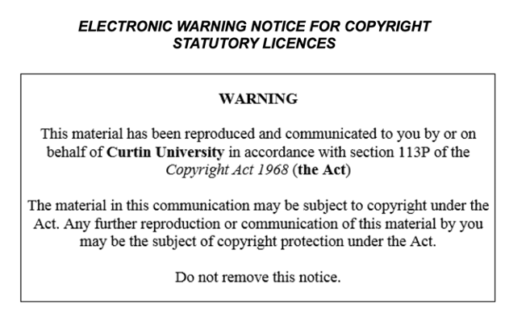

# Today

* Learn how to manage weather data using CSV files
* Understand how to use SQL to store and retrieve weather data
* Practice reading, writing, and processing data with pandas and SQLite

# OpenWeatherMap API (Homework)

* Navigate OpenWeatherMap API endpoints.
* Customise requests with parameters.
* Understand API response formats.
* Handle common API errors.

# Project Overview

* Web app displays weather trends.
* Uses OpenWeatherMap API data.
* Shows current and forecast weather.
* Location selection and unit switch.
* Handles API errors gracefully.

# Setup Project

* Create GitHub repository.
* Clone repository locally.
* Structure project folders.
* Create Python environment.
* Install dependencies via requirements.txt.

# Breakout Room Activity

* Setup Project Folder and Environment

# Managing Data with CSV Files

* Reading data from a CSV file
* Processing data by converting temperature from Kelvin to Celsius
* Writing data to a new CSV file

# Read data

import pandas as pd  
  
df = pd.read_csv('data/raw/weather_data.csv')  
df

# Processing data

def convert_temp_kelvin_to_celsius(temp_k):  
 return temp_k - 273.15  
  
df['Temperature (C)'] = df['Temperature (K)'].apply(convert_temp_kelvin_to_celsius)  
df.drop(columns=['Temperature (K)'], inplace=True)  
df

# Saving data

df.to_csv('data/processed/processed_weather_data.csv', index=False)

# Managing Data with SQL

* Creating a SQLite database and table
* Inserting data into the table
* Querying data from the table

# Create database

import sqlite3  
  
conn = sqlite3.connect('data/weather_data.db')  
cursor = conn.cursor()  
  
cursor.execute('''  
 CREATE TABLE IF NOT EXISTS weather (  
 location TEXT,  
 temperature_c REAL,  
 humidity INTEGER,  
 weather_description TEXT  
 )  
''')  
conn.commit()

# inserting into table

for index, row in df.iterrows():  
 cursor.execute('''  
 INSERT INTO weather (location, temperature_c, humidity, weather_description)  
 VALUES (?, ?, ?, ?)  
 ''', (row['Location'], row['Temperature (C)'], row['Humidity (%)'], row['Weather']))  
conn.commit()

# Querying form table

cursor.execute('SELECT * FROM weather')  
rows = cursor.fetchall()  
for row in rows:  
 print(row)  
  
df_sql = pd.DataFrame(rows, columns=['Location', 'Temperature (C)', 'Humidity (%)', 'Weather'])  
df_sql

# Combining CSV and SQL Data Management

* Reading additional weather data from a CSV file
* Inserting data into the SQLite table
* Querying combined data from the SQLite table

# Code snippet:

additional_data = pd.read_csv('data/raw/additional_weather_data.csv')  
for index, row in additional_data.iterrows():  
 cursor.execute('''  
 INSERT INTO weather (location, temperature_c, humidity, weather_description)  
 VALUES (?, ?, ?, ?)  
 ''', (row['Location'], row['Temperature (C)'], row['Humidity (%)'], row['Weather']))  
conn.commit()

# Verify

cursor.execute('SELECT * FROM weather')  
combined_rows = cursor.fetchall()  
df_combined = pd.DataFrame(combined_rows, columns=['Location', 'Temperature (C)', 'Humidity (%)', 'Weather'])  
df_combined

# Homework

* Complete Understanding the Weather Dashboard Project: WeatherVista worksheet
* Write fetch_data.py and test_fetch_data.py
* Practice reading and writing data to CSV files with different weather datasets
* Explore additional SQL queries to retrieve specific subsets of the weather data

# Summary

* manage weather data using CSV files and SQL.
* practice reading, writing, and processing data with pandas and SQLite
* combined both techniques to manage our weather data effectively.

# Next Session

* we will focus on basic data visualisation with Matplotlib.