Plotting Magic: Visualizing Weather Data with Matplotlib

Create Eye-Catching Visuals with Python

Michael Borck

Table of contents



# Today

* Introduce the importance of data visualisation in Python.
* Learn how to visualise weather data using Matplotlib
* Understand how to create basic plots to represent weather data
* Customise plots to enhance readability and presentation

# Why Visualise Data?

* Simplifies complex data
* Identifies patterns and trends
* Aids in decision-making
* Enhances data storytelling
* Facilitates better communication

# What is Data Visualisation?**

* Visual representation of data
* Uses charts, graphs, and plots
* Helps in understanding data insights

# Popular Libraries in Python**

* **Matplotlib:** Highly customisable, widely used
* **Seaborn:** Built on Matplotlib, easier syntax
* **Plotly:** Interactive visualisations, web-based
* **Bokeh:** Interactive plots, for web apps
* **Altair:** Declarative statistical visualisation

# Workflow

* Find the data you want
* What story do you want to tell
* Pick from the Python Graph Galley
* Get data (upload, wget, etc)
* Implement in notebook (or script)

# Common Visualisation Roles

* Showing change over time
* Showing a part-to-whole composition
* Looking at how data is distributed
* Comparing values between groups
* Observing relationships between variables
* Looking at geographical data

# Python Graph Gallery

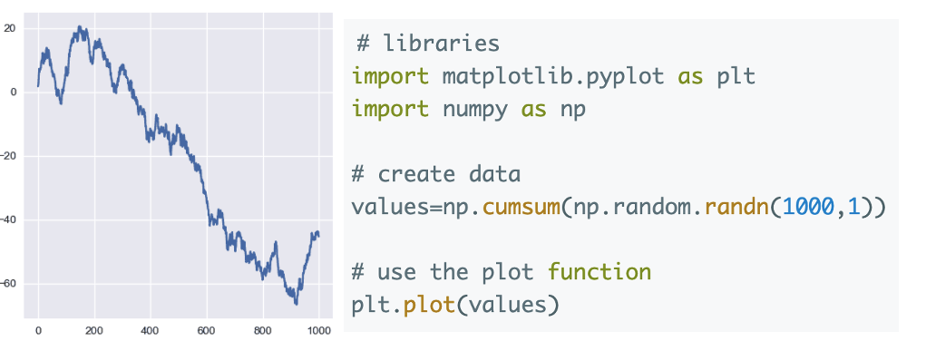

# Dashboard

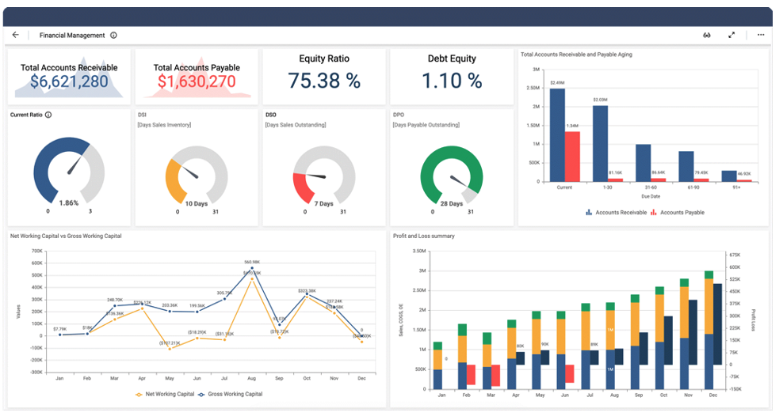

# Introduction to Matplotlib

* Matplotlib is a widely used Python library for creating static, animated, and interactive visualisations
* Import required libraries: import pandas as pd and import matplotlib.pyplot as plt

# Reading Data

* Read processed weather data from the CSV file created in the previous session

import pandas as pd  
df = pd.read_csv('data/processed/processed_weather_data.csv')

# Creating Basic Plots

* line plot for temperature
* bar plot for humidity
* pie chart ofr weather description
* scatter plots temperature vs windspeed

# Line plot for temperature

plt.plot(df['Location'], df['Temperature (C)'], marker='o')  
plt.title('Temperature by Location')  
plt.xlabel('Location')  
plt.ylabel('Temperature (°C)')  
plt.xticks(rotation=45)  
plt.grid(True)  
plt.show()

# Bar plot for humidity

plt.bar(df['Location'], df['Humidity (%)'], color='skyblue')  
plt.title('Humidity by Location')  
plt.xlabel('Location')  
plt.ylabel('Humidity (%)')  
plt.xticks(rotation=45)  
plt.show()

# Pie chart for weather description

weather_counts = df['Weather'].value_counts()  
plt.pie(weather_counts, labels=weather_counts.index, autopct='%1.1f%%', startangle=140)  
plt.title('Weather Description Distribution')  
plt.axis('equal')  
plt.show()`

# Customising Plots

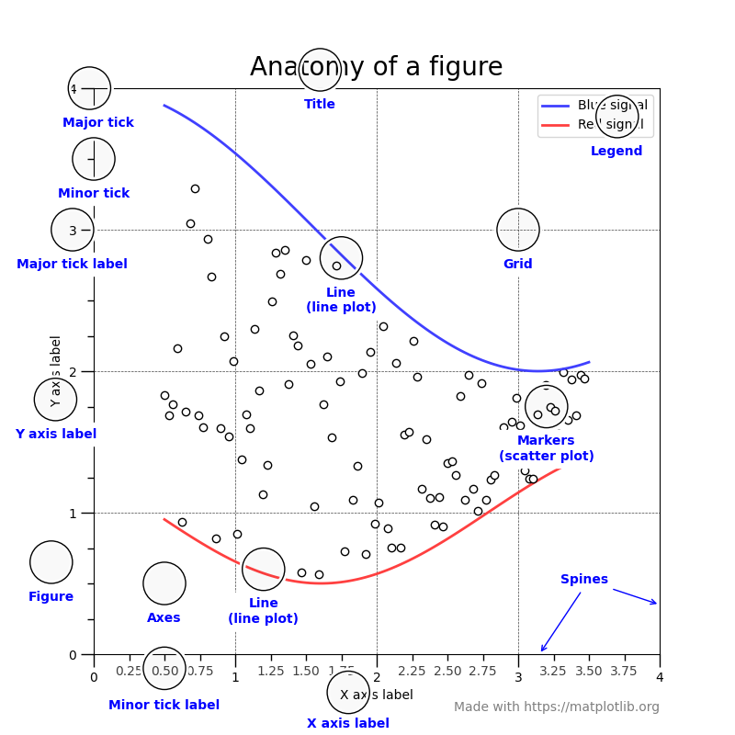

# Adding annotations

plt.annotate(f'Max Temp: {max_temp:.2f}°C', xy=(max_temp_location, max_temp),  
 xytext=(max_temp_location, max_temp+2),   
 arrowprops=dict(facecolor='black', shrink=0.05))

# Customising colors and styles

plt.plot(df['Location'], df['Temperature (C)'], marker='o', linestyle='--', color='b')  
plt.title('Temperature by Location', fontsize=14, fontweight='bold')  
plt.xlabel('Location', fontsize=12)  
plt.ylabel('Temperature (°C)', fontsize=12)  
plt.xticks(rotation=45)  
plt.grid(True, linestyle='--', linewidth=0.5)  
plt.show()

# Effective Data Visualisation

* Choose the right type of chart
* Maintain clarity and simplicity
* Use colour wisely
* Ensure accuracy and precision
* Tailor visualisations to the audience

# Conclusion

* In this session, we learned how to visualise weather data using Matplotlib
* We created basic plots such as line plots, bar plots, and pie charts, and we customised these plots to improve readability and presentation
* Next session, we will focus on advanced data visualisation techniques using subplots and grids.

# Homework

* Create additional plots to visualise other aspects of the weather data (e.g., wind speed, pressure)
* Experiment with different types of plots and customisations to enhance the visualisations