Advanced Data Visualisation and Dashboard Layout

Michael Borck

Table of contents

# Today

* Create daily forecast cards with high/low temperatures.
* Design a layout for the dashboard using subplots and grids.
* Use icons to represent weather conditions.
* **Output:**
  + 04_advanced_vix.ipynb
  + visualise_data.py

# Recap and Introduction (10 minutes)

* **Recap of Session 4:**
  + Key takeaways
  + Any remaining questions
* **Introduction:**
  + Importance of advanced data visualisation
  + Advanced visualisations can provide more insights by combining multiple plots into a single figure, allowing for easier comparison and analysis.
  + Overview of dashboard layout techniques

# Principles of Effective Data Visualisation

* **Clarity:**
  + Ensure the visual is easy to understand.
  + Avoid clutter and unnecessary elements.
* **Accuracy:**
  + Represent data truthfully.
  + Avoid misleading scales or distortions.
* **Efficiency:**
  + Convey information quickly.
  + Use visual cues like color and sise effectively.

# Dashboard Design Best Practices

* **Consistency:**
  + Maintain a uniform style and layout.
  + Use consistent colors, fonts, and iconography.
* **Relevance:**
  + Include only necessary information.
  + Prioritise key metrics and insights.
* **Interactivity:**
  + Enhance user engagement.
  + Allow for exploration and filtering of data.

# What Makes Plots Advanced?

* Combining Multiple Plots:
  + Use subplots to create complex visualisations within a single figure.
  + Examples: 2x2 grids, multi-panel plots.
* Customisations:
  + Annotations, colour schemes, and styles to enhance readability.
  + Interactive elements for user engagement.
* Data Transformation:
  + Using statistical transformations (e.g., regression lines, smoothing).
  + Aggregating and summarising data for better insights.

# Import Required Libraries

import pandas as pd  
import matplotlib.pyplot as plt  
import numpy as np

# Reading Data

* We’ll start by reading the processed weather data from the CSV file.

df = pd.read_csv('processed_weather_data.csv')  
df['Datetime'] = pd.to_datetime(df['Datetime'])  
df.head()

# Creating a 2x2 Grid of Plots

* Subplots allow us to create multiple plots within a single figure.
* We’ll create a 2x2 grid of plots to visualise different aspects of the weather data.

fig, axs = plt.subplots(2, 2, figsize=(14, 10))

# fig & axs

* fig: Entire figure container object
* axs: Array of subplot axes
* You can use fig to adjust figure-wide settings (like the overall size) and
* axs to customise each subplot individually.

# Access each subplot by indexing into axs

axs[0, 0].plot([1, 2, 3], [1, 4, 9]) # Top-left subplot  
axs[0, 1].plot([1, 2, 3], [1, 2, 3]) # Top-right subplot  
axs[1, 0].plot([1, 2, 3], [9, 4, 1]) # Bottom-left subplot  
axs[1, 1].plot([1, 2, 3], [3, 2, 1]) # Bottom-right subplot  
  
plt.tight_layout()  
plt.show()  
  
# Save the figure  
fig.savefig('my_plot.png')

# Four plots

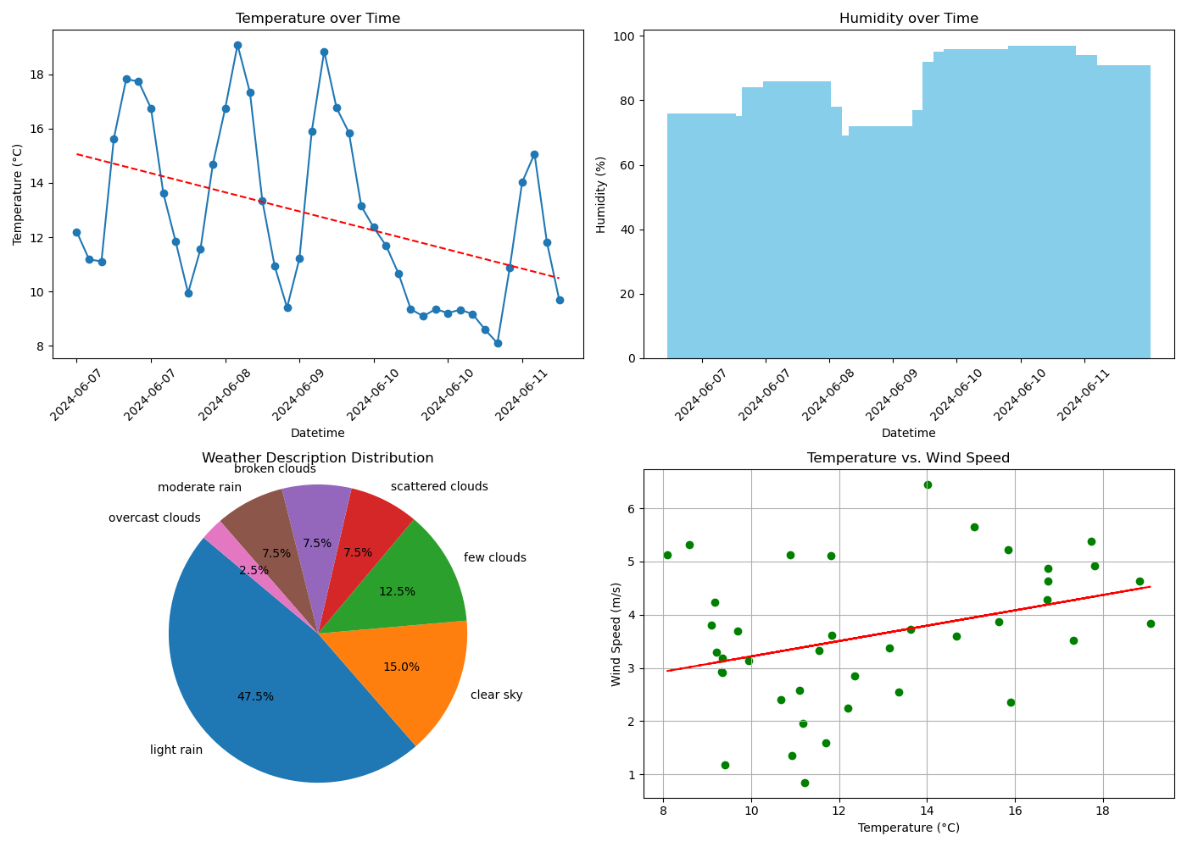

# Plot 1: Line plot for Temperature over Time

# Select every 6th datetime value for x-ticks  
x_ticks = df['Datetime'][::6]  
  
axs[0, 0].plot(df['Datetime'], df['Temperature (C)'], marker='o')  
axs[0, 0].set_title('Temperature over Time')  
axs[0, 0].set_xlabel('Datetime')  
axs[0, 0].set_ylabel('Temperature (°C)')  
axs[0, 0].set_xticks(x_ticks)  
axs[0, 0].tick_params(axis='x', rotation=45)

# Add line of best fit for Temperature over Time

s = np.polyfit(df['Datetime'].astype(np.int64) // 10**9, df['Temperature (C)'], 1)  
p = np.poly1d(s)  
axs[0, 0].plot(df['Datetime'], p(df['Datetime'].astype(np.int64) // 10**9), "r--")

# Plot 2: Bar plot for Humidity over Time

axs[0, 1].bar(df['Datetime'], df['Humidity (%)'], color='skyblue')  
axs[0, 1].set_title('Humidity over Time')  
axs[0, 1].set_xlabel('Datetime')  
axs[0, 1].set_ylabel('Humidity (%)')  
axs[0, 1].set_xticks(x_ticks)  
axs[0, 1].tick_params(axis='x', rotation=45)

# Plot 3: Pie chart for Weather Description

weather_counts = df['Weather'].value_counts()  
axs[1, 0].pie(weather_counts, labels=weather_counts.index, autopct='%1.1f%%', startangle=140)  
axs[1, 0].set_title('Weather Description Distribution')  
axs[1, 0].axis('equal') # Equal aspect ratio ensures that pie is drawn as a circle.

# Plot 4: Scatter plot for Temperature vs. Wind Speed

axs[1, 1].scatter(df['Temperature (C)'], df['Wind Speed (m/s)'], c='g', marker='o')  
axs[1, 1].set_title('Temperature vs. Wind Speed')  
axs[1, 1].set_xlabel('Temperature (°C)')  
axs[1, 1].set_ylabel('Wind Speed (m/s)')  
axs[1, 1].grid(True)

# Add line of best fit for Temperature vs. Wind Speed

s = np.polyfit(df['Temperature (C)'], df['Wind Speed (m/s)'], 1)  
p = np.poly1d(s)  
axs[1, 1].plot(df['Temperature (C)'], p(df['Temperature (C)']), "r--")  
  
# Adjust layout  
plt.tight_layout()  
plt.show()

# Customising Subplots

* Customising subplots can enhance their readability and presentation.
* Annotations
* Colours and Styles

# Setup a plot

fig, ax = plt.subplots(figsize=(10, 6))  
ax.plot(df['Datetime'], df['Temperature (C)'], marker='o')  
ax.set_title('Temperature over Time')  
ax.set_xlabel('Datetime')  
ax.set_ylabel('Temperature (°C)')  
ax.set_xticks(x_ticks)  
ax.tick_params(axis='x', rotation=45)  
ax.grid(True)

# Annotate the highest temperature

max_temp = df['Temperature (C)'].max()  
max_temp_time = df.loc[df['Temperature (C)'] == max_temp, 'Datetime'].iloc[0]  
ax.annotate(f'Max Temp: {max_temp:.2f}°C', xy=(max_temp_time, max_temp),   
 xytext=(max_temp_time, max_temp+2),   
 arrowprops=dict(facecolor='black', shrink=0.05))  
  
plt.show()

# Customising Colours and Styles

fig, ax = plt.subplots(figsize=(10, 6))  
ax.plot(df['Datetime'], df['Temperature (C)'], marker='o', linestyle='--', color='b')  
ax.set_title('Temperature over Time', fontsize=14, fontweight='bold')  
ax.set_xlabel('Datetime', fontsize=12)  
ax.set_ylabel('Temperature (°C)', fontsize=12)  
ax.set_xticks(x_ticks)  
ax.tick_params(axis='x', rotation=45)  
ax.grid(True, linestyle='--', linewidth=0.5)  
  
plt.show()

# Summary

* In this session, we learned how to visualise weather data using advanced techniques in Matplotlib. We created subplots and grids, combined multiple plots into a single figure, and customised these plots for better presentation.

# Homework - Design Dashboard

* **Task:**
  + Modify, Refine and enhance existing visualisations
    - For example: remove line of best fit, change colours, titles
  + Create additional subplots to visualise other aspects of the weather data (e.g., wind speed, pressure).
    - For example: compare min/max over 5 days, Word Cloud for description
  + Experiment with different types of subplots and customisations to enhance the visualisations.
  + Inspiration form internet or Search
    - Python Graph Library
    - Matplotlib Gallery
* **Submission:**
  + Upload the refined notebook and script to the shared folder