**ANTI-DRIFT LAB FIELD-GUIDE   
VERSION 0.2**

*Hello fellow critter.****Thank you for taking the first step in trusting me on this small journey in a margin of time.***

*This slice of the margin can last anywhere between 30 min to a whole day, if that is what you wish. I urge you to spend more time than you would expect on this, but of course, this is entirely up to you.*

*Here is the pocket of space you are to visit.*

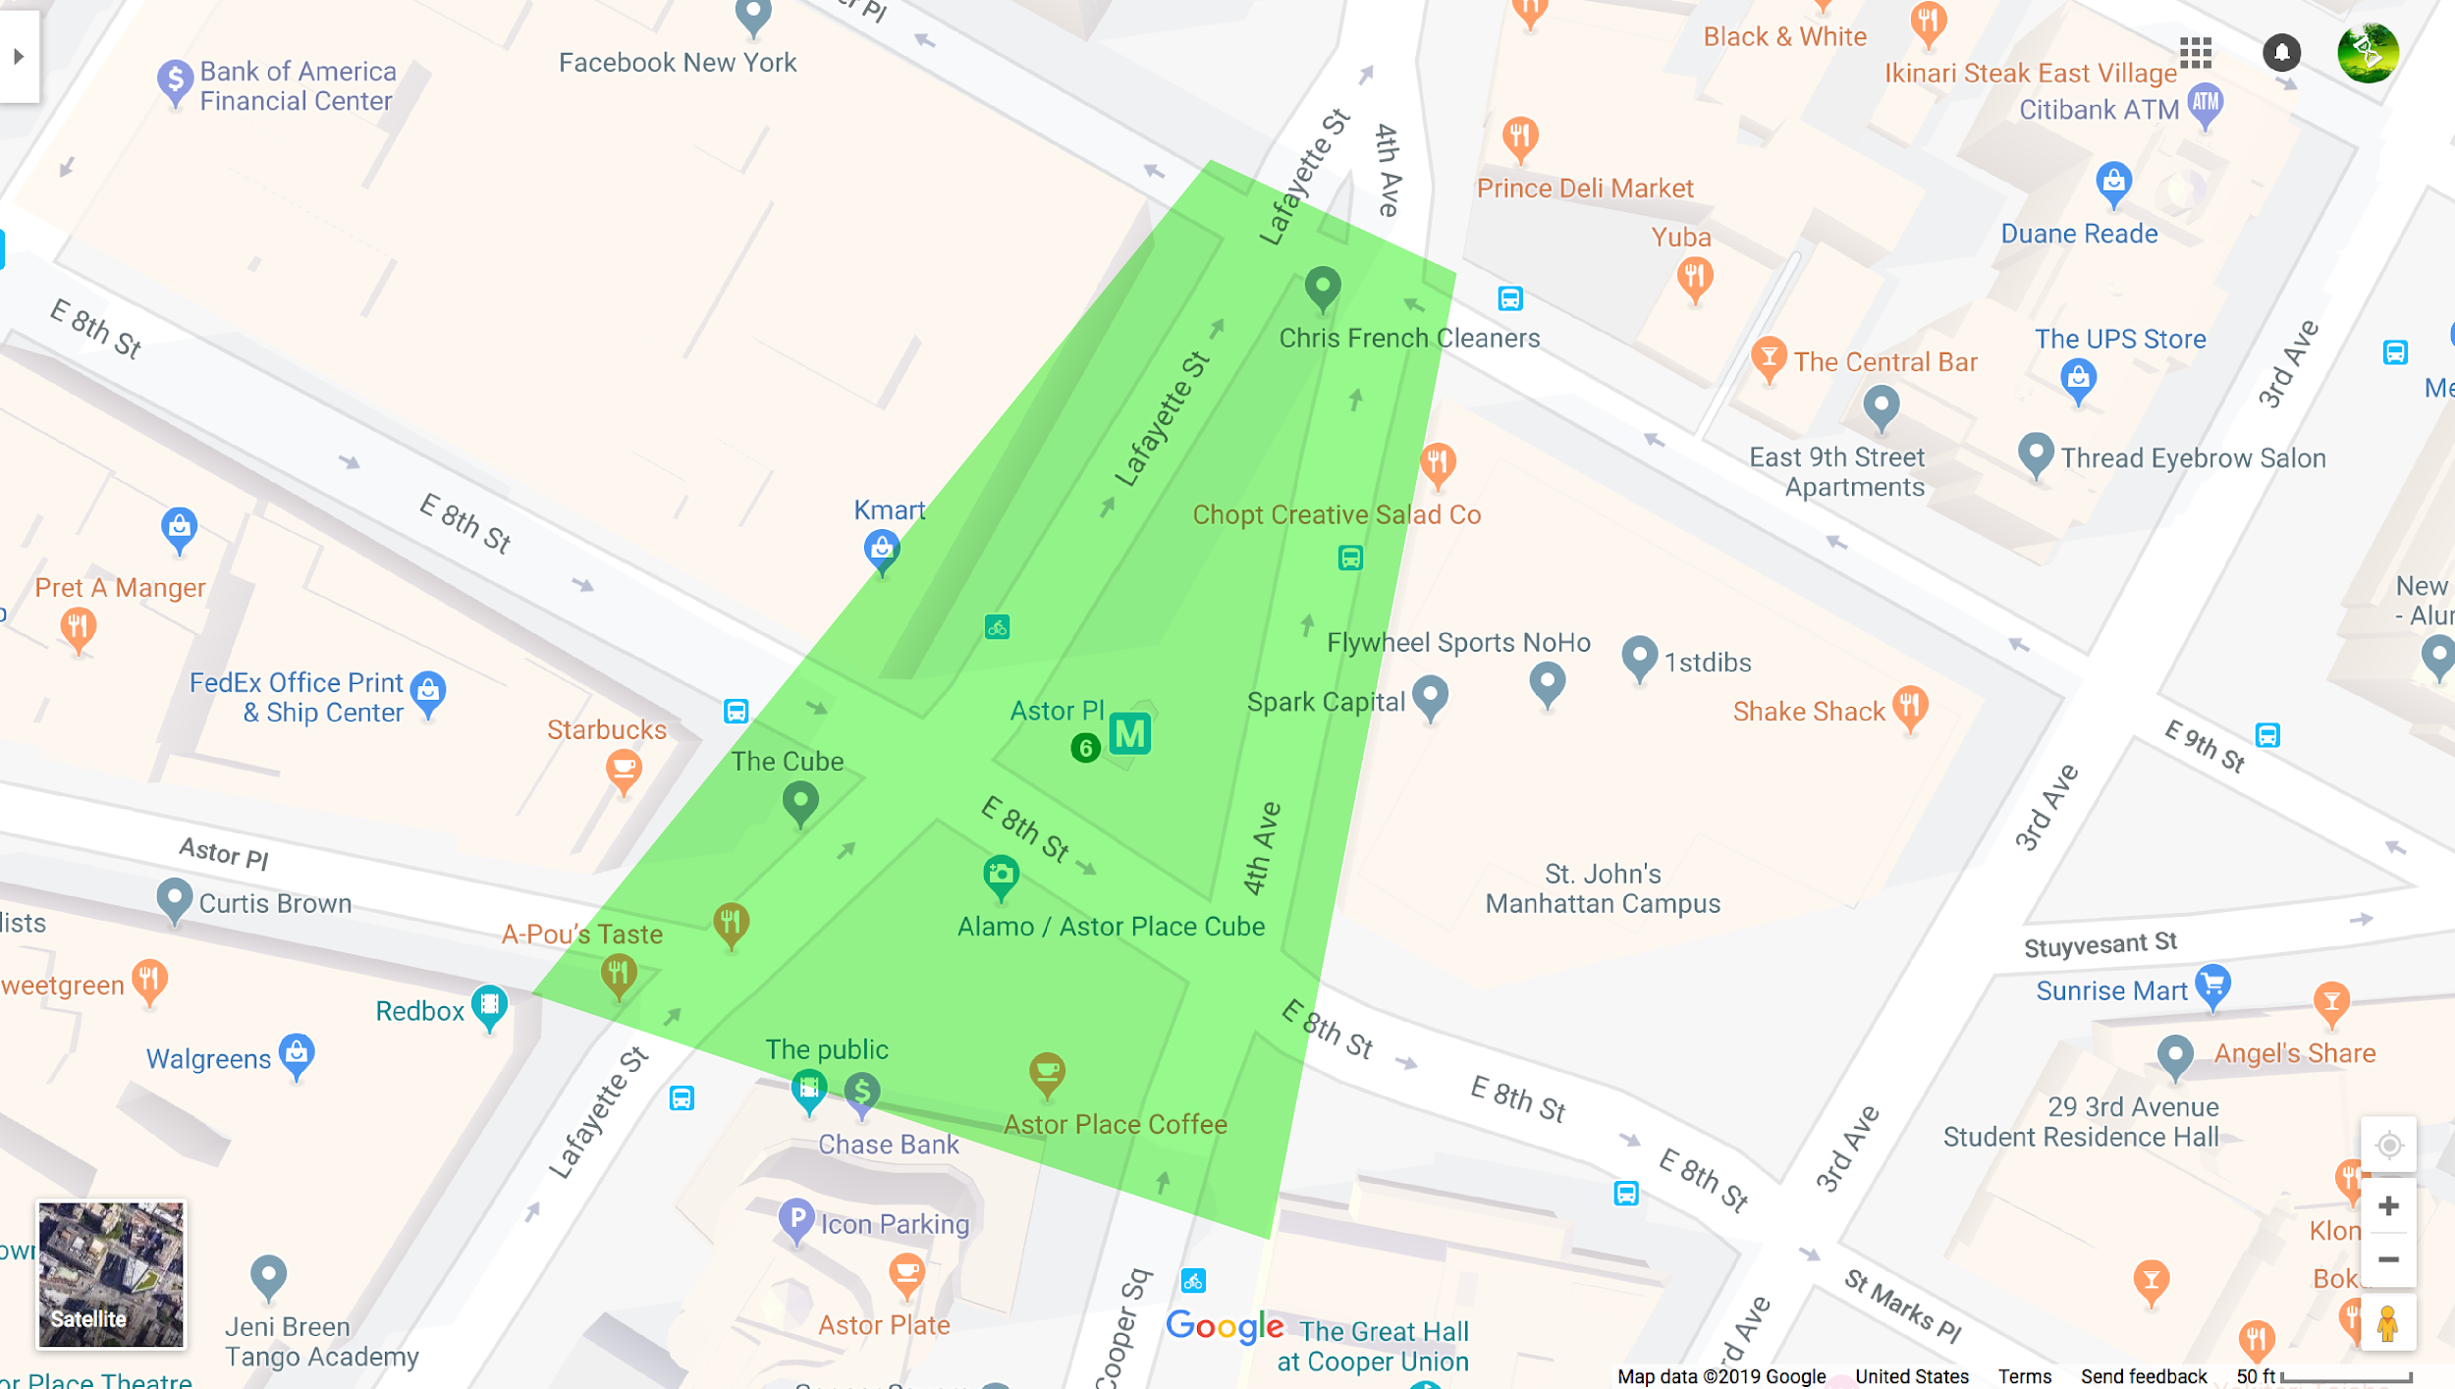

*Please try to stay within the green perimeter on this map, but if something pushes you elsewhere, don’t hesitate to fulfill the itch.*

*With this guide, you will perform a couple of tasks of slow and purposeful “data collection.”* ***These are what I like to call encounters.*** *Try not to read the rest of this guide* ***before you are local to the space****.*

*Bring with you: a print-out of this guide : something to write/draw with : a fully charged phone.*

*[ Note: do not use your phone unless it is needed for you to document or complete a task. ]*

*----------------------------------------------------------------*

***I.***

*TRY TO MAKE THIS STAGE AT LEAST* ***TEN MINUTES****. FORGET YOUR PHONE.  
( No head phones either ! Sound is good for orienting oneself as well ! )*

*Record your start time:__________________________________________*

***Begin your visit by becoming acquainted with this space:***

*Try walking the entire perimeter;*

*Walking at different speeds;*

*Crossing the same street multiple times;*

*Sitting on different street furniture;*

*Find refuge beneath a scaffolding;*

*Find different vantage points;*

*different heights;*

*Perhaps,*

*Try walking where you are not seemingly meant to walk.*

|  |
| --- |
| *CONGRATULATIONS. YOU ARE “DRIFTING” FELLOW CRITTER. You may,* ***seemingly****, have no agenda.   As you continue to “drift”, progressively pay closer attention to the surroundings*  *above your head, at your body’s height, & at the level of your feet.* |

*----------------------------------------------------------------*

***II.***

*(TAKE AT LEAST 20 MINUTES FOR THIS TASK)  
  
Whether you have decided to stall or continuously meandre, when the time comes, allow your focus to invest in one or two elements that may have been governing your navigation and observations.*

*Here is a list of focal points that could help you navigate your senses:*

|  |  |  |
| --- | --- | --- |
| *SKY* | *BODY* | *GROUND* |
| *Construction scaffoldings*  *Construction workers*  *Signage & Traffic Posts*  *Antennas*  *Banners*  *A security camera*  *Air Circulation devices* | *A patron Signage (street, construction, psa)*  *Trashcans*  *Benches*  *Fire Hydrants*  *Lampposts*  *Cones*  *Bike posts*  *Steam Chimney* | *Ditch*  *Pipes*  *Manhole covers*  *Cones*  *Potholes*  *Street Markings*  *Garbage* |

*Choose one of these elements.   
Rest your attention on it for some time. Encounter it.*

*----*

*MARK ON THE MAP ON THE OTHER PAGE, WHERE IT IS.*

Once you feel like you have had a bountiful dialogue with your chosen mass of atoms, proceed to *DOCUMENT IT in these TWO ways:*

1. Use 7 minutes to write down as many things you can about it. On the next page, some prompts and descriptors for inspiration.
2. Create some kind of physical documentation of it. This could be a photo, a screenshot of it on google earth, a poem or a specimen from this zone (A band-aid? A receipt?). Anything that itches the right itch. You will have to bring this with you to the library. (*if you have taken a photo or made something on paper,* ***feel free to send it to me at least 15 minutes prior and I will print it out myself, ready for the rest of the workshop***)

*geometry --- material --- texture --- movement --- direction --- color --- sound --- smell --- taste --- size --- length ---*

***Who or what is it for?***

***What is your personal relationship to this element?***

*Is it permanent or temporary?*

***How is it a singular component and how is it part of another system?***

***Who or what maintains it? Who are what does it maintain?***

*Is it associated to other things you have taken a note of in the space?*

*Does it function differently depending on the time of day?*

***Is it facilitating or obstructing?***

*What is in its proximity?*

***What associations may it have with things that you cannot see or hear in this space?***

***Is it manufactured? Where does it come from? Where is it going?***

|  |
| --- |
|  |

*RECORD YOUR FINISH TIME:_____________________ SEE YOU SOON, CRITTER.*