Edvinas V. – LAB 6

Lab 6: The purpose was to set up a MetaMask wallet, deploy Ethereum smart contracts (ERC-20, ERC-721, and ERC-1155) using Remix IDE, and troubleshoot contract compatibility issues with different EVM versions.

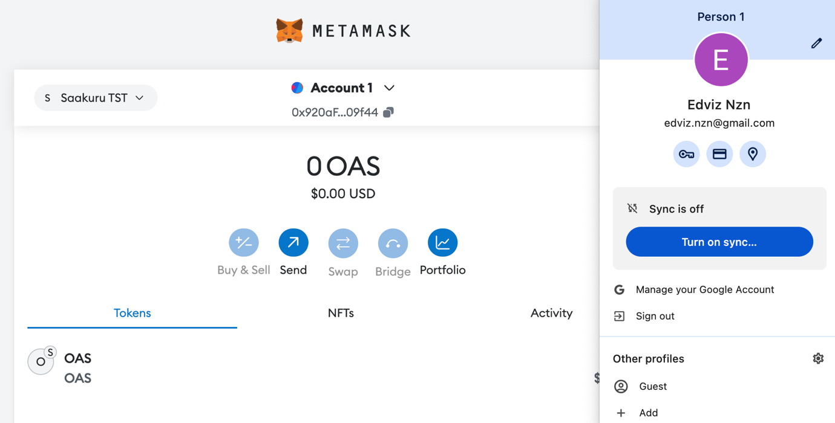
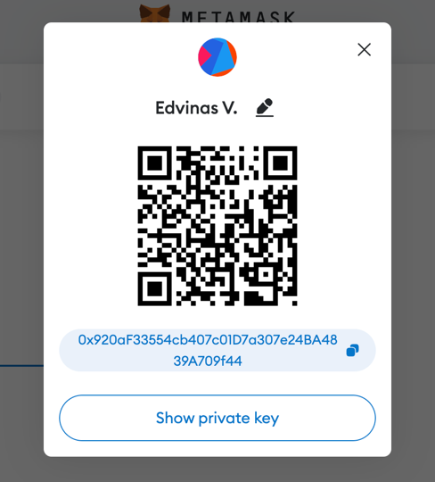

After downloading the MetaMask browser extension, creating an account and adding the Saakuru Testnet chain, Remix IDE was launched, a new “programming window” was created, and all contracts were added, namely TokenERC20.sol, TokenERC721.sol and Token1155.sol
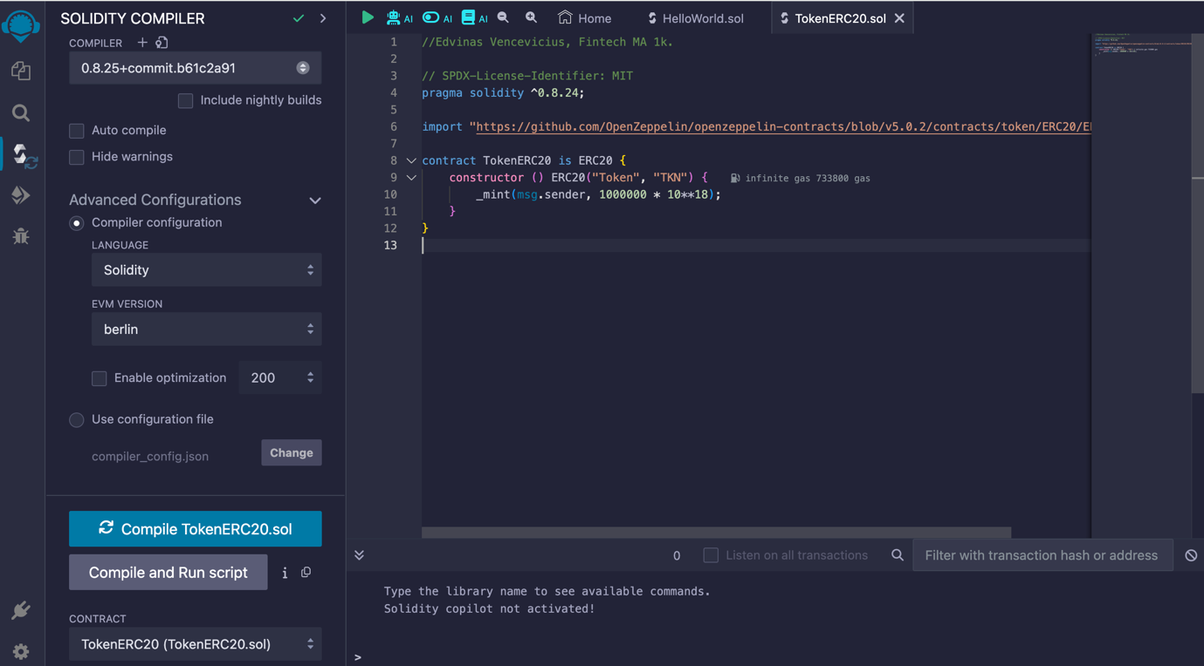

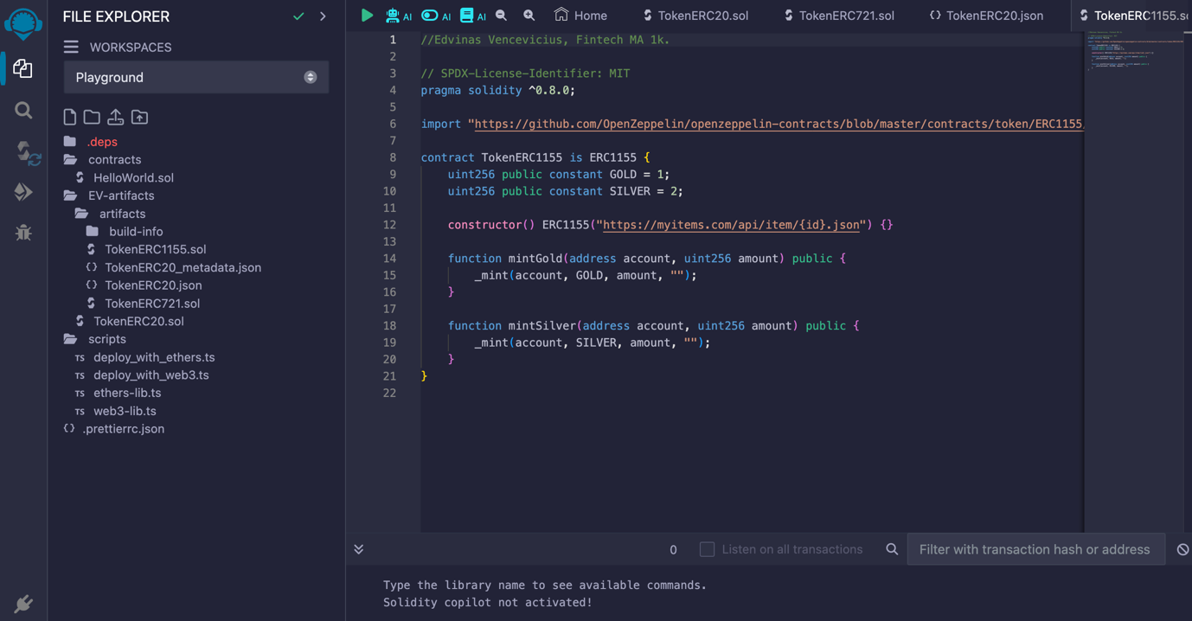
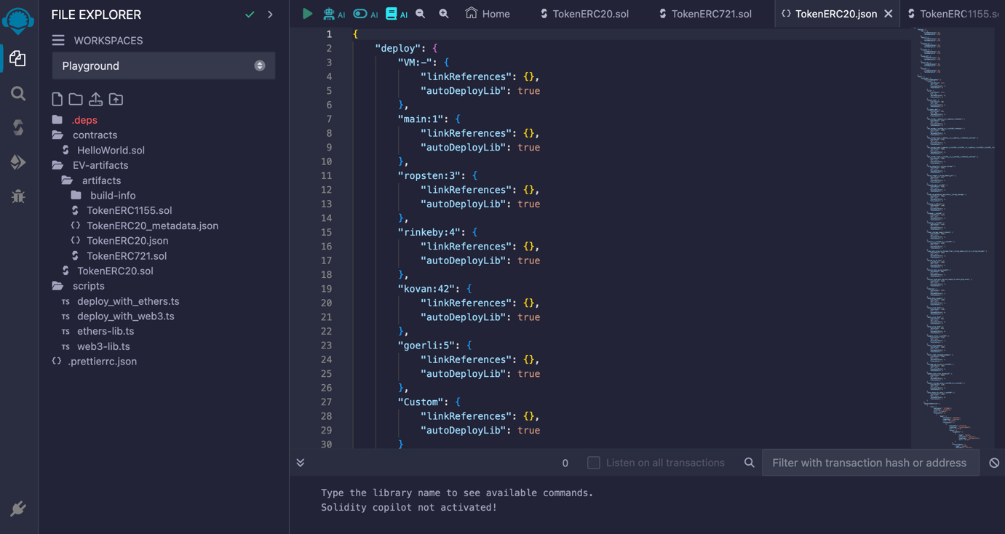

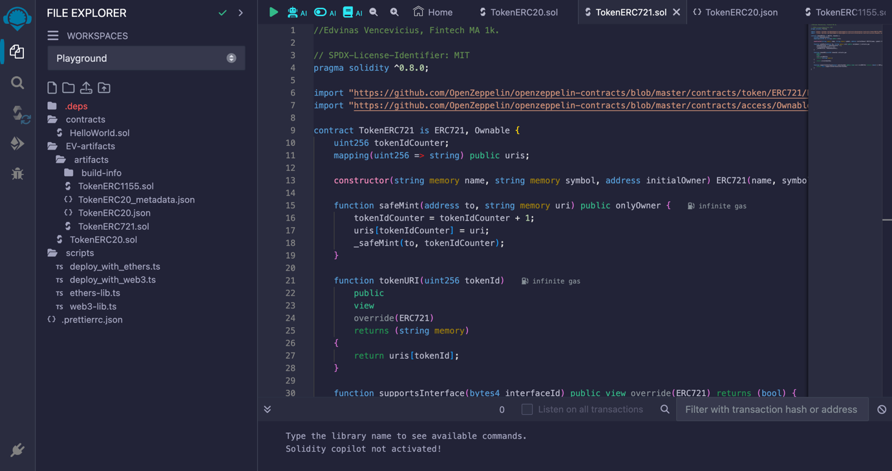

The next step was to launch the contracts themselves, it can be seen that contracts 20 and 721 are running successfully on the EVM "Berlin" version.
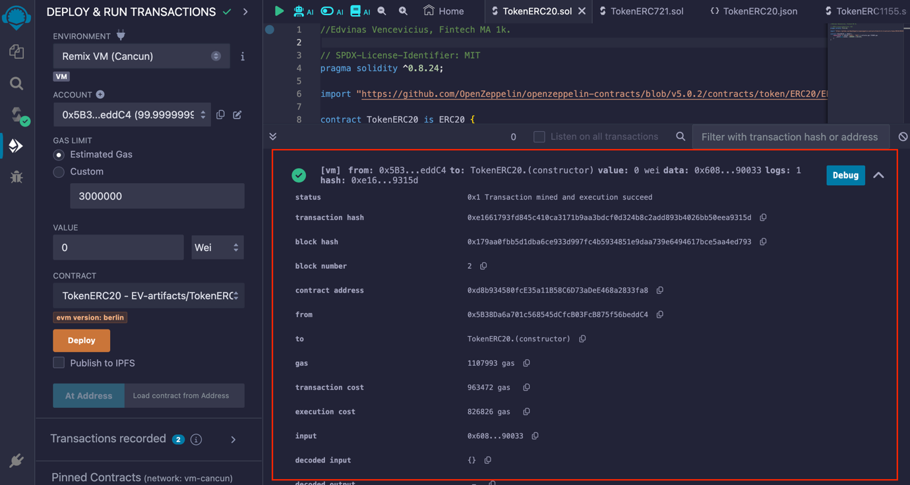

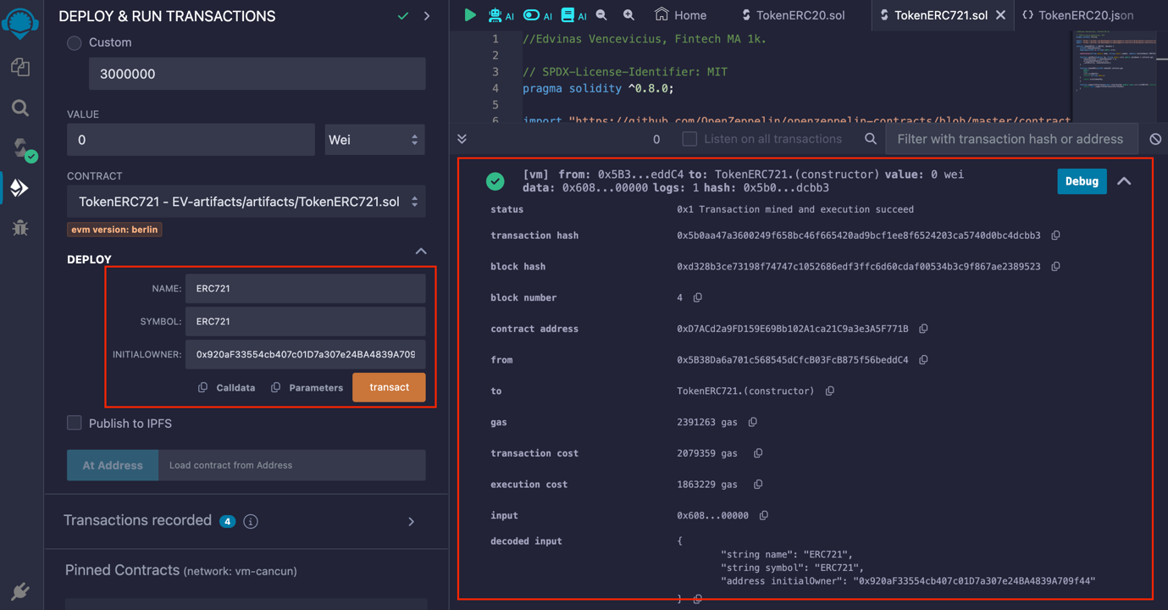

Finally, contract 1155 was launched, but for some reason the code does not work on the Berlin version, a possible solution is to change the version to Cancun
