Edvinas Vencevičius, Big Query Final Assignment

This paper builds a regression model using UAE housing/real estate data.
Objective: to predict the price of housing/real estate using certain values ​​(predictors), but excluding the current price value.

- Loading data from Kaggle. Since this array has quite a few values ​​that are not needed for the model, the next step will be data cleaning.

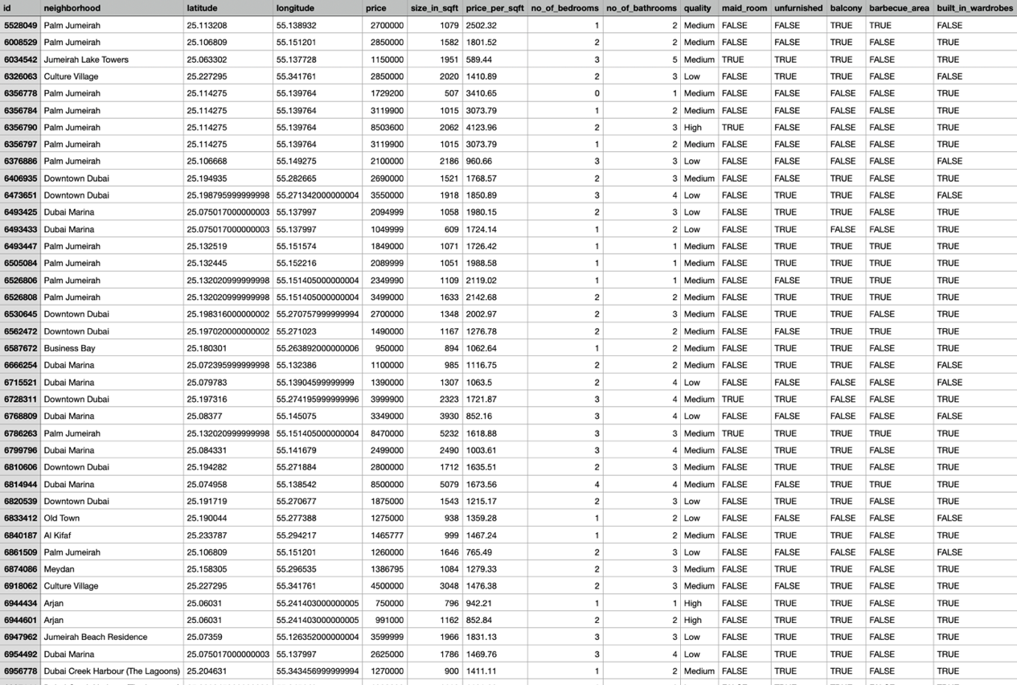

- Model creation and discarding unnecessary data. Almost all columns with non-numeric values ​​(i.e. FALSE or TRUE) were discarded, only the values ​​with the highest value (logically speaking) were left, i.e. width, length, sq.m. size, price per sq.m. and number of rooms

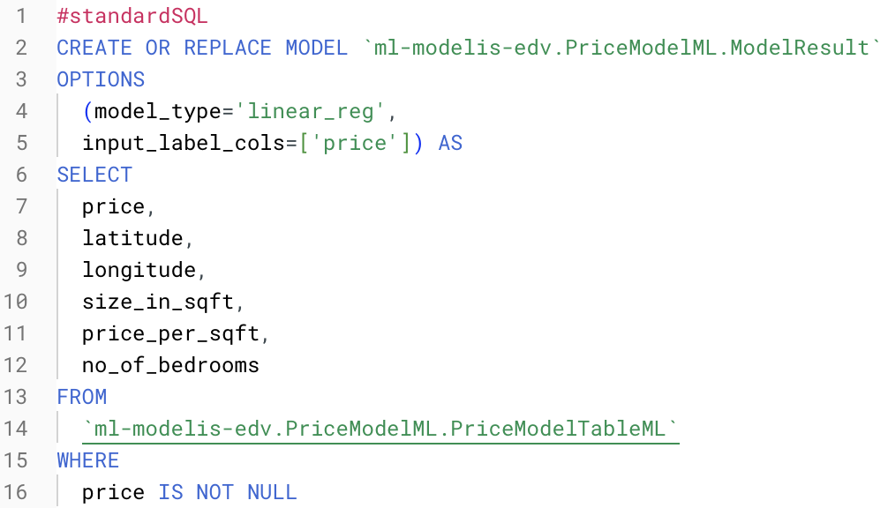

- Model evaluation using ML.EVALUATE.

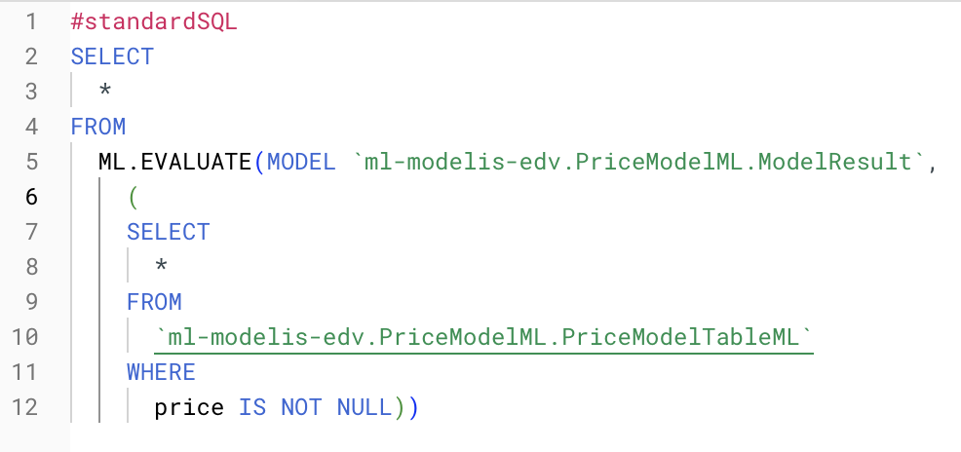

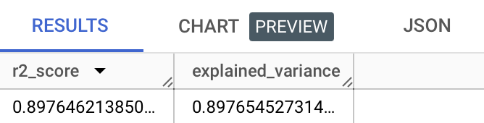

The model results show quite good results in predicting real estate/housing prices. Explained_variance - variance, which measures the part of the variance captured by the model, is impressively high - on average 89.77%. This indicates that the selected forecasts essentially determine the majority of the observed fluctuations in real estate/housing prices.

Meanwhile, the r2 value is also high - 89.76%. This further strengthens the robustness of the model in explaining the variability in real estate/housing prices. This value shows how well the model's forecasts match the actual observed prices. This r2 value indicates that almost 89.76% of the fluctuation in real estate/housing prices can be attributed to the features included in the model.

- Model prediction using ML.PREDICT.

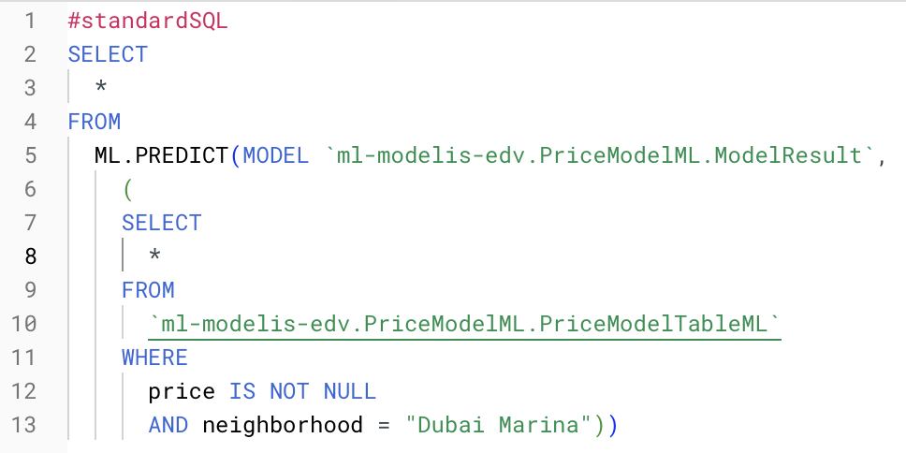

As an example, we choose to predict the prices of all residential/non-residential buildings in the UAE "Dubai Marina" area. We see that the model's predicted price values ​​differ from those already mentioned, the general trend shows that the ML model's predicted prices are higher than those already mentioned.
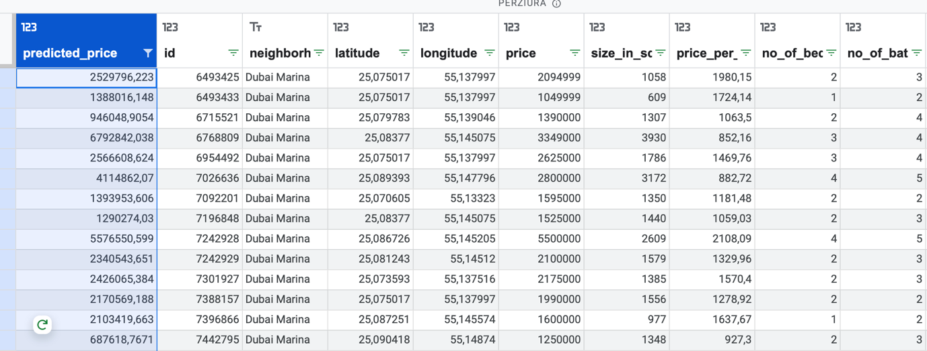

- Interpreting model results with ML.EXPLAIN_PREDICT.

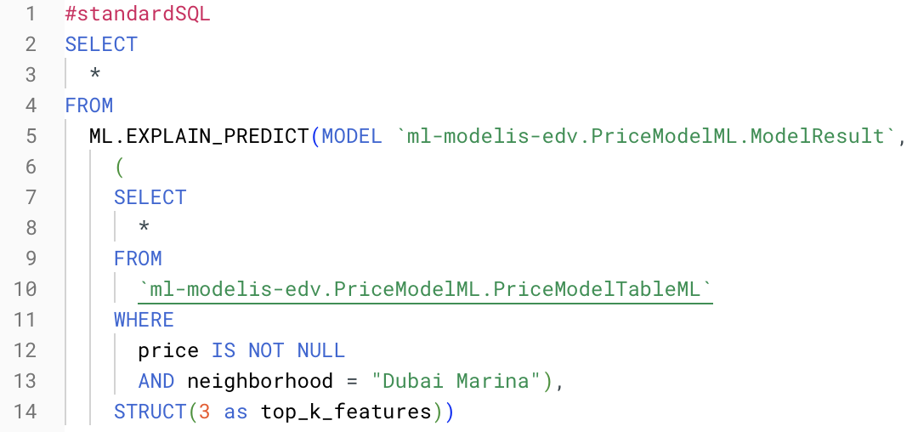

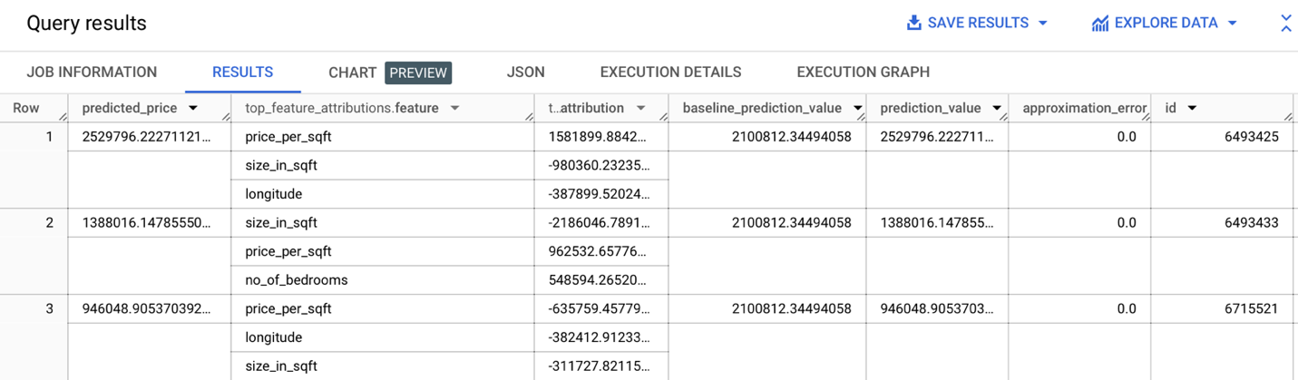

In linear regression models, Shapley values ​​are used to generate the assignment values ​​for each feature in the model. ML.EXPLAIN_PREDICT returns the top 3 feature assignments in the given row of the table, since top_k_features was set to 3 in the query. These assignments are sorted by the absolute assignment value in descending order.

Looking at the model results, specifically at the first row (Row 1), we can see that:
Predicted price: The model’s prediction for the price of the property/housing is around 2,529,796, which is significantly higher than the initial prediction value of 2,100,812. This indicates that the model believes that the property has a higher value than the initial value.
Top feature attribution: The most influential value contributing to this prediction is “price_per_sqft”, which has a value of around 1,581,900. This means that the price per square meter has the greatest influence on the predicted price of this property.
Baseline prediction value: This is the initial prediction made before considering the features. In this case, the model adjusted the prediction based on the provided features and arrived at a higher predicted price.
Approximation error: The error between the predicted price and the actual price is estimated to be 0, which indicates that the model’s prediction closely matches the actual data.

The results in Row 2 are significantly different:
Predicted price: The model’s prediction for the property price is approximately 1,388,016. This prediction is significantly lower than the initial prediction value of 2,100,812, indicating that the model believes the property is worth less than the initial value.
Top feature attribution: The most influential feature influencing this prediction is “size_in_sqft”, and the negative attribution value is approximately -2,186,046. This indicates that a larger value has a significant negative impact on the predicted price of this property.
Baseline prediction value: Similar to the first row, this shows the initial prediction made before considering the most important features. In this case, the model adjusted the prediction based on the provided features and arrived at a lower predicted price.
Approximation error: The error between the predicted price and the actual price is shown again as 0, which indicates that the model's prediction exactly matches the actual data.

In summary, it can be stated that this model was intended to predict real estate/housing prices based on various real estate/housing properties (predictors). The numbers performed and shown by the model show its fairly successful performance in predicting prices. The model is, of course, not ideal, but from a mathematical point of view, the r2 value (accuracy of the regression model) >85% indicates optimistic forecasts and hopes.

