Left-Handed Hitters
MODEL | Test Metrics | PR-AUC
Strikeout: Reduced Regression | 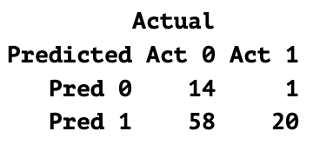  N = 93  Accuracy = 0.37  Precision = 0.26  Recall = 0.95  F1 = 0.40  Specificity = 0.19  AUC = 0.64  PR-AUC = 0.34 | 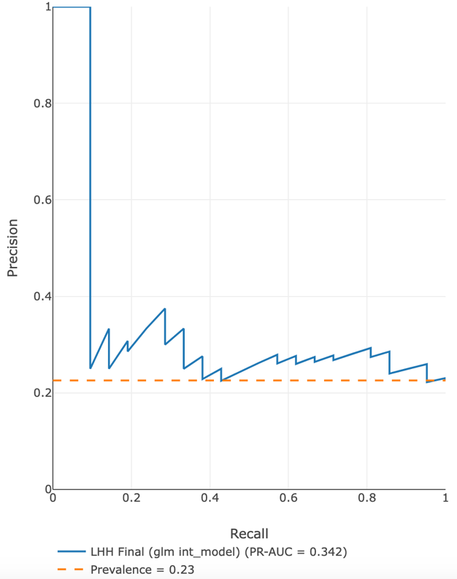
Strikeout: Domain Adaptation | 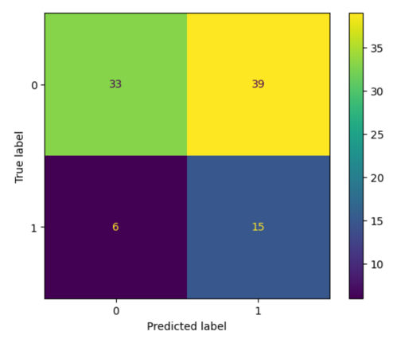  N = 93  Accuracy = 0.52  Precision = 0.28  Recall = 0.71  F1 = 0.40  Specificity = 0.46  AUC = 0.60  PR-AUC =0.33 | 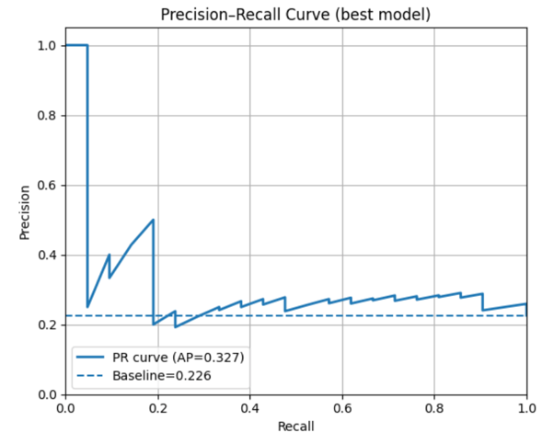
Hits: Regression | 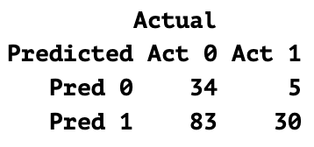  N = 160  Accuracy = 0.42  Precision = 0.27  Recall = 0.86  F1 = 0.41  Specificity = 0.29  AUC = 0.57  PR-AUC = 0.24 | 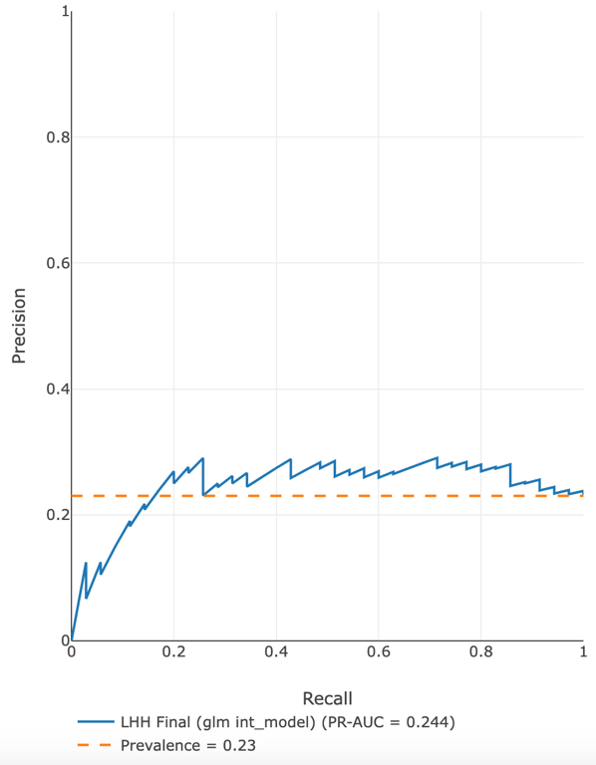
Hits: Logistic Regression Domain Adaptation | 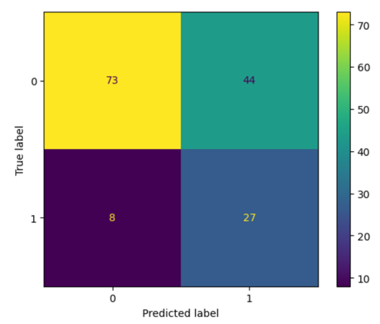  N = 152  Accuracy = 0.66  Precision = 0.38  Recall = 0.77  F1 = 0.51  Specificity = 0.62  AUC = 0.65  PR-AUC = 0.37 | 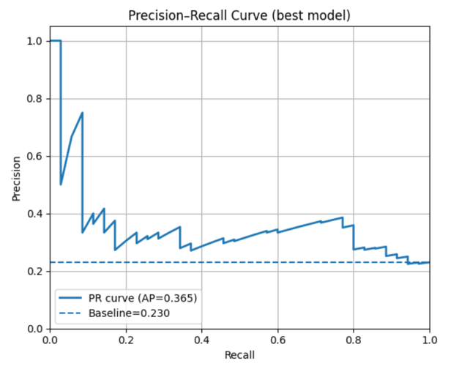
OBP: Reduced Logistic Regression | 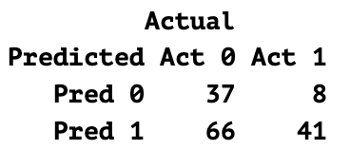  N = 160  Accuracy = 0.51  Precision = 0.38  Recall = 0.84  F1 = 0.53  Specificity = 0.36  AUC = 0.66  PR-AUC = 0.54 | 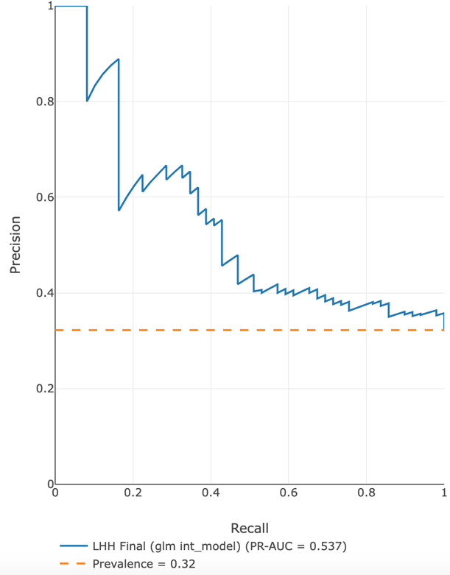
OBP: Domain Adaptation | 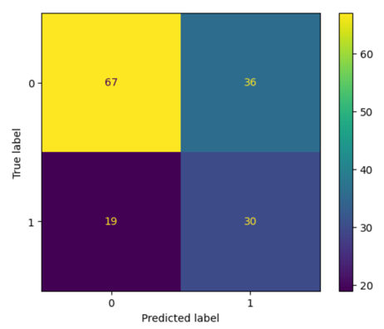  N = 152  Accuracy = 0.64  Precision = 0.45  Recall = 0.61  F1 = 0.52  Specificity = 0.65  AUC = 0.63  PR-AUC = 0.42 | 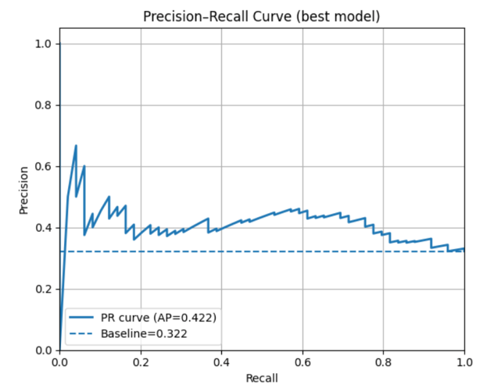
Walks: Reduced Logistic Regression | 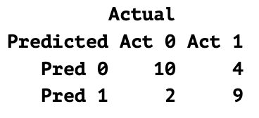  N = 25  Accuracy = 0.76  Precision = 0.82  Recall = 0.69  F1 = 0.75  Specificity = 0.83  AUC = 0.78  PR-AUC = 0.86 | 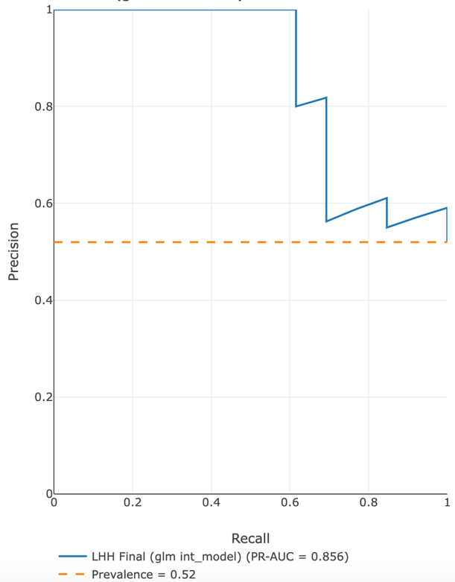
Walks: Domain Adaptation | 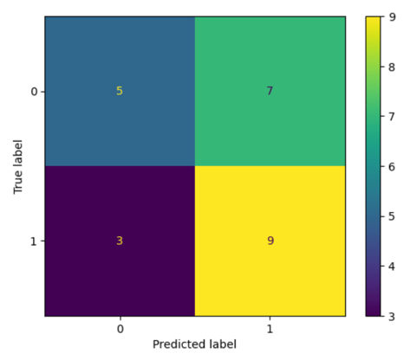  N = 24  Accuracy = 0.58  Precision = 0.56  Recall = 0.75  F1 = 0.64  Specificity = 0.42  AUC = 0.47  PR-AUC = 0.50 | 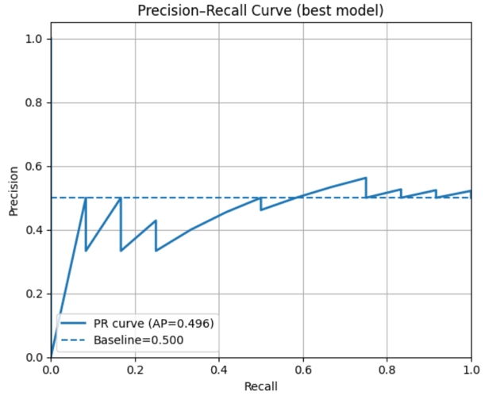
Home Runs: Reduced Logistic | 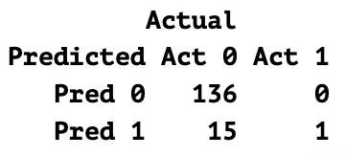  N = 160  Accuracy = 0.90  Precision = 0.06  Recall = 1.00  F1 = 0.12  Specificity = 0.90  AUC = 0.96  PR-AUC = 0.075 | 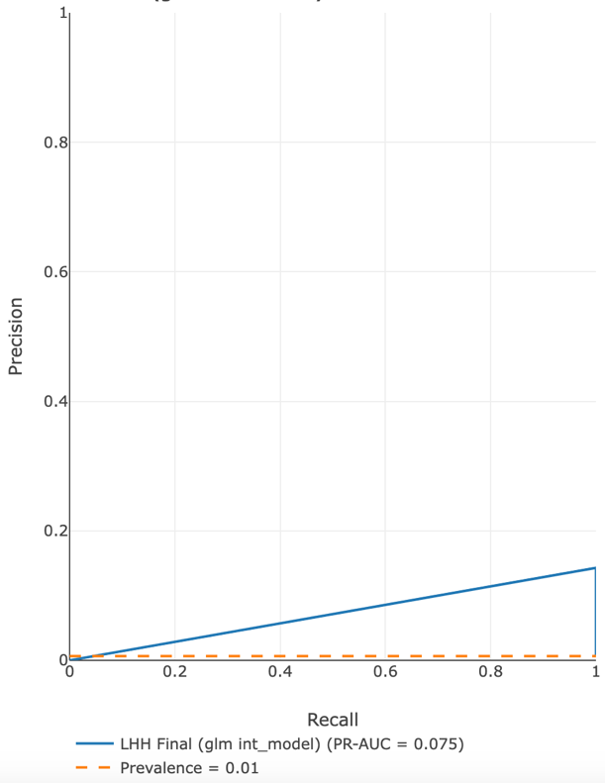
Home Run: Domain Adaptation | 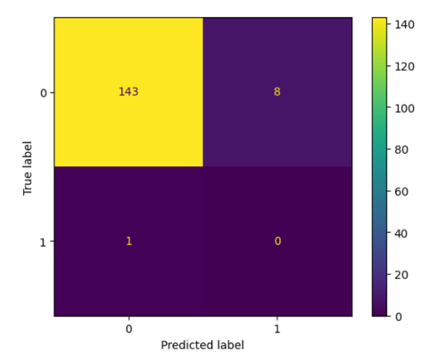  N = 152  Accuracy = 0.94  Precision = 0  Recall = 0  F1 = 0  Specificity = 0.95  AUC = 0.27  PR-AUC = 0.01 | 