Hits – 80/20
MODEL | MATRIX | REC | PREC |  | F1 |  | ACC | SPEC | AUC
Regression - R | 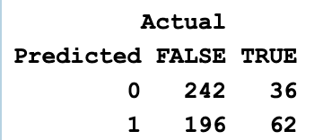 | 24 | 63 | 35 |  | 57 |  | 87 | 64
Regression - L | 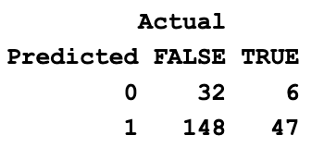 | 24 | 89 | 38 |  | 34 |  | 84 | 56
Decision - R | 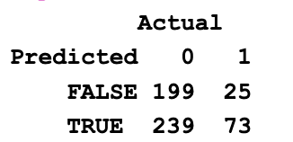 | 23 | 74 | 36 |  | 51 |  | 89 | 61
Decision - L | 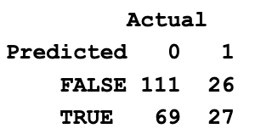 | 28 | 51 | 36 |  | 59 |  | 81 | 51
Random - R | 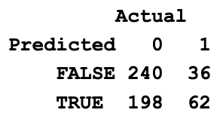 | 24 | 63 | 35 |  | 56 |  | 87 | 63
Random - L | 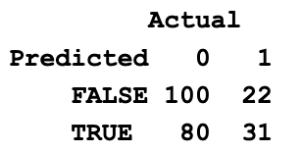 | 29 | 64 | 40 |  | 56 |  | 84 | 61
Domain - R
Domain - L

