Model | Test Metrics | PR-AUC
Strikeouts: Decision Tree | 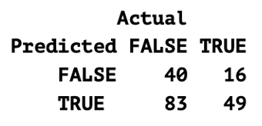  N = 188  Accuracy = 0.47  Precision = 0.37  Recall = 0.75  F1 = 0.50  Specificity = 0.33  AUC = 0.62  PR-AUC =0.475 | 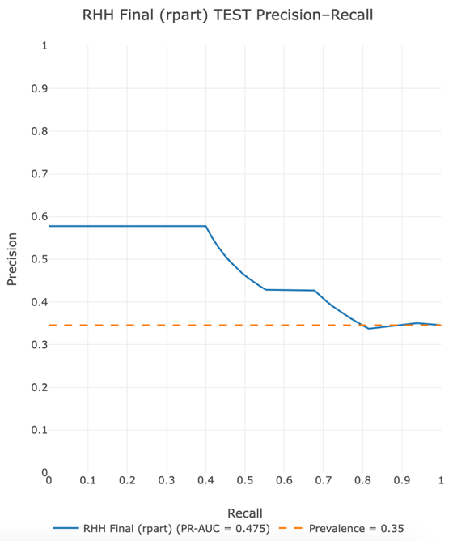
Strikeouts: Logistic Domain Adaptation | 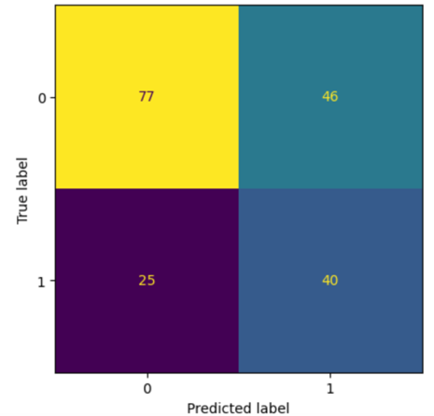  N = 188  Accuracy = 0.62  Precision = 0.47  Recall = 0.62  F1 = 0.53  Specificity = 0.63  AUC = 0.62  PR-AUC = 0.48 | 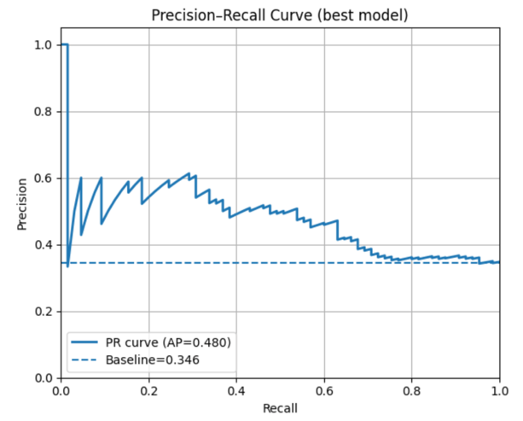
Hits: Decision Tree | 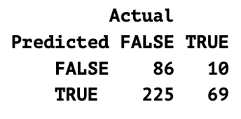  N = 390  Accuracy = 0.40  Precision = 0.23  Recall = 0.87  F1 = 0.37  Specificity = 0.28  AUC = 0.64  PR-AUC = 0.29 | 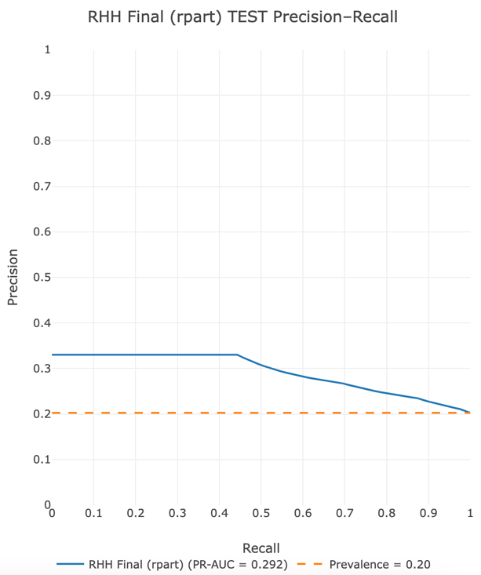
Hits: Logistic Regression Domian Adaptation | 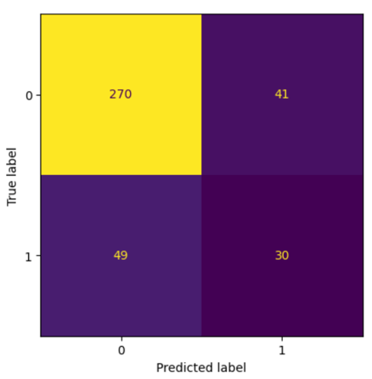  N = 390  Accuracy = 0.77  Precision = 0.42  Recall = 0.34  F1 = 0.40  Specificity = 0.87  AUC = 0.69  PR-AUC = 0.37 | 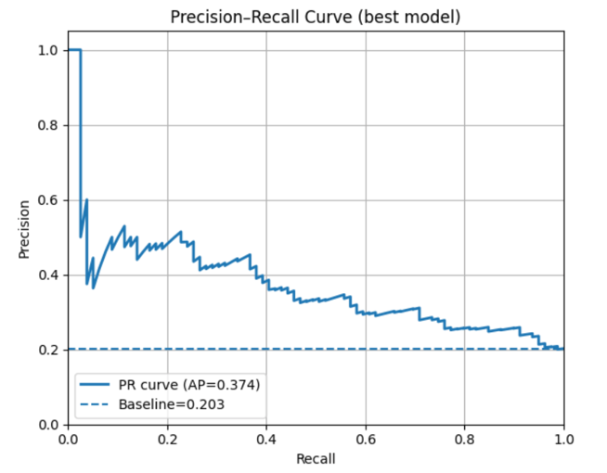
OBP: Decision Tree | 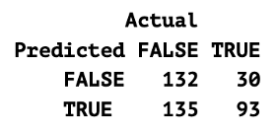  N = 390  Accuracy = 0.58  Precision = 0.41  Recall = 0.76  F1 = 0.53  Specificity = 0.49  AUC = 0.68  PR-AUC = 0.50 | 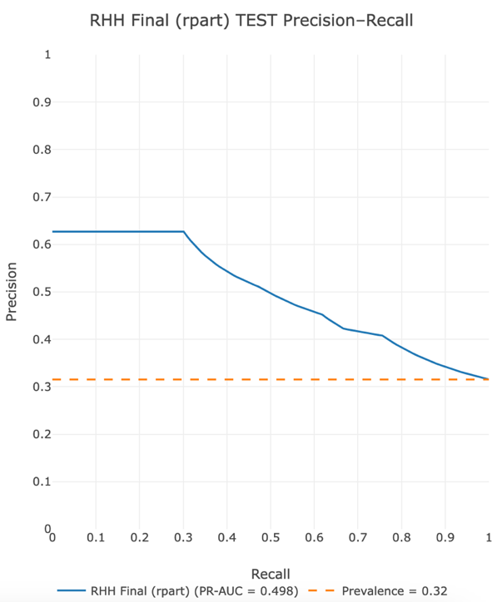
OBP: Domain Adaptation | 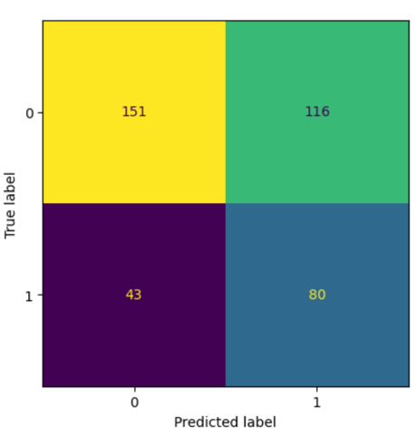  N = 390  Accuracy = 0.59  Precision = 0.41  Recall = 0.65  F1 = 0.50  Specificity = 0.57  AUC = 0.63  PR-AUC = 0.44 | 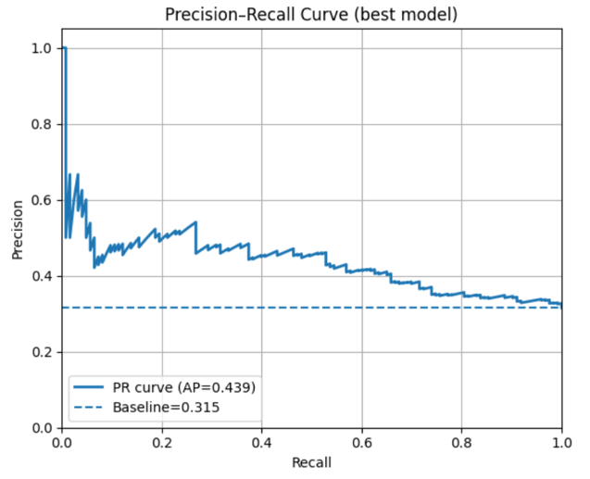
Walks: Reduced Random Forest | 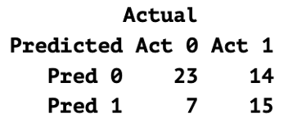  N = 59  Accuracy = 0.64  Precision = 0.68  Recall = 0.52  F1 = 0.59  Specificity = 0.77  AUC = 0.71  PR-AUC = 0.57 | 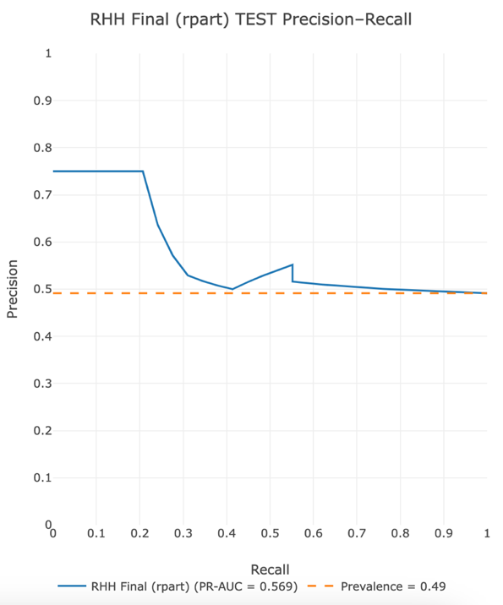
Walks: Domain Adaptation | 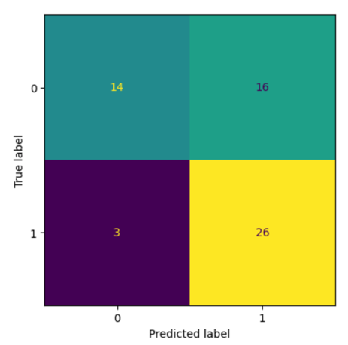  N = 59  Accuracy = 0.68  Precision = 0.62  Recall = 0.90  F1 = 0.73  Specificity = 0.47  AUC = 0.71  PR-AUC =0.70 | 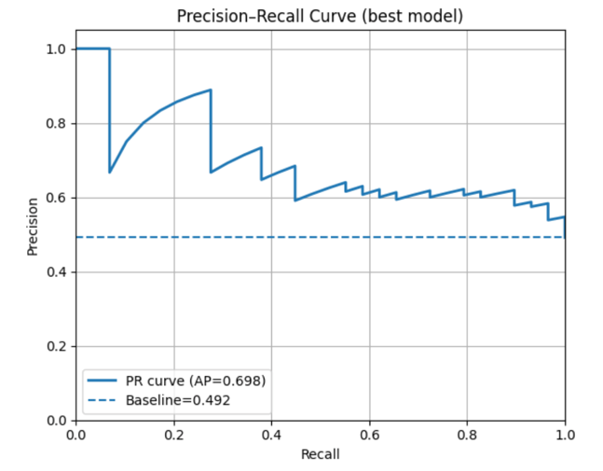
Home Run: Logistic Regression | 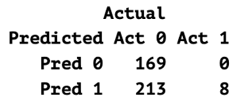  N = 404  Accuracy = 0.45  Precision = 0.04  Recall = 1.00  F1 = 0.07  Specificity = 0.44  AUC = 0.89  PR-AUC = 0.14 | 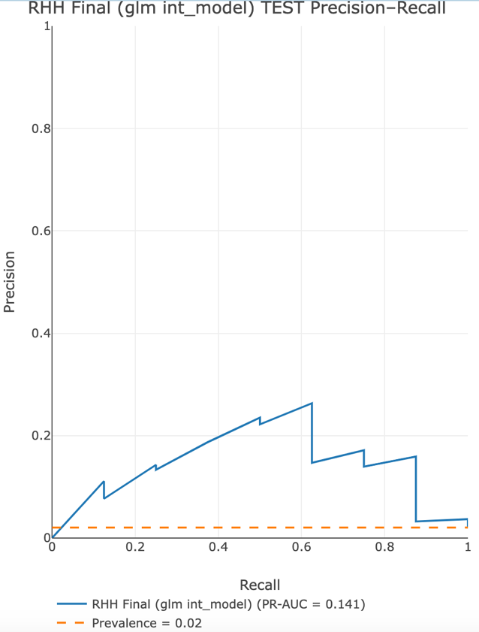
Home Run: Domain Adaptation | 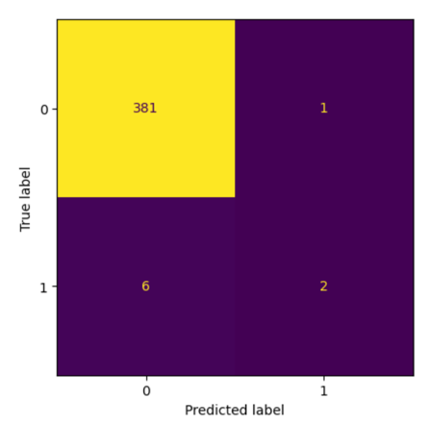  N = 390  Accuracy = 0.98  Precision = 0.67  Recall = 0.25  F1 = 0.36  Specificity = 0.997  AUC = 0.70  PR-AUC = 0.27 | 