MODEL | Metrics
Decision – Strikeout | 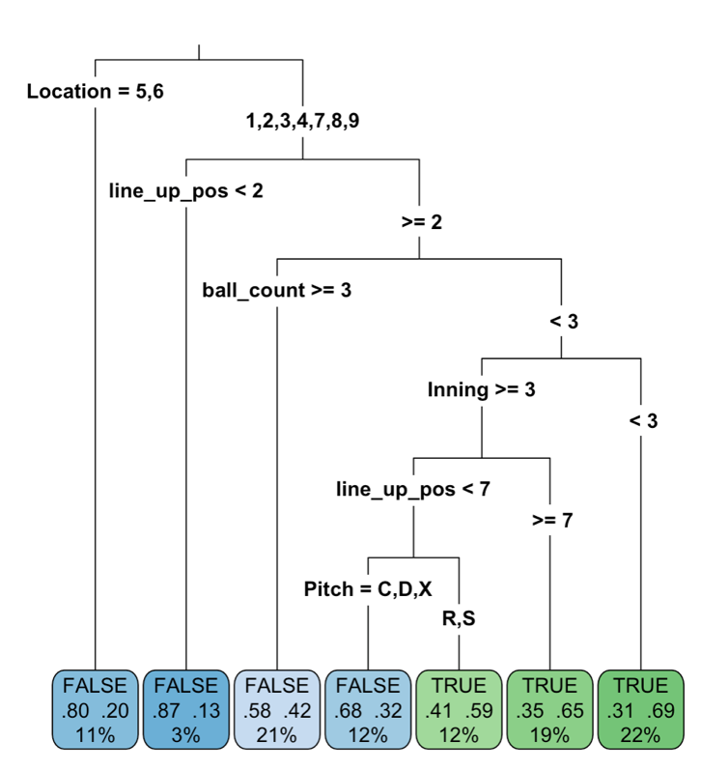
Logistic Domain SO | 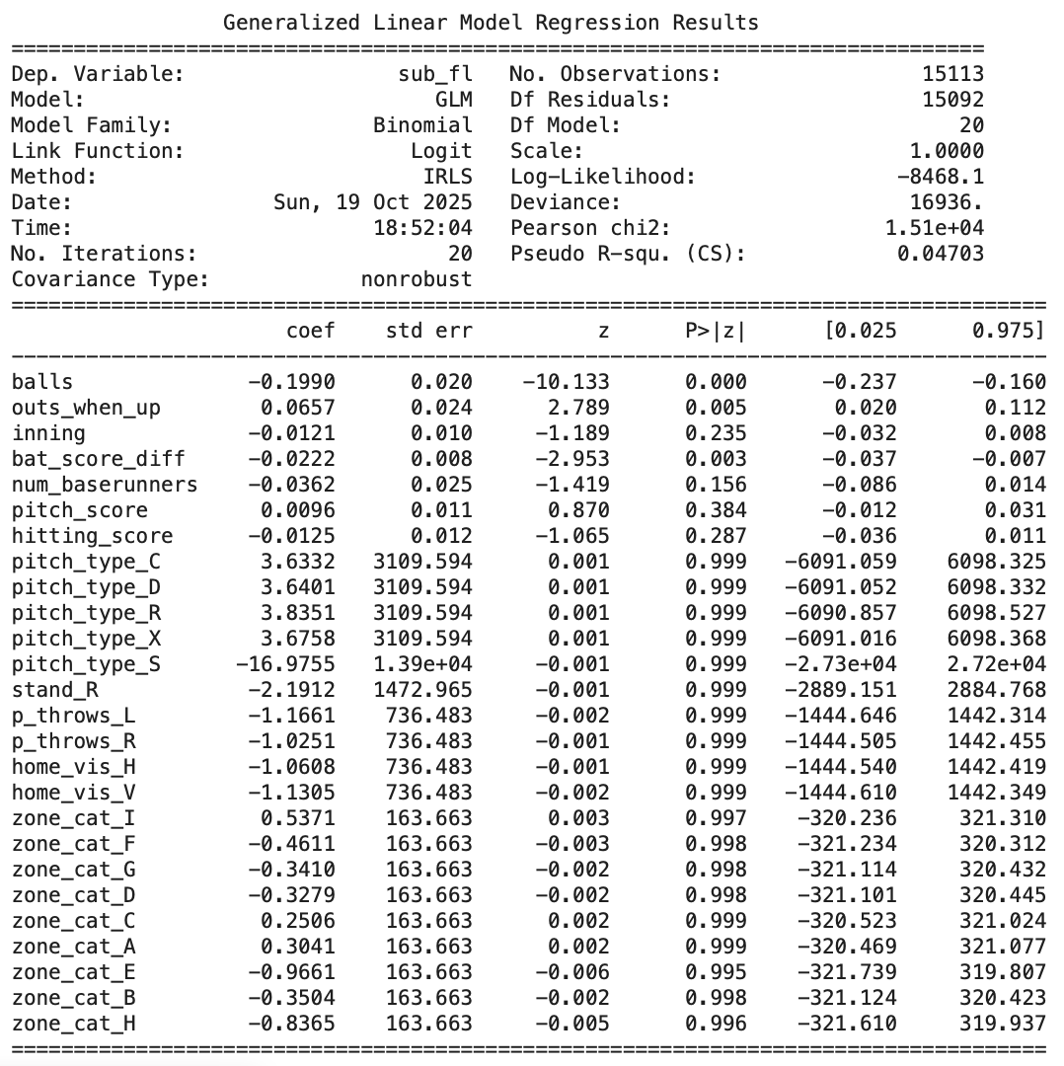  compare density plots for pca1  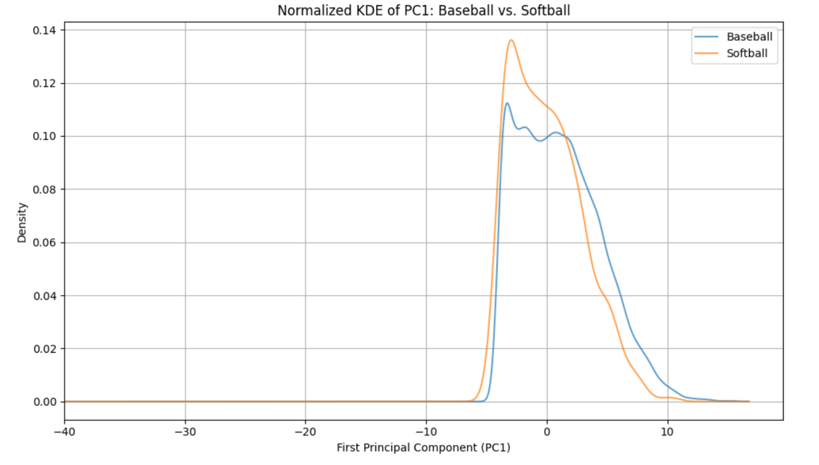  Finally, I selected the 70% of baseball observations that were closest to the "center" of the softball pca bivariate distribution. You can see that there is alot of "noise" in the baseball data, so this was my way of filtering only the most relevant baseball observations to include as the source domain data.  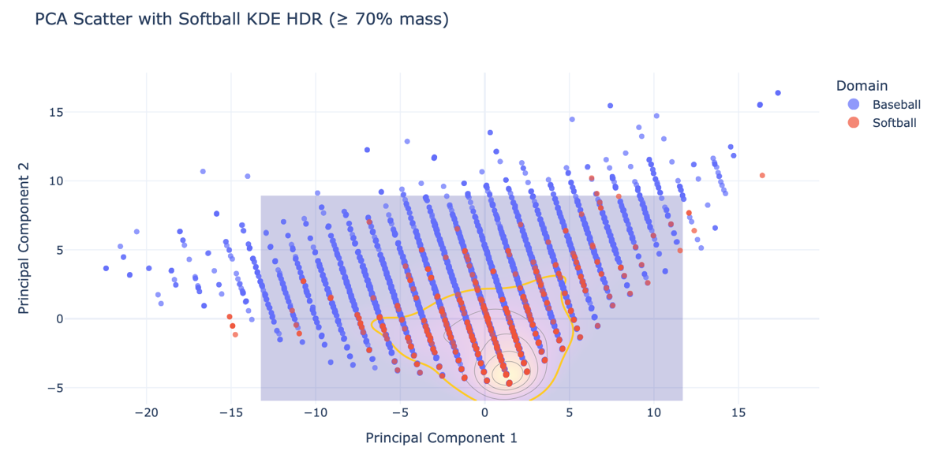  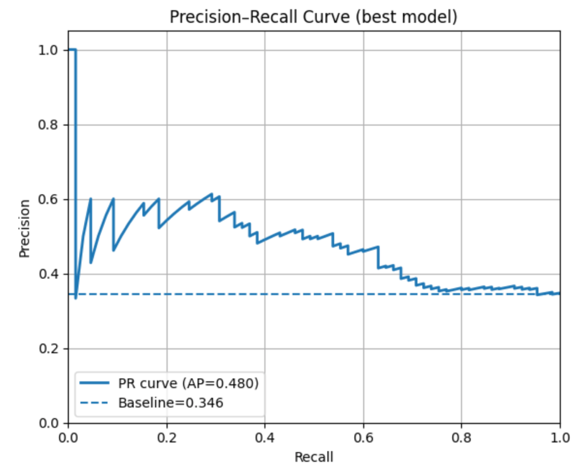  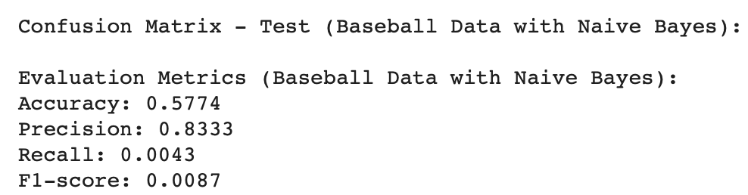  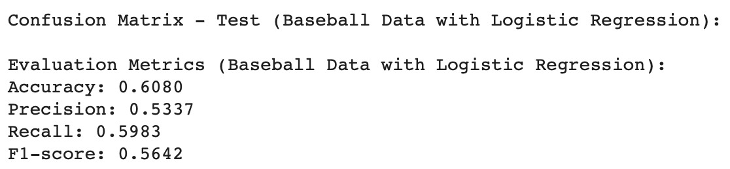
Decision – Hits | 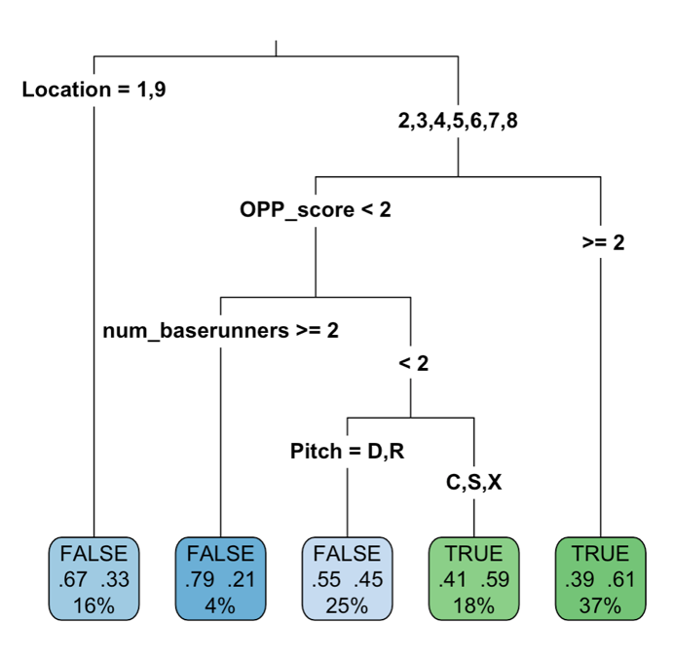
Domain Hits | 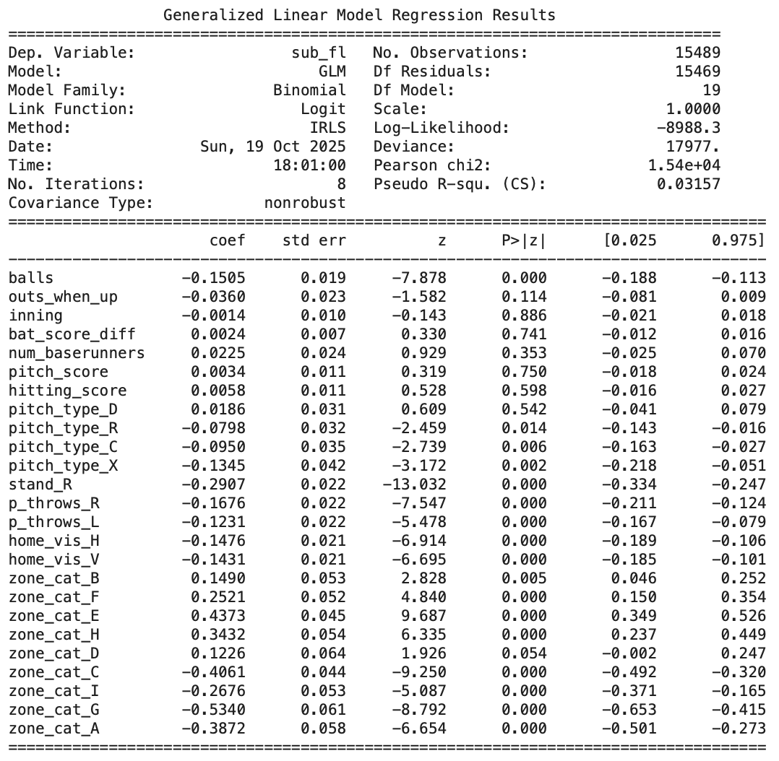
Decision – OBP | 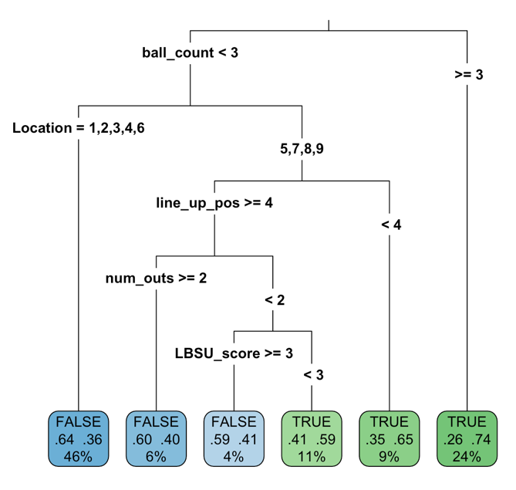
Domain OBP | 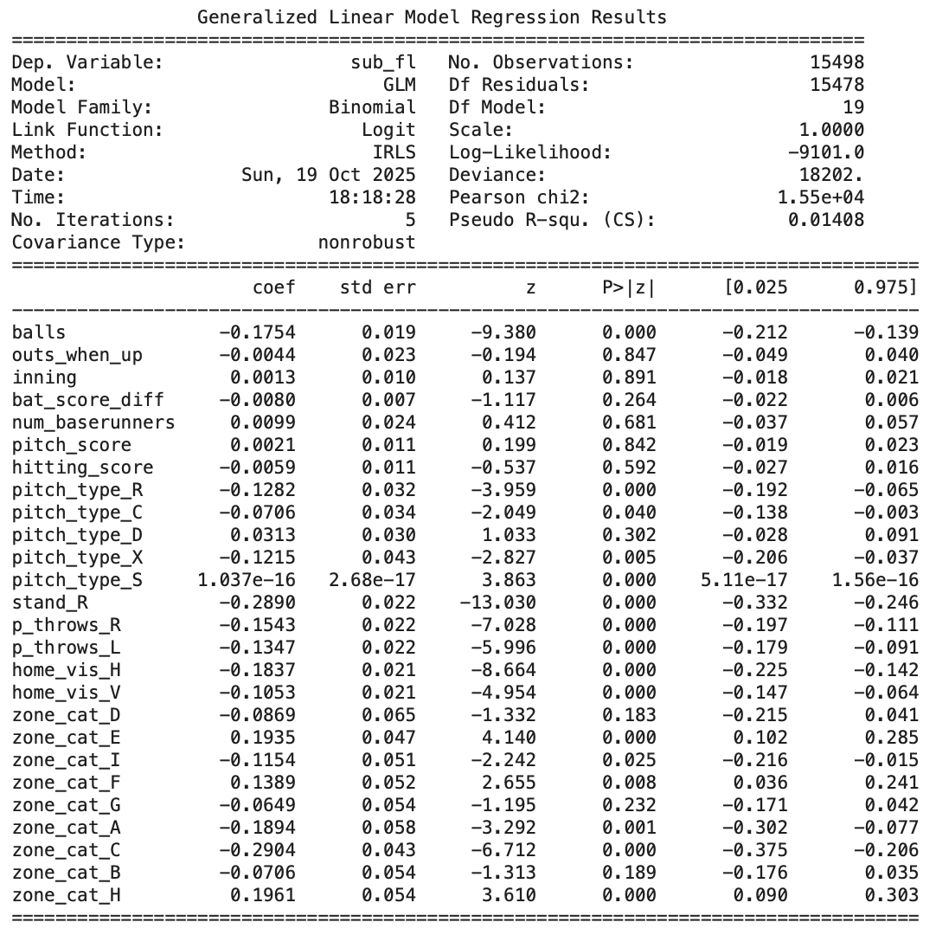
Random Reduced - BB | 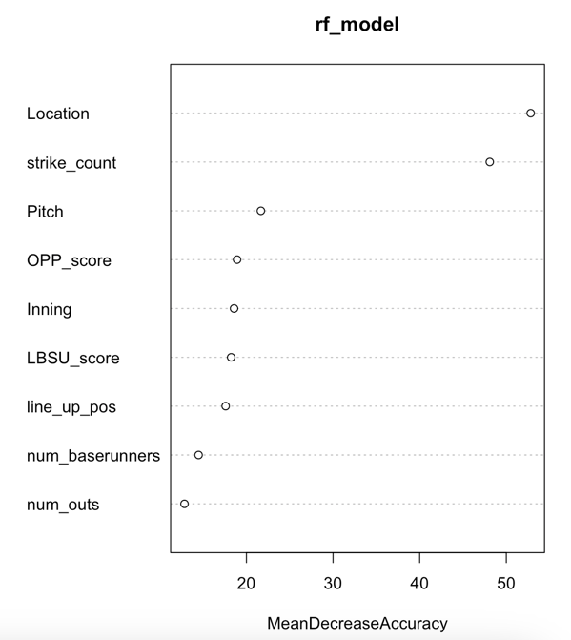
Domain BB | 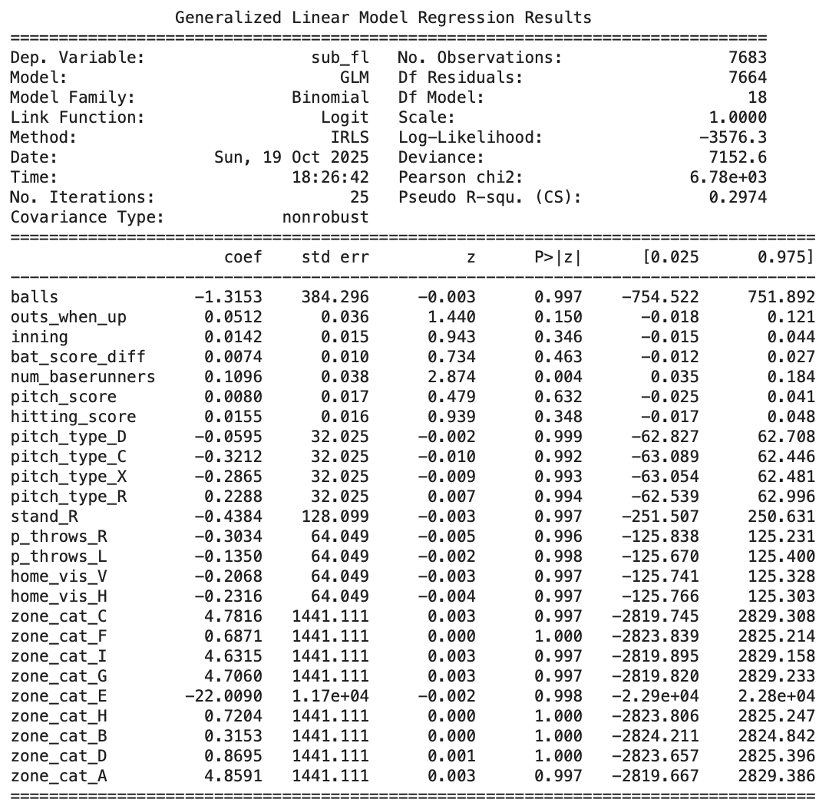
Regression – HR | 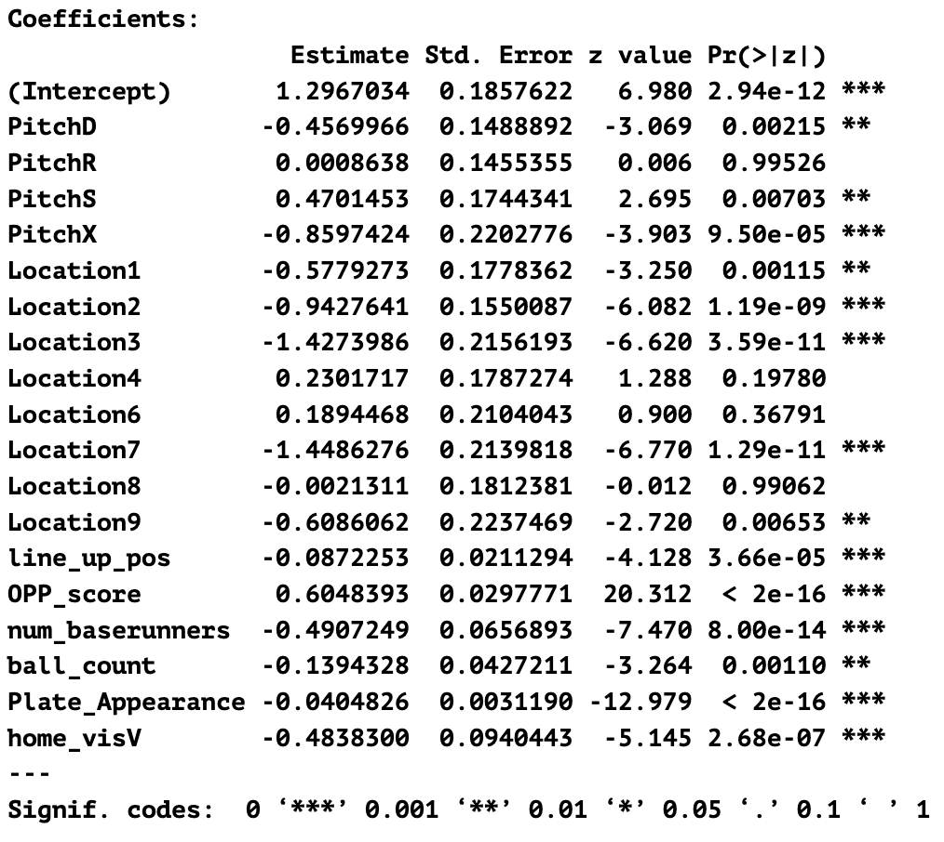
Domain HR | 