Software Requirements Specification

“Bovis Tor Ltd”

(MyCalculator V1.0 )

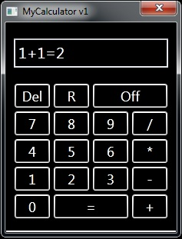
Prepared by:
Hristo Dimitrov - Developer
Galina Vossen - PM
Delyana Penkova - PM
Sofiya Bojurina – QA Lead
Lyubomira Georgieva - QA
Stivan Dimitrov - QA
Stanislav Tsvetanov – Developer

Version: (1.0) Date: (16/04/2016)

Contents
1. Introduction 3
1.1 Purpose 3
1.2 Scope 3
1.3 Definitions, Acronyms, and Abbreviations. 3
1.4 References 4
1.5 Overview 4
2. The Overall Description 4
2.1 Product Perspective 4
2.1.1 System Interfaces 5
2.1.2 Interfaces 5
2.1.3 Software Interfaces View : 6
2.1.4 Button funcionaltions : 7
2.1.5 Hardware interfaces: 7
2.2 Product Functions 7
2.3 User Characteristics 7
2.4 Constraints 8
2.5 Assumptions and Dependencies 8
2.6 Apportioning of Requirements. 8
3. Implementation 8
3.3 Performance Requirements 8
3.4 Logical Database Requirements 9
3.5 Design Constraints 9
3.5.1 Standards Compliance 9
4. Change Management Process 9
5. Functional requirements 9
5.1User Cases : 10
5.2Unwanted user cases: 11

1. Introduction

The following subsections provide an overview of this entire document.

1.1 Purpose

This project is to present specifications for the product MyCalculator V1.0, which is a Software Application for calculations built for Windows OS.

The application MyCalculator V1.0 is targeted to various users and customers which have installed Windows OS. The application goal is to provide the basic algebraic functions like addition, subtraction, division, and multiplication.

The user is expected to implement simple computations through the Application.

1.2 Scope

The task of this Project is to provide a quality service in a Software Application for Calculations. The Application should give the opportunity to the user to enter figures and implement simple operations with them which give an end result of the operation. For this The MyCalculator V1.0 include: the keyboard that helps the user to implement the simple calculations
The scope of this project is to plan the requirements for the Application MyCalculator V1.0 , develop, design, implement, and test the product.
The development of the Application is assigned to a team of two Software Developers and Designers and the Testing is to be implemented by the Team of three Quality Assurance Specialists.
The project and the tasks are to be managed by a two Project Managers.

1.3 Definitions, Acronyms, and Abbreviations.

Abbreviations

PM – Project Manager
QA – Quality Assurance
Dev - Developer
API – Application Programming Interface
Del – Delete
R – Remove the last symbol
Num- Numeric Value
FR – Functional requirement
OFF – Exit of the Application

1.4 References

Order N-256 from client “Selections” Ltd.

1.5 Overview

The rest of this document will give further details on the overall product description, including the hardware, software, and communications interfaces, product functions, user characteristics, and any assumptions that will be made.

The document will also include the specific requirements needed. These will include the functions, performance, design, and software attributes.

This document is organized in a logical manner and is easy to follow. Readers should refer to the table of contents, or index if looking for something in specific. Otherwise, reading this document from start to finish will start with a vague description and get more specific and detailed as changing sections and reading further.

2. The Overall Description

The Project of Building MyCalculator V1.0 is to provide a quality service in a Software Application for Calculations. The Application should give the opportunity to the user to enter figures and implement simple operations with them which give an end result of the operation. The calculator’s functionality will feature basic algebraic calculations, simple arithmetic capabilities. Input will be done through an intuitive virtual keyboard for most of the input. Also, attachment of an auxiliary keyboard to the port PC will also be allowed.

2.1 Product Perspective

The developing of the product application MyCalculator V1.0 is designed for the Client “Selections” Ltd. The implementation will be done from “Bovis Tor Ltd”.
The Apllication is planned to be ordered by payment and downloadable afterwards. The End users are required to have Windows OS installed and to use any conventional web browser to download and use the application.
The interface is intuitive and doesn’t require training. The software can be downloaded and installed on the desktop or in a desired directory and run and started from there when the user has the necessity to implement a simple arithmetic calculation.

2.1.1 System Interfaces

Arithmetic: the system will use the built in API to compute all the arithmetic that will be done for the calculator.

2.1.2 Interfaces

- Virtual Keyboard: The main user interface will be through the virtual keyboard. The virtual keyboard will be keyboard that is displayed in the application field of the PC screen. It will allow the user to input all the commands and information that is needed for the calculator to do its work

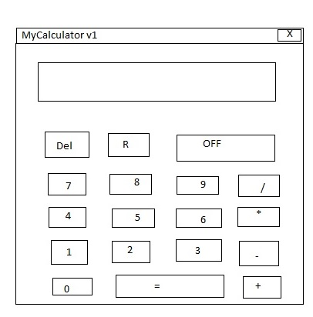

Virtual Keyboard Mockup

- Functions menu: The function buttons are a menu like interface that the user can input simple calculations. The importance of this menu is that it gives the calculator the ability to do arithmetic calculations:

  - addition,
  - subtraction,
  - division,
  - multiplication,
  - Should calculate integer numbers

2.1.3 Software Interfaces View:

.

The display field should display 10 symbols
Software interface view includes:
- Buttons: 0, 1, 2, 3, 4, 5, 6, 7, 8, 9;
- Button: Del
- Button: R
- Button: OFF
- Button: =
- Button: +
- Button: -
- Button: /
- Button: *
- Input/Output Display;
- Closing button X

2.1.4 Button functionalities:

- Button: Del – clear the Display area
- Button: R – clean the last symbol
- Button: OFF – close the application; exit
- Button: = -submit command
- Button: + - click on button + display + on Display area
- Button: - -click on button - display - on Display area
- Button: / - click on button / display / on Display area
- Button: * - click on button * display * on Display area
- Closing button X – closes the application; exit
- Button: 1 – click on button 1 display 1 on Display area
- Button: 2 – click on button 2 display 2 on Display area
- Button: 3 – click on button 3 display 3 on Display area
- Button: 4 – click on button 4 display 4 on Display area
- Button: 5 – click on button 5 display 5 on Display area
- Button: 6 – click on button 6 display 6 on Display area
- Button: 7 – click on button 7 display 7 on Display area
- Button: 8 – click on button 8 display 8 on Display area
- Button: 9 – click on button 9 display 9 on Display area
- Button: 0 – click on button 0 display 0 on Display area

2.1.5 Hardware interfaces:

The user needs to have Personal Computer or Laptop to have the possibility for installing the software.

2.2 Product Functions

Arithmetic calculations: As a calculator, it seems obvious that this machine will be able to perform basic arithmetic calculations. Addition, subtraction, multiplication etc. will be done with this tool.

2.3 User Characteristics

Users of this device will usually be students from the middle school level to the undergraduate college. The user will have to to know basic arithmetic (or at least how arithmetic works) to make functional use of the calculator.

2.4 Constraints

The application needs to be only run on Windows OS on Personal Computer or Laptop.

The project must be completed within the budget
The project must be completed within a specified period of time.
The application should be up when is run.
The system should enforce user authentication security and guarantee reliability of dimple mathematic operation.

2.5 Assumptions and Dependencies

Because everything will be coded from scratch. The only dependency that the machine
will encounter are the hardware (personal computer or laptop) and software constrains (windows operation system installed.)

2.6 Apportioning of Requirements.

It is possible in the future that a few additional features be implemented into this system.

- Auxiliary keypad: This will allow the user to input information much faster and bypassing the virtual keypad that will be built into the operating system.

- Integration and Differentiation: Further versions of the calculator might allow for the use of integration and differentiation for users.

3. Implementation

The system shall verify that the algorithm input into the system is valid before processing. If the input sequence is valid, the algorithm processor will produce a response that will be output to the screen. If the input sequence is invalid, an error message will be displayed and the user will be prompted to correct the input.

3.3 Performance Requirements

The software will be designed to support a single user inputting a mathematical algorithm into system and will return a result of numerical value. All user variables saved in the system will be stored as 32-bit floating point values. 98% of all algorithms input by the user into the system will be processed within one second.

3.4 Logical Database Requirements

The software system will hold three logical databases.

The algorithm processor will parse the algorithm into a tree structure before processing. After processing the tree, the data inside will not be accessed a second time.

A database will be kept to store options about the software. This database will hold integers and floats as well as Boolean data. The information stored will be access at almost every possible interface with the user and by almost every internal system.

The software will allow a user to store and recall values. These values will be stored in a database and will be accessed only if the user updates or requests a stored value. The input interface and the algorithm processor will access this database.

3.5 Design Constraints

All data processed and returned for display by the user will be of 32-bit floating point precision. The output of this value may or may not be truncated per user request.
Data output will be limited to the Application display screen.
Data input will be limited to manipulation of the Application display screen button set.

The application display screen is limited 10 symbols.

3.5.1 Standards Compliance

There are no standards or regulation pertaining to the API format or the associated calculator design.

Change Management Process

As a team, we will update and evaluate our SRS document every week as we make changes in our design and requirements. We will add new detailed information which will include: research, references, charts and graphs, and more specifications and requirements that we find along the way in the designing and implementation of the product.

Functional requirements

This section includes the requirements that specify all the fundamental actions of the software system.

5.1User Cases:

ID: FR1 TITLE: Download the application
Description: A user should be able to download the application through either an application store or through the web site of the client Selections Ltd.

ID: FR2 TITLE: Download and notify users of new releases (Update)
Description: When a new/updated version or release of the software is released, the user should check for these manually.

ID: FR3 TITLE: Start the application
Description: Double click the Icon of the application or Open from the directory with the Application.

ID: FR4 TITLE: Input the Numeric Value
Description: The User is expected a numeric value in Display Field of the Application via API or the Keyboard.

ID: FR5 TITLE: Input the desired Arithmetic Function
Description: The User is expected to input the desired Arithmetic Function Display Field of the Application via API or the Keyboard like Add, Subtract, Multiply or Divide.

ID: FR6 TITLE: Input the Numeric Value
Description: The User is expected a numeric value in Display Field of the Application via API or the Keyboard.

ID: FR7 TITLE: Select the button “=”
Description: The User is expected to press the button “=” in order to receive the desired result of the calculation.

ID: FR8 TITLE: Multicalculation of numbers
Description: The User should have possibility to do functional requirements FR4 and FR5 multi times till select FR7.

ID: FR9 TITLE: Clear the Display field.
Description: If it is selected button “Del”, the Display field should be cleared from all entered characters or operations.

ID: FR10 TITLE: Clear last entered symbol.
Description: If it is selected button “R”, the last entered symbol should be deleted from the Display field.

ID: FR11 TITLE: Exit from the Application
Description: The user can exit from application by selection of the buttons „OFF” or “X”.

Overall Use Case Diagram

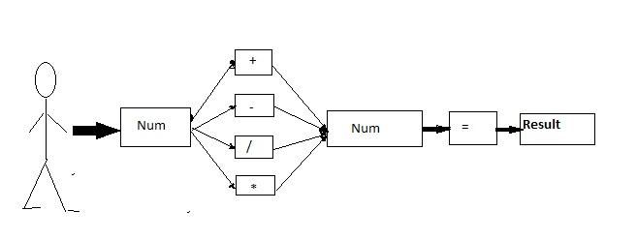

5.2Unwanted user cases:

ID: UFR1 TITLE: Should not accept characters from an alphabet.
Description: The application should not react and display letter’s symbols.

ID: UFR1 TITLE: Should not accept Specific symbols or functions.
Description: The application should not react and display specific symbols or functions.

ID: UFR1 TITLE: Should be able to not possible to divide to 0.
Description: If operation is dividing to 0, application should display Error on the Display.

Static Model
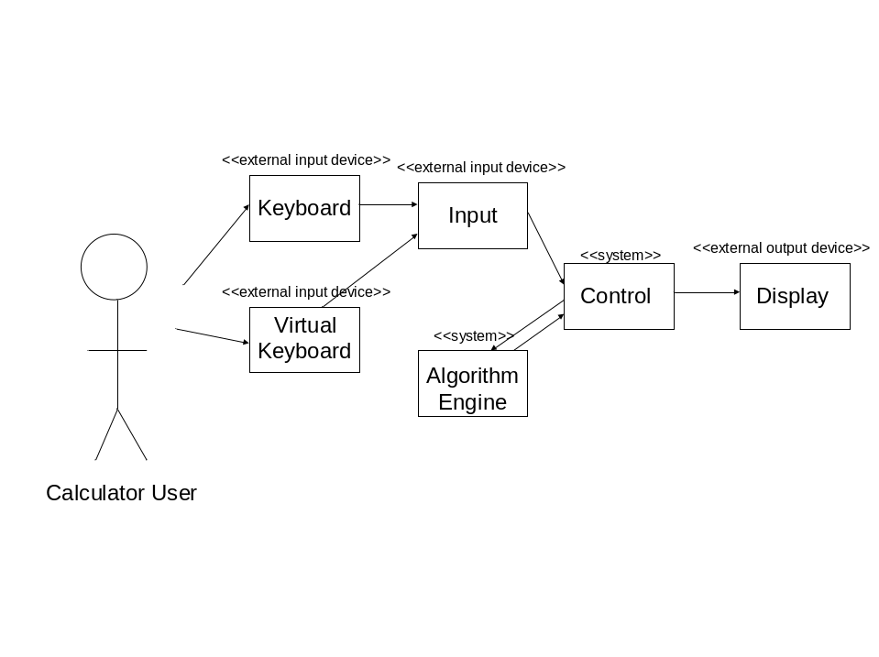

Acceptance Testing Table

Algorithm Engine

1+1 | 2
1+1*5 | 6
0123456789 | 0123456789
45- 3 | 42
13*2 | 26
44/2 | 22
9/0 | 9
-2/0 | Error
(-2)+(-2) | -4

