**Title:** [TFS 10939 – Release 453]: Live stream is not loading when the race starts in Greyhounds

**Description:** Live stream is not loading when the race starts

**Test Steps to Replicate:**

1. Launch mobile wrapper then navigate to Test URL
2. Login successfully (tttttcathflores/123456)
3. Navigate to Greyhounds page
4. Successfully bet a qualified stake to a race with live streaming
5. Wait for the race to start
6. Tap watch live button

**Expected:** Live Streaming should play when a race with qualified bet starts

**Actual:** Live stream is not loading when the race starts

**==================================TEST DETAILS=====================================**

**Test URL\App:** m3.boylesports.com

**Browser Details:** Tablet wrapper(Samsung Galxy Note 10.1)

**Date Tested:** October 03, 2017

**Screenshot/s:**

Actual:

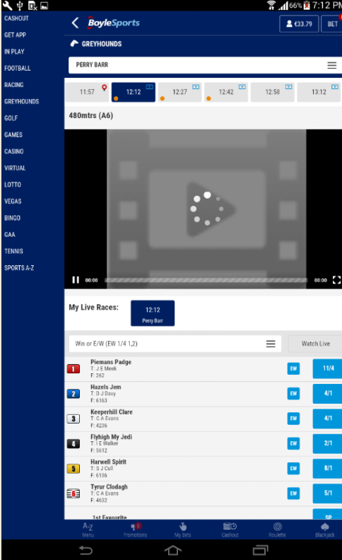

**Title:** [TFS 10939 – Release 453]: Live stream is not loading when the race starts in Greyhounds

**Description:** Live stream is not loading when the race starts

**Test Steps to Replicate:**

1. Launch mobile wrapper then navigate to Test URL
2. Login successfully (tttttcathflores/123456)
3. Navigate to Greyhounds page
4. Successfully bet a qualified stake to a race with live streaming
5. Wait for the race to start
6. Tap watch live button

**Expected:** Live Streaming should play when a race with qualified bet starts

**Actual:** Live stream is not loading when the race starts

**==================================TEST DETAILS=====================================**

**Test URL\App:** m3.boylesports.com

**Browser Details:** Tablet wrapper(Samsung Galxy Note 10.1)

**Date Tested:** October 11, 2017

**Screenshot/s:**

Actual:

