## Date

### Time
- Person: hours worked

### Goal
What we intended to achieve during this session.

### Work completed
- Person: concrete changes made
- Current result and whether it works
- Relevant GitHub issue, commit or pull request

### Decisions
- What we decided
- Alternatives considered
- Why we chose this option

### Problems and solutions
- What went wrong
- Suspected or confirmed cause
- What we tried
- Final solution or current blocker

### Testing
- What was tested
- Expected result
- Actual result
- Any feedback received

### Plan changes
Anything added, removed or postponed from the MVP and why.

### Evidence
- Screenshots or short videos
- Useful source, tutorial or asset links
- Asset creator and licence where relevant

### Next steps
What each person should continue with next session.

DUPLICATE THIS

## Date
15.09.2026
### Time
- Lorenc: 3h

### Goal
Lorenc: intended to get the github repo structure further and prepare the steps for starting this project
Maksym: intended to get a movable character, placeholder assets and a small map for testing the character movement

### Work completed
- Person: concrete changes made
- Current result and whether it works
Lorenc: Made the MVP document along with Maksym, set up labels for the GitHub Project, started documenting our work
Maksym: TYPE HERE

### Decisions
We did cut a few things like inventory slots, and decided on everything in the MVP
We cut this stuff to save time and effort

### Problems and solutions
Nothing went wrong really… not a lot happened

### Plan changes
We decided on the entire game design and cut features we thought were unnecessary or too hard to implement.

### Evidence
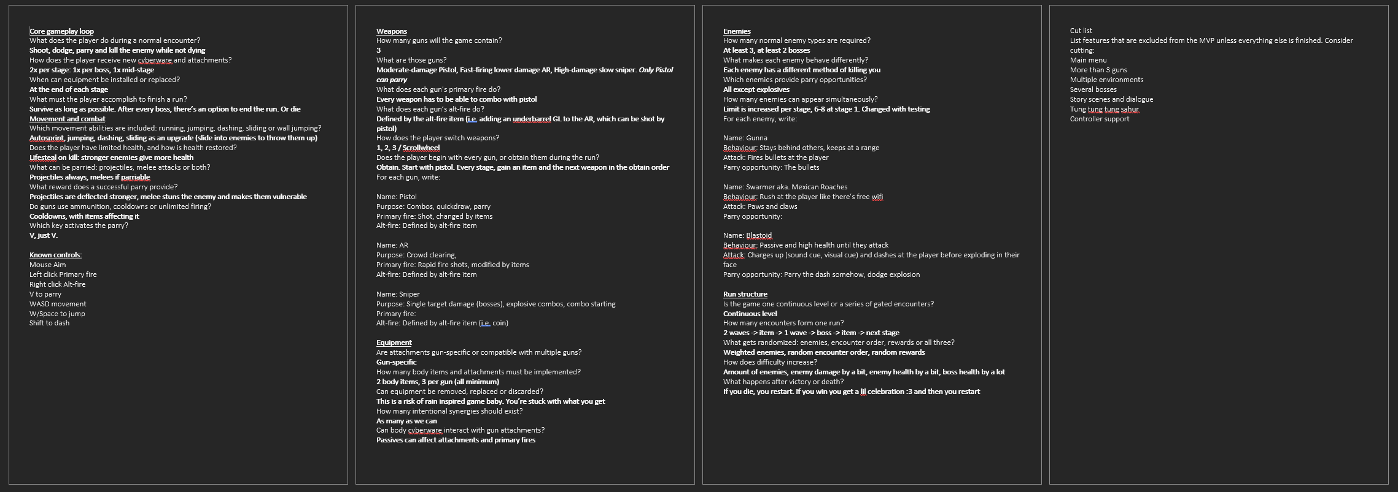
### Next steps
Lorenc will continue with assets, Maksym will start work on base systems.

## Date
16.09.2026
### Time
- Person: hours worked

### Goal
Lorenc: intends to get a visual style down and make some testing assets that fit with the style the game will have

### Work completed
- Person: concrete changes made
- Current result and whether it works
- Relevant GitHub issue, commit or pull request

### Decisions
- What we decided
- Alternatives considered
- Why we chose this option

### Problems and solutions
- What went wrong
- Suspected or confirmed cause
- What we tried
- Final solution or current blocker

### Testing
- What was tested
- Expected result
- Actual result
- Any feedback received

### Plan changes
Anything added, removed or postponed from the MVP and why.

### Evidence
- Screenshots or short videos
- Useful source, tutorial or asset links
- Asset creator and licence where relevant

### Next steps
What each person should continue with next session.

