**CP5046** ASSESSMENT TASK 1: **Project Documentation**

This assessment task has been prepared by Dr. Dmitry Konovalov for James Cook University. Updated 21 April 2019.

**© Copyright 2019**

This publication is copyright. Apart from any fair dealing for the purpose of private study, research, criticism, or review as permitted under the Copyright Act, no part may be reproduced by any process or placed in computer memory without written permission.

**ASSESSMENT TASK 1: PROJECT DOCUMENTATION**

|  |  |
| --- | --- |
| **Aligned subject learning outcomes** | All |
| **Group or individual** | Group |
| **Weighting** | 20% |
| **Due date** | Friday First Study Break at 5pm |

**ASSESSMENT TASK 1: DESCRIPTION**

This task is the ***iteration-1*** in terms of the Agile Software development. It defines the initial project specifications including goals, deliverables, and planning for ***iteration-2*** (***alpha release***).

**ASSESSMENT TASK 1: CRITERIA SHEET**

**[_____/20 marks] Assignment is done in a group with 2-4 students.**

***Every team member gets the same mark for this assessment item***

Write group members here:

Student Name-1, Project role(s), specific ***individual*** contributions to this assessment item:

Student Name-2:

**[____/Prerequisite for marking]** Assignment is completed using electronic copy of ***this*** document and submitted to LearnJCU electronically.One submission per team.

**[_____/20 marks] Project description for non-ICT-technical stakeholders and general audience.** Write here: minimum **TWO** pages, maximum **TEN** pages.

* [___/10] Justification for the project: Why a new ICT solution is required. Include some market and ICT technology research, plus available ICT solutions.
* [___/5] Project goals: Describe exactly what and how your proposed ICT solution will be delivered to the client.
* [___/5] Justify between two and four major milestones with timeline. Is your proposed schedule too ambitious (over-optimistic) or too conservative?

**[_____/20 marks] Project scope of the full final-release (Project audit at the end of CP5047 subject). Clearly specify the scope of alpha-release (Project audit at the end of CP5046 subject), and .** Write here: Minimum **TWO** pages, maximum **TEN** pages.

**Available days:** PASS-level (minimum) effort is 1-day and maximum is 3-days per teaching week (assume 12 weeks per study period), per team member. For example: 12 x 2 = 24 days is the minimum for a team with 2 students, 12x2x3=72 days is the maximum. The available days must match the SUM of your user story estimates below.

User story 1: title, short description, effort estimate (in days, maximum of 5 days).

User story 2: ...

**[_____/20 marks] Project sponsor/client/customer signed/agreed to the scopes of the alpha-release and the final-release.** Cut/Paste clients’ email here, or show signed the preceding “**Project scope**” to your marking lecturer.

**[_____/20 marks] Project development and release ICT infrastructure.** This must include development environment, programming languages, source code repositories (Configuration Management), project collaboration tools, and development tools. Write here: minimum **TWO** pages, maximum **TEN** pages.

* [___/5 marks] **Configuration Management**/version control, e.g. git, github, heroku, bitbucket;
* [___/5 marks] **Project tools**. Programming languages/IDEs, e.g. php/WebStorm, java/IntelliJ; Building tools/procedures, e.g. git-push to heroku; e.g. how to set-up your development environment for a new team member
* [___/5 marks] **Testing** tools, data and procedures (what and how you are planning to test), e.g. junit; Client testing and access to release, e.g. domain name, domain hosting; Client training document, and procedures; Release testing tools, data and procedures (what and how you are planning to test);
* [___/5 marks] **Prototypes are demonstrated to justify the proposed ICT solutions**;

**Marking Rubric for Project Documentation:** This assessment rubric provides you with the characteristics of exemplary, competent, marginal and unacceptable work in relation to task criteria.

|  |  |  |  |  |
| --- | --- | --- | --- | --- |
| **Criteria** | **Exemplary (DISTINCTION-level)** | **Competent (CREDIT-level)** | **Marginal (PASS-level)** | **Unacceptable (FAILED-level)** |
| **Assignment is done in a group with 2-4 students.** | **20**  Group demonstrated **exemplary ability** to work collaboratively, e.g. all team members always attended the same workshop | **15** Group demonstrated **competent ability** to work collaboratively, e.g. all team members nearly always attended the same workshop. | **10**  Group demonstrated **marginal ability** to work collaboratively, e.g. all team members sometimes attended the same workshop. | **0**  Group did not demonstrated ability to work collaboratively. |
| **Project description for non-ICT-technical stakeholders and general audience** | **20**  Project is described **very clearly** for a non-technical audience. No presentation and style errors | **15** Project is described clearly for a non-technical audience; or Outside page limits, or Minor presentation and/or style errors. | **10** Project is not described clearly. Outside page limits; or Major presentation and/or style errors. | **0**  Not done, or done unacceptably. |
| **Project Planning and scope** | **20**  All user stories are correct, and correctly estimated. | **15** Most user stories are correct, and correctly estimated. | **10**  More than half of user stories are correct, and correctly estimated. | **0**  Less than half of user stories are correct, and correctly estimated. |
| **Project client signed the scope** | **20**  Intellectual property (IP) in client agreement; Clear evidence of clients priority and ranking of user stories; Signed and agreed scope. | **15** Some evidence of clients priority and ranking of user stories. Signed and agreed scope | **10**  No evidence of clients priority and ranking of user stories.  Signed and agreed scope. | **0**  Not done, or done unacceptably. Project scope is not signed. |
| **Project development and alpha-release ICT infrastructure** | **20**  Description very clearly communicates exemplary ICT solutions. | **15** Description clearly communicates competent ICT solutions. | **10**  Description communicates ICT solutions. | **0**  Not done, or done unacceptably. |

## Justification for the project

Higher education industry has been one of the fastest growing industries, especially in countries like United States of America, United Kingdom, Europe and the Australia. Number of International students have is growing exponentially, nearly 4.3 million students are enrolled in university-level education outside their home country. Australia, UK, Switzerland, New Zealand and Austria have in descending order, the highest percentage in international students. (OECD)

Asian students represent 53% of foreign student enrolled worldwide. The largest numbers of foreign students are from China, India, Korea. OECD countries receive more international students than they send abroad for tertiary education. Almost three times as many foreign students are enrolled in tertiary education in OECD countries as there are OECD citizens studying abroad. (OECD)

83% of foreign students are enrolled in G20 countries while 77% are enrolled in OECD countries. These proportions have remained stable during the past decade. The number of international students in Oceania has tripled since 2000, although this region only accounts for 10% of the global average students. Australia, United Kingdom, Canada, France and the United States together receive more than 50% of all foreign students worldwide. Over the past three decades, the number of students enrolled outside their country of citizenship has risen dramatically, from 0.8 million worldwide in 1975 to 4.3 million in 2011, a more than fivefold increase.

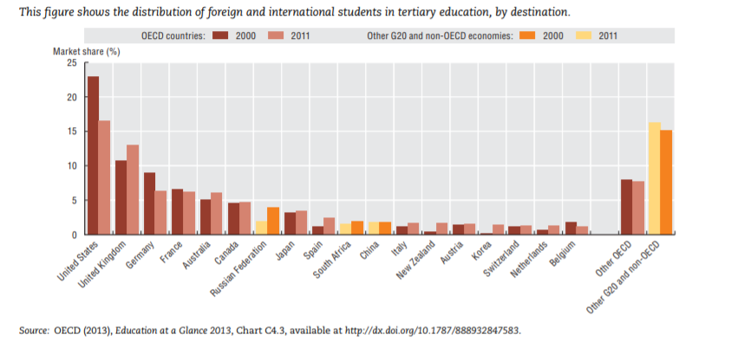

This chart shows that there has been an increase in the overseas student market share in Australian Higher Education sector. While a decrease is observed in United States, Germany, France. This statistic only proves growing percent of students highly look up to Australia as their next study destination or preferred higher education destination. The reason for prospective students favouring Australia can be justified by affordable tuition fees, ability to easily secure a place on desired course or university, Location (most universities are located in developed cities or touristy destination), option to stay back after completing education to find work (Post-Study work visa or Permanent residency option). Major reason for why there has been decline in international student in United States can be related to increasing tuition fees, competition to secure a place on the desired course and university, less university options for favourable location, difficulty to get a post study work visa or permanent residency.

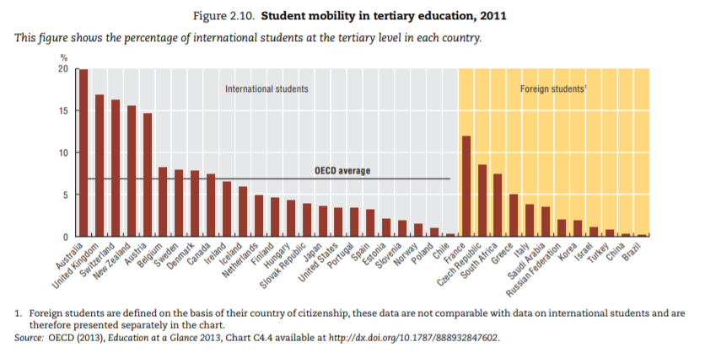

The above chart shows that Australia has the highest percentage of international than any other OECD countries. 20% of total students enrolled in Australian education program, come from outside of Australia or don’t hold citizenship at the time of enrolment. This trend is only assumed to increase as the economy is bound to grow.

There is a high demand for sound ICT solution which will streamline and speed up the delivery of new and constantly changing information right to the prospective international students. Universities would like to market their programs, campus, features and facilities at the highest priority, while the students would like to stay updated with their new study adventure on all widely used platforms. The traditional way students find university information is to head the university website, search for available courses, tuitions fees, and the process for enrolment, which can be very tedious, repetitive and time-consuming task which needs to be done with each university separately. Currently, there is no platform that will provide course information, handle application and provide a portal for universities easily process student applications, all in place, on one platform, until Kiran Das gave life to his amazing idea of CoursePal.

## CoursePal

CoursePal is new business venture which is in its initial phase of development. The CoursePal website was developed by BRIKS Infotech, which is an upcoming start-up, founded and owned by Kiran Das, a JCUB alumni. CoursePal provides information on university, course, location, part-time job, living options, Visa, on-arrival and other related information, necessary for the students. It is the one place students will find authentic and updated information which they can rely on 100%.

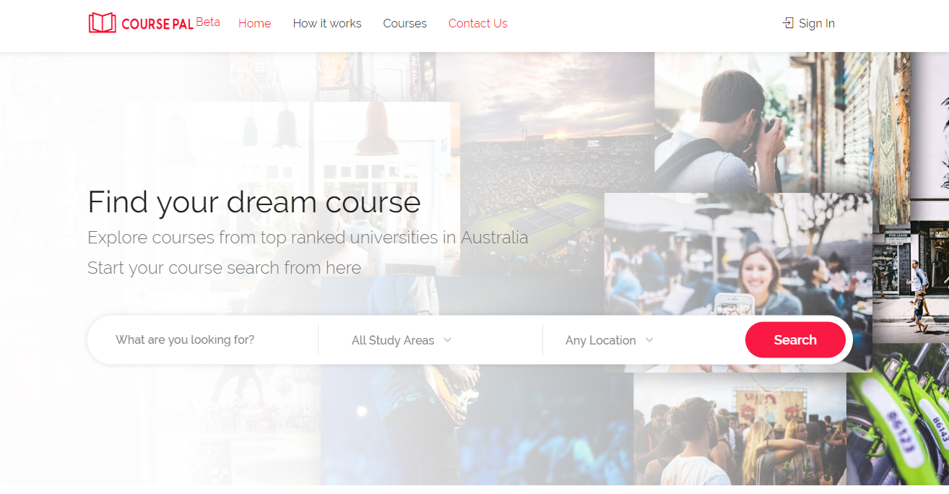

CoursePal also provides students application handling capabilities which will be viewed by respective universities using a university log-in portal provided by CoursePal. Universities then can download all the documents the student has uploaded and process the application, providing a faster, concise system to handle enrolment applications without the need for worrying the underlying implementation. In addition, CoursePal has a very user-friendly appeal which attracts majority of the young student age group. Currently, CoursePal website is still in Beta development phase and we are undertaking the development for android application for the same.

## Project Goals

The project is designed to be developed, tested and delivered between March and September 2019, as part of ICT 1 and ICT 2, course subjects under James Cook University. The project