CP5046 ICT Project 1

ASSIGNMENT 1

**PROJECT DOCUMENTATION**



*COURSEPAL ANDROID APPLICATION*

**Submitted to:** **Submitted by:**

Laura Antochi *Team 08*

Rucha Dhamke

Nancy Arora

Gaurav Suryawanshi

Tanvi Mali

|  |  |
| --- | --- |
| Table of Contents | Page Number |
| TEAM DESCRIPTION | 3 |
| Contribution of team members | 3 |
| PROJECT DESCRIPTION | 4 |
| Justification For the project | 4 |
| Project Goals | 6 |
| Deliverables | 7 |
| Justification between major milestones with timelines | 7 |
| PROJECT AUDIT | 8 |
| Milestone 1: Alpha Release | 9 |
| User Stories | 9 |
| Milestone 2: Beta Release | 11 |
| User Stories | 12 |
| PROJECT AGREEMENT AND CONVERSATION WITH CLIENT | 15 |
| PROJECT DEVELOPMENT Tools |  |
| Configuration Management Tool: Github | 19 |
| IDE: IntelliJ IDEA | 21 |
| Android Studio | 22 |
| Software Development Language: Kotlin | 22 |
| Database: MYSQL | 22 |
| Hosting Environment: Google Play store | 23 |
| Testing Tools: MonkeyTalk | 24 |
| AppLayout(Prototype): EmulatorView | 25 |
| References | 27 |

**TEAM DESCRIPTION**

Contribution of Team Members:

|  |  |
| --- | --- |
| **Team Member** | **Responsibilities** |
| Gaurav Suryawanshi | **Documentation:**  Project description, Justification, Project Goals, Milestones with timelines  **Development:**  Implementing Main features for mobile app and API call  **Testing:**  Writing Unit Test cases |
| Nancy Arora | **Documentation:**  Project Audit, Alpha and Beta Release Milestones, Research on Trello  **Development:**  Front End development  **Testing:**  Testing Application flow from start to end |
| Rucha Dhamke | **Documentation:**  Client Agreement  **Designing:**  Interface design in proto.io  **Development:**  Front End Development  **Testing:**  Handling multiple test cases using Testing tool MonkeyTalk |
| Tanvi Mali | **Documentation:**  Project development and release ICT infrastructure  **Development:**  Implementing Main features for mobile App and Database connectivity  **Testing:**  Handling multiple test cases using Testing tool MonkeyTalk |

**PROJECT DESCRIPTION**

This project is a part of the subject CP5046 ICT Project 1: Analysis and Design, which is taught by Ms. Laura Antochi, at James Cook University, Brisbane. The subject is about learning software methodologies, like **AGILE-SCRUM** and **SDLC**; and delivering a sound software solution to a business or an individual client, designed, developed and maintained rigorously. The initial task was finding a client who has a need for ICT solution and discussing the requirements. Our client Mr Kiran Das, needs an android app for his upcoming interactive informational platform for international students, **CoursePal**; which will be delivered by end of September 2019. Our team consists of 4 highly motivated developers, Gaurav, Tanvi, Nancy and Rucha, who share the same goal for the project. A short research has been done, which explains why such application is needed, how is it better than traditional ways and how can it make life easier. An introduction to CoursePal is noted below along with project goals, timeline, requirements and deliverables.

**JUSTIFICATION FOR THE PROJECT: Market Research**

Higher education industry has been one of the fastest growing industries, especially in countries like United States of America, United Kingdom, Europe and the Australia. Number of International students have is growing exponentially, nearly 4.3 million students are enrolled in university-level education outside their home country. Australia, UK, Switzerland, New Zealand and Austria have in descending order, the highest percentage in international students. (OECD)

Asian students represent 53% of foreign student enrolled worldwide. The largest numbers of foreign students are from China, India, Korea. OECD countries receive more international students than they send abroad for tertiary education. Almost three times as many foreign students are enrolled in tertiary education in OECD countries as there are OECD citizens studying abroad. (OECD)

83% of foreign students are enrolled in G20 countries while 77% are enrolled in OECD countries. These proportions have remained stable during the past decade. The number of international students in Oceania has tripled since 2000, although this region only accounts for 10% of the global average students. Australia, United Kingdom, Canada, France and the United States together receive more than 50% of all foreign students worldwide. Over the past three decades, the number of students enrolled outside their country of citizenship has risen dramatically, from 0.8 million worldwide in 1975 to 4.3 million in 2011, a more than fivefold increase.

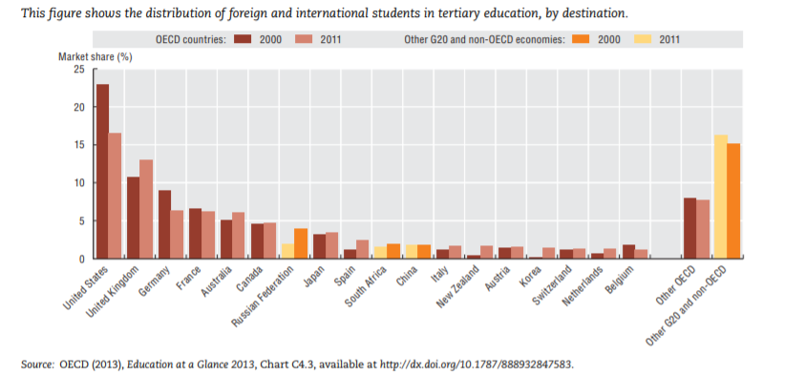

This chart shows that there has been an increase in the overseas student market share in Australian Higher Education sector. While a decrease is observed in United States, Germany, France. This statistic only proves growing percent of students highly look up to Australia as their next study destination or preferred higher education destination. The reason for prospective students favouring Australia can be justified by affordable tuition fees, ability to easily secure a place on desired course or university, Location (most universities are located in developed cities or touristy destination), option to stay back after completing education to find work (Post-Study work visa or Permanent residency option). Major reason for why there has been decline in international student in United States can be related to increasing tuition fees, competition to secure a place on the desired course and university, less university options for favourable location, difficulty to get a post study work visa or permanent residency.

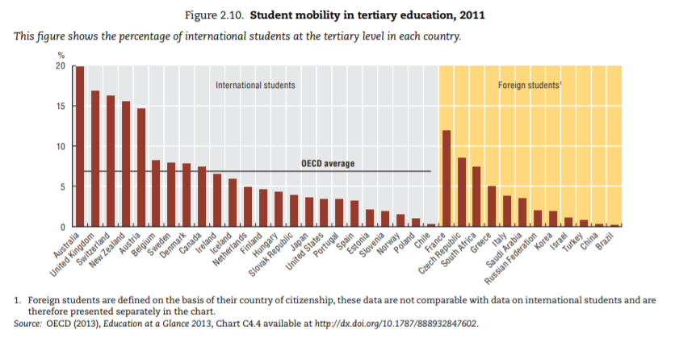

The above chart shows that Australia has the highest percentage of international than any other OECD countries. 20% of total students enrolled in Australian education program, come from outside of Australia or don’t hold citizenship at the time of enrolment. This trend is only assumed to increase as the economy is bound to grow.

There is a high demand for sound ICT solution which will streamline and speed up the delivery of new and constantly changing information right to the prospective international students. Universities would like to market their programs, campus, features and facilities at the highest priority, while the students would like to stay updated with their new study adventure on all widely used platforms. The traditional way students find university information is to head the university website, search for available courses, tuitions fees, and the process for enrolment, which can be very time-consuming, repetitive and head-scratchy task which needs to be done with each university separately. Currently, there is no platform that will provide course information, handle application and provide a portal for universities easily process student applications, all in place, on one platform, until Kiran Das gave life to his amazing idea of CoursePal.

## **COURSEPAL**

CoursePal is new business venture which is in its initial phase of development. The CoursePal website was developed by BRIKS Infotech, which is an upcoming start-up, founded and owned by Kiran Das, a JCUB alumni. CoursePal provides information on university, course, location, part-time job, living options, Visa, on-arrival and other related information, necessary for the students. It is the one place students will find authentic and updated information which they can rely on 100%.

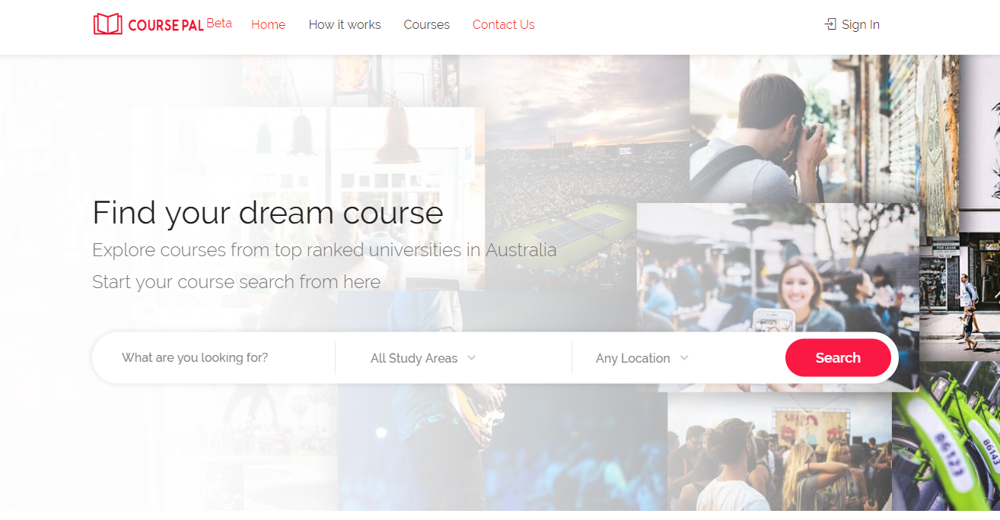

CoursePal also provides students application handling capabilities which will be viewed by respective universities using a university log-in portal provided by CoursePal. Universities then can download all the documents the student has uploaded and process the application, providing a faster, concise system to handle enrolment applications without the need for worrying the underlying implementation. In addition, CoursePal has a very user-friendly appeal which attracts majority of the young student age group. Currently, CoursePal website is still in Beta development phase and we are undertaking the development for android application for the same.

## **PROJECT GOAL**

The project is designed to be developed, tested and delivered between March and September 2019. The main goal is to develop the android application to extend usability for current CoursePal web platform. We aim to develop a completely new android app for users in android OS segment, which is in line with CoursePal brand thus eliminating the need to use a browser or a computer to access CoursePal. We plan to develop the exact same look and feel, which will ensure 100% user acceptance.

Our secondary goal is to learn the technologies involved in development by working on them. Learning through the means of this project will prove very beneficial for us as developers. We also aim to learn team work, effective communication between team members and the client, software development life cycle-requirements gathering to project deployment and the whole cycle, implementing agile methodology.

**DELIVERABLES:**

The projected ICT solution will be carried with detailed deadlines with various phases in application development

* UI Designs
* Alpha Release: Search functionality, Splash screens, Login Registration Screen
* Beta Release: App functionality development
* Testing – User Acceptance Testing and software assurance test
* Complete Documentation of project
* Submitting and publishing on Application store
* Provide Maintenance and support

## **Four major milestones with timeline:**

The project development cycle is based on completing various milestones. Milestones are used to record the group progress and developing highest priority functionalities first. The following milestones explain the overall project cycle.

**Milestone 1**

**The project requirements collection and drafting Client agreement are initial steps and forms milestone 1. This was completed during the client meeting and the agreement contract was signed. User stories were noted, and this marks the completion of milestone 1 as of 27th April 2019.**

**Milestone 2**

**The project planning and environment setup marks milestone 2. We have decided to use the JetBrains IntelliJ IDE for App development as it has Build functionalities, emulator, easy and reliable to use. Kotlin as our development language. Kotlin is the most versatile native development language. We are using github which is based on git version control as a collaboration platform, Trello to effectively communicate between client, group members and to assign tasks.**

**Milestone 3**

**Iteration Planning and task assignment is achieved in 3rd milestone. Iterative development approach refers to the way of breaking down the software development into small chunks, and designed, developed and tested in repeated cycles. The first feature the client has requested to be developed is the search functionality. Other features will be implemented according to the client demand upon further meetings. Once the top priority features are developed, alpha release will be scheduled with the client. The timeline may vary for this milestone as things often tend to not work as planned, but a top priority will be given to ensure that tasks are completed on time and as planned by each team member, managing and balancing work loads.**

**Milestone 4**

**Development and testing of all feature will be done in the last milestone. After the completion, the beta release will be delivered to the client. Beta release will be deployed in Google AppStore and will be then tested on various scale.**

**PROJECT AUDIT:**

In this part, we are discussing the scope of alpha: what things to do first, what is the least important task, how much time will they take. The key dates for this project are:

Start Date: 20th March 2019

End date:27th September 2019

We met our client on 23rd April 2019 and discuss some key points which are as follow:

* What COURSE PAL is about, what and how it offers to get a clear idea of the project so that we as developers can make the application appealing to the viewers.
* The platform used in making the application.
* Collected the user stories for the alpha release.
* Giving numbers to the user stories according to their importance. Assigning 10 to the top most priority and 50 to the least important.
* The basic design of the application: how should it look like is explained by the client.

Our team strength is 4, and we agree to meet at least 2 days a week. For the **alpha release** we have 5 weeks so the time-period to complete this project would be 2 * 4 * 5 = 40.

For Beta release = 5 weeks* 4 members* 2 days + 3 days for fixing errors = 43

Our team velocity for alpha and beta releases is 40 and 43 respectively.

We are using Trello software to keep records of our tasks and manage our project.

**Trello software:**

Trello is an outstanding tool for managing projects. Mostly it is used in businesses to manage group tasks but it could be used informally to plan a wedding, vacations and many more.

It gives an idea of what is left, what is being worked on and by whom. It resembles a whiteboard with notes representing tasks of a project.

Below is the link and snapshot of Trello used by our team for the project:

<https://trello.com/b/x8w8QmG5/coursepal-android-project>

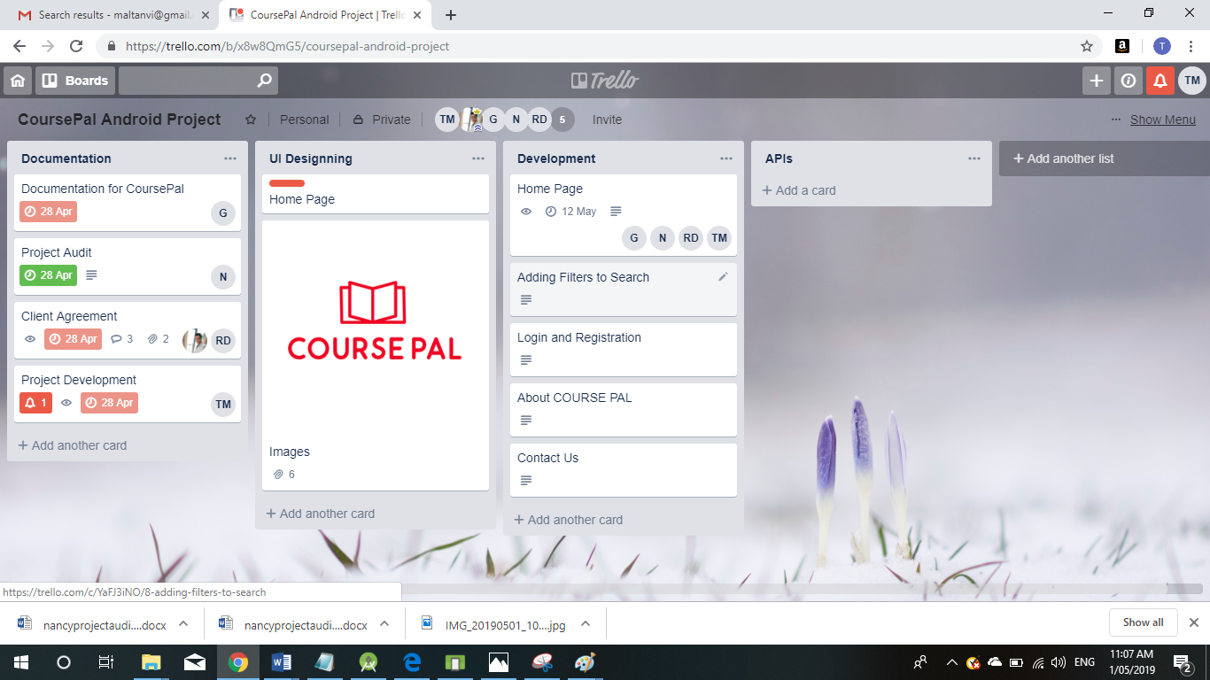

**MILESTONE 3: ALPHA RELEASE**

|  |  |  |  |  |
| --- | --- | --- | --- | --- |
| **No.** | **User Story** | **Description** | **Priority** | **Time (days)** |
| 1 | About COURSE PAL | Short description about what this business is and its history and background | 50 | 4 |
| 2 | Login and Registration | Login and Registration functionalities for new and existing users. A dashboard where all the previous user activities are there. | 20 | 10 |
| 3 | Home | Search bar for finding courses/universities based on location selected | 10 | 12 |
| 4 | Adding Filters to Search | Below Search bar we should display filter for Campus and fees Range, with Apply button at bottom | 20 | 10 |
| 5 | Contact Us | Social media Profiles and Contact details | 50 | 4 |

**USER STORIES:**

|  |
| --- |
| **Title**: About COURSE PAL |
| **Description**: As a viewer, I need to have idea about what COURSEPAL is so that I can decide to go through it or not. |
| **Priority**: 50 **Estimate time**: 4 days |

|  |
| --- |
| **Title**: Login and Registration for User/Student |
| **Description**: As a student/User I need to register and login in order to make any inquiries. |
| **Priority**: 20 **Estimate time**: 5 days |

|  |
| --- |
| **Title**: Login and Registration for Admin |
| **Description**: As an Admin I can have rights to login, register, update, insert, delete, records. |
| **Priority**: 20 **Estimate time**: 5 days |

|  |
| --- |
| **Title**: Home |
| **Description**: As a student, I need to find courses and universities with location. |
| **Priority**: 10 **Estimate time**: 12 days |

|  |
| --- |
| **Title:** Adding Filters to Search |
| **Description:** As a student, I can use filters to select fees range, course and related information according to my needs. |
| **Priority:** 20  **Estimate time:** 10 days |

|  |
| --- |
| **Title**: Contact Us |
| **Description**: As a visitor, I need to know the contact details of the company in case of unclear information. |
| **Priority**: 50 **Estimate time**: 4 days |

**MILESTONE 4: BETA RELEASE:**

* Start date: 15 July 2019
* End date: 27 Sept 2019

|  |  |  |  |  |
| --- | --- | --- | --- | --- |
| **No.** | **User Story** | **Description** | **Priority** | **Time (days)** |
| 1 | Creating User Dash Board | It is a collection of Dashboard Widgets like Courses, Legal Services, Explore, Meet Friend and Community. | 30 | 7 |
| 2 | Search and Apply | From the feature implemented in ICT-1, after searching universities and courses, students can apply to universities using application form | 20 | 5 |
| 3 | Adding Field in Courses | To implement sub categories under Course section like Bookmarks, Applied/Enquire, Active Applications | 50 | 5 |
| 3.1 | Bookmarks | Student can bookmark any visited page of universities where he/she finds it important for future reference | 40 | 3 |
| 3.2 | Applied List | To show the list of universities and course that he/she has applied | 40 | 3 |
| 3.3 | Enquired List | To show the list of universities and course that he/she has enquired | 40 | 3 |
| 3.4 | Active Application | To show list of universities and course for which universities has started processing the application | 40 | 3 |
| 4 | Legal Services | All Student Visa related information will be displayed on app which will help student to process the application further | 50 | 4 |
| 5 | Explore | Several Events information is there by which students can become a part of those. | 50 | 4 |
| 6 | Meet Friend and Communities | Connecting people and communities who installed the app to seek help. | 50 | 3 |
| 7 | Complete Functional Testing | To test all functionalities from start to end | 10 | 10 |

**USER STORIES:**

|  |
| --- |
| **Title**: Creating User Dash Board |
| **Description**: As a student, when I login I must see complete dashboard consisting of courses, legal services, explore, meet friend and community. |
| **Priority**: 30 **Estimate time**: 7 days |

|  |
| --- |
| **Title**: Adding Field in Courses |
| **Description**: As a student, When I select Course, 3 subcategories must be seen below: bookmarks, applied universities and current applications. |
| **Priority**: 50 **Estimate time**: 5 days |

|  |
| --- |
| **Title**: Bookmarks |
| **Description**: As a student, I can bookmark any visited page of universities which I find important for future reference |
| **Priority**: 40 **Estimate time**: 3 days |

|  |
| --- |
| **Title**: Applied List |
| **Description**: As a student, I can see the list of universities and course that I have applied in past |
| **Priority**: 40 **Estimate time**: 3 days |

|  |
| --- |
| **Title**: Enquired List |
| **Description**: As a student, I can see the list of universities and course that I have enquired in past |
| **Priority**: 40 **Estimate time**: 3 days |

|  |
| --- |
| **Title**: Active Application |
| **Description**: As a student, I can see the list of universities and course for which universities has started processing my application |
| **Priority**: 40 **Estimate time**: 3 days |

|  |
| --- |
| **Title**: Legal Services |
| **Description**: As a student, I need to know the requirements of applying student visa. |
| **Priority**: 50 **Estimate time**: 4 days |

|  |
| --- |
| **Title**: Explore |
| **Description**: As a student, I need to know about important educational events occurring nearby which I could attend. |
| **Priority**: 50 **Estimate time**: 4 days |

|  |
| --- |
| **Title**: Meet Friend and Communities |
| **Description**: As a student, I need to know people about their experiences. |
| **Priority**: 50 **Estimate time**: 3 days |

|  |
| --- |
| **Title**: Complete Functional Testing |
| **Description**: As a Developer/Tester, I need to test all functional flow from start to end. |
| **Priority**: 10 **Estimate time**: 10 days |

**PROJECT AGREEMENT WITH CLIENT:**

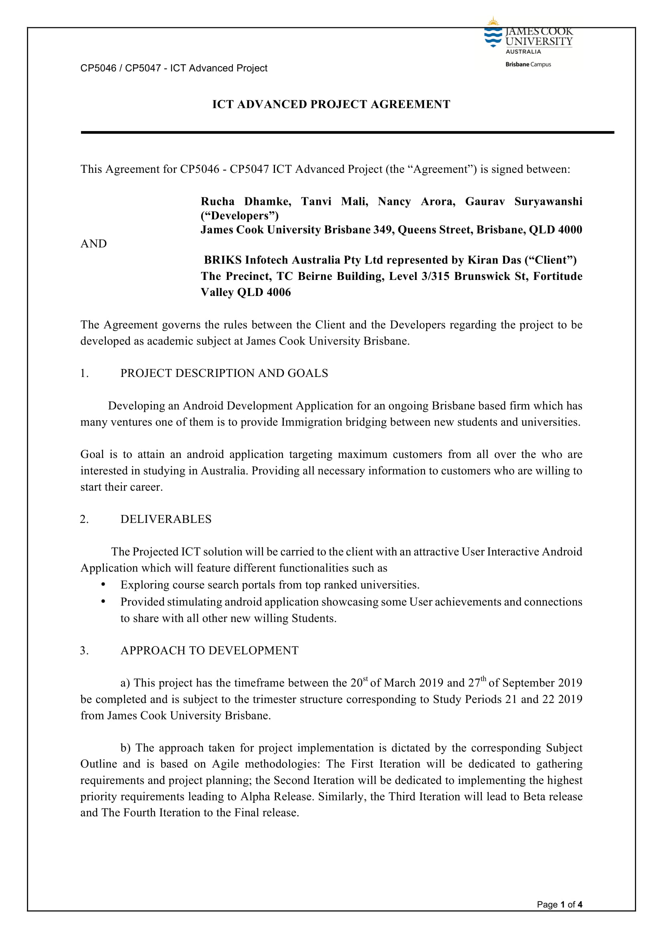

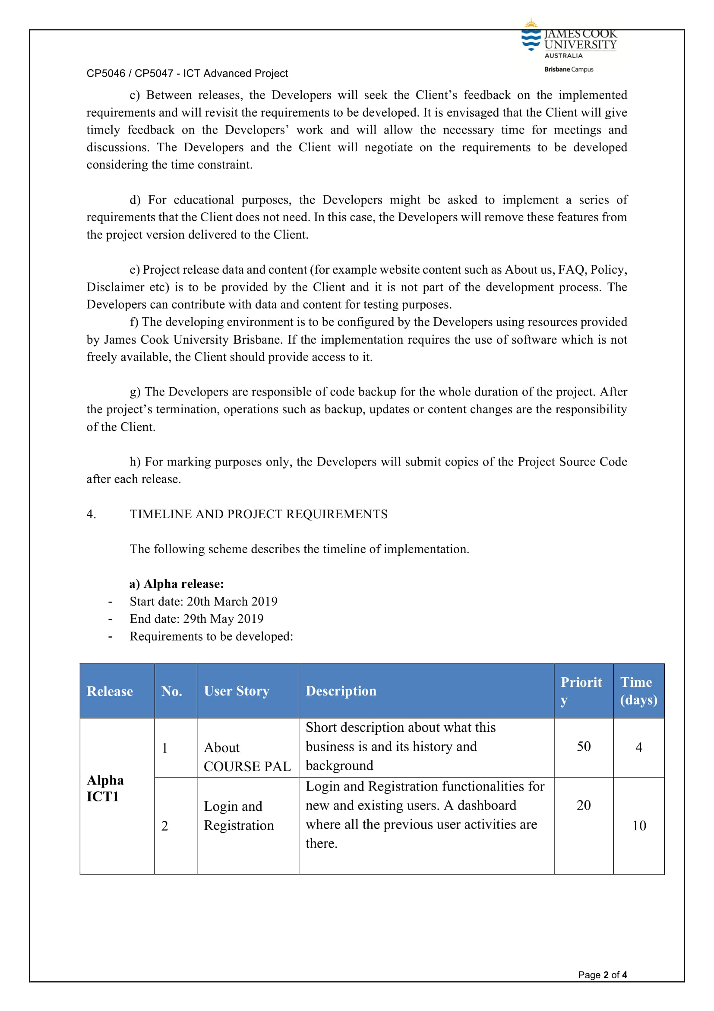

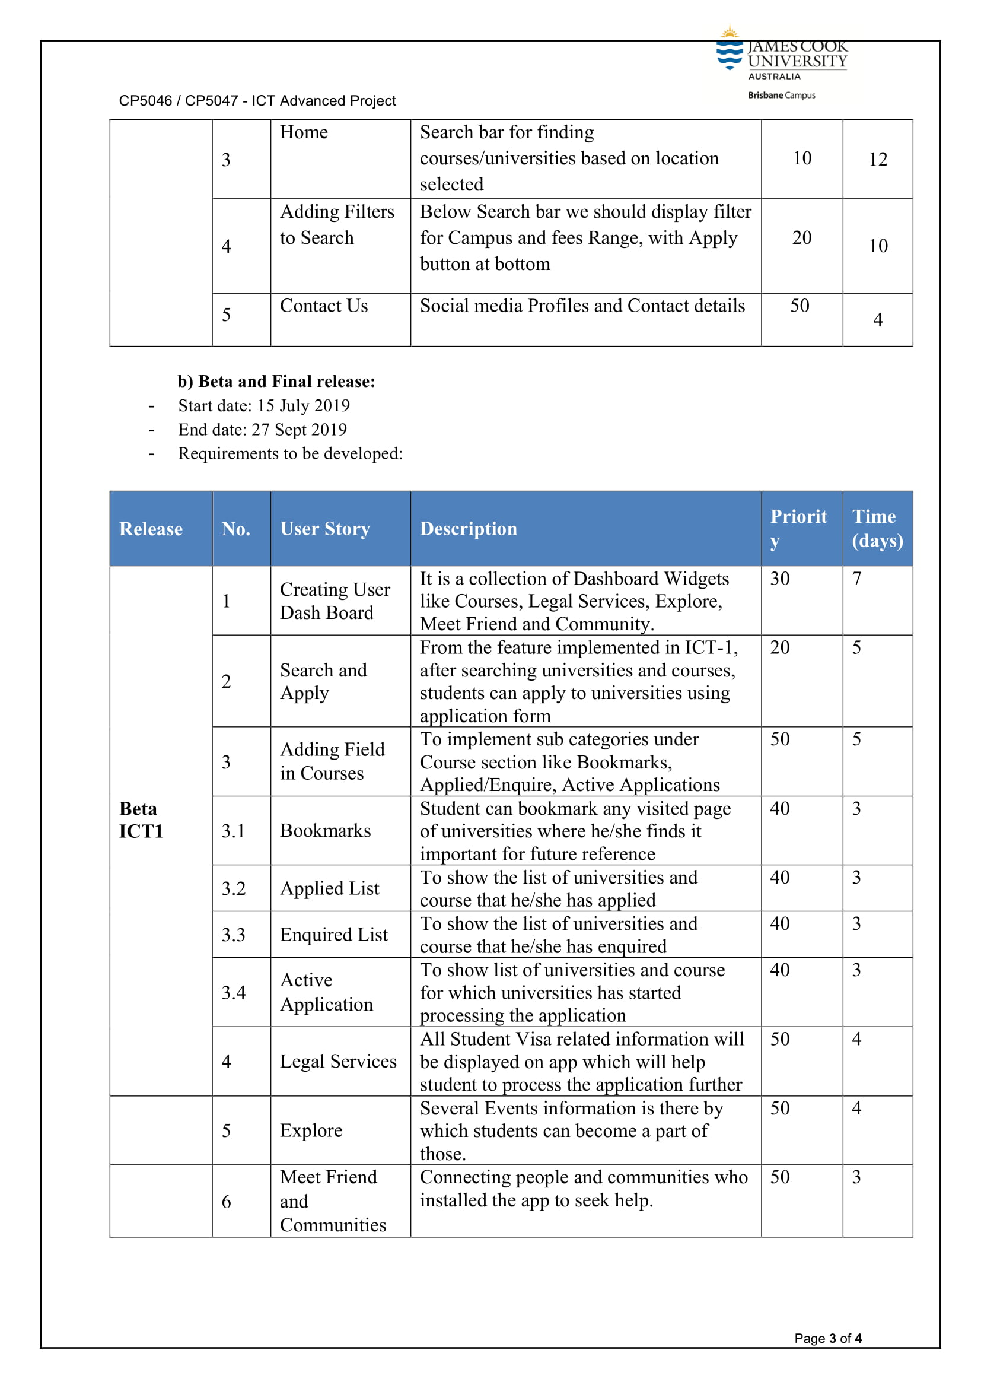

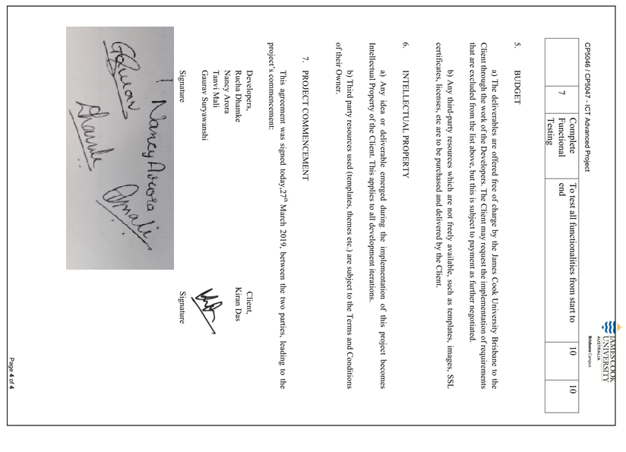

**PROJECT DEVELOPMENT TOOLS:**

**CONFIGURATION MANAGEMENT TOOL: GITHUB**

GitHub is web-based project collaboration tool, which is a distributed computing instrument ordered under Software as a Service (SaaS) class.

Every individual from the group would have allotted certain assignment, pages and capacities to manufacture or refresh, and because the group bunch isn't huge, it is anything but difficult to evade clashes when we consolidate our changes.

For this task, Git would be the form control framework for dealing with its diverse variants. We have picked Git because (git-scm, 2.21.0.1 latest release: 2019) says, it is anything but difficult to learn and claiming is a standout amongst the most famous dispersed adaptation control framework. GitHub would be utilized for the store to help to getting the code in one spot as expressed. Thusly, it is simpler to deal with the difference in all the designer group in one spot and it is anything but difficult to include new Developers. (TortoiseGit, 2015-2019 )

The variety of reason to select tortoise git are stated below:

* Simple to use no need to memorize git bash commands.
* Integrated spell checker for log messages.
* Spell checker.
* Can resolve merge conflicts.
* Conflict numbers are regenerate into links that open the web browser directly on the corresponding issue.
* Shows changes you created to your files.
* Will apply patch files you bought from users while not commit access to your repository.
* TortoiseGitIDiff: to determine the changes you created to your image files (see screenshot)
* TortoiseGit is stable.

**To Setup GitHub Account:**

1. You will need a GitHub account to create a GitHub repository where the revision will be stored.

Go to [https://github.com/join](https://github.com/).

Type a user name, your email address, and a password.

Choose **Sign up for GitHub**, and then follow the instructions.

1. Create a GitHub Repository: You will need a GitHub repository to store the revision.

In the **Repository name** box, enter [**team08-jcu/ICT**](https://github.com/team08-jcu/ICT)

1. Upload sample application to GitHub repository

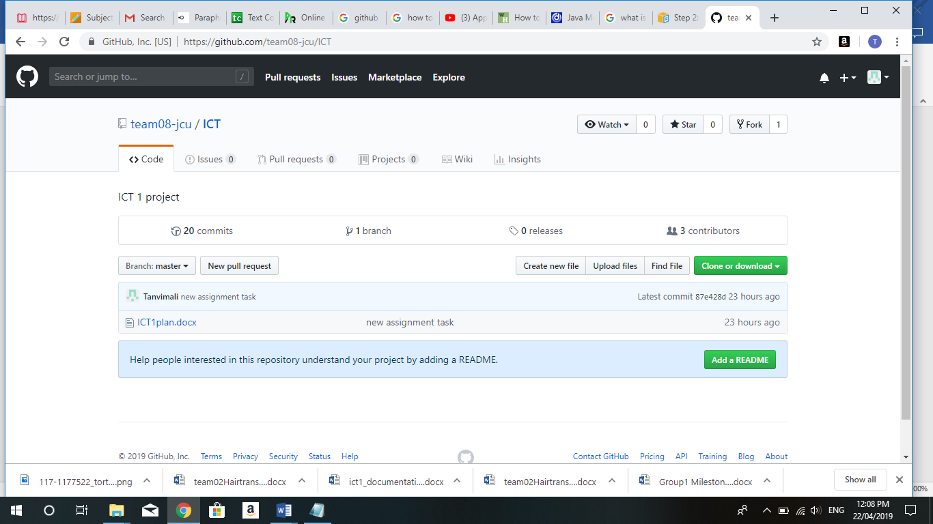

### Install Git and set it up in the project

* Download Git for Windows from <https://git-scm.com/downloads>
* Run Git-2.21.0.1-64-bit.exe
* Click next and when you reach the Configuring the line ending conversions select the first option “Checkout Windows-style …” as the image below:

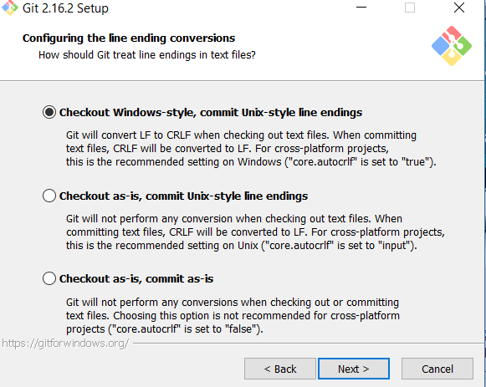

* Click next until finish the installation.
* After installation gets completed we can clone repository in local folder and can add new files, edit files, commit files and push files. (AWS, 2014)

Note: For new members in our team who are not exposed to git commands they use tortoise git instead of Git Bash.

**DEVELOPMENT TOOL:**

**IntelliJ IDEA:**

Android Studio depends on a standout amongst the most mainstream IDEs for Java advancement—IntelliJ IDEA Community Edition from JetBrains. IntelliJ is extensible, giving designers a chance to include usefulness and backing for more dialects and stages.

The IDE we are going to use is IntelliJ Idea Community edition version 2018.1. The ultimate edition, in comparison with the Community edition, offer additional tools such as Java EE Frameworks, Database Tools, SQL and Javascript that is important for our project and others additional tools.

IntelliJ Idea Ultimate is US $ 499 the first year, but there is also the opportunity to get free as a student.

We selected IntelliJ among others IDE mainly because IntelliJ IDEA it is the base IDE used by Android Studio for developing Android apps, and all the members are already familiar with Android Studio. We also took into consideration the next statistics retrieved from <https://insights.stackoverflow.com/survey/2018> in where we can see the most wanted JAVA IDE is IntelliJ IDEA. (more info in 14 Appendix A :Research - Most Popular Technologies at section “Most popular Development Environment”)

**MINIMUM SYSTEM REQUIREMENT**

**OS Version:** Microsoft Windows 7/8/10 (32-bit or 64-bit)

**RAM:** 8 GB RAM recommended

**DISK SPACE:** 4 GB recommended (500 MB for IDE + 1.5 GB for Android SDK and emulator system image)

**JAVA VERSION:** Java Development Kit (JDK) 8, use of bundled OpenJDK is recommended

**PROCESSOR:** intel core i5-7th Generation

**Setting up environment:**

* Run IntelliJ idea by double clicking **Invalid source specified.**
* idea-2018.1.1.exe
* Follow all steps from the wizard. **Invalid source specified.**
* Activate IntelliJ IDEA

After installing the IDE, the next step is to activate the product. For doing so, you should open the activation link from the email you have received when you have applied for the ultimate version as a student. You will see from there the License Id in which you are going to enter after run IntelliJ Idea for first time (see Figure 3. Activation Licences).

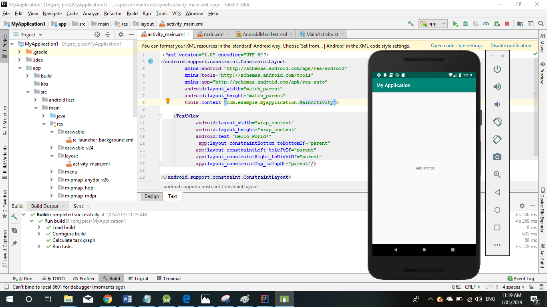

**ANDROID STUDIO**

Android Studio is the endorsed integrated development environment (IDE) for [Google](https://en.wikipedia.org/wiki/Google)'s [Android](https://en.wikipedia.org/wiki/Android_(operating_system)) [operating system](https://en.wikipedia.org/wiki/Operating_system). It is built on [JetBrains](https://en.wikipedia.org/wiki/JetBrains)' [IntelliJ IDEA](https://en.wikipedia.org/wiki/IntelliJ_IDEA). It was designed specifically for Mobile Application development. It is a replacement for the [Eclipse Android Development Tools](https://en.wikipedia.org/wiki/Eclipse_(software)#Android_Development_Tools) (ADT) as the primary IDE for native Android application development. It works on various Operating systems like Windows, MacOS and Linux. Android Studio supports all programming languages like Java, c++, Go Lang, Kotlin etc.

Comparing with other tools like Xamarin, Appcelerator, PhoneGap, etc. Android Studio provides some grateful features like

1.it's a compiler that you get the opportunity to use to make a record framework for organizing your application venture, to make different APK documents

2.it's a supervisor for the programming language that you'll choose to use in your application's improvement procedure (regardless of whether it's Java, Kotlin, C++...)

3.it's XML supervisor (giving you a "plan see", also, that will manage you in showing your application's components on the screen; essential for staying aware of Google's Material structure rules)

4.it likewise incorporates the Android SDK itself (yet, the Java SDK should be downloaded independently)

In short, Android Studio is **the “can't live without” tool-set for any developer!**

**SOFTWARE DEVELOPMENT LANGUAGES: KOTLIN**

Kotlin is an extraordinary programming language and has been coordinated by its fame in our industry. There was multiple reason for us to select Kotlin over java. In any case, for those who are unconscious of Kotlin, here are some amazing parts of the programming language, some of them are mentioned below

•Kotlin keeps running on the Java Virtual Machine and can gather into JVM bytecode or JavaScript

•Kotlin can use all current Java-based structures and libraries

•Kotlin uncovered Java 8 usefulness to Android designers, expelling constraints of Java 6

•The type system in Kotlin is focused on eliminating the dangers of null references from code

•Kotlin is appropriate for Functional Programming ventures

**DATABASE: MYSQL**

After brief discussion with team members and client we came up with the decision that we will integrate PHP and MYSQL with your android application. This is very beneficial in case of webserver, while we want to access its data on your android application.

MYSQL is used as a database at the webserver and PHP is used to fetch data from the database. Our application will communicate with the PHP page with necessary parameters and PHP will contact MYSQL database and will fetch the result and return the results to us.

## **Android - Connecting MYSQL**

### Connecting through Get Method:

There are two ways to connect to MYSQL via PHP page. The first one is called **Get method**. We will use **HttpGet** and **HttpClient** class to connect.

### Connecting through Post Method:

In the Post method, the **URLEncoder**, **URLConnection** class will be used. The url encoder will encode the information of the passing variables.



**HOSTING ENVIRONMENT: GOOGLE PLAYSTORE**

Google Play, some time ago known as Android Market, is the official dissemination customer facing facade for Android applications and other computerized media, such a music, motion pictures and books, from Google. It is accessible on cell phones and tablets that run the Android working framework (OS), bolstered Chrome OS gadgets and on the web. Clients can get to Google Play to peruse, buy and download programming applications from Google and outsider designers. As of now, the retail facade is accessible in more than 190 nations and regions.

To host our COURSEPAL Application on Google playstore we need to,

* Create a developer account on playstore, by paying 25$ USD as registration charges
* Upload COURSEPAL app which should be less then 50 MB in size
* Mention description about our app in less then 4000 words
* Upload screenshots of our application with Min length for any side: 320px. Max length for any side: 3840px including "Phone", "7-inch tablet" and "10-inch tablet".

**TESTING TOOLS: MONKEYTALK**

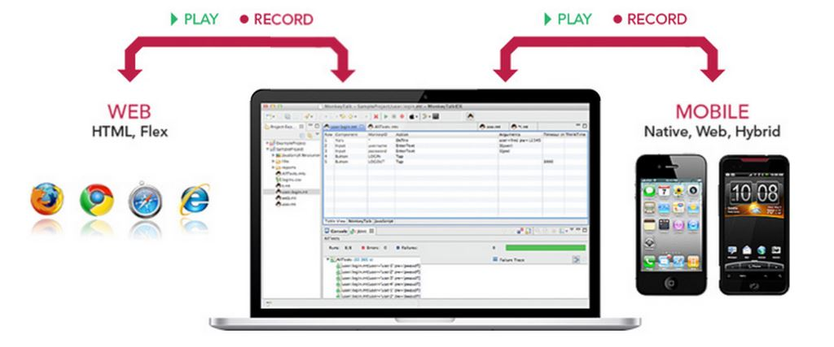

MonkeyTalk is an open source mobile app automation testing tool for Android and iOS. MonkeyTalk is an easy to-utilize apparatus which computerizes genuine, practical intuitive tests for iOS, Android, Web/HTML5, Hybrid and Flex applications. This open source instrument can be utilized for basic 'smoke tests' or for 'information driven test' suites on local, versatile, and mixture applications, genuine gadgets or test systems. It is genuine application for performing unit testing, regression testing on android application

MonkeyTalk is an open source tool which support for android and iOS. It also plays a vital role in supporting cross platform recording. Moreover, automation saves time, it is reusable and repeatable. It is very easy to learn and it’s a powerful functional testing tool. MonkeyTalkPro provides an inbuilt feature to instrument the build, which injects MonkeyTalk Agent to the built. Otherwise, we can manually integrate the MonkeyTalk Agent by configuring the source code using

To install MonkeyTalk to start testing we require

* Download and install Java
* Download MonkeyTalk Pro
* Need Android Studio/Intellij to configure the source code.

We are aware that testing plays critical role in Mobile Application development. Testing guarantees that the project that our team have developed is running smoothly on all devices like mobiles and tablets without any error. We will use different types of testing procedures mentioned below to test our application:

## **Unit Testing:**

## Unit Testing is a dimension of programming testing where singular units/segments of a product are tested. The intention is to approve that every unit of the product executes as planned. Unit testing is a useful asset for guaranteeing code quality by empowering developer to get bugs while still in the development stage which brings about delivering application rapidly with less bugs.

## **Regression Testing:**

Regression Testing is characterized as a sort of programming testing to affirm that an ongoing project or code change has not unfavourably influenced existing highlights. Regression Testing is required when code is altered because of the adjustment in prerequisite, including new component and bug fixing. For Regression testing we need to re-test all the current experiments, so it requires colossal time and resources (guru99, n.d.)

**User Acceptance Testing:**

For the user Acceptance testing, we have decided to include other ICT groups for testing the user interface of our project. This is the after phase of testing where the final product is given for testing purpose to some non-technical audience, the layout and the content is clear for any customer who installs the application

**APPLICATION LAYOUT (PROTOTYPES): EMULATOR VIEW**

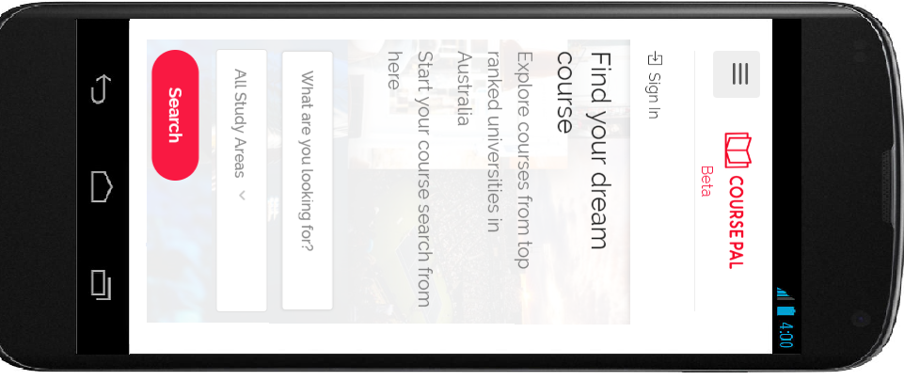 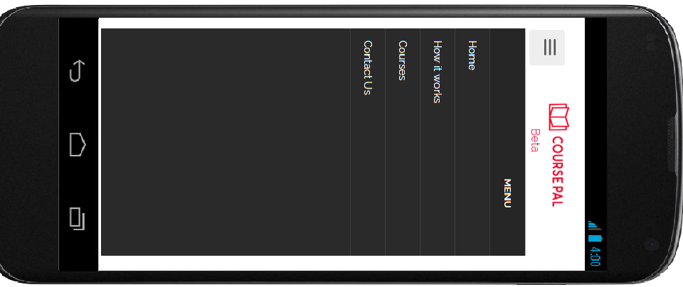

Home Page Menu Page

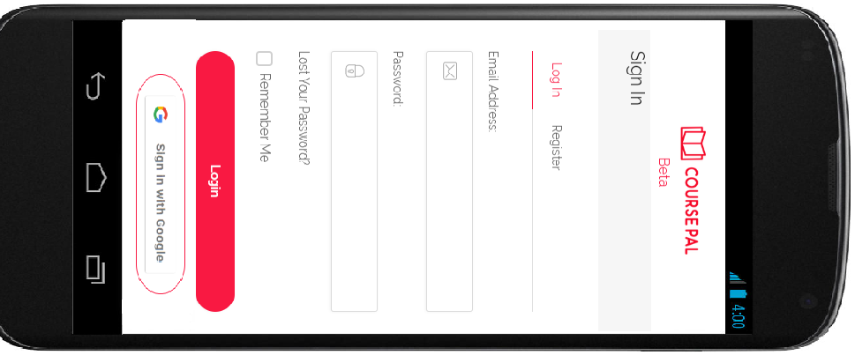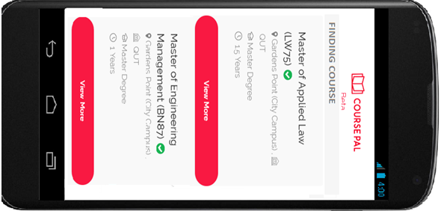

Login Page Finding Course

# References

AWS. (2014, 10 6). *AWS CodeDeploy*. Retrieved from https://docs.aws.amazon.com/codedeploy/latest/userguide/tutorials-github-create-github-account.html?tag=askcomdelta-20

*guru99*. (n.d.). Retrieved from Regression testing: https://www.guru99.com/regression-testing.html

OECD. (n.d.). *OECD-ilibrary.org*. Retrieved from OECD.org.

*softwaretestingfundamentals*. (n.d.). Retrieved from Unit-testing: http://softwaretestingfundamentals.com/unit-testing/

*TortoiseGit*. (2015-2019 ). Retrieved from https://tortoisegit.org/about/