**PROJECT DEVELOPMENT TOOLS:**

**CONFIGURATION MANAGEMENT: GITHUB**

GitHub is web-based project collaboration tool, which is a distributed computing instrument ordered under Software as a Service (SaaS) class.

Every individual from the group would have allotted certain assignment, pages and capacities to manufacture or refresh, and because the group bunch isn't huge, it is anything but difficult to evade clashes when we consolidate our changes.

For this task, Git would be the form control framework for dealing with its diverse variants. We have picked Git because (git-scm, 2.21.0.1 latest release: 2019) says, it is anything but difficult to learn and claiming is a standout amongst the most famous dispersed adaptation control framework. GitHub would be utilized for the store to help to getting the code in one spot as expressed. Thusly, it is simpler to deal with the difference in all the designer group in one spot and it is anything but difficult to include new Developers. (TortoiseGit, 2015-2019 )

The variety of reason to select tortoise git are stated below:

* Simple to use no need to memorize git bash commands.
* Integrated spell checker for log messages.
* Spell checker.
* Can resolve merge conflicts.
* Conflict numbers are regenerate into links that open the web browser directly on the corresponding issue.
* Shows changes you created to your files.
* Will apply patch files you bought from users while not commit access to your repository.
* TortoiseGitIDiff: to determine the changes you created to your image files (see screenshot)
* out there in several languages.
* TortoiseGit is stable.

**To Setup GitHub Account:**

1. You will need a GitHub account to create a GitHub repository where the revision will be stored.

Go to [https://github.com/join](https://github.com/).

Type a user name, your email address, and a password.

Choose **Sign up for GitHub**, and then follow the instructions.

1. Create a GitHub Repository: You will need a GitHub repository to store the revision.

In the **Repository name** box, enter [**team08-jcu/ICT**](https://github.com/team08-jcu/ICT)

1. Upload sample application to GitHub repository

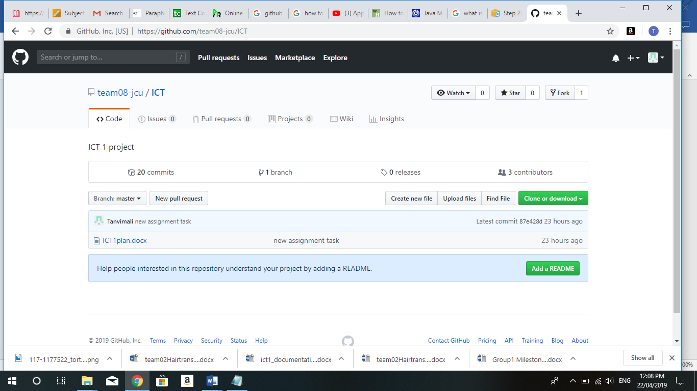

### Install Git and set it up in the project

* Download Git for Windows from <https://git-scm.com/downloads>
* Run Git-2.21.0.1-64-bit.exe
* Click next and when you reach the Configuring the line ending conversions select the first option “Checkout Windows-style …” as the image below:

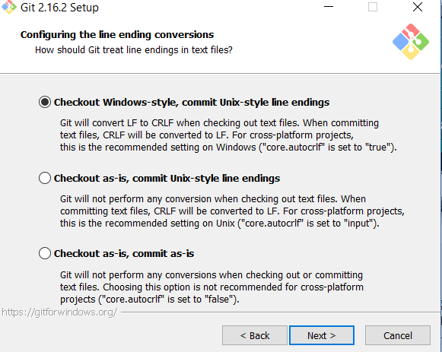

* Click next until finish the installation.
* After installation gets completed we can clone repository in local folder and can add new files, edit files, commit files and push files. (AWS, 2014)

Note: For new members in our team who are not exposed to git commands they use tortoise git instead of gitbash.

**DEVELOPMENT TOOL:**

**IntelliJ IDEA:**

Android Studio depends on a standout amongst the most mainstream IDEs for Java advancement—IntelliJ IDEA Community Edition from JetBrains. IntelliJ is extensible, giving designers a chance to include usefulness and backing for more dialects and stages.

### IDE - IntelliJ Idea Ultimate

The IDE we are going to use is ItelliJ Idea Ultimate edition version 2018.1. The ultimate edition, in comparison with the Community edition, offer additional tools such as Java EE Frameworks, Database Tools, SQL and Javascript that is important for our project and others additional tools.

IntelliJ Idea Ultimate is US $ 499 the first year, but there is also the opportunity to get free as a student.

We selected IntelliJ among others IDE mainly because IntelliJ IDEA it is the base IDE used by Android Studio for developing Android apps, and all the members are already familiar with Android Studio. We also took into consideration the next statistics retrieved from <https://insights.stackoverflow.com/survey/2018> in where we can see the most wanted JAVA IDE is IntelliJ IDEA. (more info in 14 Appendix A :Research - Most Popular Technologies at section “Most popular Development Environment”)

**MINIMUM SYSTEM REQUIREMENT**

**OS Version:** Microsoft Windows 7/8/10 (32-bit or 64-bit)

**RAM:** 8 GB RAM recommended

**DISK SPACE:** 4 GB recommended (500 MB for IDE + 1.5 GB for Android SDK and emulator system image)

**JAVA VERSION:** Java Development Kit (JDK) 8, use of bundled OpenJDK is recommended

**PROCESSOR:** intel core i5-7th Generation

**Setting up environment:**

* Run IntelliJ idea by double clicking (JetBrains, 2018)

idea-2018.1.1.exe

* Follow all steps from the wizard. (JetBrains, 2018)
* Activate IntelliJ IDEA

After installing the IDE, the next step is to activate the product. For doing so, you should open the activation link from the email you have received when you have applied for the ultimate version as a student. You will see from there the License Id in which you are going to enter after run IntelliJ Idea for first time (see Figure 3. Activation Licences).

**ANDROID STUDIO**

Android Studio is the endorsed integrated development environment (IDE) for [Google](https://en.wikipedia.org/wiki/Google)'s [Android](https://en.wikipedia.org/wiki/Android_(operating_system)) [operating system](https://en.wikipedia.org/wiki/Operating_system). It is built on [JetBrains](https://en.wikipedia.org/wiki/JetBrains)' [IntelliJ IDEA](https://en.wikipedia.org/wiki/IntelliJ_IDEA). It was designed specifically for Mobile Application development. It is a replacement for the [Eclipse Android Development Tools](https://en.wikipedia.org/wiki/Eclipse_(software)#Android_Development_Tools) (ADT) as the primary IDE for native Android application development. It works on various Operating systems like Windows, MacOS and Linux. Android Studio supports all programming languages like Java, c++, Go Lang, Kotlin etc.

Comparing with other tools like Xamarin, Appcelerator, PhoneGap, etc. Android Studio provides some grateful features like

1.it's a compiler that you get the opportunity to use to make a record framework for organizing your application venture, to make different APK documents

2.it's a supervisor for the programming language that you'll choose to use in your application's improvement procedure (regardless of whether it's Java, Kotlin, C++...)

3.it's XML supervisor (giving you a "plan see", also, that will manage you in showing your application's components on the screen; essential for staying aware of Google's Material structure rules)

4.it likewise incorporates the Android SDK itself (yet, the Java SDK should be downloaded independently)

In short, Android Studio is **the “can't live without” tool-set for any developer!**

**MINIMUM SYSTEM REQUIREMENT TO INSTALL ANDROID STUDIO**

**OS Version:** Microsoft Windows 7/8/10 (32-bit or 64-bit)

**RAM:** 8 GB RAM recommended

**DISK SPACE:** 4 GB recommended (500 MB for IDE + 1.5 GB for Android SDK and emulator system image)

**JAVA VERSION:** Java Development Kit (JDK) 8, use of bundled OpenJDK is recommended

**PROCESSOR:** intel core i5-7th Generation

**SOFTWARE DEVELOPMENT LANGUAGES: KOTLIN**

Kotlin is an extraordinary programming language and has been coordinated by its fame in our industry. There was multiple reason for us to select Kotlin over java. In any case, for those who are unconscious of Kotlin, here are some amazing parts of the programming language, some of them are mentioned below

•Kotlin keeps running on the Java Virtual Machine and can gather into JVM bytecode or JavaScript

•Kotlin can use all current Java-based structures and libraries

•Kotlin uncovered Java 8 usefulness to Android designers, expelling constraints of Java 6

•The type system in Kotlin is focused on eliminating the dangers of null references from code

•Kotlin is appropriate for Functional Programming ventures

**DATABASE: MYSQL**

After brief discussion with team members and client we came up with the decision that we will integrate PHP and MYSQL with your android application. This is very beneficial in case of webserver, while we want to access its data on your android application.

MYSQL is used as a database at the webserver and PHP is used to fetch data from the database. Our application will communicate with the PHP page with necessary parameters and PHP will contact MYSQL database and will fetch the result and return the results to us.

## **Android - Connecting MYSQL**

### Connecting through Get Method:

There are two ways to connect to MYSQL via PHP page. The first one is called **Get method**. We will use **HttpGet** and **HttpClient** class to connect.

### Connecting through Post Method:

In the Post method, the **URLEncoder**, **URLConnection** class will be used. The url encoder will encode the information of the passing variables.

**HOSTING ENVIRONMENT: GOOGLE PLAYSTORE**

Google Play, some time ago known as Android Market, is the official dissemination customer facing facade for Android applications and other computerized media, such a music, motion pictures and books, from Google. It is accessible on cell phones and tablets that run the Android working framework (OS), bolstered Chrome OS gadgets and on the web. Clients can get to Google Play to peruse, buy and download programming applications from Google and outsider designers. As of now, the retail facade is accessible in more than 190 nations and regions.

To host our COURSEPAL Application on Google playstore we need to,

* Create a developer account on playstore, by paying 25$ USD as registration charges
* Upload COURSEPAL app which should be less then 50 MB in size
* Mention description about our app in less then 4000 words
* Upload screenshots of our application with Min length for any side: 320px. Max length for any side: 3840px including "Phone", "7-inch tablet" and "10-inch tablet".

**TESTING TOOLS: MONKEYTALK**

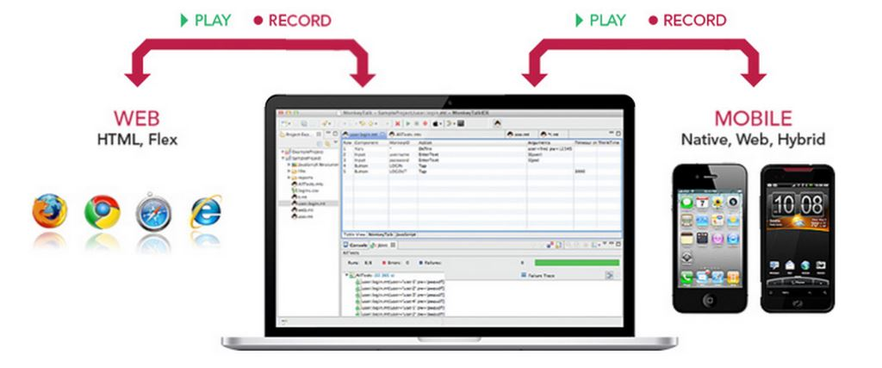

MonkeyTalk is an open source mobile app automation testing tool for Android and iOS. MonkeyTalk is an easy to-utilize apparatus which computerizes genuine, practical intuitive tests for iOS, Android, Web/HTML5, Hybrid and Flex applications. This open source instrument can be utilized for basic 'smoke tests' or for 'information driven test' suites on local, versatile, and mixture applications, genuine gadgets or test systems. It is genuine application for performing unit testing, regression testing on android application

MonkeyTalk is an open source tool which support for android and iOS. It also plays a vital role in supporting cross platform recording. Moreover, automation saves time, it is reusable and repeatable. It is very easy to learn and it’s a powerful functional testing tool. MonkeyTalkPro provides an inbuilt feature to instrument the build, which injects MonkeyTalk Agent to the built. Otherwise, we can manually integrate the MonkeyTalk Agent by configuring the source code using

To install MonkeyTalk to start testing we require

* Download and install Java
* Download MonkeyTalk Pro
* Need Android Studio/Intellij to configure the source code.

We are aware that testing plays critical role in Mobile Application development. Testing guarantees that the project that our team have developed is running smoothly on all devices like mobiles and tablets without any error. We will use different types of testing procedures mentioned below to test our application:

## **Unit Testing:**

## Unit Testing is a dimension of programming testing where singular units/segments of a product are tested. The intention is to approve that every unit of the product executes as planned. Unit testing is a useful asset for guaranteeing code quality by empowering developer to get bugs while still in the development stage which brings about delivering application rapidly with less bugs.

## **Regression Testing:**

Regression Testing is characterized as a sort of programming testing to affirm that an ongoing project or code change has not unfavourably influenced existing highlights. Regression Testing is required when code is altered because of the adjustment in prerequisite, including new component and bug fixing. For Regression testing we need to re-test all the current experiments, so it requires colossal time and resources (guru99, n.d.)

**User Acceptance Testing:**

For the user Acceptance testing, we have decided to include other ICT groups for testing the user interface of our project. This is the after phase of testing where the final product is given for testing purpose to some non-technical audience, the layout and the content is clear for any customer who installs the application

**APPLICATION LAYOUT (PROTOTYPES): EMULATOR VIEW**

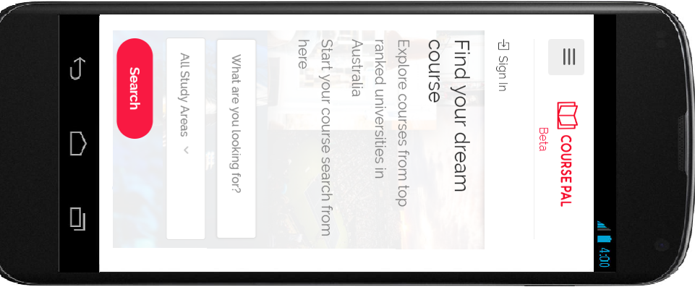 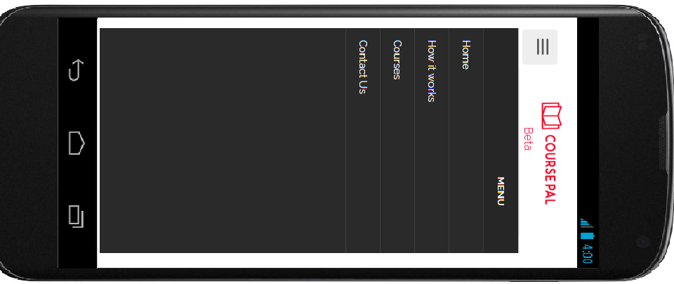

Home Page Menu Page

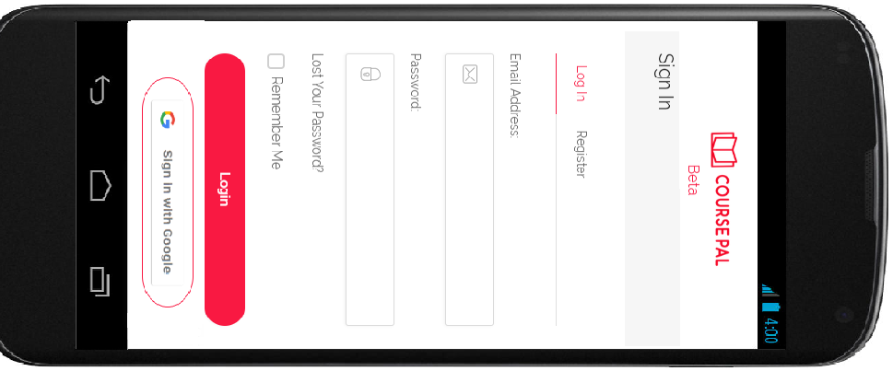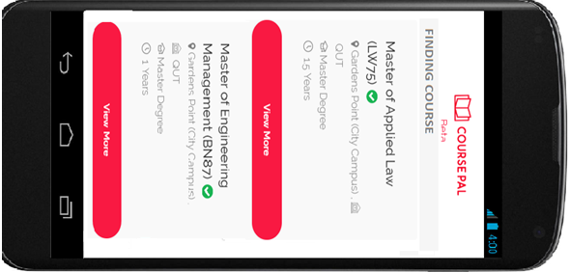

Login Page Finding Course

# Bibliography

AWS. (2014, 10 6). *AWS CodeDeploy*. Retrieved from https://docs.aws.amazon.com/codedeploy/latest/userguide/tutorials-github-create-github-account.html?tag=askcomdelta-20

*guru99*. (n.d.). Retrieved from Regression testing: https://www.guru99.com/regression-testing.html

*softwaretestingfundamentals*. (n.d.). Retrieved from Unit-testing: http://softwaretestingfundamentals.com/unit-testing/

*TortoiseGit*. (2015-2019 ). Retrieved from https://tortoisegit.org/about/