**Project Audit at the end of CP5046**

In this part, we are discussing the scope of alpha: what things to do first, what is the least important task, how much time will they take. The key dates for this project are:

Start Date: 20th March 2019

End date:29th May 2019

We met our client on 23rd April 2019 and discuss some key points which are as follow:

* What COURSE PAL is about, what and how it offers to get a clear idea of the project so that we as developers can make the application appealing to the viewers.
* The platform used in making the application.
* Collected the user stories for the alpha release.
* Giving numbers to the user stories according to their importance. Assigning 10 to the top most priority and 50 to the least important.
* The basic design of the application: how should it look like is explained by the client.

For the project we are working 2 days per week and we are 4 members in our team. For the alpha release we have 5 weeks so the time period to complete this project would be 2   
* 4 * 5 = 40 that is 40 days.

Requirements for this project are:

|  |  |  |  |
| --- | --- | --- | --- |
| Title | Description | Client Priority | Time estimate (days) |
| Search | Search button to find different courses and universities according to the user choices. | 10 | 2 |
| About COURSE PAL | In short description about what this business is and its history and background | 10 | 2 |
| Login and Registration | Login and Registration functionalities for new and existing users.A dashboard where all the previous user activities are there. | 10 | 2 |
| List of Courses with location | Information of different courses so that students can choose the one from their field and the place where they want to study. | 20 | 3 |
| Contact Us | Social media Profiles and Contact details | 20 | 1 |
| Working procedure | Functionality to look at the current jobs based on the qualification and skills. | 30 | 3 |
| Booking Accommodation | After the course and university is selected, looking for rental place to avoid mess after the arrival. | 40 | 2 |

In the second meeting with the client in his office, furthermore information was taken about the business which are as follow:

* Images of universities of Australia
* With the development of business, contact with accommodation companies to help students with their stay.
* Very low fees and good service.
* As the business is just start up, creating links of social media like Facebook, Instagram at the bottom helps in getting people know about the updates of the company.

**Trello software:**

Trello is an outstanding tool for managing project. Mostly it is used in businesses to manage group tasks but it could be used informally to plan a wedding, vacations and many more.

It gives an idea of what is left, what is being worked on and by whom. It resembles a whiteboard with notes representing tasks of a project.

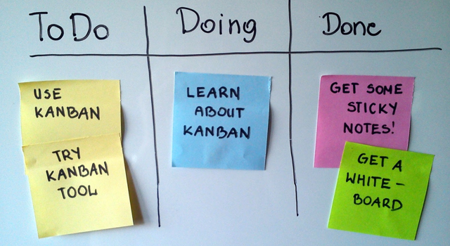

(How we effectively use Trello for project management, 2015). Retrieved from <https://wpcurve.com/trello-for-project-management/>

Below is the snapshot of Trello used by our team for the project:

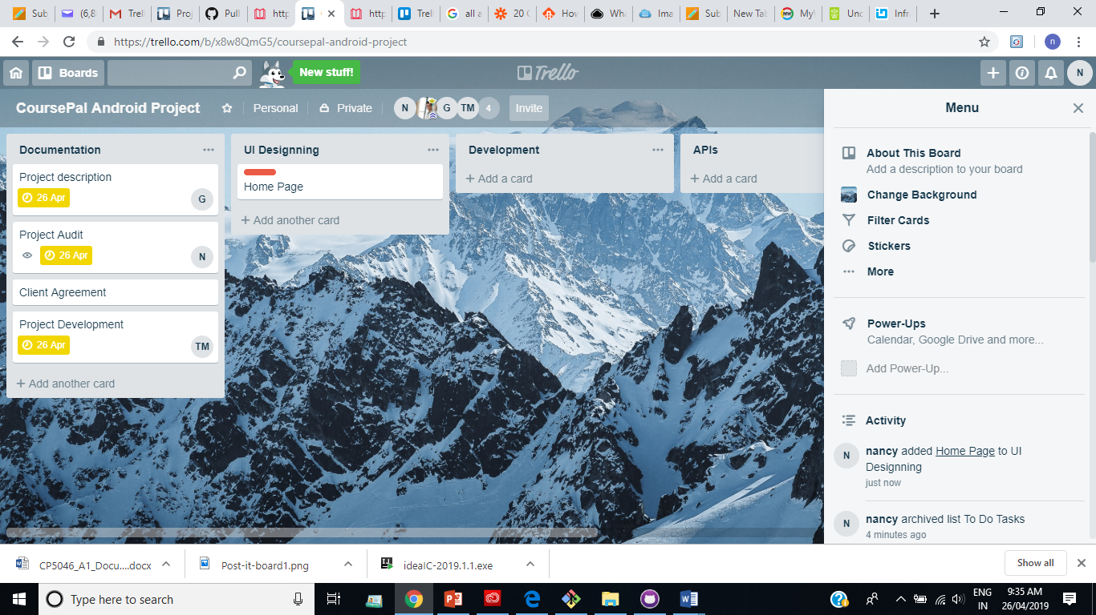

Beta release:

Start Date: 9th June 2019

End date:29th September 2019

|  |  |  |  |
| --- | --- | --- | --- |
| Title | Description | Client Priority | Time estimate |
| Images | Pictures showing universities and Subject Reviews. | 30 | 3 |
| Videos | Students can view videos of universities students about their experience and decide with which they want to go. | 30 | 3 |
| Payment | Payment option by which students can pay money after their offer letter. | 30 | 4 |
| Blogs | News and Information regarding to the changing scenarios in Australian Education System. | 40 | 2 |
| Reviews | User experiences and reviews of services offered by the Application | 50 | 1 |