**Project Audit at the end of CP5046**

In this part, we are discussing the scope of alpha: what things to do first, what is the least important task, how much time will they take. The key dates for this project are:

Start Date: 20th March 2019

End date:29th May 2019

We met our client on 23rd April 2019 and discuss some key points which are as follow:

* What COURSE PAL is about, what and how it offers to get a clear idea of the project so that we as developers can make the application appealing to the viewers.
* The platform used in making the application.
* Collected the user stories for the alpha release.
* Giving numbers to the user stories according to their importance. Assigning 10 to the top most priority and 50 to the least important.
* The basic design of the application: how should it look like is explained by the client.

For the project we are working 2 days per week and we are 4 members in our team. For the alpha release we have 5 weeks so the time period to complete this project would be 2   
* 4 * 5 = 40 that is 40 days.

Requirements for this project are:

|  |  |  |  |
| --- | --- | --- | --- |
| Title | Description | Client Priority | Time estimate (days) |
| Search | Search button to find different courses and universities according to the user choices. | 10 | 2 |
| About COURSE PAL | In short description about what this business is and its history and background | 10 | 2 |
| Login and Registration | Login and Registration functionalities for new and existing users.A dashboard where all the previous user activities are there. | 10 | 2 |
| List of Courses with location | Information of different courses so that students can choose the one from their field and the place where they want to study. | 20 | 3 |
| Contact Us | Social media Profiles and Contact details | 20 | 1 |
| Working procedure | Functionality to look at the current jobs based on the qualification and skills. | 30 | 3 |
| Booking Accommodation | After the course and university is selected, looking for rental place to avoid mess after the arrival. | 40 | 2 |

In the second meeting with the client in his office, furthermore information was taken about the business which is as follow:

* Images of universities of Australia
* With the development of business, contact with accommodation companies to help students with their stay.
* Very low fees and good service.
* As the business is just start up, creating links of social media like Facebook, Instagram at the bottom helps in getting people know about the updates of the company.

We are using Trello software to keep records of our tasks and manage our project.

**Trello software:**

Trello is an outstanding tool for managing projects. Mostly it is used in businesses to manage group tasks but it could be used informally to plan a wedding, vacations and many more.

It gives an idea of what is left, what is being worked on and by whom. It resembles a whiteboard with notes representing tasks of a project.

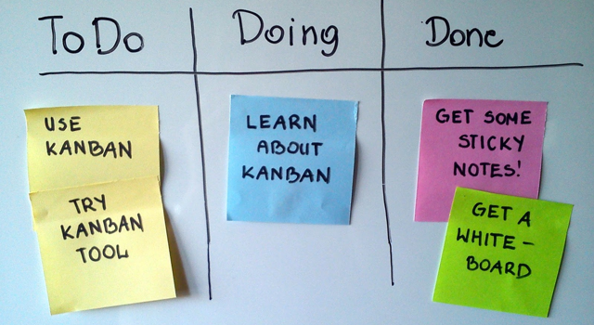

(How we effectively use Trello for project management, 2015). Retrieved from <https://wpcurve.com/trello-for-project-management/>

Below is the snapshot of Trello used by our team for the project:

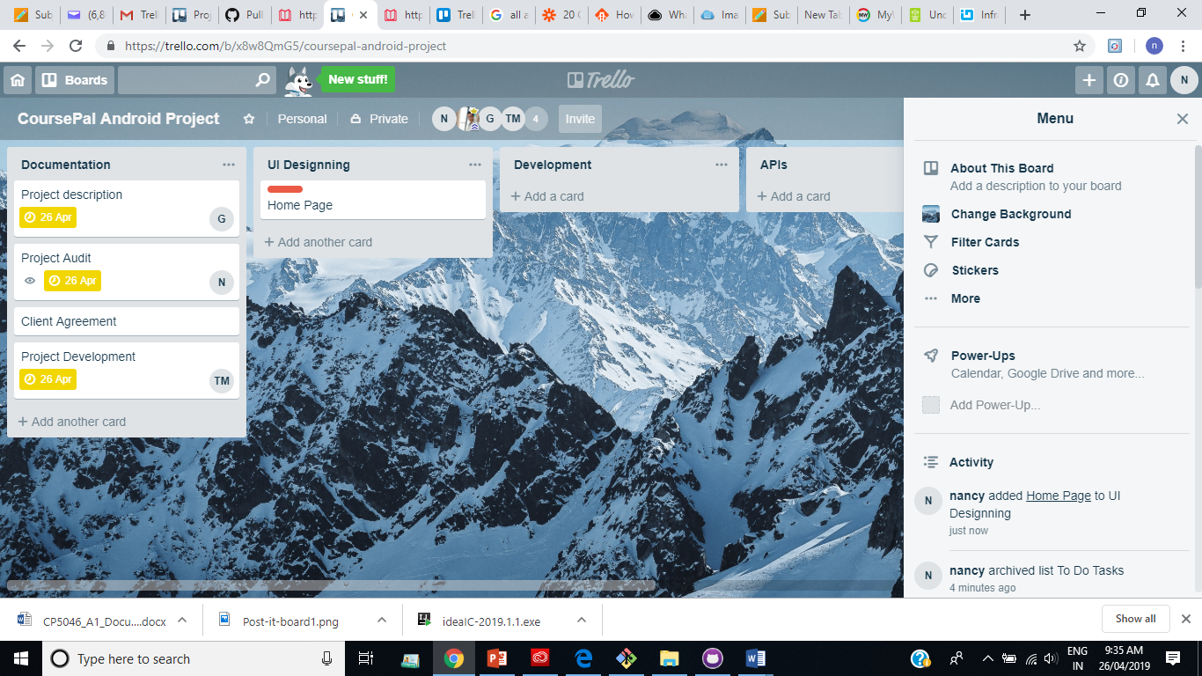

Beta release:

Start Date: 9th June 2019

End date:29th September 2019

Requirements to be developed:

|  |  |  |  |
| --- | --- | --- | --- |
| Title | Description | Client Priority | Time estimate |
| Images | Pictures showing universities and Subject Reviews. | 30 | 3 |
| Videos | Students can view videos of universities students about their experience and decide with which they want to go. | 30 | 3 |
| Payment | Payment option by which students can pay money after their offer letter. | 30 | 4 |
| Blogs | News and Information regarding to the changing scenarios in Australian Education System. | 40 | 2 |
| Reviews | User experiences and reviews of services offered by the Application | 50 | 1 |