Definition and examples of functional & non-functional requirements & specification

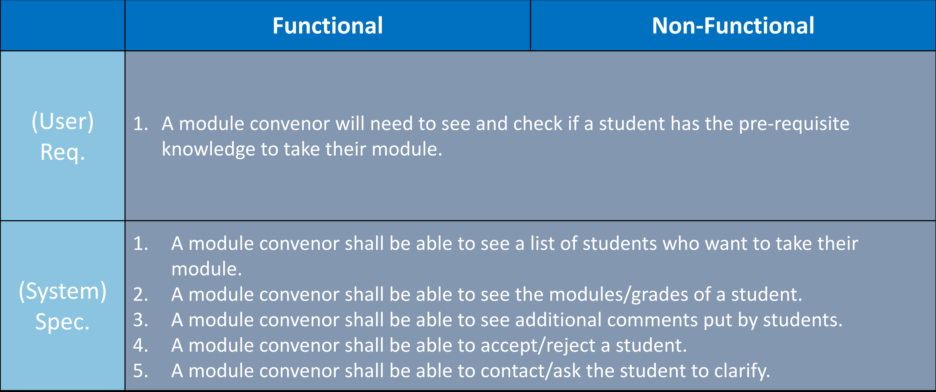

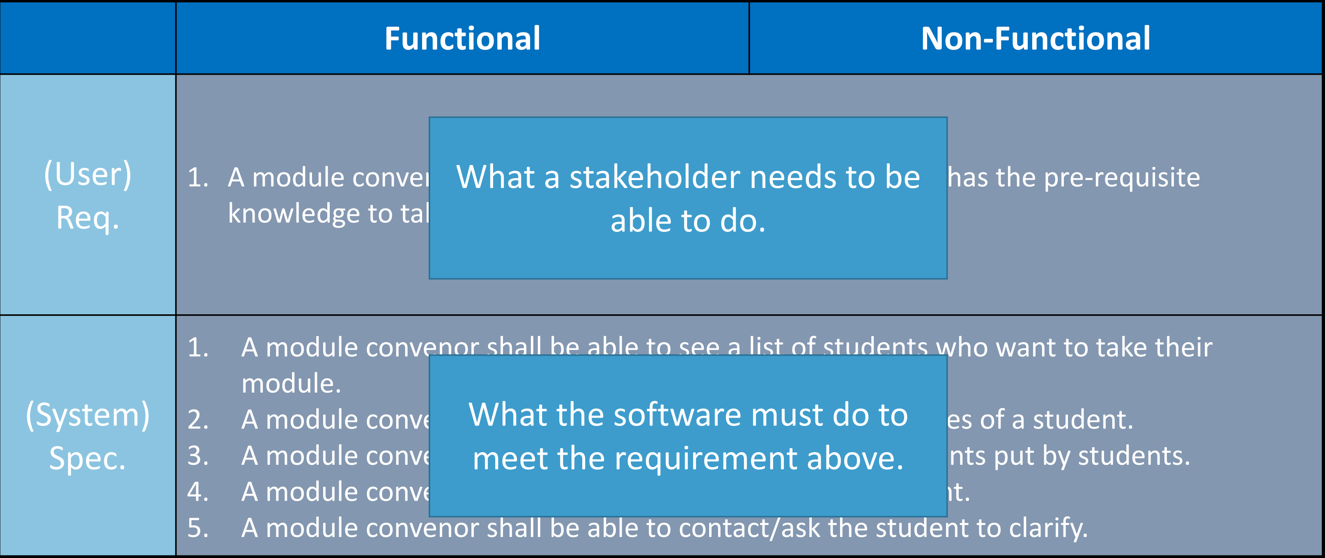

Requirements engineering process figure

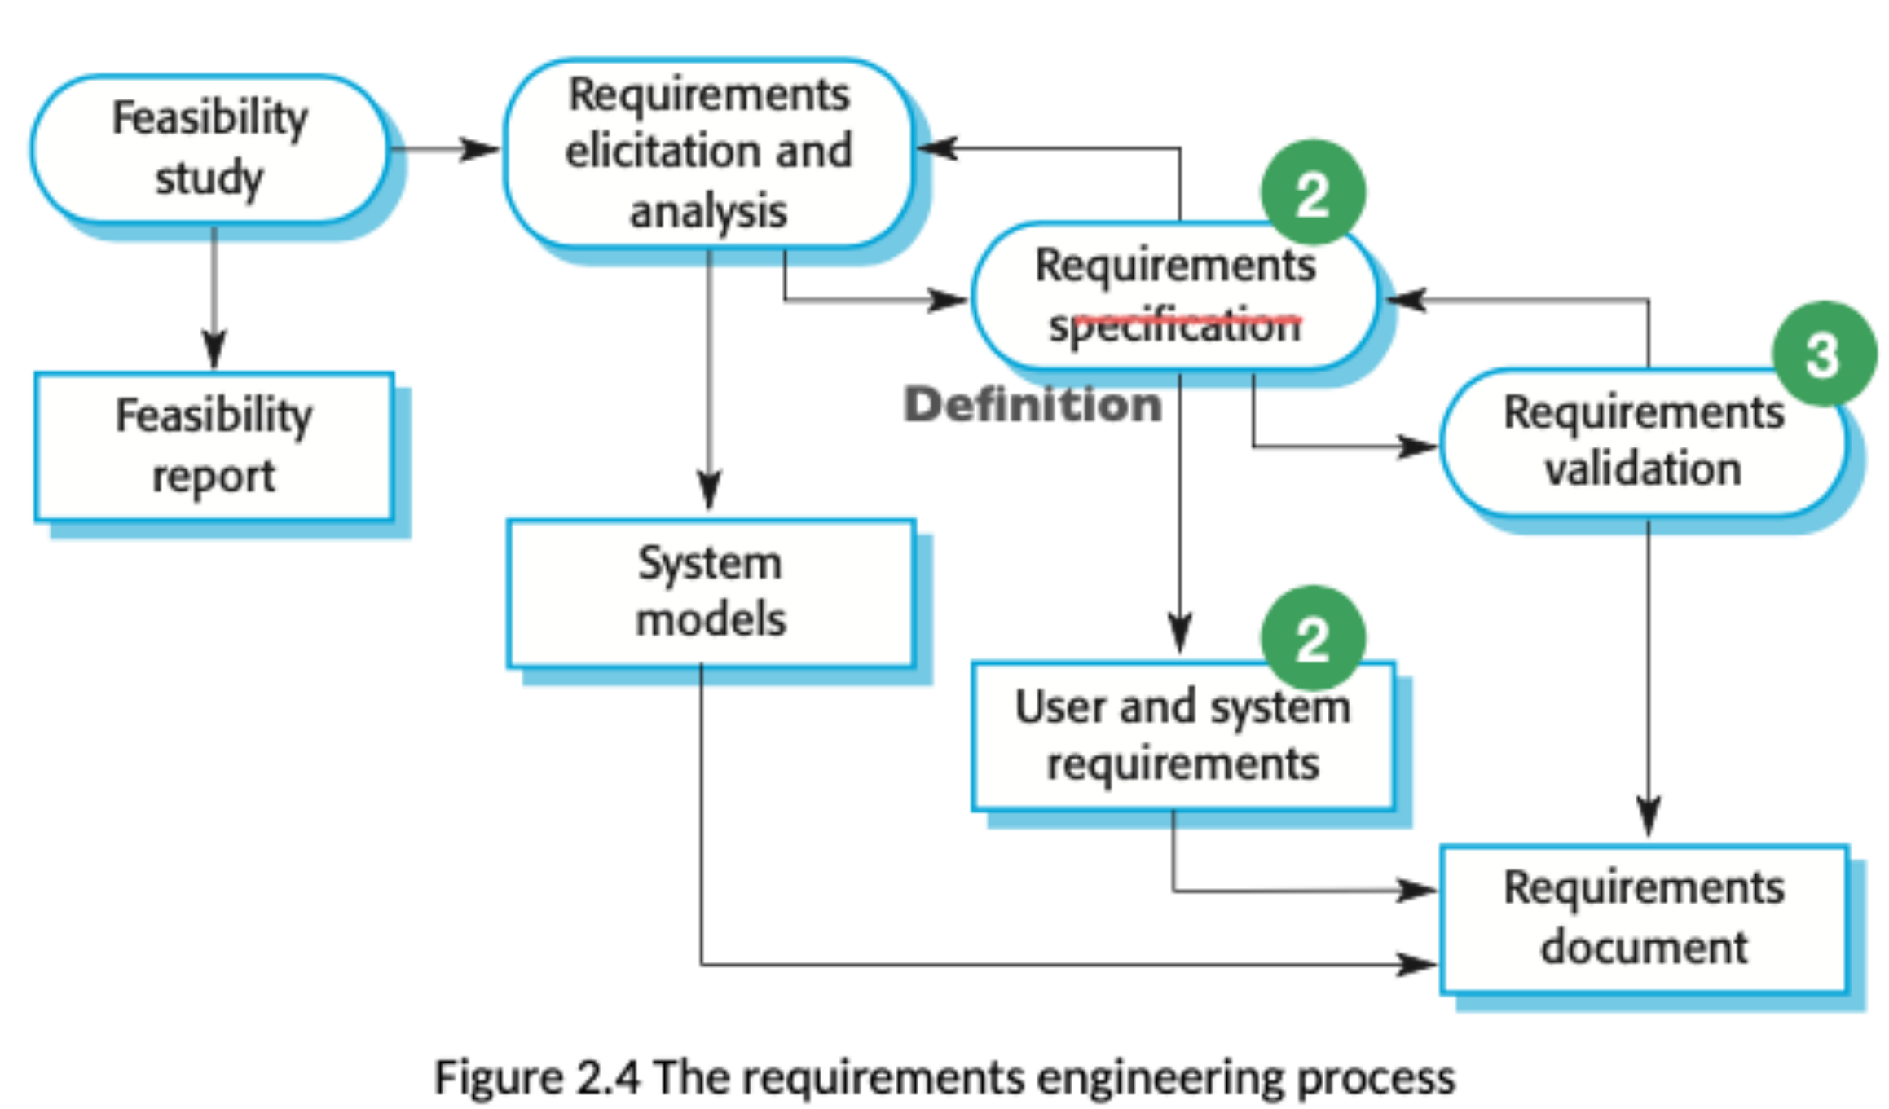

Examples of 1617 project

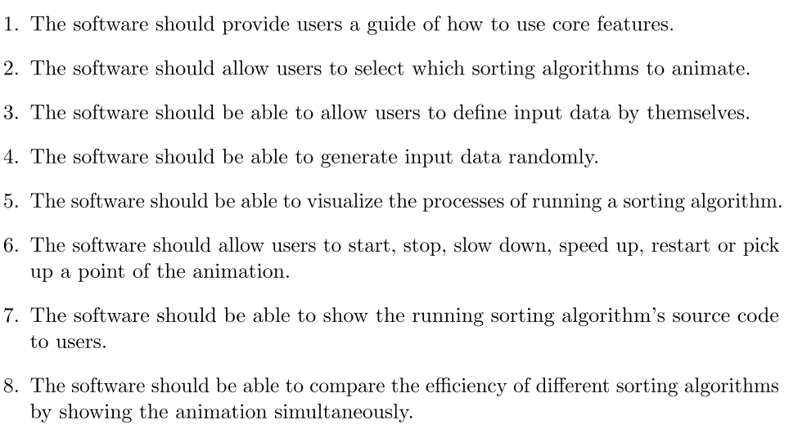

The software allows user to choose an algorithm to animate

The software allows user to change language of the software

The software allows user to take a beginner tutorial to learn how to use the software

The software allows user to start and pause the animation

The software allows user to control the animation step by step

The software allows user to take exercise by interacting with the software

The software allows user to see and copy code in several programming language

The software allows user to download a cheat sheet which displays basic idea of a particular algorithm

The software allows user to input an array

The software allows user to start lesson from the last time it exits

The software provides history of learning process