Questionnaire report

**Motivation**

**Objective**

1. Understand target user acquisition level of sorting algorithm and their learning habits.

2. Collect requirements from target users.

3. Test the user acceptance of functions we plan to design.

**Time**

From November 10th to November 12th.

**Respondent**

Students from the University of Nottingham, Ningbo, China.

**Questionnaire**

**Result**

This survey is about collecting user requirements of animated learning software for sorting algorithms. It was released by the Wenjuanxing platform. 1xx valid questionnaires were finally recovered. The results are as follows:

Question1. What's your gender?

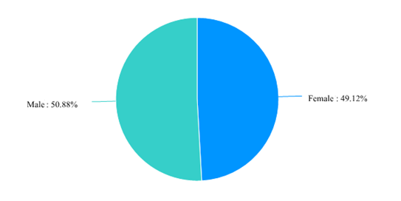

Fig1. The pie chart of results of question 1.

114 students from the University of Nottingham, Ningbo, China were investigated, among which 50.88% were male and 49.12% were female. The male to female ratio is about 1:1.

Question2. Which year are you in university?

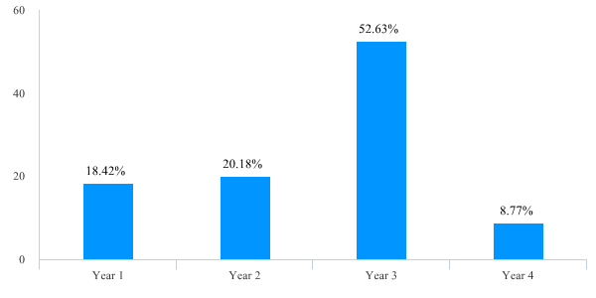

Fig2. The bar chart of results of question 2.

More than half of the participants were year three students, which is 52.63 percent. Second are from year 2 and year 1, accounting for 20.18% and 18.42% respectively. And 8.77% of those who filled in the questionnaire were year 4 students.

Question3. I learn algorithms because of:

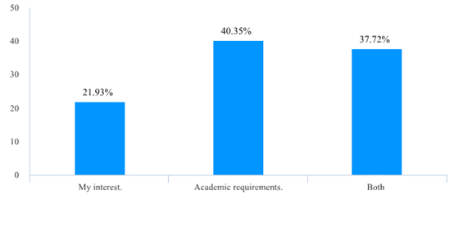

Fig3. The bar chart of results of question 3.

For the learning motivation, the proportion of studying out of interest and preparing for examination are both high. By contrast, students who learn sorting algorithms because of academic requirements are relatively more.

Question4. How well do you know about sorting algorithms? (The content of following questionnaire will be adjusted according to your answer)

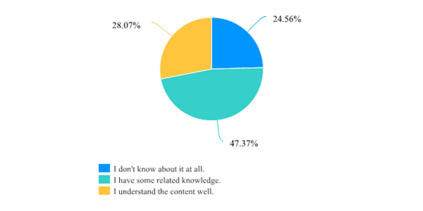

Fig4. The pie chart of results of question 4.

According to investigation result, most participants have some knowledge of sorting algorithms. However, there are 24.56% of participants choose that they do not know what is sorting algorithms at all. That reminds us to provide teaching module about basic concepts for beginners.

Question5. In your opinion, a software which helps learn algorithms should more focus on:

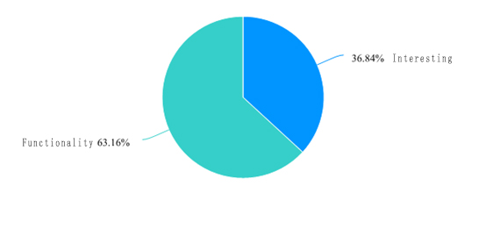

Fig5. The pie chart of results of question 5.

According to investigation result, 63.16% of the participants preferred useful learning functions rather than entertaining interactive functions. That means we may reduce some of the interactive game design and pay more attention to the functions which can provide more help for learning and understanding the algorithms.

Question6. How much time are you willing to spend each time using our software?

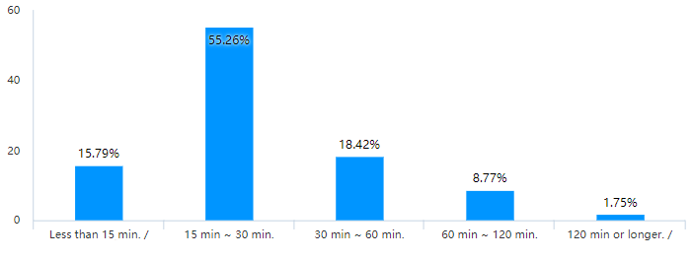

Fig6. The bar chart of results of question 6.

In general, the participants thought that within 60 minutes was acceptable for them to learn each time. More than half of the participants chose to spend 15-30 minutes each time. That reminds us that it is better to control the learning time of one single algorithm within about 30 minutes.

Question7. You learn algorithms or programming mainly by:

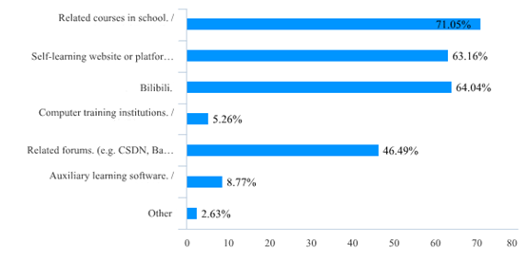

Fig7. The bar chart of results of question 7.

Obviously, in addition to the courses provided by the university, there are still a large number of students learning sorting algorithms on website platforms. It is worth noting that the video teaching software is very popular, which was chosen by 60% of students. Another 40% of participants preferred to discuss with others on the forum. It suggests that there is a vast market for our products. Moreover, we may provide the function that allows users to share their thoughts with others.

Question8. Which platform do you prefer to use this software (e.g. likes to use mobile terminal most, and computer terminal second, then1 iOS/Android, 2 PC/Mac...)

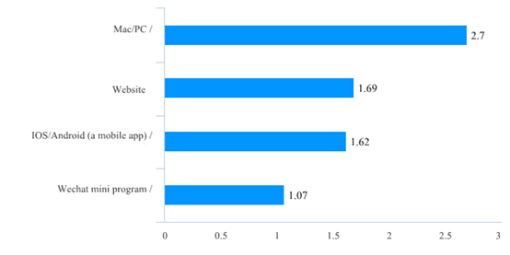

Fig8. The bar chart of results of question 8.

The investigation result demonstrates that more participants used to using similar learning software on the computer terminal. Second is the website terminal. This result may help us to decide our development platform.

Question9. What goal you want to achieve through learning:

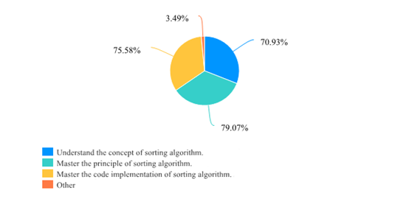

Fig9. The pie chart of results of question 9.

Question10. What language would you like to present the code?

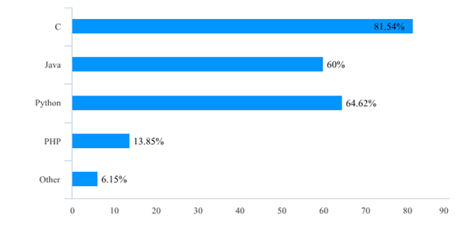

Fig10. The bar chart of results of question 10.

This question aims to collect the programming language preference of our target users. The result shows that the user demand for C, Java, and Python is relatively high.

Question11. Which following function do you prefer?

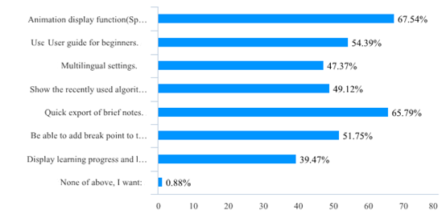

Fig11. The bar chart of results of question 11.

For the functions we envisioned, what the participants like best are the animation display function and exporting brief notes function. Second are the user guide and adding break points. Then, there are also lots of participants select multilingual settings function and recently used function. The result demonstrates that our envisioned functions can be acceptable to the users basically. Further, one participant proposed that he needed some practice problems after learning.

Question12. What other functions do you think the software should have? Are there anything we should pay attention to?

**Analysis and future work**

**综合分析**：

（问卷参与者基本信息概述）

本次问卷参与者均为unnc在读学生,其中xx%y1学生,xx%y2学生…….男女比例xx：xx……学习目的，对于排序算法了解程度。。。（基于前四题）

（重要结论总结及合理设计方案）

e.g. 1. 与软件趣味性相比，参与者更看中软件的功能性。

建议减少游戏机制，重点开发对用户学习帮助较大的相关功能。