Functional

1. A small balance under two bars being compared
2. First time enter the software, display “LANGUAGE” option waiting for user to set a language
3. At the main page, the software will display all available sorting algorithms as buttons. 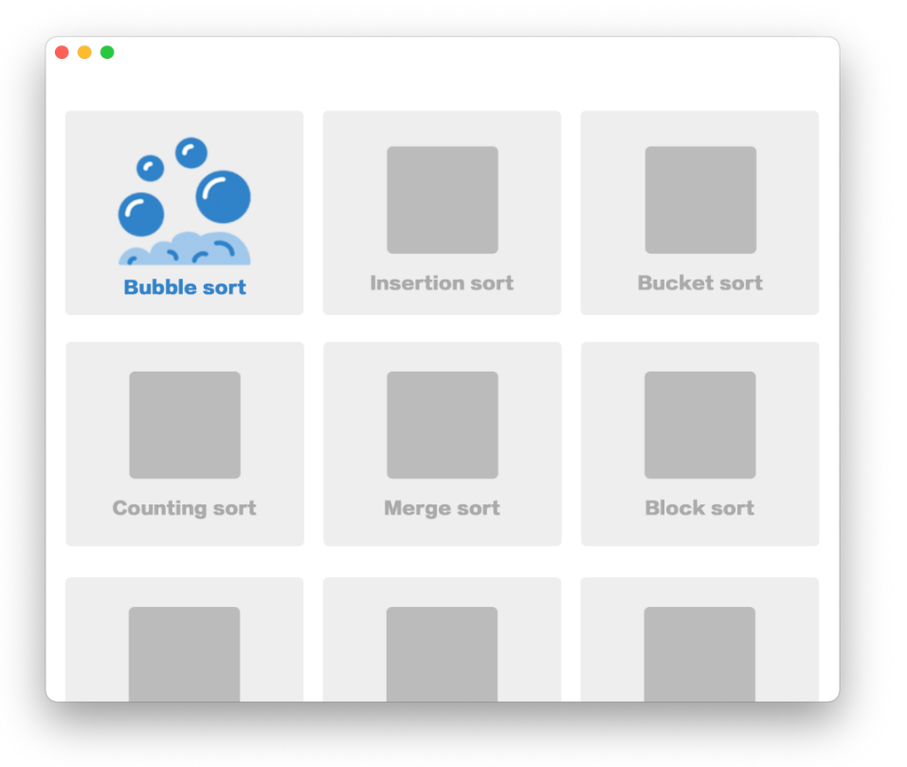
4. The icon will be animated to show basic idea of this algorithm once user hover on it
5. The first-time user clicks into one specific algorithm, a beginner tutorial will be activated. It will first introduce with automatic animation and subtitles. Then it will give an example which allow user to click “next” or “previous” to control the whole sorting process, what’s more, for each step, instructions will be given for guidance.

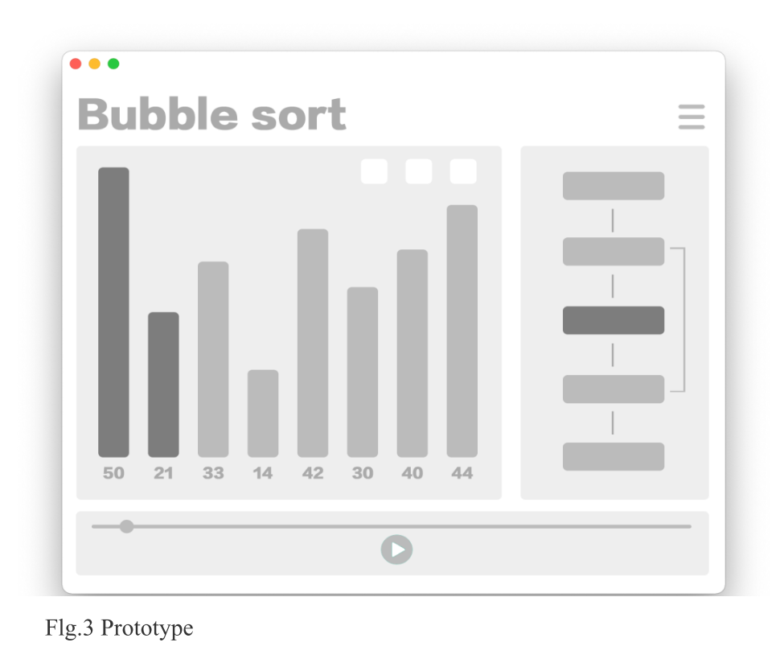

1. After the tutorial, a milestone is reached which means the user is basically know how this sorting algorithm works. A badge will be given with fancy animation to encourage user move on.
2. The next part is testing part. This part focuses on letting user repeatedly see and learn the whole process. Learn the algorithm from observation. In this part, user is allowed to press “previous” and “next” button for observing each step of sorting a random array. The users can also type in an array themselves for specific point they are confused about.
3. Another milestone is reached and another badge is given for encouragement
4. After this part, the user will enter a module, in which the user is able to drag bars themselves imitating the process done by the computer in the previous sections. The software will monitor each step of the user and give prompt when necessary.
5. The last part is pseudo code part. This part provides moulded pseudo code in almost correct order except one or two small mistakes for users to modify. After several successful trial, the software may provide all the possible module for user to construct the algorithm from scratch. This would be the final challenge.
6. User can get back to the main page at any point of the procedure, and the software will save the state for the next time user enter
7. User is able to choose a stage (tutorial, testing, etc.) after click one of the algorithm button. The latter ones can be unlocked by completing the previous ones.
8. User is able to switch language
9. User is able to switch background colour, e.g. Night mode, other colours can be unlocked by badges user earned from their practice.

Unfunctional

1. Multi-platform
2. Multi-language
3. Source code sharing

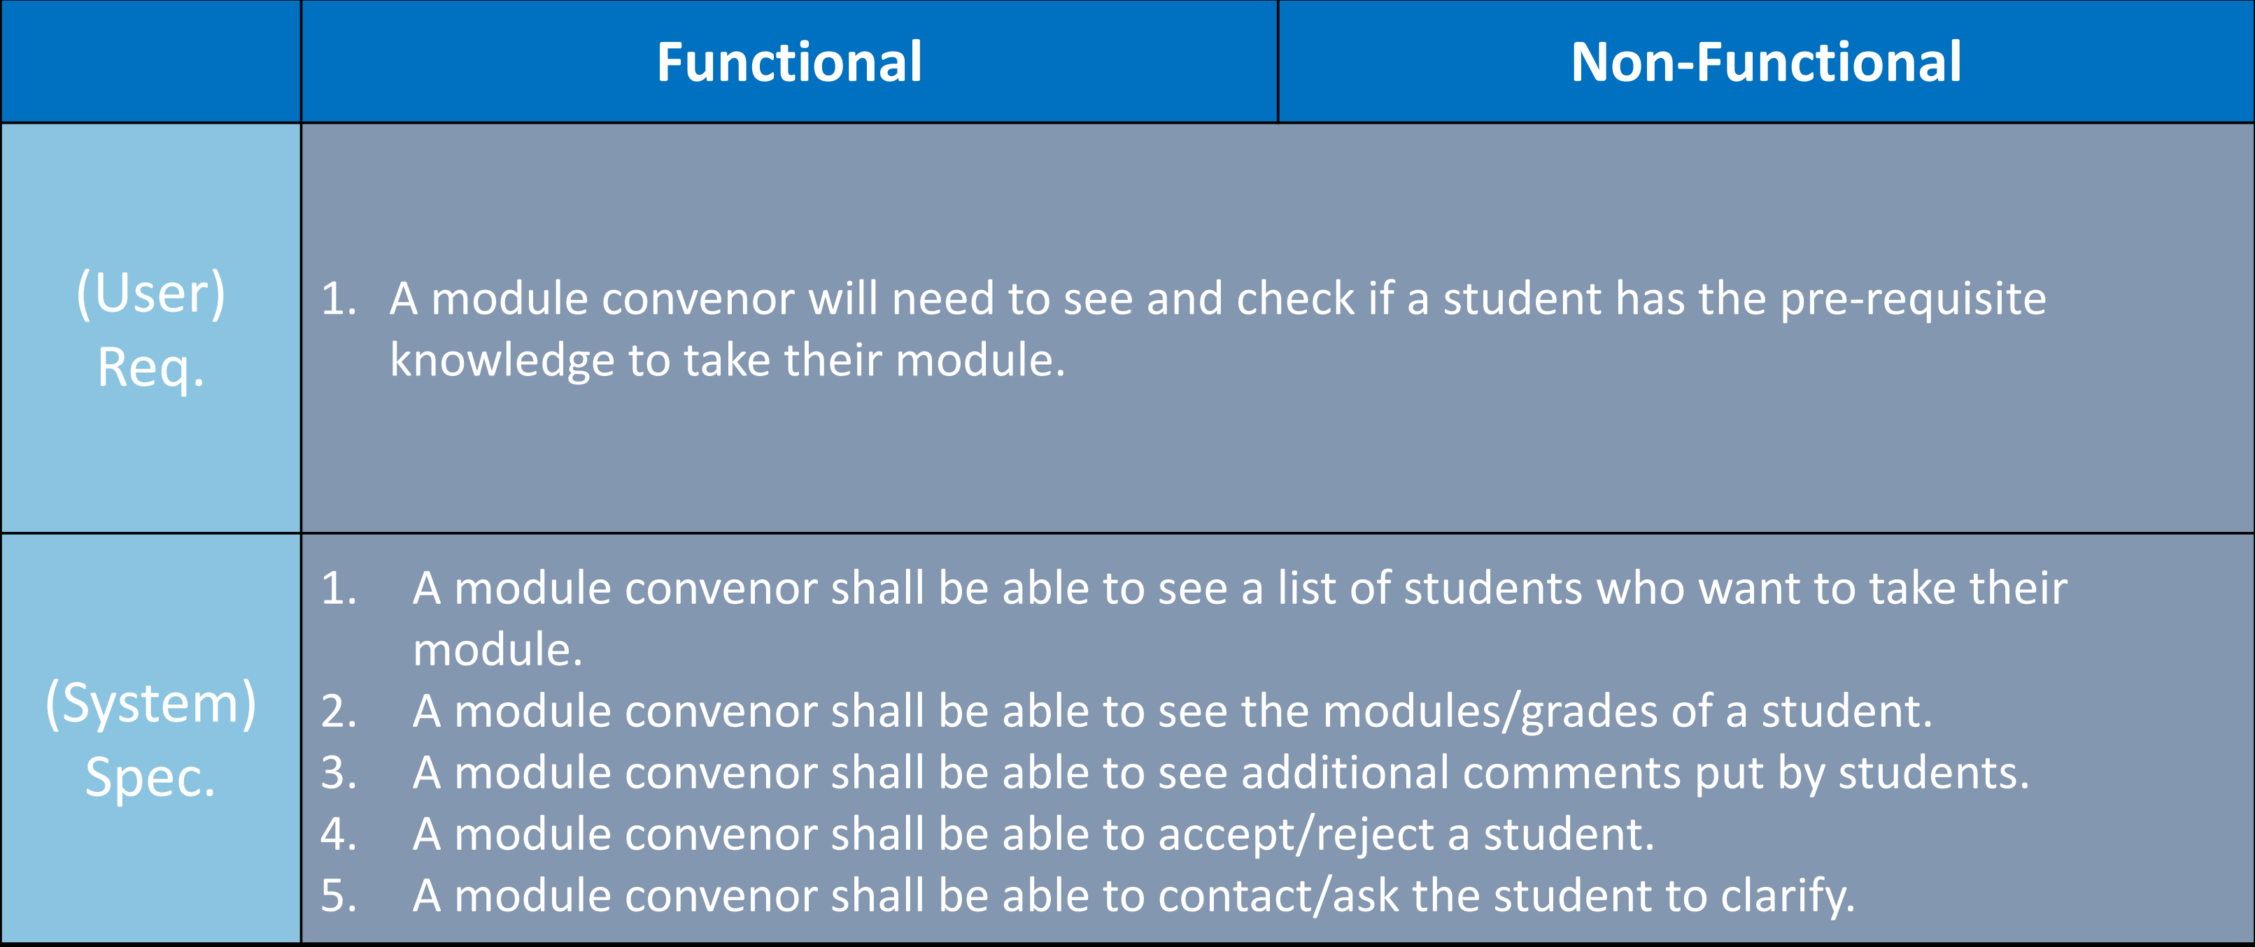

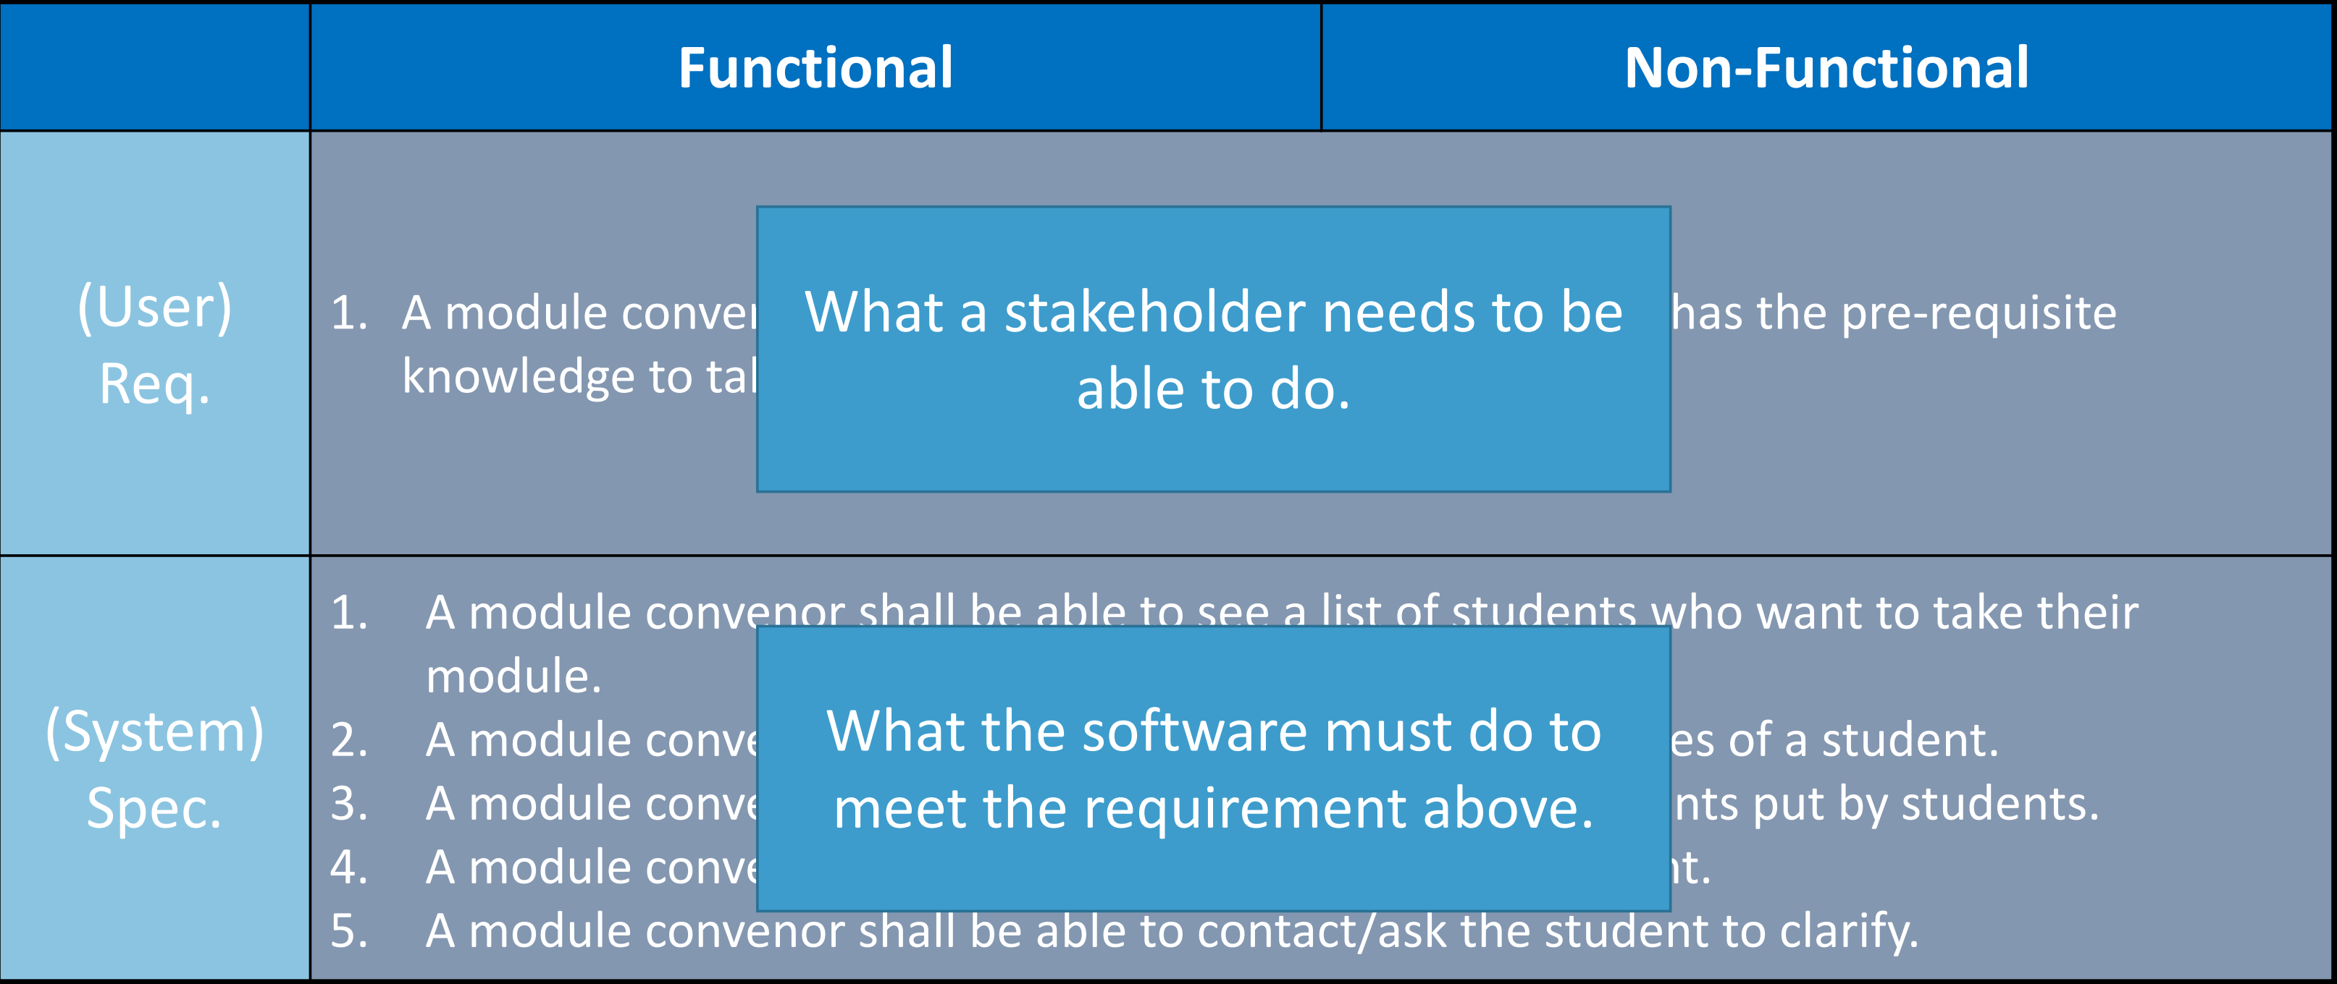

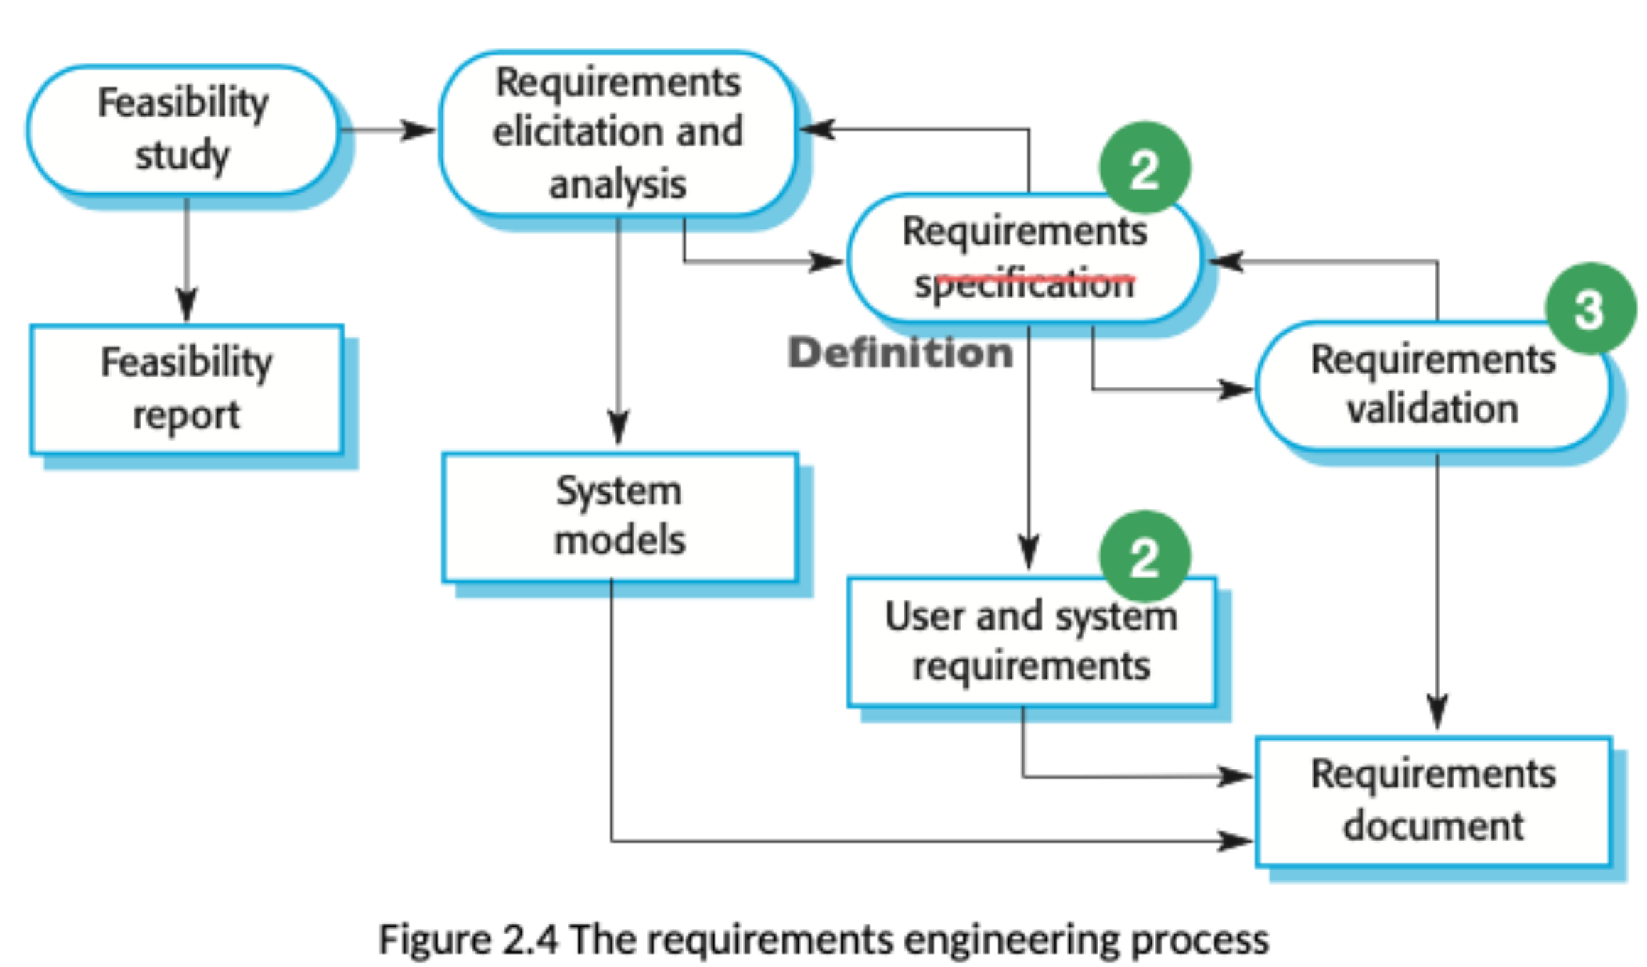

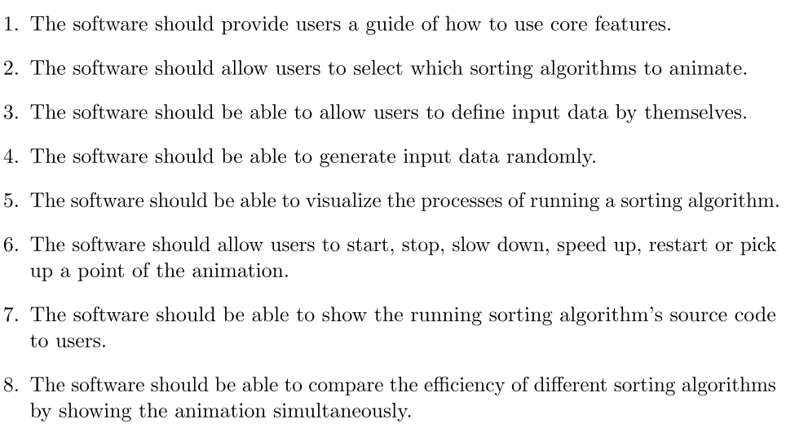

The software allows user to choose an algorithm to animate

The software allows user to change language of the software

The software allows user to take a beginner tutorial to learn how to use the software

The software allows user to start and pause the animation

The software allows user to control the animation step by step

The software allows user to take exercise by interacting with the software

The software allows user to see and copy code in several programming language

The software allows user to download a cheat sheet which displays basic idea of a particular algorithm

The software allows user to input an array

The software allows user to start lesson from the last time it exits

The software provides history of learning process