Sequence diagram description

This software provides user the most flexibility and the freedom of choice, so four small sequence diagrams are presented to show some beginning steps of each function part, instead of one diagram for the whole process.

Get in

Diagram[num] show the process when user open the software. According to user’s answer, customized page will be presented.

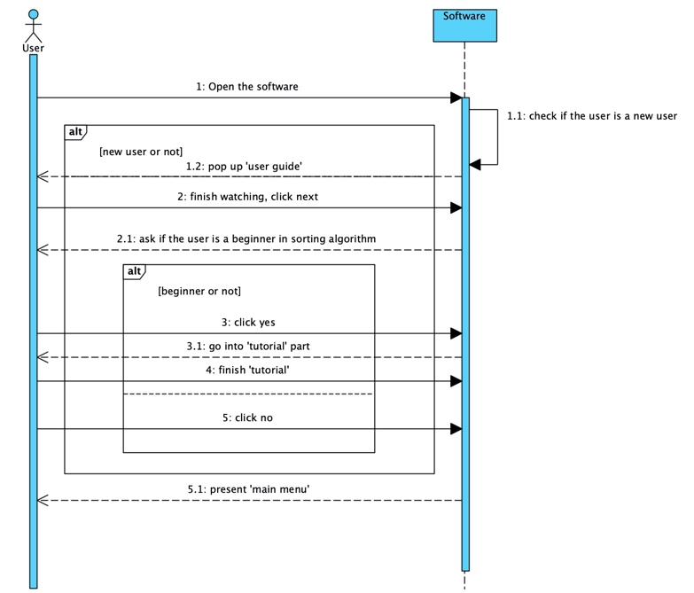

Animation:

Diagram[num] show the process when user enter “animation” page, and how they can use this function. After choosing a sorting algorithm, a simple front page will be presented with the algorithm’s brief introduction, then software will play the preset animation. After that, user can go to the “customized page”, where user can type in inputs they want.

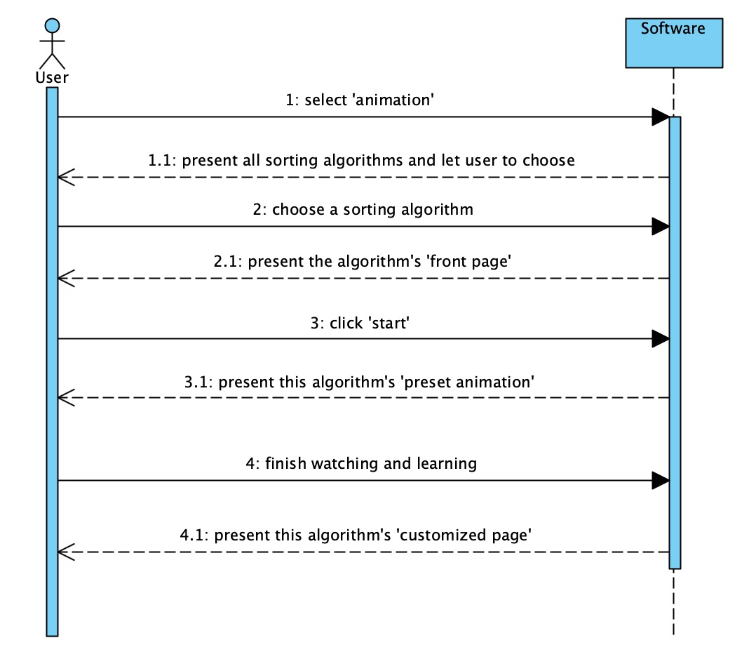

Efficiency

Diagram[num] show the process when user enter “efficiency” page, and how they can use this function. User should first select one or more sorting algorithms they want to learn and compare. According to user’s selection, different interfaces will be presented. “Efficiency page” means an introduction page of this algorithm’s efficiency. “Animation page” refers to one algorithm’s sorting animation. All selected algorithms’ animation page will be presented in the same stage, and they will start at same time and play with same speed.

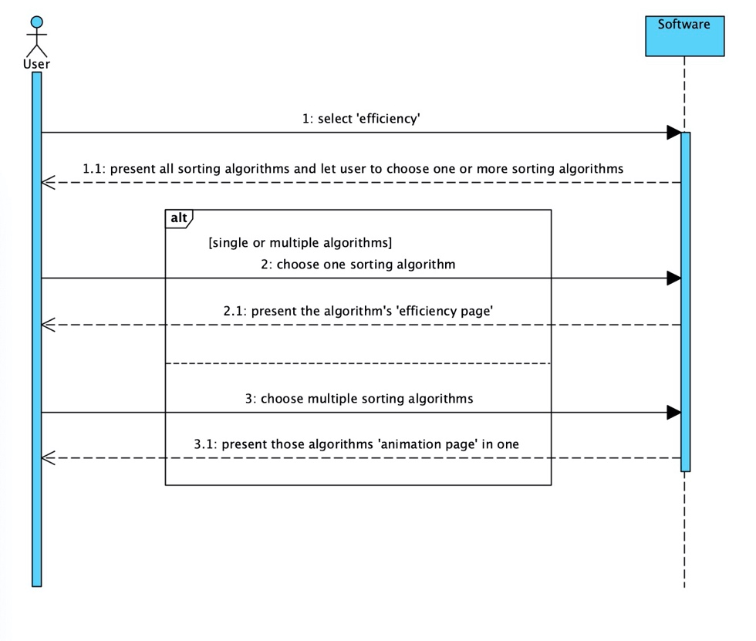

Correctness

Diagram[num] show the process when user enter “correctness” page, and how they can use this function. After choosing a sorting algorithm, “animation page” will be presented. User can choose inputs set from pre-defined legal and illegal inputs. Then the software will play the animation of selected inputs.

