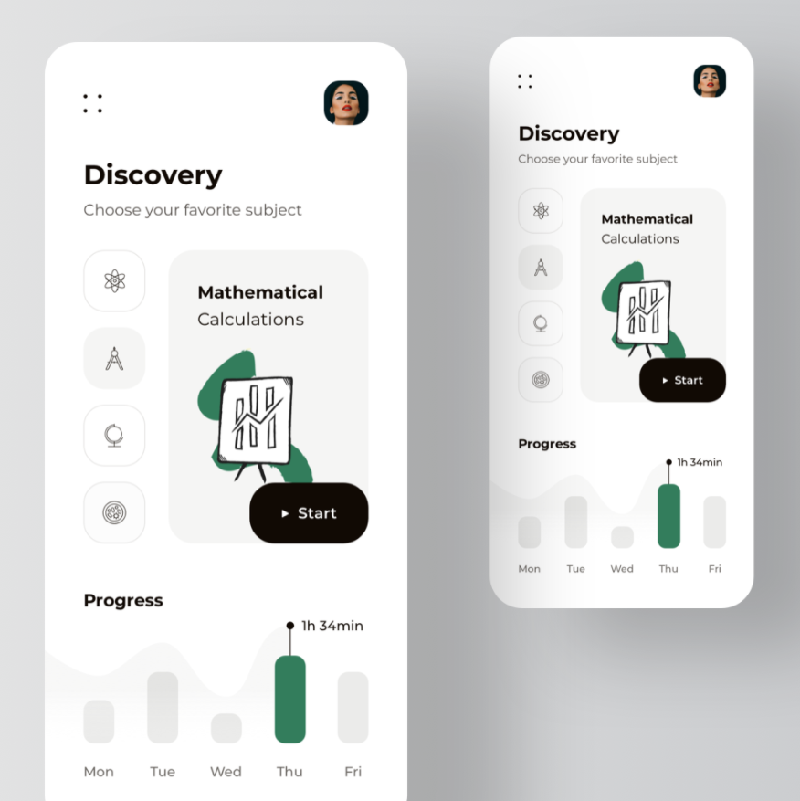

<https://dribbble.com/shots/14247562-MathOs-eLearning-Educational-Platform-Animation>

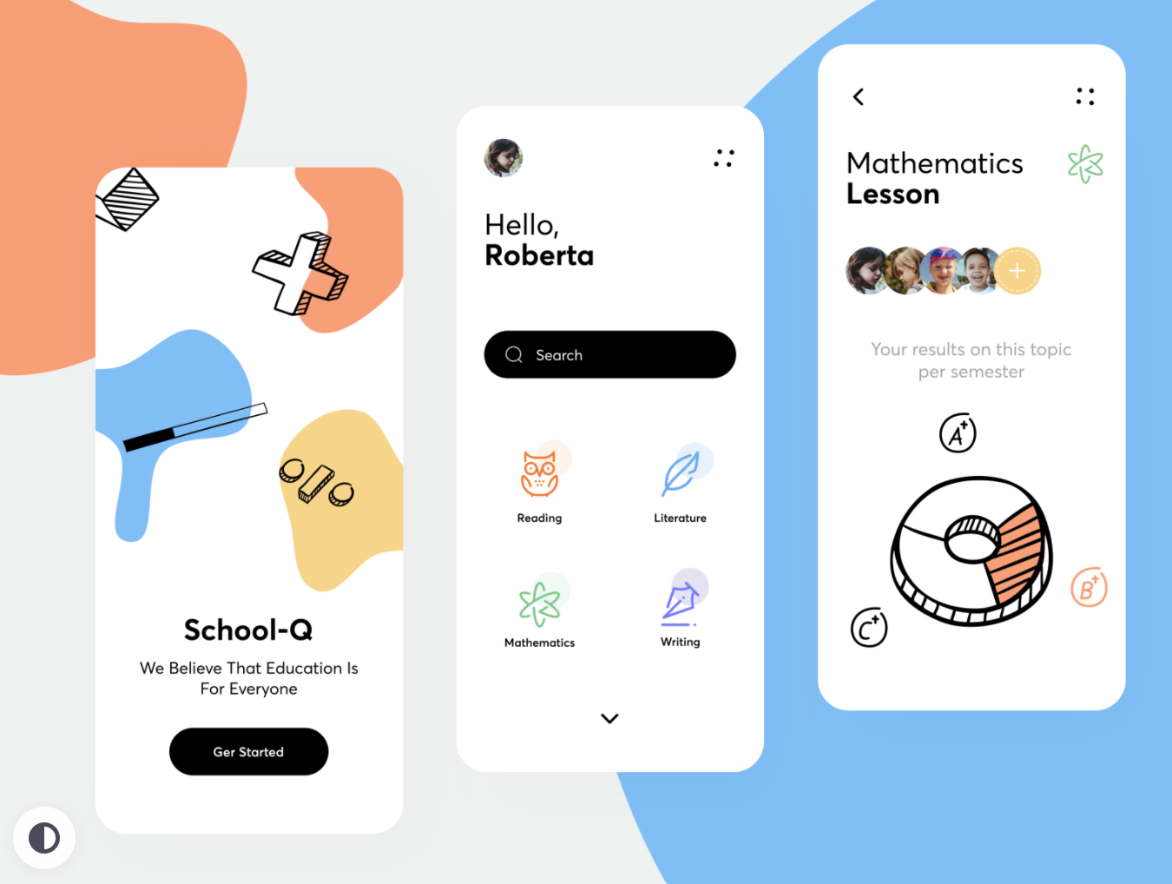

<https://dribbble.com/shots/14277717-Online-School-Q-App>

https://dribbble.com/shots/14007545-Distance-Learning-I

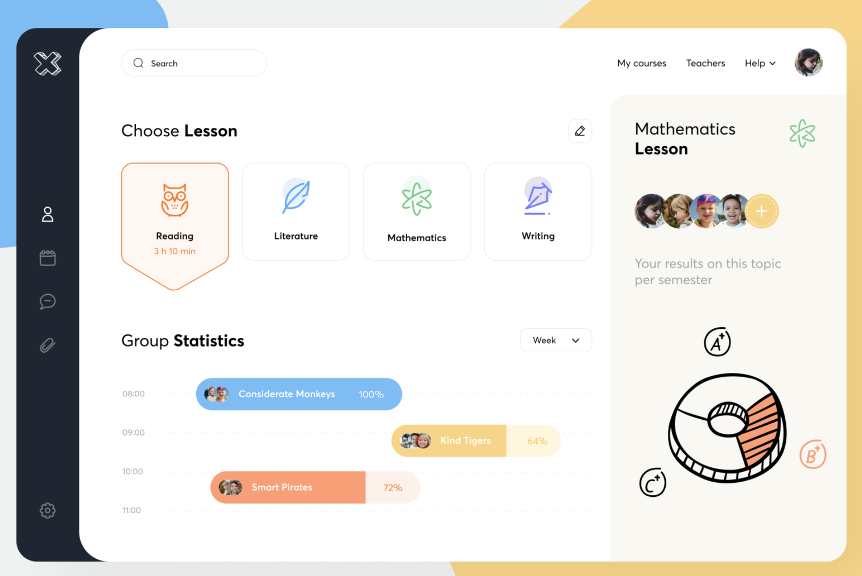

https://dribbble.com/shots/14407778-Online-School-Q-Dashboard