Software Requirements Specification (SRS)
Project: Traffic Management System (Simulation)
Version: 0.4 (Draft for review)
Authors: Khushi Gupta, Tarun Gowda P, Tejas Shetty
Date: 04-09-2026
Status: Draft

Revision History
Version | Date | Author | Change Summary
0.1 | 28-08-2026 | Khushi Gupta | Initial draft
0.2 | 01-09-2026 | Khushi Gupta | Added UML use-case diagrams (Section 7)
0.3 | 03-09-2026 | Khushi Gupta | Added Source/Stakeholder and Comments columns to FR tables and RTM, per template
0.4 | 04-09-2026 | Khushi Gupta | Added full team author details (Tarun Gowda P, Tejas Shetty) ahead of 50% milestone

Approvals
Role | Name | Signature/Email | Date
Course Coordinator

Table of Contents
1. Introduction
2. Overall Description
3. External Interface Requirements
4. System Features (detailed)
5. Non-Functional Requirements (detailed)
5.1 Robustness & Data-Integrity Requirements
6. Quality Attributes & Acceptance Tests
7. UML Use-Case Diagrams
8. Requirements Traceability Matrix (RTM)

1. Introduction

1.1 Purpose
This document specifies the functional and non-functional requirements for a Traffic Management System Simulation. It defines what the simulation must do, its interfaces, and the acceptance criteria used to verify it, for use by the development team, evaluators, and future maintainers.

1.2 Scope
The system simulates vehicle flow through one or more road intersections using queue-based data structures. It covers vehicle generation, per-lane queueing, fixed-timer and adaptive traffic-signal control, emergency-vehicle priority handling, multi-intersection coordination, and statistics reporting. It excludes real hardware integration, real GPS/map data, and real-world traffic-law enforcement.

1.3 Audience
Developers (team members), course instructor/evaluator, and QA reviewer (self/peer review).

1.4 Definitions
TMS: Traffic Management System. FIFO: First-In-First-Out. Queue: Linear data structure used per lane. Priority Queue: Queue where emergency vehicles are served ahead of normal vehicles. Tick: One discrete simulation time step. FR: Functional Requirement. NFR: Non-Functional Requirement.

2. Overall Description

2.1 Product Perspective
The TMS is a standalone console-based (or lightweight GUI) simulation application, self-contained with no external hardware or network dependency. It reads simulation parameters from a configuration file or startup prompts and runs entirely in-process.

2.2 Major Product Functions
- Generate vehicles at randomized intervals per lane
- Maintain a queue of waiting vehicles per lane
- Control traffic signals (fixed-timer and adaptive modes) per intersection
- Give emergency vehicles priority within their lane and preempt signals when needed
- Simulate two or more coordinated intersections
- Report wait time, queue length, and throughput statistics

2.3 User Roles and Characteristics
- End User / Evaluator: runs the simulation, observes console output and final report, does not need programming knowledge.
- Developer: configures simulation parameters, extends modules, maintains code.

2.4 Operating Environment
Runs as a native C/C++ console application on Linux or Windows, compiled with a C++17 (or C11) compliant compiler (g++/clang/MSVC). No special hardware required.

2.5 Constraints
Must be implemented in C or C++. Must use queue (and priority queue) data structures as the core mechanism for modeling traffic flow. Must run within standard desktop/lab hardware without GPU or special libraries.

3. External Interface Requirements

3.1 User Interfaces
Primary interface: text-based console output showing, per tick, each lane's queue length, current signal state (Red/Yellow/Green), and any emergency-vehicle alerts. A final summary report is printed at the end of the run. A simple GUI (optional, e.g., built with a lightweight library) may be added as a stretch goal.

3.2 Hardware Interfaces
None — this is a pure software simulation with no physical sensors, dispensers, or controllers.

3.3 Software Interfaces
Standard C/C++ Standard Library (queue, deque, priority_queue, random number generation). Optional: a config-file parser (plain text or simple key=value format) for simulation parameters.

3.4 Communications
Not applicable — the simulation is single-process and does not communicate over a network.

4. System Features (detailed)
Each requirement below has an ID of the form TMS-F-###, grouped by feature area.

4.1 Vehicle Generation & Arrival
Req ID | Requirement (shall...) | Type | Priority | Source / Stakeholder | Acceptance Criteria / Test Ref | Comments / Dependencies
TMS-F-001 | The system shall generate vehicles at randomized intervals following a configurable arrival rate, independently per lane. | Functional | High | Project Spec / Simulation Realism | Vehicles appear in the correct lane at rates matching the configured average over a long run. | Depends on RNG module
TMS-F-002 | The system shall assign each generated vehicle a unique ID, arrival timestamp (tick), and type (normal or emergency). | Functional | High | Design Decision (Team) | Every vehicle object has a unique, non-null ID/type/timestamp when created. | Requires Vehicle class
TMS-F-003 | The system shall enqueue each generated vehicle into its lane's queue in FIFO order. | Functional | High | Project Spec (Queue-based requirement) | Vehicles dequeue in the same order they were enqueued for a given lane. | Depends on LaneQueue class

4.2 Lane Queue Management
Req ID | Requirement (shall...) | Type | Priority | Source / Stakeholder | Acceptance Criteria / Test Ref | Comments / Dependencies
TMS-F-010 | The system shall maintain one independent queue data structure per lane per intersection. | Functional | High | Project Spec (Queue-based requirement) | Each lane's queue state is independent; enqueue/dequeue on one lane does not affect another. | Core data structure
TMS-F-011 | The system shall enforce a configurable maximum capacity per lane queue; vehicles arriving to a full lane shall be logged as blocked/dropped rather than crash the system. | Functional | High | Robustness (PRJ-SR-004) | Attempting to enqueue beyond capacity logs a blocked event and does not corrupt state. | Linked to PRJ-SR-004
TMS-F-012 | The system shall dequeue a vehicle from a lane only while that lane's signal is Green. | Functional | High | Design Decision (Team) | No dequeue events occur while a lane's signal is Red or Yellow. | Depends on SignalController
TMS-F-013 | The system shall record each vehicle's wait time as (dequeue tick − arrival tick). | Functional | Medium | Statistics Requirement | Recorded wait time matches the difference between logged arrival and dequeue ticks. | Feeds Stats module

4.3 Traffic Signal Control
Req ID | Requirement (shall...) | Type | Priority | Source / Stakeholder | Acceptance Criteria / Test Ref | Comments / Dependencies
TMS-F-020 | The system shall implement a fixed-timer signal cycle (Green → Yellow → Red) with configurable durations per lane group as the default mode. | Functional | High | Project Spec / Instructor Baseline | Signal phases change at the configured intervals in the default mode. | Default mode
TMS-F-021 | The system shall support an adaptive signal mode where Green duration extends proportionally to current queue length, up to a configured maximum. | Functional | Medium | Team Design Decision (Stretch Goal) | Longer queues measurably receive longer Green durations, bounded by the configured max. | Optional mode; toggled via config
TMS-F-022 | The system shall ensure only one non-conflicting direction (or conflict-free set) is Green at any tick. | Functional | High | Safety / Correctness | No two conflicting lanes are simultaneously Green during a run. | Core correctness rule
TMS-F-023 | The system shall transition through a configurable-duration Yellow phase before switching a lane from Green to Red. | Functional | Medium | Project Spec / Realism | Every Green-to-Red transition passes through Yellow for the configured duration. | None
TMS-F-024 | The system shall allow switching between fixed-timer and adaptive mode via configuration, without code changes. | Functional | Medium | Maintainability (TMS-NF-003) | Changing a config value alone changes the active signal mode on next run. | Linked to TMS-NF-003

4.4 Emergency Vehicle Priority
Req ID | Requirement (shall...) | Type | Priority | Source / Stakeholder | Acceptance Criteria / Test Ref | Comments / Dependencies
TMS-F-030 | The system shall mark a generated vehicle as "emergency" type with a configurable probability. | Functional | Medium | Team Design Decision (Stretch Goal) | Emergency vehicles appear at approximately the configured rate over a long run. | Depends on Vehicle Generator
TMS-F-031 | The system shall use a priority mechanism so emergency vehicles are dequeued ahead of normal vehicles within the same lane. | Functional | High | Team Design Decision (Stretch Goal) | An emergency vehicle enqueued after normal vehicles is still dequeued first. | Requires priority_queue
TMS-F-032 | The system shall preempt the current signal cycle to grant Green to a lane holding a waiting emergency vehicle, within a configurable max preemption delay. | Functional | High | Team Design Decision (Stretch Goal) | Emergency-holding lane turns Green within the configured delay bound, logged as a preemption event. | Depends on SignalController

4.5 Multi-Intersection Coordination
Req ID | Requirement (shall...) | Type | Priority | Source / Stakeholder | Acceptance Criteria / Test Ref | Comments / Dependencies
TMS-F-040 | The system shall support simulating two or more independent intersections concurrently within a single run. | Functional | High | Team Design Decision (Stretch Goal) | A run configured with N ≥ 2 intersections maintains independent state for each. | Scales core engine
TMS-F-041 | The system shall support an optional link where a vehicle exiting one intersection is enqueued into an adjacent intersection's inbound lane ("green wave"). | Functional | Medium | Team Design Decision (Stretch Goal) | Vehicles exiting a linked lane appear in the downstream intersection's queue on the next tick. | Depends on TMS-F-040
TMS-F-042 | The system shall track and report per-intersection statistics independently as well as aggregated system-wide totals. | Functional | Medium | Statistics Requirement | Final report shows both per-intersection and combined totals that sum correctly. | Feeds Stats module

4.6 Statistics & Reporting
Req ID | Requirement (shall...) | Type | Priority | Source / Stakeholder | Acceptance Criteria / Test Ref | Comments / Dependencies
TMS-F-050 | The system shall compute and report average wait time per lane and overall at the end of a run. | Functional | High | Evaluation Requirement | Reported averages match manual calculation from logged wait times for a test run. | Depends on TMS-F-013
TMS-F-051 | The system shall compute and report the maximum queue length observed per lane during the run. | Functional | Medium | Evaluation Requirement | Reported max matches the highest queue length logged during the run. | None
TMS-F-052 | The system shall compute and report total throughput (vehicles fully processed) per intersection. | Functional | Medium | Evaluation Requirement | Reported throughput equals count of dequeue events per intersection. | None

4.7 Simulation Control & Configuration
Req ID | Requirement (shall...) | Type | Priority | Source / Stakeholder | Acceptance Criteria / Test Ref | Comments / Dependencies
TMS-F-060 | The system shall allow configuration of arrival rates, signal durations, number of intersections, and run length via a config file or startup input. | Functional | High | Project Spec / Usability | Changing config values changes corresponding simulation behavior without recompiling. | Requires config parser
TMS-F-061 | The system shall allow the user to start and cleanly terminate a run, producing a summary report at termination (normal end or user-requested stop). | Functional | High | Project Spec / Usability | Every completed or stopped run ends with a printed summary report and clean exit (no crash). | Depends on TMS-F-050 to 052

5. Non-Functional Requirements (detailed)
IDs follow TMS-NF-###.
Req ID | Requirement (shall...) | Type | Priority | Acceptance Criteria / Test Ref
TMS-NF-001 | The simulation shall process at least 500 simulated ticks per second on standard development hardware for up to 4 intersections. | Performance | High | Measured tick-processing rate ≥ 500/sec in a benchmark run. Test: TC-Perf-01
TMS-NF-002 | The simulation shall run 10,000+ consecutive ticks without crashing or leaking memory. | Reliability | High | A 10,000-tick run completes with clean exit; Valgrind/ASan reports no leaks. Test: TC-Rel-01
TMS-NF-003 | The codebase shall be modular (separate files/classes per module: Vehicle, Lane, Signal, Intersection, Engine, Stats) so a new topology can be added via config, not core-code changes. | Maintainability | Medium | Adding an intersection via config requires no edits to core engine files. Test: TC-Maint-01
TMS-NF-004 | Console output shall clearly display current tick, per-lane queue lengths, and active signal state at a readable refresh interval. | Usability | Medium | Manual review confirms output is legible and updates at the configured interval. Test: TC-UX-01
TMS-NF-005 | The code shall compile and run on both Linux and Windows using standard C++17 (or C11) without platform-specific dependencies. | Portability | Medium | Successful build and run on both a Linux and a Windows machine/VM. Test: TC-Port-01

5.1 Robustness & Data-Integrity Requirements
Note: this project has no network/user-account attack surface, so the template's "security" section is scoped instead to software robustness and data integrity — protecting the simulation from crashing or producing corrupt results due to invalid input or resource limits.

5.1.1 Objectives
- Prevent undefined behavior or memory corruption caused by invalid or out-of-range configuration input.
- Keep simulation state consistent — no vehicle is lost, duplicated, or double-counted under any valid input condition.
- Prevent resource exhaustion (unbounded queue growth) from crashing or hanging the simulation.

5.1.2 Robustness Requirements
Req ID | Requirement (shall...) | Type | Priority | Acceptance Criteria / Test Ref
PRJ-SR-001 | All array/queue index and pointer operations shall be bounds-checked; no unchecked raw pointer arithmetic. | Robustness | High | Code review + ASan run finds no out-of-bounds access.
PRJ-SR-002 | All user-supplied configuration values shall be validated against safe ranges before use; invalid values are rejected with a clear error message. | Robustness | High | Feeding out-of-range/malformed config values produces a handled error, not a crash.
PRJ-SR-003 | Dynamic memory shall be managed via RAII/smart pointers (C++) or strictly paired malloc/free (C), with zero leaks under Valgrind. | Robustness | High | Valgrind run on a full simulation reports zero leaked bytes.
PRJ-SR-004 | Lane queues shall strictly enforce configured max capacity; overflow attempts are rejected/logged, never causing a crash or silent data loss elsewhere. | Robustness | High | Forcing overflow via a high arrival rate logs blocked events and the program keeps running.
PRJ-SR-005 | The system shall not terminate abnormally (segfault/unhandled exception) on malformed input; all errors are caught and logged. | Robustness | High | Feeding malformed config/input files results in a graceful error message, not a crash.

6. Quality Attributes & Acceptance Tests
Exit criteria for acceptance: all High-priority functional requirements implemented and verified, no critical NFR/robustness failures, and the RTM shows all test cases passed.
Acceptance test suites: Vehicle Generation, Queue Management, Signal Control (fixed + adaptive), Emergency Priority, Multi-Intersection, Statistics, and Robustness/Stress tests.

7. UML Use-Case Diagrams

7.1 Use Case Diagram 1 — Run Simulation
Actor: User. Covers configuring parameters (with input validation included), starting/pausing/resuming a run, viewing live output, and stopping the run with an included summary report.
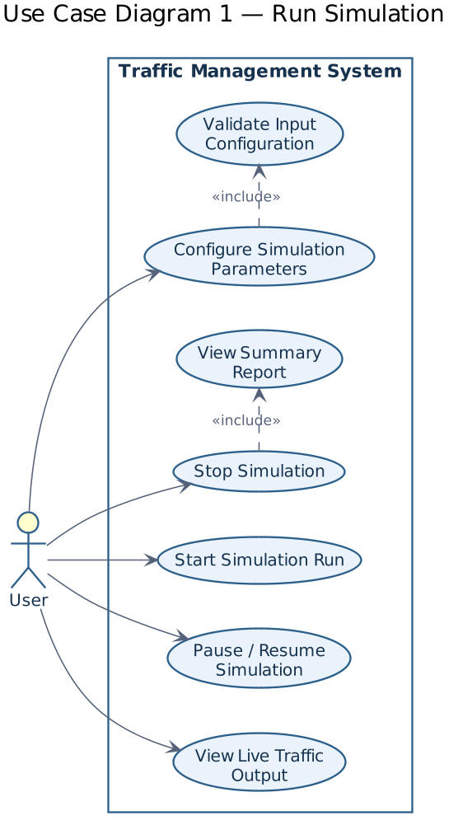

7.2 Use Case Diagram 2 — Handle Emergency Vehicle
Actor: Simulation Engine (system-triggered, not a human actor). Covers detecting an emergency vehicle, prioritizing it in its lane queue, preempting the active signal, logging the preemption event, and resuming the normal signal cycle.
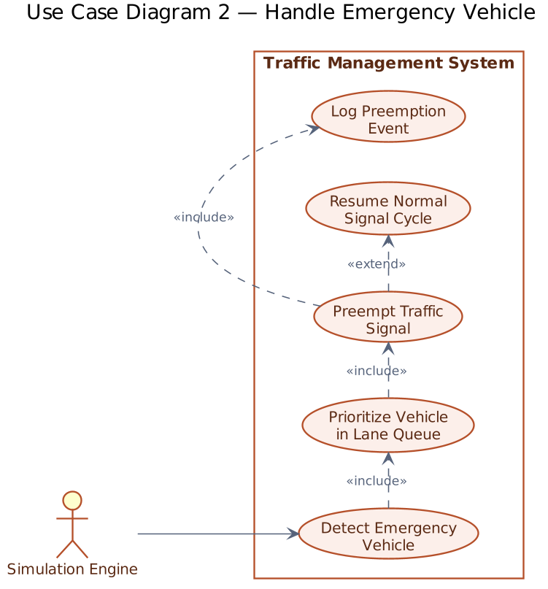

8. Requirements Traceability Matrix (RTM)
Req ID | Requirement (short) | Design Spec Ref | Module | Test Case(s) | Status (N/P/A) | Comments
TMS-F-003 | Enqueue vehicle FIFO | DS-Queue-01 | LaneQueue | TC-Queue-01 | N | Core requirement
TMS-F-020 | Fixed-timer signal cycle | DS-Signal-01 | SignalController | TC-Sig-01 | N | Default mode
TMS-F-031 | Emergency priority dequeue | DS-Priority-01 | LaneQueue | TC-Emg-01 | N | Stretch goal
TMS-NF-002 | No crash / leak over 10k ticks | DS-Engine-01 | SimulationEngine | TC-Rel-01 | N | Run via Valgrind
PRJ-SR-004 | Queue overflow handled safely | DS-Queue-01 | LaneQueue | TC-Rob-01 | N | Robustness check

Note: RTM to be completed in full once all test cases are finalized in the Test Plan (due Sept 15).

