Software Architecture and Design Specification (SAD)
Project: Traffic Management System (Simulation)
Version: 0.3 (Complete draft — all template sections)
Authors: Khushi Gupta, Tarun Gowda P, Tejas Shetty
Date: 29-08-2026
Status: Draft

Revision History
Version | Date | Author | Change Summary
0.1 | 27-08-2026 | Tarun Gowda P | Initial architecture draft: core 4-module design, high-level diagram (text form), 2 workflows (text form), C++ interfaces for LaneQueue and SignalController.
0.2 | 28-08-2026 | Tejas Shetty | Reviewed and refined the LaneQueue and SignalController class interfaces against the SRS; confirmed the emergency-vehicle priority mechanism and signal-preemption logic (TMS-F-030 to 032) so the design matches the module he owns (Data Models, LaneQueue.cpp, SignalController.cpp).
0.3 | 29-08-2026 | Khushi Gupta | Completed all remaining template sections (Document Overview, Stakeholders, Constraints, Tech Stack, Risks, Traceability, Security/Robustness Architecture, Design Overview, Error Handling, UX Design, Open Issues, Appendices). Added ConsoleView and Multi-Intersection support to the architecture. Replaced text-only diagrams with rendered UML class and sequence diagrams. Corrected date/status/author-name inconsistencies.

Approvals
Role | Name | Signature/Date
Course Coordinator

1. Introduction

1.1 Purpose
This document specifies the software architecture and detailed design of the Traffic Management System (TMS) Simulation. It explains how the C++ modules interact, how data flows through the discrete-tick simulation loop, and how the design satisfies the requirements defined in the SRS.

1.2 Scope
Covers the internal architecture of a single-process C++ console simulation: vehicle generation, per-lane FIFO queues with emergency priority, fixed-timer and adaptive traffic-signal control across one or more intersections, live console output, and end-of-run statistics reporting. Excludes any real hardware, networked, or GUI-based implementation.

1.3 Audience
Development team (Khushi Gupta, Tarun Gowda P, Tejas Shetty), course instructor/evaluator, and QA reviewer (self/peer review).

1.4 Definitions
TMS: Traffic Management System. FIFO: First-In-First-Out. Tick: one discrete simulation time step. RAII: Resource Acquisition Is Initialization (C++ memory-safety idiom). STL: Standard Template Library. FR/NFR: Functional/Non-Functional Requirement.

2. Document Overview

2.1 How to Use This Document
Section 3 (Architecture) describes the system at a component level: goals, constraints, stakeholders, the class diagram, and how components trace back to SRS requirements. Section 4 (Design) goes one level deeper: sequence diagrams for key workflows, class interfaces, and cross-cutting concerns like error handling and UX. Section 5 lists supporting reference material.

2.2 Related Documents
Software Requirements Specification (SRS) v0.4 — defines the TMS-F-###, TMS-NF-###, and PRJ-SR-### requirements referenced throughout this document. Software Test Plan (STP) — to be written against the modules and interfaces defined here.

3. Architecture

3.1 Goals & Constraints
Goals:
- Modularity — vehicle generation, queueing, signal control, statistics, and console output live in separate, independently testable C++ classes.
- Memory safety — RAII and STL containers only; zero leaks over long runs (supports TMS-NF-002).
- Deterministic execution — a single synchronized tick loop, no multi-threading, so runs are reproducible and easy to debug/test.
- Meet performance targets — process at least 500 ticks/second (TMS-NF-001).
Constraints:
- Must be implemented in C++17, using only the Standard Library (no external GUI or database dependencies).
- Console-only output — no GUI framework in the baseline scope.
- Single-threaded — no concurrency, to keep behavior deterministic and testable within the team's timeline.
- Must build and run on both Linux and Windows on standard lab/desktop hardware (TMS-NF-005).
- Three-person team, course deadlines: SRS (Sept 6), 50% working-prototype milestone, Test Plan (Sept 15).

3.2 Stakeholders & Concerns
Stakeholder | Primary Concerns
Course Instructor / Evaluator | Correctness against the SRS, code quality, completeness and clarity of documentation.
Development Team | Maintainability, clear module boundaries so each member can build/test independently before integration.
End User (person running the simulation) | Readable live output, accurate and trustworthy statistics.
Future Maintainers | Extensibility — e.g., adding a new intersection topology without touching core engine code (TMS-NF-003).

3.3 Component (UML) Diagram
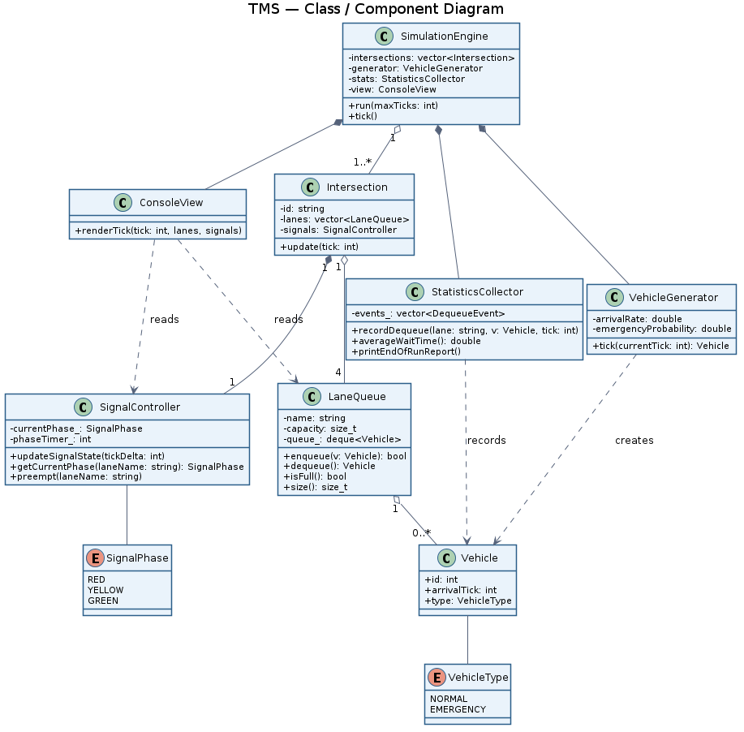

3.4 Component Descriptions
Component | C++ Class | Responsibilities
Simulation Engine | SimulationEngine | Owns the tick loop; coordinates every other module once per tick (TMS-F-060/061).
Intersection | Intersection | Groups one SignalController with its lane queues; multiple instances enable multi-intersection runs (TMS-F-040/041).
Vehicle Generator | VehicleGenerator | Spawns Vehicle objects per lane based on configurable arrival and emergency probabilities (TMS-F-001/002/030).
Lane Queue | LaneQueue | FIFO queue per lane with emergency-priority handling; enforces capacity and logs blocked vehicles (TMS-F-010/011/031).
Signal Controller | SignalController | Manages the 3-phase signal cycle; supports emergency preemption (TMS-F-020 to 024, TMS-F-032).
Statistics Collector | StatisticsCollector | Records dequeue events; computes wait time and throughput, per-lane and aggregated (TMS-F-013, TMS-F-050 to 052).
Console View | ConsoleView | Renders live per-tick lane/signal state and the end-of-run report (TMS-NF-004).

3.5 Chosen Architecture Pattern and Rationale
A Synchronous Tick-Driven Modular Architecture was chosen: a single tick loop in SimulationEngine drives every module in a fixed order each step. This was chosen over a multi-threaded or event-driven design because it keeps state changes fully deterministic and reproducible — important both for debugging and for writing repeatable test cases — and avoids race-condition risk that a three-person team would have limited time to debug. A more elaborate event-driven architecture was considered and rejected as unnecessary complexity for a course-scale simulation.

3.6 Technology Stack & Data Stores
Implemented in standard C++17 using only the STL (std::deque, std::queue/priority_queue, std::vector, std::map). No external database — all simulation state lives in memory for the duration of a run. Configuration is read from a plain-text config file or startup prompt. Built with g++ (MinGW on Windows) and GNU Make. Output is console text via std::cout; no GUI library is used in the baseline scope.

3.7 Risks & Mitigations
Risk | Mitigation
Memory leaks or undefined behavior over long runs | RAII, STL containers only, 10,000-tick Valgrind/ASan stress test (TMS-NF-002, PRJ-SR-003).
Integration mismatch between modules (e.g., LaneQueue interface vs. ConsoleView's assumptions) | Interfaces fixed in Section 4.3 as the shared contract; agreed before implementation, not after.
Team members blocked waiting on each other's modules | Mock/stub headers used so each member develops and tests independently, then swaps in real headers at integration.
Underestimating time for adaptive signal mode / multi-intersection stretch goals | Baseline (fixed-timer, single intersection) implemented and stable first; stretch features layered on incrementally.

3.8 Traceability to Requirements
Requirement(s) | Component(s)
TMS-F-001 to 003 (Vehicle generation & arrival) | VehicleGenerator, LaneQueue
TMS-F-010 to 013 (Lane queue management) | LaneQueue
TMS-F-020 to 024 (Signal control) | SignalController
TMS-F-030 to 032 (Emergency priority) | LaneQueue (priority), SignalController (preemption)
TMS-F-040 to 042 (Multi-intersection) | Intersection, SimulationEngine
TMS-F-050 to 052 (Statistics & reporting) | StatisticsCollector
TMS-F-060/061 (Simulation control & config) | SimulationEngine
TMS-NF-002 (Reliability — no leaks/crashes) | All modules — see Section 3.6/3.9
TMS-NF-004 (Usability — live output) | ConsoleView
PRJ-SR-001 to 005 (Robustness / data integrity) | See Section 3.9

3.9 Security Architecture
Note: this project has no network or user-account attack surface, so — consistent with the SRS — this section covers software robustness and data-integrity design decisions rather than conventional application security.
Robustness Requirement | Design Decision
PRJ-SR-001 — bounds-checked access | All queue/array access goes through STL containers (std::deque, std::vector); no raw pointer arithmetic.
PRJ-SR-002 — validated config input | SimulationEngine::loadConfig() validates every parameter against a safe range before any module starts running.
PRJ-SR-003 — no memory leaks | RAII throughout; no raw new/delete. Verified with a 10,000-tick Valgrind/ASan run.
PRJ-SR-004 — safe queue overflow handling | LaneQueue::enqueue() returns bool and rejects a push past capacity rather than throwing or crashing; the rejection is logged via StatisticsCollector.
PRJ-SR-005 — no abnormal termination | SimulationEngine::tick() wraps each module call in try/catch, so a fault in one module logs an error and skips that tick instead of terminating the whole run.

4. Design

4.1 Design Overview
Each tick, SimulationEngine drives the modules in a fixed order: (1) VehicleGenerator may spawn a new vehicle into a lane; (2) each Intersection's SignalController advances its phase timer, or preempts for a waiting emergency vehicle; (3) any lane currently Green has its front vehicle dequeued; (4) StatisticsCollector records the dequeue event; (5) ConsoleView renders the resulting state. This fixed order is what keeps the simulation deterministic and testable.

4.2 UML Sequence Diagrams
Two workflows are shown below, covering vehicle intake and the signal/priority/dequeue path — including the emergency-preemption behavior, which the initial draft of this document omitted.
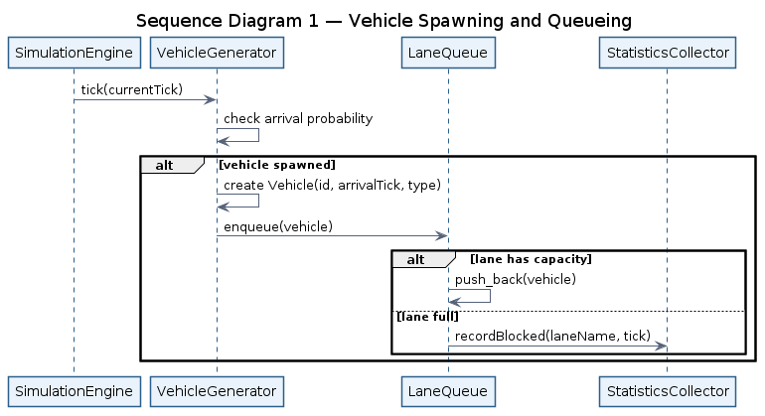
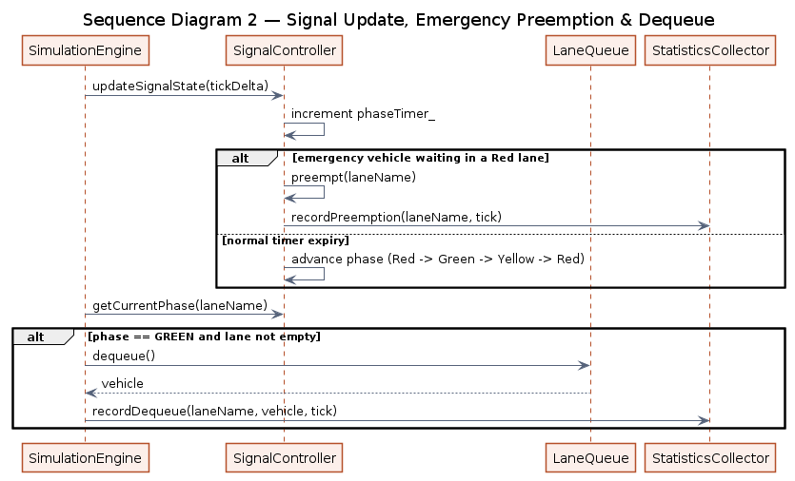

4.3 API Design
C++ interfaces for the four components with the most cross-module interaction. Method names here are the shared contract every module is built against.
class LaneQueue {
public:
explicit LaneQueue(std::string name, size_t maxCapacity);
bool enqueue(const Vehicle& vehicle); // false if full
Vehicle dequeue();
bool isFull() const;
bool isEmpty() const;
const std::string& name() const;
size_t size() const;
size_t capacity() const;
private:
std::string name_;
size_t capacity_;
std::deque<Vehicle> queue_;
};
enum class SignalPhase { RED, YELLOW, GREEN };
class SignalController {
public:
SignalController(int greenDuration, int yellowDuration, int redDuration);
void updateSignalState(int tickDelta);
SignalPhase getCurrentPhase(const std::string& laneName) const;
void preempt(const std::string& laneName); // emergency override
};
class StatisticsCollector {
public:
void recordDequeue(const std::string& laneName, const Vehicle& v, int dequeueTick);
double averageWaitTime() const;
int totalThroughput() const;
void printEndOfRunReport() const;
};
class ConsoleView {
public:
void renderTick(int tick,
const std::vector<LaneQueue>& lanes,
const SignalController& signals) const;
};

4.4 Error Handling, Logging & Monitoring
Invalid configuration values are caught by SimulationEngine::loadConfig(), printed as a clear console error, and replaced with a safe default rather than crashing the run. Blocked/dropped vehicles and emergency preemptions are logged as events through StatisticsCollector. Each SimulationEngine::tick() call wraps module calls in try/catch, so a fault in one module is logged and that tick is skipped rather than terminating the whole simulation. Monitoring is limited to console output and the end-of-run report — no external logging system is used, which is appropriate for a course-scale simulation.

4.5 UX Design
Console output shows, every tick, each lane's current signal color and queue length, plus a simple bar-of-# visual so congestion is visible at a glance (implemented in ConsoleView, satisfying TMS-NF-004). The end-of-run report prints total throughput and average wait time, both overall and broken down per lane, in a clearly labeled summary block.

4.6 Open Issues & Next Steps
- Finalize the exact config-file format (key=value text vs. a small JSON subset).
- Lane identification must be consistently a std::string name (as used by ConsoleView and this SAD) across every module before integration — this was an inconsistency in the initial draft and must be resolved first.
- Adaptive signal mode (TMS-F-021) and "green wave" inter-intersection linking (TMS-F-041) are stretch goals, to be implemented only after the fixed-timer, single-intersection baseline is stable and tested.

5. Appendices

5.1 Glossary
TMS, FIFO, Tick, RAII, STL, FR, NFR.

5.2 References
Project SRS v0.4 (this team). C++17 Standard Library documentation. IEEE 42010 (Systems and software engineering — Architecture description).

5.3 Tools
PlantUML (diagrams), GNU Make, g++ / MinGW, Valgrind / AddressSanitizer, Git & GitHub, Jira.

