Pre-Travel Checklist
- Are drive station software versions (NI tools, wpilib) up to date?
- Pack laptop, power supply
- Controller and button board
- USB cable for direct connection to RIO
- Ethernet and USB-C-to-ethernet adapter
- 2 pigtails with CAN bus connectors as used by motor adapter boards
- WAGO connectors
- ZIP ties

Event Checklist
- First thing, remove radio from robot and line up to get it programmed
- Mount radio back on robot, checking
  - RIO “RIO”
  - Cameras ”Aux1” and “Aux2”
  - “DS” available for drive station laptop
- Get robot inspected ASAP

Match Checklist
- Robot touches start line
- Moving the hood causes numbers on dashboard to update
- Hood down gives reading close to zero
- Moving intake arm causes numbers on dashboard to update
- Moving intake arm all up against stop results in reading close to 130 degrees
- At least one camera sees April tags
- Robot position on dashboard reflects correct field position

Back 1.5m and open
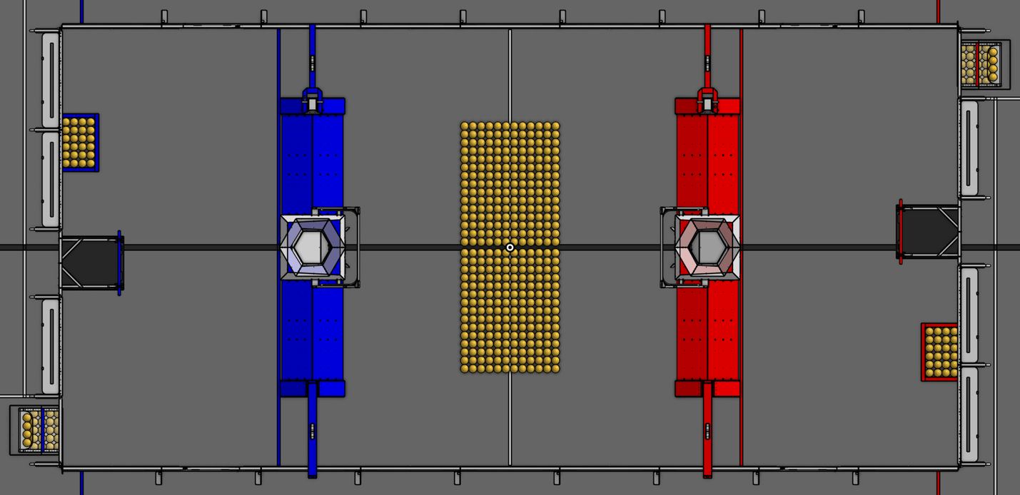

Simply drives back from any start position

Nose@red,shoot,trench

Starts with nose of robot on red hub

Nose@blue,shoot,trench, center

Starts with nose of robot on blue hub

Another 

