
Ministry of Communications
and Information Technology Digital Egypt Pioneers Builders (Rwaad Misr)

Project Documentation Wazuh SIEM & Windows Endpoint Monitoring Persistence Threat Hunting & Automated SOC Alerting

A Centralized SIEM/XDR Environment with Internal Endpoint Threat Simulation and Discord Webhook Automation

Team 2 Members

Name Role

Ahmed Ossama Lead Technical Architect & Engineer Mohamed Deyaa Project Manager & Documentation Lead Ali Mohamed Detection & Telemetry Specialist
Hoda Alaa System Integration Specialist
Eman Ayman Penetration Tester & Threat Analyst Mariam Salama Quality Assurance & Technical Writer

Year: 2026
Submitted in fulfillment of the Digital Egypt Pioneers Builders Program requirements

Contents

- Project Planning & Management 5
  - Project Proposal . . . . . . . . . . . . . . . . . . . . . . . . . . . . . . . 5
    - Overview . . . . . . . . . . . . . . . . . . . . . . . . . . . . . . . 5
    - Objectives . . . . . . . . . . . . . . . . . . . . . . . . . . . . . . . 5
    - Scope . . . . . . . . . . . . . . . . . . . . . . . . . . . . . . . . . 6
  - Project Plan . . . . . . . . . . . . . . . . . . . . . . . . . . . . . . . . . . 6
    - Timeline & Milestones (Gantt Chart) . . . . . . . . . . . . . . . . 6
    - Deliverables . . . . . . . . . . . . . . . . . . . . . . . . . . . . . . 8
    - Resource Allocation . . . . . . . . . . . . . . . . . . . . . . . . . . 8
  - Task Assignment & Roles . . . . . . . . . . . . . . . . . . . . . . . . . . 9
  - Risk Assessment & Mitigation Plan . . . . . . . . . . . . . . . . . . . . . 9
  - KPIs (Key Performance Indicators) 10
- Literature Review 11
  - Feedback & Evaluation 11
  - Suggested Improvements 11
  - Final Grading Criteria 12
- Requirements Gathering 13
  - Stakeholder Analysis 13
  - User Stories & Use Cases 13
    - User Stories 13
    - Use-Case Scenarios 14
  - Functional Requirements 15
    - Log Ingestion & Endpoint Telemetry 15
    - Detection & Rule Engine 16
    - Automated Discord Alerting 16
  - Non-Functional Requirements 17
- System Analysis & Design 18
  - Problem Statement & Objectives 18
    - Problem Statement 18
    - Objectives 18
    - Use Case Diagram 18
  - Software Architecture 19
    - Database Design & Data Modeling 19
  - Data Flow & System Behavior 21
    - Data Flow Diagram (DFD) 21
    - Sequence Diagram (Endpoint Detection Flow) 21
    - Activity Diagram 22
    - State Diagram 23
  - UI/UX Design 25
    - Wazuh Dashboard 25
    - Discord SOC Interface 26
  - System Deployment 27
    - Component Diagram 29
- Implementation: Source Code & Execution 31
  - Core Configurations 31
  - Python Automation Script 32
  - Internal Threat Simulation 35
  - Version Control & Deployment Strategy 36
- Testing & Quality Assurance 37
  - Testing Overview & Success Metrics 37
  - Test Cases 37
  - Evidence & Validation Screenshots 38
- Final Presentation & Reports 40
  - User Manual: Reading the Discord SOC Alerts 40
  - Conclusion 40

List of Figures

  - Project Gantt chart aligned to the Rwaad Misr milestone deadlines. . . . 6
  - Use Case Diagram of the SOC environment (Wazuh SIEM & Windows Endpoint). 19
  - Entity-Relationship Diagram (including the Discord Ticket entity). 20
  - Data Flow Diagram of the SOC detection and alerting pipeline. 21
  - Sequence Diagram of the endpoint persistence detection and Discord alert-
ing pipeline. 22
  - Activity Diagram of the SOC detection and alerting workflow. 23
  - State Diagram of the Wazuh Agent lifecycle. 24
  - Wazuh central SOC overview dashboard. 25
  - MITRE ATT&CK framework mapping matrix in the Wazuh Dashboard. 26
  - Color-coded incident embed in the Discord SOC channel. 26
  - System Deployment Diagram (VMnet8 192.168.135.0/24 with Discord
API edge). 28
  - Component Diagram of the SOC architecture and its dependencies. 30
  - Sysmon and Wazuh Agent configuration for process and DLL telemetry
on DESKTOP-SLN103I 32
  - Color-coded Discord embed generated by custom-discord.py (Source IP
= N/A for the internal event). 34
  - Internal malware simulation on DESKTOP-SLN103I: suspicious process cre-
ation and taskschd.dll load. 36
  - Wazuh Threat Hunting timeline showing the alert-hit spike during the simulation. 38
  - Color-coded incident embed evidence in the Discord SOC channel. 39

List of Tables

  - Official Rwaad Misr Milestone Deadlines . . . . . . . . . . . . . . . . . . 7
  - Project Timeline & Gantt Schedule (aligned to Student deadlines) . . . . 7
  - Resource Allocation . . . . . . . . . . . . . . . . . . . . . . . . . . . . . . 8
  - Risk Assessment & Mitigation 10
  - Final Grading Criteria 12
  - User Stories 14
  - Use Case UC-01 — Simulate Endpoint Persistence (DLL Injection) 14
  - Use Case UC-02 — Detect & Alert via Discord 15
  - Functional Requirements — Log Ingestion & Telemetry 15
  - Functional Requirements — Detection & Rules 16
  - Functional Requirements — Discord Automation 16
  - Non-Functional Requirements 17
  - Deployment Node Addressing (VMnet8 — 192.168.135.0/24) 27
  - Test Cases and Results 37

Chapter 1
Project Planning & Management

Project Proposal

Overview
This project focuses on the architecture, configuration, and validation of a comprehen-sive Security Operations Center (SOC) environment. The core of the system utilizes the Wazuh Security Information and Event Management (SIEM) and extended Detection and Response (XDR) platform. The monitored infrastructure is deployed on a custom, isolated VMware NAT virtual switch (VMnet8) on the subnet 192.168.135.0/24, and comprises a monitored Windows 10 endpoint (DESKTOP-SLN103I) instrumented with Mi-crosoft Sysmon and a centralized Wazuh Manager. The threat simulation focuses on internal, host-based adversary behaviour — native background process creation and sus-picious Dynamic Link Library (DLL) loads used for delayed-execution persistence. De-tection events are surfaced in real time to a Discord channel that operates as a lightweight SOC incident dashboard.

Objectives
The primary goals of the project are:
      - Achieve real-time telemetry ingestion from the Windows 10 endpoint (DESKTOP-SLN103I) into the centralized Wazuh Manager (192.168.135.130).
      - Implement custom detection engineering mapped to the MITRE ATT&CK frame-work, including native process-creation detection (Wazuh Rule 67027) and suspi-cious DLL-load persistence detection (Wazuh Rule 92154 — taskschd.dll).
      - Deploy an automated alerting pipeline using a custom Python integra-tion script (custom-discord.py) that parses raw Wazuh JSON alerts, performs smart source-IP extraction, and formats structured payloads.
      - Operationalize a Discord Webhook as the SOC dashboard, delivering dy-namic, severity-based color-coded incident embeds (Green: Level 1–4, Orange: Level 5–9, Red: Level 10+).
      - Conduct and validate threat-hunting simulations of internal malicious behaviour — background process spawning and taskschd.dll injection — on the Windows 10 endpoint.

Scope
The project scope covers deploying the Wazuh Manager, configuring the Windows 10 target endpoint with Microsoft Sysmon and File Integrity Monitoring (FIM), and in-strumenting it for advanced endpoint telemetry. It further includes running an internal malware simulator on the endpoint to generate host-based persistence behaviour, develop-ing custom XML detection rules, editing ossec.conf to register the custom-discord.py integration, and validating the end-to-end pipeline from the internal OS event to a color-coded Discord alert.

Project Plan

Timeline & Milestones (Gantt Chart)
The project follows a phased delivery model aligned with the official Rwaad Misr (Digital Egypt Pioneers Builders) submission deadlines. Figure 1.1 presents the visual Gantt chart, Table 1.1 lists the program milestone deadlines, and Table 1.2 decomposes each milestone into the detailed task schedule — including the Wazuh and Discord automation stack and the endpoint persistence / DLL-injection testing phase.
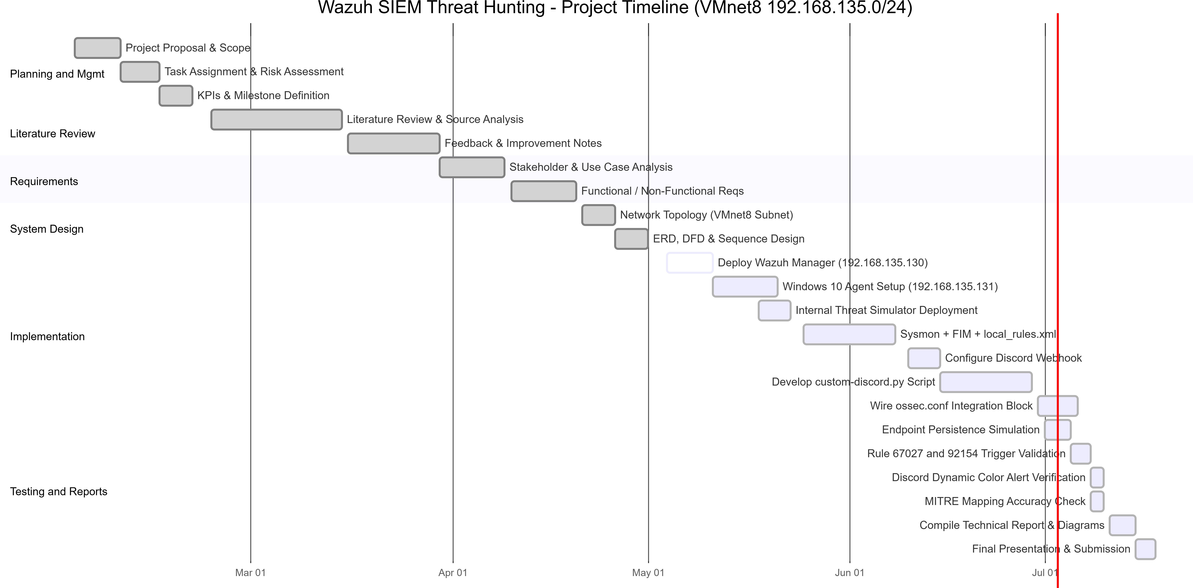

Figure 1.1: Project Gantt chart aligned to the Rwaad Misr milestone deadlines.

Table 1.1: Official Rwaad Misr Milestone Deadlines

Milestone | Student Deadline | Graduate Deadline
Project Planning & Management | 20 Feb 2026 | 27 Jan 2026
Literature Review | 20 Apr 2026 | 01 Mar 2026
Requirements Gathering | 20 Apr 2026 | 01 Mar 2026
System Analysis & Design | 01 May 2026 | 03 Apr 2026
Implementation (Source Code & Ex- | 10 Jul 2026 | 17 May 2026
ecution)
Final Presentation, Testing & Re- | 17 Jul 2026 | 24 May 2026
ports

Table 1.2: Project Timeline & Gantt Schedule (aligned to Student deadlines)

Task |  | Start | Dur. | Milestone (Deadline)
Project Proposal & Scope |  | 02 Feb | 7d | Planning & Mgmt (20 Feb)
Task Assignment & Risk |  | 09 Feb | 6d | Planning & Mgmt (20 Feb)
Assessment
KPIs & Milestone Defini- |  | 15 Feb | 5d | Planning & Mgmt (20 Feb)
tion
Literature Review & |  | 23 Feb | 20d | Literature Review (20 Apr)
Source Analysis
Feedback & | Improvement | 16 Mar | 14d | Literature Review (20 Apr)
Notes
Stakeholder | & Use Case | 30 Mar | 10d | Requirements (20 Apr)
Analysis
Functional | / Non- | 10 Apr | 10d | Requirements (20 Apr)
Functional Reqs
Network Topology (VM- |  | 21 Apr | 5d | System Design (01 May)
net8 Subnet)
ERD, DFD & Sequence |  | 26 Apr | 5d | System Design (01 May)
Design
Deploy Wazuh Manager |  | 04 May | 7d | Implementation (10 Jul)
(.130)
Windows 10 Agent + Sys- |  | 11 May | 10d | Implementation (10 Jul)
mon (.131)
FIM + local rules.xml |  | 25 May | 14d | Implementation (10 Jul)
(67027/92154)
Configure Discord Web- |  | 10 Jun | 5d | Implementation (10 Jul)
hook
Develop custom- |  | 15 Jun | 14d | Implementation (10 Jul)
discord.py Script
 |  |  |  | continued on next page

Table 1.2 – continued from previous page
Task | Start | Dur. | Milestone (Deadline)
Wire ossec.conf integra- | 30 Jun | 6d | Implementation (10 Jul)
tion block
Endpoint Persistence / | 01 Jul | 4d | Testing & Reports (17 Jul)
DLL Sim
Rule 67027/92154 Valida- | 05 Jul | 3d | Testing & Reports (17 Jul)
tion
Discord Color Alert Verifi- | 08 Jul | 2d | Testing & Reports (17 Jul)
cation
MITRE Mapping Accu- | 08 Jul | 2d | Testing & Reports (17 Jul)
racy Check
Compile Technical Report | 11 Jul | 4d | Testing & Reports (17 Jul)
& Diagrams
Final Presentation & Sub- | 15 Jul | 3d | Testing & Reports (17 Jul)
mission

Deliverables
      - Configured Wazuh SIEM/XDR platform with functional Windows 10 endpoint (Sysmon) telemetry.
      - Custom MITRE-mapped detection rules in localrules.xml.
      - Automated response pipeline: custom-discord.py integration delivering color-coded Discord incident tickets.
      - Validated threat-hunting evidence from the internal endpoint persistence / DLL-injection simulation.
      - Complete technical documentation and diagrams hosted on GitHub.

Resource Allocation
Table 1.3: Resource Allocation

Resource |  | Purpose
VMware | Workstation | Isolated | NAT | virtual | switch | hosting | the

(VMnet8)
Wazuh Manager VM (Linux)
Windows 10 Target VM (DESKTOP-SLN103I)

Internal Malware Sim-ulator
192.168.135.0/24 lab subnet.
Central SIEM engine at 192.168.135.130: log decod-ing, rule evaluation, alert generation.
Monitored endpoint at 192.168.135.131 hosting the Wazuh Agent and Microsoft Sysmon for advanced pro-cess and DLL telemetry.
Host-based tooling run locally on the Windows 10 endpoint to generate suspicious process creation and taskschd.dll load persistence behaviour.

Resource Purpose

Python 3 (requests,
json)

Discord Webhook (SOC Dashboard)
Runtime for the custom-discord.py integration script that parses alerts and formats embeds.
Outbound API endpoint receiving automated, severity-colored incident alerts as the SOC dashboard.

GitHub Repository Version control for localrules.xml, agent configura-tions, and documentation.

Task Assignment & Roles
Responsibilities are divided into two tracks: Technical Implementation and Project Doc-umentation.
- Ahmed Ossama — Lead Technical Architect & Engineer: Owns the system architecture, Wazuh Manager deployment, Windows 10 endpoint (DESKTOP-SLN103I) configuration, and oversees custom detection engineering and endpoint threat sim-ulations.
- Mohamed Deyaa — Project Manager & Documentation Lead: Owns the project plan, literature review, requirements formatting, and the final technical reports and presentation.
- Ali Mohamed — Detection & Telemetry Specialist: Customizes Windows Wazuh Agent telemetry, integrates Sysmon, and authors the MITRE-mapped rules in localrules.xml.
- Hoda Alaa — System Integration Specialist: Configures the Sysmon inte-gration and validates the <syscheck> FIM module for critical Windows directories and registry keys.
- Eman Ayman — Penetration Tester & Threat Analyst: Executes the inter-nal malware simulation (suspicious process creation and taskschd.dll injection) on the endpoint to trigger the custom SOC alerts.
- Mariam Salama — Quality Assurance & Technical Writer: Records simu-lation metrics, drafts the user manual, and ensures GitHub documentation is well structured.

Risk Assessment & Mitigation Plan

Table 1.4: Risk Assessment & Mitigation

Risk Mitigation

Malformed XML rules crashing the Wazuh Manager due to characters dropped when pasting large blocks into the terminal.
Raw, noisy event logs overwhelming the SIEM analysis engine.

Failure to detect host-based persistence mechanisms (e.g., scheduled-task DLL loads).
Discord Webhook exposure or delivery failure breaking the alert pipeline.
Use a “Here Document” with the tee command to bypass terminal buffer lim-its, and keep a crash-proof master copy of localrules.xml.
Customize the endpoint agent to monitor specific channels (e.g., PowerShell/Oper-ational) and filter for specific Event IDs (4624, 4688, 4702).
Configure Sysmon image-load monitoring and custom rules for suspicious modules such as taskschd.dll (Rule 92154).
Store the webhook URL only in ossec.conf, keep it out of version control, and validate delivery with a 204 response check inside custom-discord.py.

KPIs (Key Performance Indicators)
- Detection Validation Metric: A high volume of direct hits recorded on the Threat Hunting dashboard during simulation confirms accurate rule parsing (target: 420 direct hits).
- Automation Trigger Accuracy: Reliable execution of the custom-discord.py integration on every qualifying alert, with correct severity-to-color mapping deliv-ered to the Discord SOC channel.
- Threat Intelligence Correlation: Successful mapping of triggered alerts to the correct MITRE ATT&CK techniques (e.g., T1053.005 for scheduled-task persis-tence, T1059 for process execution).

Chapter 2 Literature Review
This chapter records the academic evaluation of the project in line with the official Rwaad Misr (Digital Egypt Pioneers Builders) documentation guidelines. It captures the lec-turer’s feedback, suggested improvements, and the final grading criteria applied to the deliverables.

Feedback & Evaluation
The supervising lecturer’s assessment of the SOC implementation and threat-hunting project is summarized below:
    - Strengths: The project demonstrates a complete, working detection pipeline — from Sysmon endpoint telemetry on the Windows 10 host, through custom MITRE-mapped rule correlation on the Wazuh Manager, to an automated Discord notifica-tion channel. The addition of the custom-discord.py integration and the internal endpoint persistence simulation shows practical, end-to-end SOC engineering rather than a purely theoretical design.
    - Areas Observed: Detection fidelity was validated against a live internal-threat simulation, with alerts correctly triggered (Rules 67027 and 92154) and forwarded as color-coded incident embeds. The isolated VMnet8 (192.168.135.0/24) topology keeps the exercise safe and reproducible.
    - General Comment: The documentation is well structured and mapped to recog-nized frameworks (MITRE ATT&CK), and the automation component adds clear operational value for a SOC dashboard workflow.

Suggested Improvements
    - Extend the detection coverage beyond process creation and DLL loads to include automated correlation rules for multi-stage persistence chains (e.g., a scheduled task created shortly after a suspicious process spawn).
    - Add rate limiting and retry/back-off handling in custom-discord.py to protect against Discord API throttling during high-volume alert storms.

    - Introduce threat-intelligence enrichment (e.g., VirusTotal or an IP reputation lookup) before an alert is posted to the SOC channel.
    - Externalize the webhook URL into a protected secret store rather than ossec.conf to further harden the integration.

Final Grading Criteria
The final grade is distributed across documentation quality, technical implementation, testing/validation, and the final presentation, as detailed in Table 2.1.

Table 2.1: Final Grading Criteria

Criterion Weight Focus Area

Documentation Quality 25% Structure, clarity, dia-grams, guideline compli-ance
Technical Implementation 35% Wazuh deploy-ment, custom rules, custom-discord.py inte-gration
Testing & Validation 25% Endpoint persistence / DLL simulation, rule/alert accuracy, MITRE map-ping
Final Presentation 15% Delivery, live demonstra-tion, Q&A handling

Total 100%

Chapter 3
Requirements Gathering

This chapter identifies the stakeholders, articulates the user stories, and defines the func-tional and non-functional requirements that the SOC environment must satisfy. The requirements explicitly account for the automated Discord alerting pipeline and the re-silience of the platform under active internal-threat simulation.

Stakeholder Analysis
Identifying the key users and stakeholders ensures the system is built to meet operational needs.
- SOC Analysts & Incident Responders: Require a centralized dashboard with real-time log ingestion and alerts mapped to MITRE ATT&CK. They addition-ally rely on the Discord SOC channel for instant, at-a-glance, color-coded incident notifications away from the main console.
- Detection Engineers: Require the ability to write, test, and deploy custom XML rules without destabilizing the Manager, and to route qualifying alerts through the custom-discord.py integration.
- Security Architects / System Administrators: Require reliable deployment of the Wazuh Manager and the Windows 10 Agent, and secure handling of the outbound webhook integration.
- Penetration Testers (Red Team): Require a safe, isolated Windows 10 endpoint (DESKTOP-SLN103I, 192.168.135.131) on which to run internal malware behaviour (process spawning, DLL injection) and validate that host-based actions reliably generate detections.

User Stories & Use Cases

User Stories
The following user stories capture the primary interactions between the security team and the SOC environment. Each is coded (US) and prioritized as Must or Should.

 | Table 3.1: User Stories
Code | User story | Must/ | Comments
 |  | Should
US01 | As a SOC Analyst, I want alerts mapped to the | Must | Threat hunting.
 | MITRE ATT&CK framework so that I can track
 | and understand simulated internal threats.
US02 | As an Incident Responder, I want to be alerted | Must | Endpoint secu-
 | when a suspicious background process is created |  | rity.
 | (Rule 67027) so that I can identify malicious ex-
 | ecution on the Windows endpoint.
US03 | As a Security Engineer, I want an instant alert | Must | Persistence /
 | when a process loads taskschd.dll (Rule 92154) |  | DLL load.
 | so that I can detect delayed-execution persistence
 | tasks.
US04 | As an on-call SOC Analyst, I want endpoint per- | Must | Discord au-
 | sistence detections pushed to a Discord channel |  | tomation.
 | as a color-coded embed so that I am notified of
 | high-severity incidents in real time.
US05 | As a Detection Engineer, I want to deploy custom | Should | Rule stability.
 | XML rules without destabilizing the Manager so
 | that I can extend coverage safely.
3.2.2 | Use-Case Scenarios

Table 3.2: Use Case UC-01 — Simulate Endpoint Persistence (DLL Injection)
Use Case Number: UC-01

Use Case Name: Simulate Endpoint Persistence (DLL Injection)
Actors: Internal Malware Simulator (Local Threat)
Overview: The local threat spawns a suspicious background process that loads taskschd.dll to register a delayed-execution persis-tence task, generating Sysmon telemetry.
Related Use Detect & Alert (UC-02)

Cases:

Event (stimulus): User Actions: System Action:

      - Spawn a suspicious process on DESKTOP-SLN103I.
      - Process loads taskschd.dll.
- Sysmon emits Event ID 1 (Process Create).
- Sysmon emits Event ID 7 (Image Loaded) to the moni-tored channel.

Exceptions: Sysmon channel not monitored, agent offline, event outside telemetry scope.
Comments: Primary internal-threat simulation used to validate the de-tection pipeline.

Table 3.3: Use Case UC-02 — Detect & Alert via Discord
Use Case Number: UC-02

Use Case Name: Detect & Alert via Discord
Actors: Wazuh Manager, custom-discord.py, SOC Analyst
Overview: The Manager correlates the Sysmon events, triggers a rule, and the Python integration posts a color-coded embed to Discord.
Related Use Simulate Endpoint Persistence (UC-01)

Cases:

Event (stimulus): User Actions: System Action:

- Agent forwards events to the Manager.
- (Automated — no analyst input.)
- Decodes events and matches Rules 67027 / 92154.
- Invokes
custom-discord.py; source IP resolves to N/A.
- Maps severity to color and POSTs the embed (endpoint DESKTOP-SLN103I).

Exceptions: Webhook unreachable, Discord API rate limit (HTTP 429), malformed JSON alert.
Comments: Core automation use case; validates the end-to-end SOC alert flow.

Functional Requirements
The functional requirements are coded (FR) and grouped by capability area, following the standard Code / Requirements statement / Must-Should / Comments format.

Log Ingestion & Endpoint Telemetry

Table 3.4: Functional Requirements — Log Ingestion & Telemetry

Code Requirements statement Must/ Should

Comments

FR001 The Wazuh Manager (192.168.135.130) must receive and analyze telemetry from the Windows 10 endpoint (DESKTOP-SLN103I).
FR002 The Windows Wazuh Agent must integrate with Microsoft Sysmon to collect process-creation (Event ID 1) and image-load (Event ID 7) teleme-try.
Must Central aggre-gation.
Must Advanced telemetry.

Code Requirements statement Must/ Should

Comments

FR003 The <syscheck> module must perform real-time FIM on critical Windows directories and Registry keys (Run, RunOnce, Winlogon).
Must Real-time FIM.

Detection & Rule Engine

Table 3.5: Functional Requirements — Detection & Rules

Code Requirements statement Must/ Should

Comments

FR004 The system must support custom detection en-gineering via localrules.xml, including native process-creation detection (Rule 67027).
FR005 The system must detect suspicious module loads, specifically a process loading taskschd.dll indi-cating a delayed-execution persistence task (Rule 92154).
FR006 Triggered alerts must be mapped to the correct MITRE ATT&CK technique (e.g., T1053.005 scheduled-task persistence, T1059 process execu-tion).
Must Custom rule parsing.
Must Persistence de-tection.

Must Framework mapping.

Automated Discord Alerting

Table 3.6: Functional Requirements — Discord Automa-tion

Code Requirements statement Must/ Should

Comments

FR007 On every qualifying alert the Manager must in-voke the custom-discord.py integration regis-tered in ossec.conf.
FR008 The script must perform smart source-IP extraction (searching data.srcip and win.eventdata.ipAddress) and gracefully as-sign N/A for internal OS events with no network source.
FR009 The integration must set the embed border color by severity: Green (Level 1–4), Orange (Level 5–9), Red (Level 10+).
Must Python web-hook.
Must Multi-source parsing.

Must Dynamic color coding.

Code Requirements statement Must/ Should

Comments

FR010 The script must post a structured embed (Rule ID, target endpoint DESKTOP-SLN103I, severity, source IP) to the Discord Webhook SOC channel.
Must Alert delivery.

Non-Functional Requirements
The performance, security, and reliability criteria are coded (NFR) using the same format.
Table 3.7: Non-Functional Requirements

Code Requirements statement Must/ Should

Comments

NFR01 Performance: The Windows agent must collect only actionable threat data, filtering noisy raw event logs before transmission.
NFR02 API Response Handling: The custom-discord.py integration must vali-date the Discord response (expect 204 No Content), fail safely without crashing the inte-gration daemon, and avoid data loss when the endpoint is unreachable or rate-limited.
NFR03 Stability Under Load: The pipeline must sus-tain a rapid burst of endpoint events (process spawns and DLL loads) without dropping alerts, crash-looping, or blocking log processing.
NFR04 Reliability: Custom rule deployment must use the secure “Here Document” (tee) approach to prevent malformed-XML crash loops.
NFR05 Accuracy: Detection rules must produce valid alerts with minimal false positives (target metric: 420 direct hits).
NFR06 Security: The Manager must securely handle sensitive telemetry, and the Discord webhook URL must be protected and kept out of version control.
NFR07 Usability: Discord alerts must remain legible using redundant text labels alongside color so severity is clear without relying on color alone.
Must Log filtering.

Must Webhook resilience.

Must Event-burst re-silience.

Must System stabil-ity.
Must Alert fidelity.

Must Data protec-tion.

Should Accessibility.

Chapter 4
System Analysis & Design

Problem Statement & Objectives

Problem Statement
Modern enterprise endpoints are a primary target for adversaries who rely on native operating-system mechanisms — background process creation and malicious DLL loads
— to execute code and establish stealthy persistence, yet these host-based behaviours frequently go undetected without centralized endpoint visibility. In a small lab or SOC training context, analysts additionally lack an out-of-band, real-time notification channel: they must watch the dashboard continuously to notice a live incident. This project addresses both gaps by building a centralized SIEM/XDR pipeline on the isolated VMnet8 subnet (192.168.135.0/24) that monitors internal Windows 10 endpoint telemetry, and by pushing high-severity detections to a Discord channel that acts as a lightweight, always-on SOC dashboard.

Objectives
      - Implement a centralized SIEM/XDR platform (Wazuh Manager) providing real-time telemetry ingestion from the Windows 10 endpoint (DESKTOP-SLN103I).
      - Perform detection engineering mapped to the MITRE ATT&CK framework, in-cluding process-creation detection (Rule 67027) and taskschd.dll persistence de-tection (Rule 92154, T1053.005).
      - Validate the pipeline with a live internal malware simulation — suspicious process spawning and DLL injection — on the endpoint.
      - Automate incident notification through the custom-discord.py integration, deliv-ering severity-based color-coded embeds to the Discord SOC channel.

Use Case Diagram
Figure 4.1 identifies the system actors — the Internal Threat (Local Malware Simulator), Detection Engineer, SOC Analyst, and the Discord SOC Channel — and their interactions with the SOC environment.

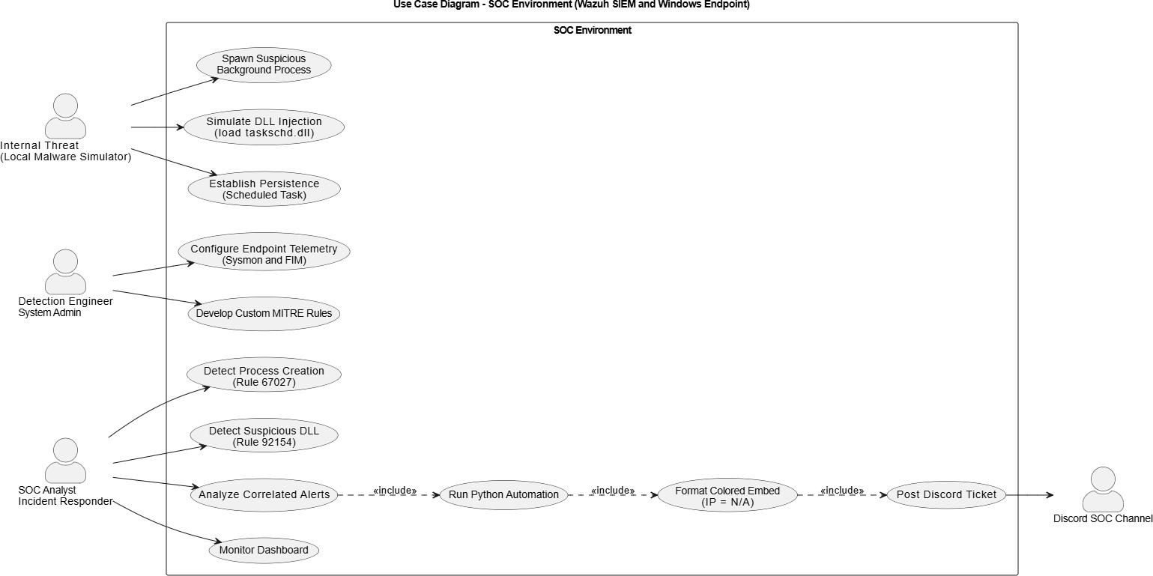
Figure 4.1: Use Case Diagram of the SOC environment (Wazuh SIEM & Windows End-point).

Software Architecture
The system implements a Hub-and-Spoke (Centralized SIEM) architecture. The Wazuh Manager acts as the central aggregation and analysis engine (the Hub), while the Wazuh Agent deployed on the Windows 10 endpoint acts as the telemetry collector (the Spoke). The spoke forwards filtered, encrypted Sysmon telemetry to the hub, which decodes it, evaluates it against localrules.xml, and indexes the resulting alerts.
This project extends the classic Hub-and-Spoke model with an outbound automa-tion edge. When a qualifying alert is generated, the Manager invokes the custom-discord.py integration script, which formats the alert and performs an outbound HTTPS call to the Discord Webhook API. The Discord channel therefore becomes an additional, cloud-hosted presentation layer alongside the on-premises Wazuh Dashboard — extending the hub’s reach beyond the isolated lab network without exposing the internal infrastructure.

Database Design & Data Modeling
As a SIEM, Wazuh uses a NoSQL/document-based indexer rather than a traditional relational database. Data is stored as JSON documents in the Wazuh Indexer, with decoders parsing raw Sysmon events into structured key–value pairs (e.g., rule.id, agent.name, win.eventdata.image). Relationships are established through rule correla-tion: a SecurityAlert entity is generated when a RawLogEvent matches a DetectionRule, and each alert may in turn produce a DiscordTicket. Figure 4.2 presents the logical entity-relationship model.

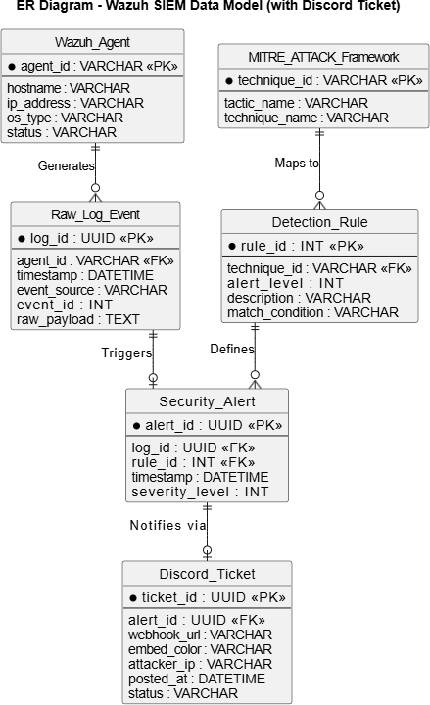

20

Data Flow & System Behavior
The end-to-end detection pipeline flows as follows:
- Internal Threat (Local Malware Simulator): On the Windows 10 endpoint (DESKTOP-SLN103I), the simulator spawns a suspicious background process that loads taskschd.dll to register a delayed-execution persistence task.
- Data Generation (Sysmon): Sysmon captures the behaviour, emitting Event ID 1 (Process Create) and Event ID 7 (Image Loaded).
- Data Collection (Wazuh Agent): The Agent reads and filters the event data and forwards it over an encrypted channel to the Manager.
- Data Processing (Wazuh Manager): The Manager decodes the events, corre-lates them, and triggers Rules 67027 and 92154, mapping the persistence behaviour to MITRE T1053.005.
- Integration (custom-discord.py): The Manager invokes the Python script, which resolves the source IP (N/A for this internal OS event), maps severity to a color, and formats a JSON embed.
- Response (Discord API): The script POSTs the embed to the Discord Webhook, and a color-coded incident card for DESKTOP-SLN103I appears instantly in the SOC channel.

Data Flow Diagram (DFD)
Figure 4.3 shows the data flow from the internal malware simulator and Sysmon, through the Wazuh collection and analysis processes, to the indexer, dashboard, and the extended custom-discord.py → Discord API → SOC Analyst output path.

Figure 4.3: Data Flow Diagram of the SOC detection and alerting pipeline.

Sequence Diagram (Endpoint Detection Flow)
Figure 4.4 details the ordered message exchange, from the suspicious process execution and taskschd.dll load, through Sysmon capture and Manager rule processing, to the dynamic colored Discord embed.

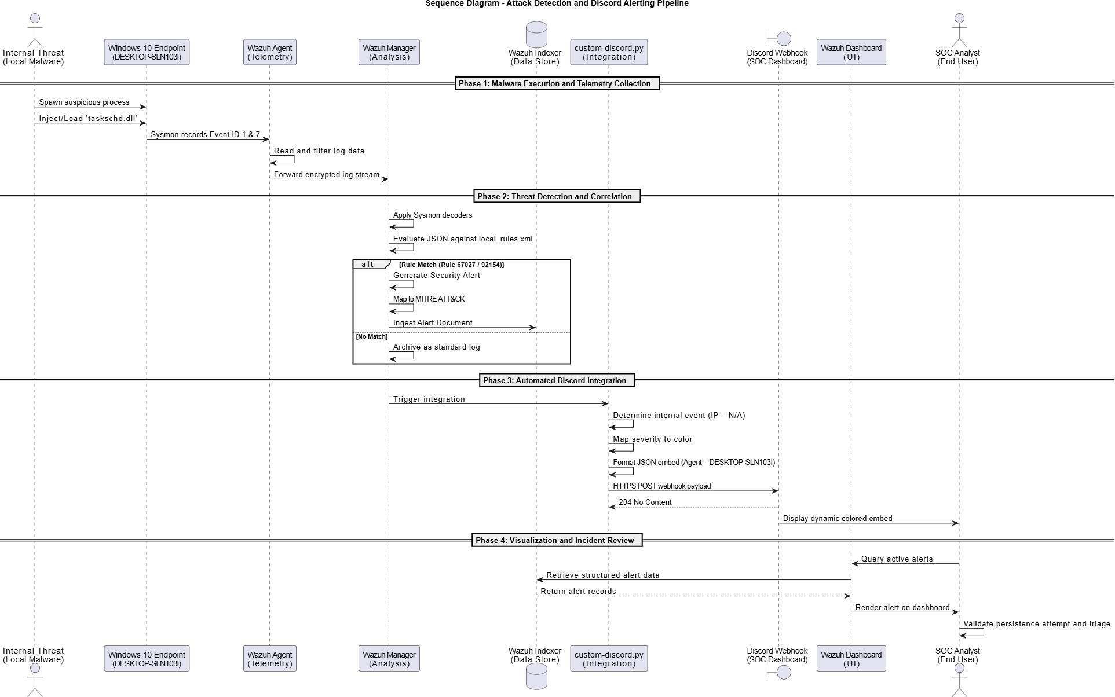

Figure 4.4: Sequence Diagram of the endpoint persistence detection and Discord alerting pipeline.

Activity Diagram
Figure 4.5 presents the swimlaned workflow across the Target Environment, Wazuh Agent, Wazuh Manager, the Discord/Python Integration, and the SOC Analyst.

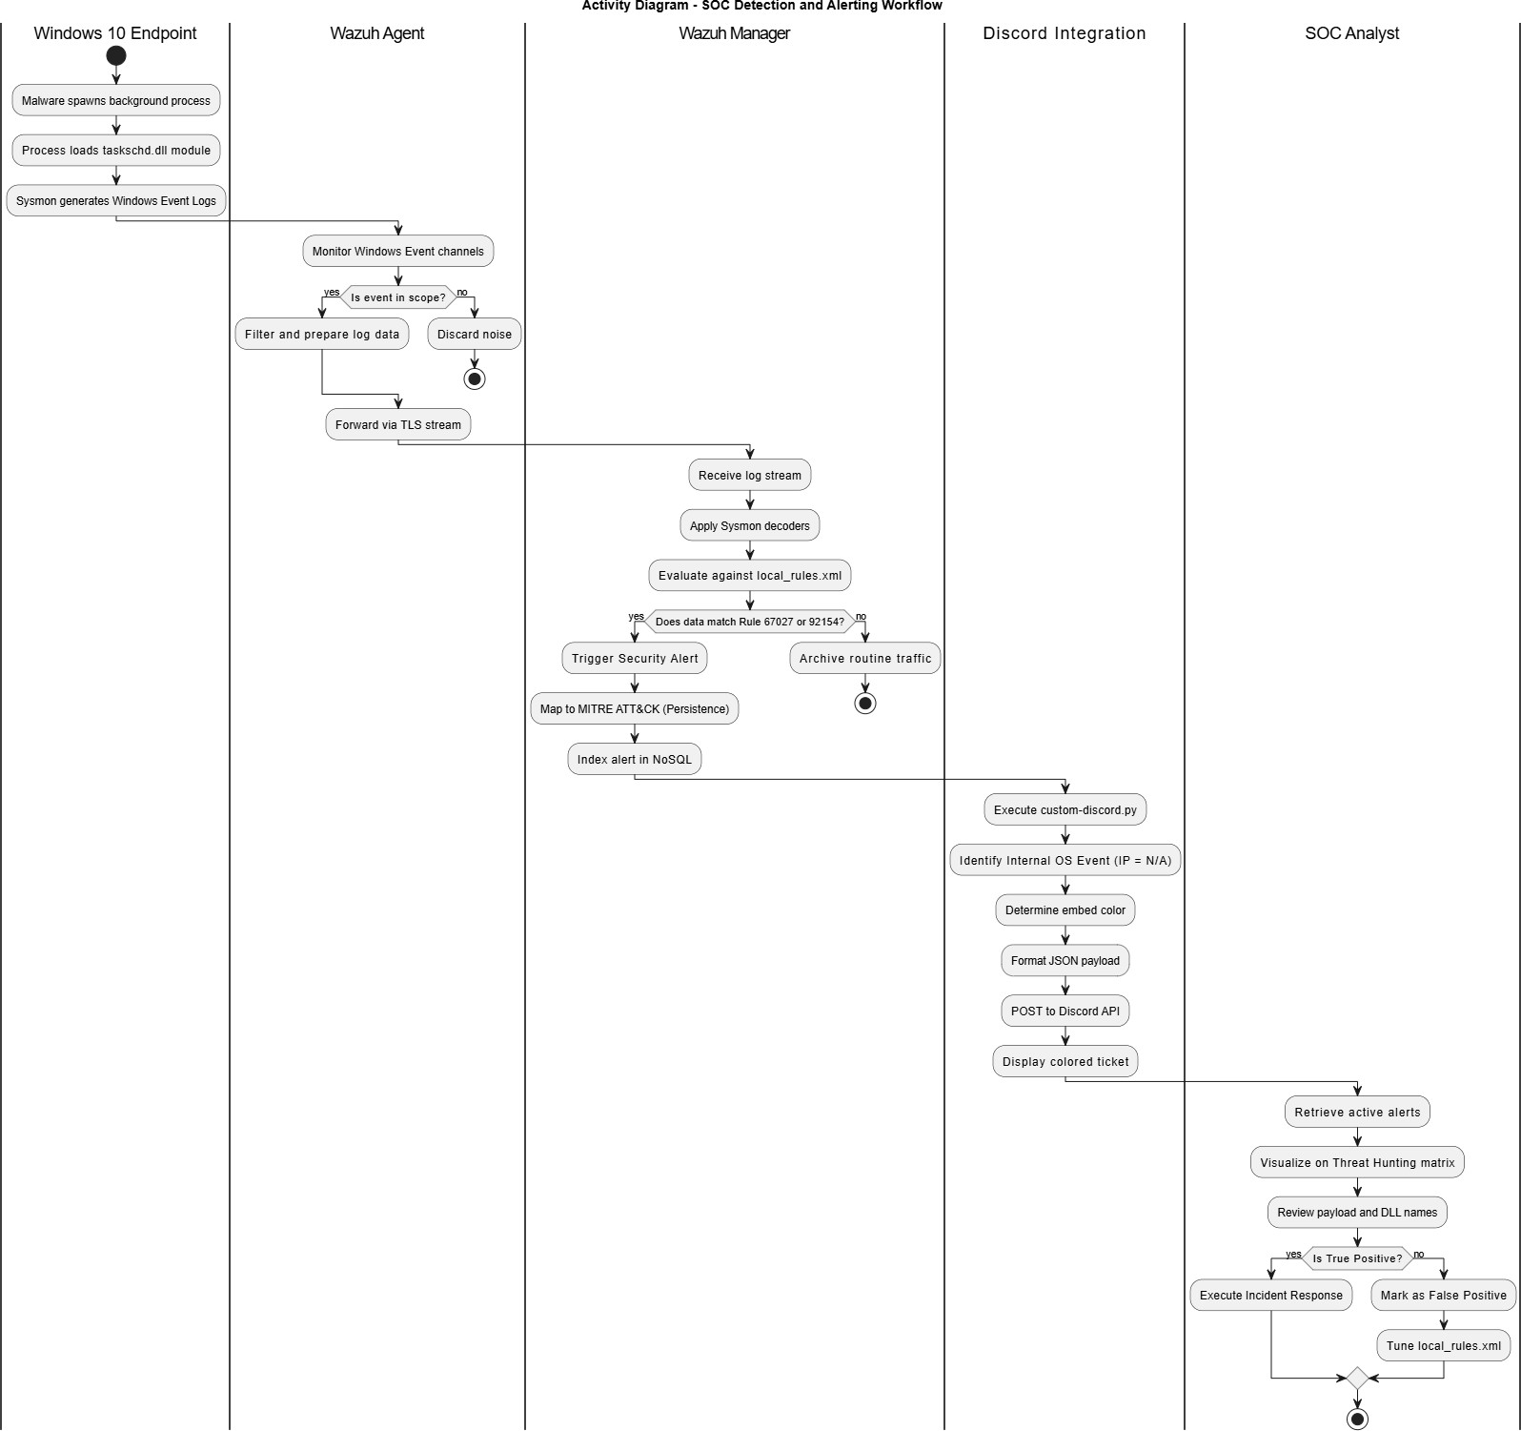

Figure 4.5: Activity Diagram of the SOC detection and alerting workflow.

State Diagram
Figure 4.6 models the Wazuh Agent lifecycle, transitioning from Unregistered through WaitingForAuth to the Registered composite state (Disconnected, Active, ErrorState).

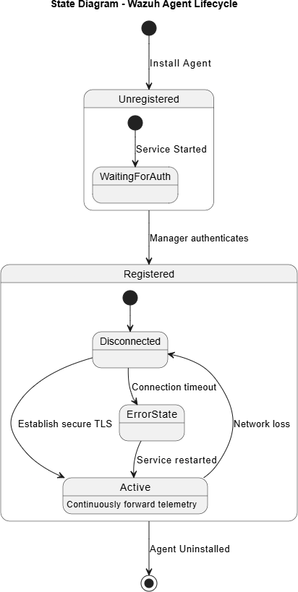
Figure 4.6: State Diagram of the Wazuh Agent lifecycle.

UI/UX Design
The system presents two complementary interfaces: the on-premises Wazuh Dashboard for deep analysis and threat hunting, and the cloud-based Discord channel for instant, at-a-glance incident notification.

Wazuh Dashboard
The Wazuh Dashboard (OpenSearch-based) is the primary SOC console. It follows a top-down, progressive-disclosure flow: a central overview with agent-summary and severity breakdown widgets, drill-down into tactical MITRE mapping, and finally granular “Doc-ument Details” views exposing the raw JSON payload. A strict semantic color system is used — Deep Red for critical (Level 15+), Bright Orange for high (Level 12–14), and Yel-low/Blue for medium and low — so that the highest-severity incidents are immediately visible. Figure 4.7 shows the central SOC overview.
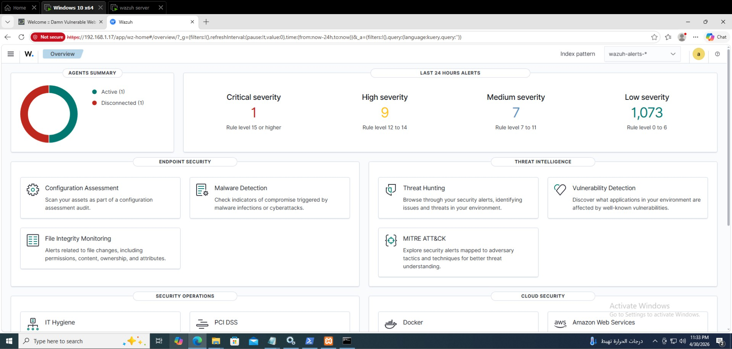

Figure 4.7: Wazuh central SOC overview dashboard.

The MITRE ATT&CK mapping matrix (Figure 4.8) provides immediate context on adversary tactics, mapping triggered alerts across tactics (e.g., Execution, Persistence) and listing techniques such as T1053.005 (Scheduled Task) and T1059 (Command & Scripting Interpreter) alongside their alert counts.

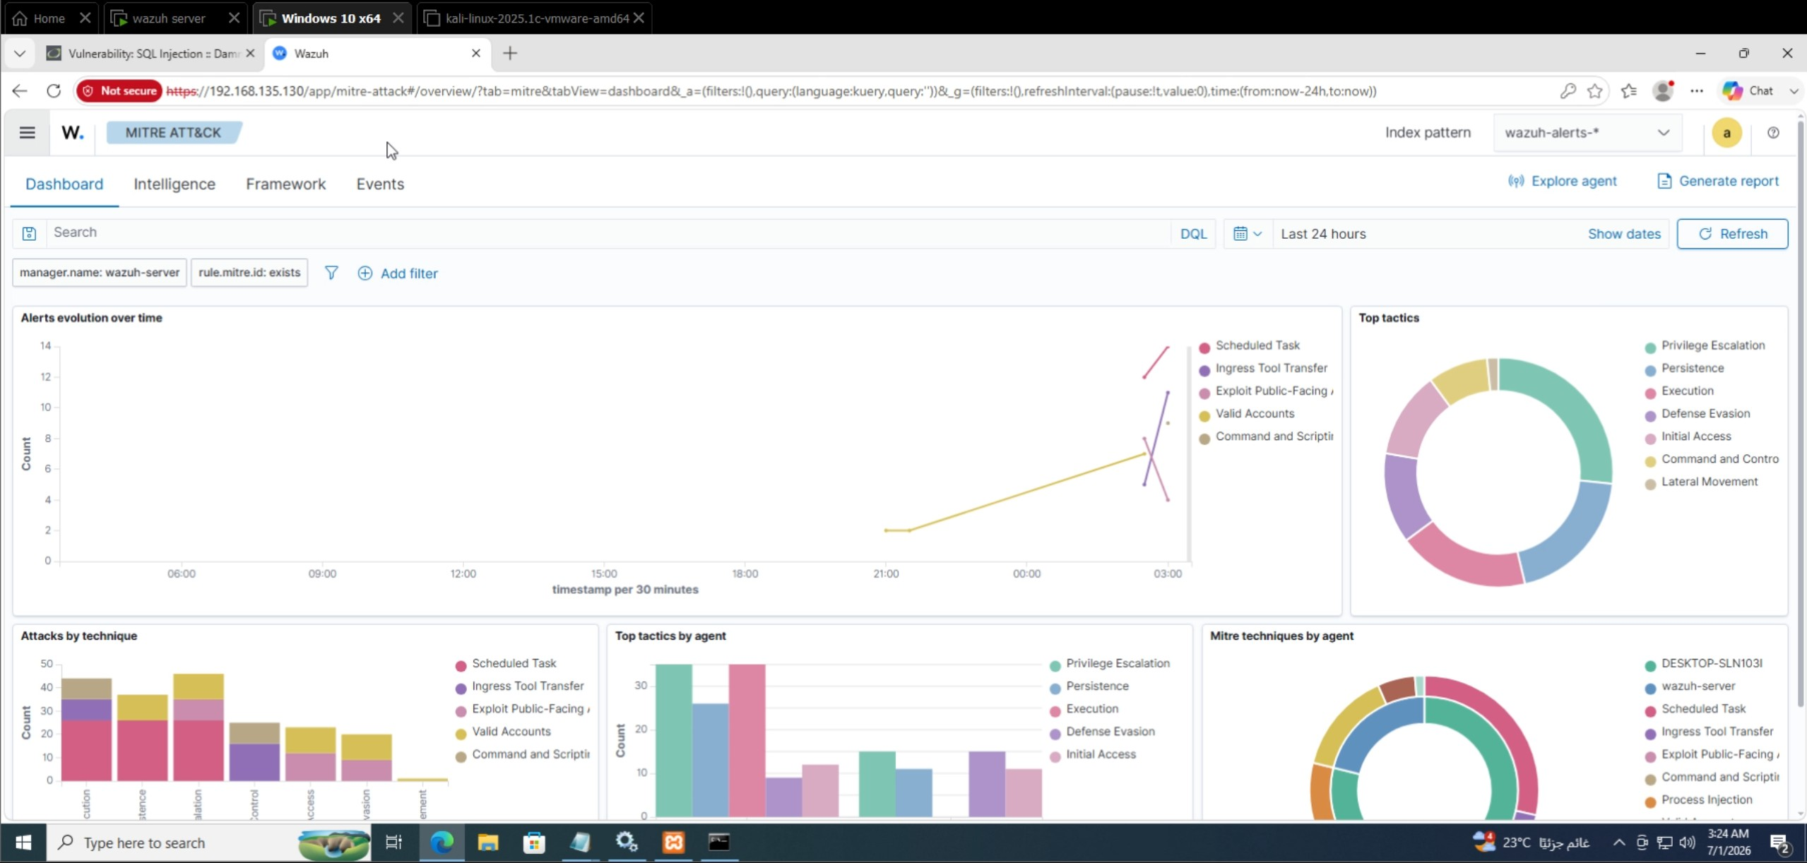
Figure 4.8: MITRE ATT&CK framework mapping matrix in the Wazuh Dashboard.

Discord SOC Interface
The Discord channel serves as a lightweight, always-on SOC dashboard. Each inci-dent arrives as a graphical embed (card) whose border color is set dynamically by the custom-discord.py script according to the Wazuh severity level — Green (Level 1–4), Orange (Level 5–9), and Red (Level 10+). Every embed carries redundant text fields (Rule ID, target endpoint DESKTOP-SLN103I, severity, and source IP — shown as N/A for internal OS events) so severity is clear without relying on color alone. Figure 4.9 shows a color-coded alert as rendered in the Discord SOC channel.
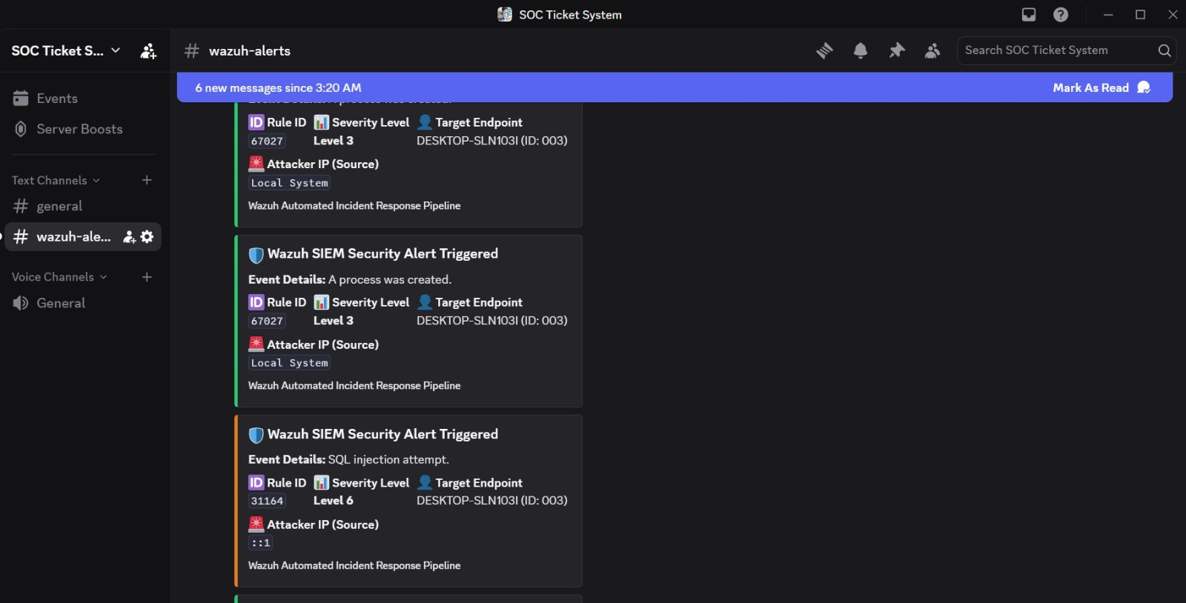
Figure 4.9: Color-coded incident embed in the Discord SOC channel.

System Deployment
The deployment is a distributed Virtual Machine (VM) model on VMware Workstation, simulating a localized enterprise network on the isolated NAT virtual switch VMnet8 (subnet 192.168.135.0/24). Table 4.1 defines the exact host addressing.

Table 4.1: Deployment Node Addressing (VMnet8 — 192.168.135.0/24)
Node |  |  | IP Address | Role
Wazuh (Linux)  Windows | 10 | Manager  Target | 192.168.135.130  192.168.135.131 | Central SIEM hub: event decoding, rule evaluation, alert generation, and custom-discord.py integration.  Monitored endpoint hosting the Wazuh

(DESKTOP-SLN103I)
Discord Webhook API Outbound
(HTTPS)
Agent, Microsoft Sysmon, and the in-ternal malware simulator.
Cloud SOC dashboard receiving severity-colored incident embeds.

Figure 4.10 shows the full deployment topology, including the VMnet8 subnet, the Manager and Windows 10 endpoint VMs, and the outbound API edge to the Discord Webhook.

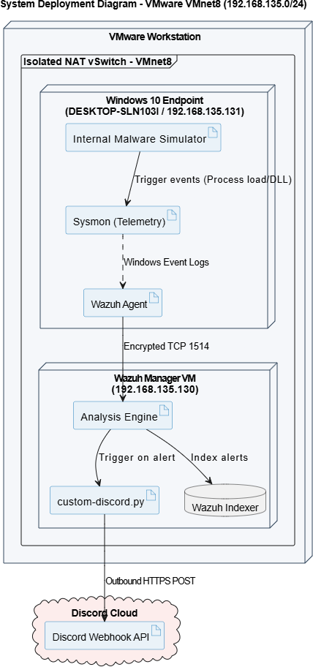

Figure 4.10: System Deployment Diagram (VMnet8 192.168.135.0/24 with Discord API edge).

Component Diagram
Figure 4.11 shows the high-level software components and their dependencies — from the internal malware simulator and Sysmon, through the Wazuh Agent, decoders, and rule engine, to the custom-discord.py integration, the Discord Webhook API, and the Wazuh Dashboard.

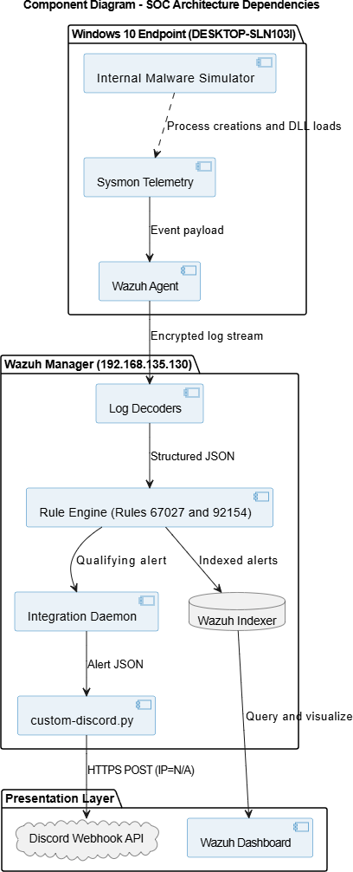

Figure 4.11: Component Diagram of the SOC architecture and its dependencies.

Chapter 5
Implementation: Source Code & Execution

This chapter documents the concrete implementation of the automated SOC pipeline: the Wazuh integration configuration, the custom-discord.py automation script, the internal endpoint threat simulation, and the version-control and deployment strategy.

Core Configurations
The alerting pipeline is activated by registering the Python integration inside the main Wazuh configuration file on the Linux Manager, /var/ossec/etc/ossec.conf. The
<integration> block instructs the Wazuh integrator daemon to execute custom-discord.py whenever an alert is generated, passing the alert to the script in JSON format and sup-plying the Discord channel’s webhook URL.
1 <integration >
2 <name >custom - discord . py</ name >
3 <hook_url > YOUR_DISCORD_WEBHOOK_URL_HERE </ hook_url >
4 < alert_format >json </ alert_format >
5 </ integration >
Listing 5.1: The <integration> block added to /var/ossec/etc/ossec.conf
Key fields:
    - <name> — the script the integrator executes on each alert (custom-discord.py).
    - <hookurl> — the Discord Webhook endpoint; kept out of version control for se-curity.
    - <alertformat> — set to json so the script receives the full structured alert rather than plain text.
Endpoint telemetry is provided by Microsoft Sysmon on the Windows 10 host, config-ured to capture process-creation (Event ID 1) and image-load (Event ID 7) events. The Wazuh Agent forwards these Sysmon operational logs to the Manager for rule evaluation (Figure 5.1).

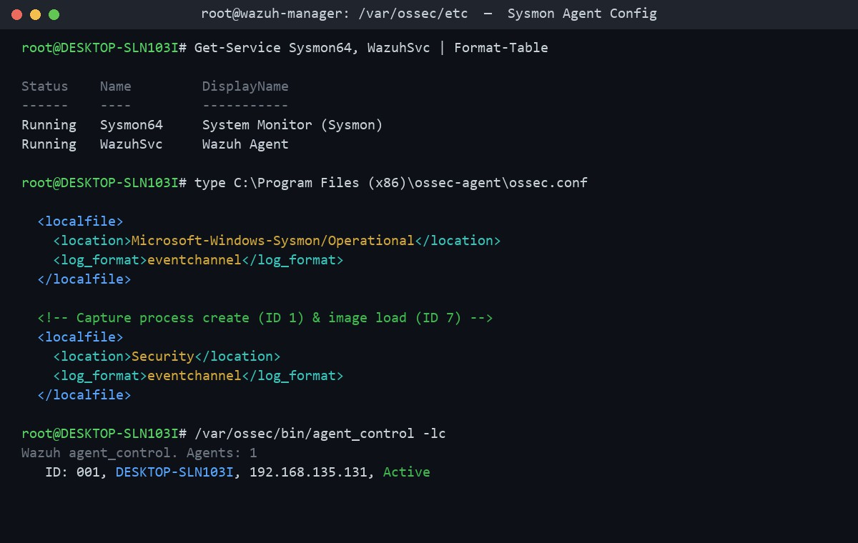
Figure 5.1: Sysmon and Wazuh Agent configuration for process and DLL telemetry on DESKTOP-SLN103I.

Python Automation Script
The custom-discord.py script is the core of the automation layer. It intercepts the raw JSON alert emitted by the Wazuh Manager, extracts the relevant fields, and posts a formatted Discord “Embed” (a graphical card) to the SOC channel. Its logic comprises three main responsibilities:
    - JSON Parsing: The script reads the alert file passed by the integrator daemon and loads it with the json library, isolating the rule (ID, level, description) and data objects.
    - Smart IP Extraction (graceful N/A handling): The source IP can appear in different fields depending on the log source, so the script searches multiple locations
— data.srcip first, then win.eventdata.ipAddress. For internal OS events such as a process creation or DLL load, no network source exists, so the lookup falls through to a safe default of N/A rather than raising an error — keeping the embed well-formed for host-based detections.
    - Dynamic Colors: The embed border color is chosen from the Wazuh severity level: Green for Level 1–4 (low risk), Orange for Level 5–9 (medium risk), and Red for Level 10+ (high/critical). The formatted payload is then delivered to the webhook via an HTTP POST using the requests library.
1 import sys , json , requests
2

#
39 ]
40 }]
41 }
42
43 requests. post( hook_url , json = embed )
Green -
Low
29
30 embed = {
31 " embeds": [{
32 " title ": f" Wazuh Alert - Rule { rule . get(’ id ’)}",
33 " description ": rule . get(" description ", " N/ A"),
34 " color": color ,
35 " fields": [
36

37
{" name ": " Severity Level",
": True },
{" name ": " Source IP", ": True },
{" name ": " Target Endpoint", ": True }
" value ": str( level), " inline
" value ":
src_ip ,
" inline
38
" value ":
endpoint ,
" inline
27
28
Medium
Orange -
#
25
26
High / Critical
-
Red
#
on Wazuh severity level
# Dynamic colors based
if level >= 10: color = 0 xE74C 3C
elif level >= 5: color = 0 xE67E22
else :
color = 0 x2ECC 71
22
23
24
18
19 # Target endpoint ( the monitored Windows host , e. g., DESKTOP - SLN 103I)
20 endpoint = alert. get(" agent", {}). get(" name ", " N/ A")
21
IP parsing: look in multiple places; internal OS events fall
to N/ A
( data . get(" srcip ")
or data . get(" win ", {}). get(" eventdata ", {}). get(" ip Address"
)
or " N/ A")
17
3 # The Wazuh integrator passes the alert file path and the hook URL as
arguments
4 alert_file = sys. argv [1]
5 hook_url = sys. argv [3]
6
7 with open ( alert_file ) as f:
8 alert = json . load ( f)
9
10 rule = alert. get(" rule ", {})
11 data = alert. get(" data ", {})
12 level = int( rule . get(" level", 0))
13
14 # Smart
back
15 src_ip =
16
Listing 5.2: Core logic of custom-discord.py: smart IP parsing and dynamic severity color

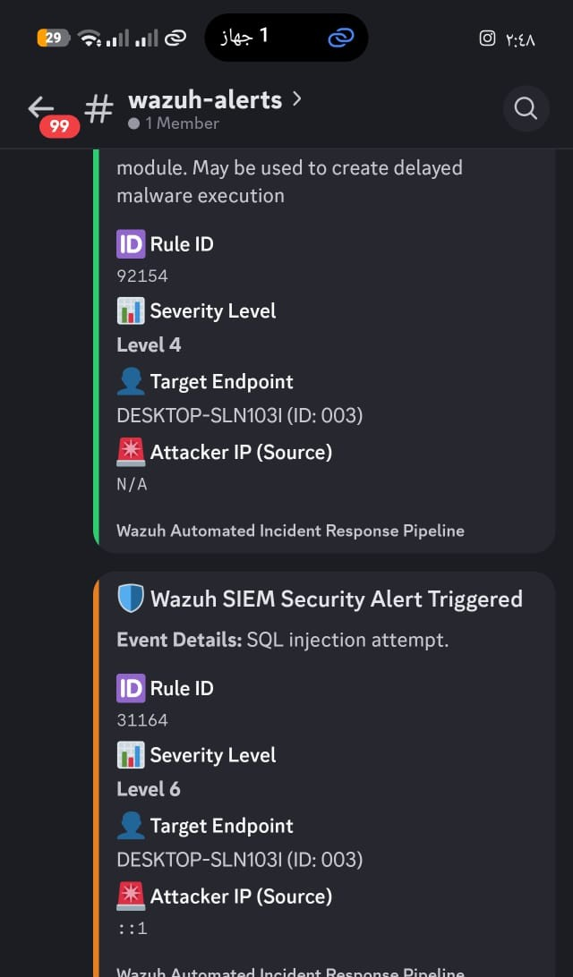

34

Internal Threat Simulation
The detection pipeline is validated by simulating internal malicious behaviour directly on the Windows 10 endpoint (DESKTOP-SLN103I), rather than any external network at-tack. The simulation reproduces a common persistence technique: a suspicious back-ground process is spawned, and that process loads the Windows Task Scheduler module taskschd.dll in order to register a delayed-execution (scheduled) task — behaviour associated with MITRE ATT&CK T1053.005.
When the process is created, Sysmon records an Event ID 1 (Process Create), which the Manager matches to Rule 67027 (a process was created). When the pro-cess loads taskschd.dll, Sysmon records an Event ID 7 (Image Loaded), which matches Rule 92154 (process loaded the taskschd.dll module), flagging the delayed-execution persistence attempt. The illustrative simulation is shown below.
1 # Spawn a suspicious background process ( triggers Sysmon Event ID 1
-> Rule 67027)
2 $proc = Start - Process - File Path " powershell. exe " - PassThru ‘
3 - ArgumentList "- No Profile - Window Style Hidden - Command ", ‘
4 " Add - Type - AssemblyName Microsoft. Win32 . TaskScheduler "
5
6 # The process loads taskschd. dll
7 # ( triggers Sysmon Event ID 7 -> Scheduled Task)
8 schtasks / Create / SC ONLOGON / TN
to register a delayed - execution task
Rule 92154 , persistence via
" UpdaterTask " ‘
9 / TR " powershell. exe - Window Style Hidden - File C:\ Users\ Public\
payload . ps1 " / F
Listing 5.3: Internal malware simulation on DESKTOP-SLN103I: spawn a process that loads taskschd.dll for scheduled-task persistence (PowerShell)
Because these are internal operating-system events with no network origin, the custom-discord.py script resolves the Source IP to N/A and reports the Target Endpoint as DESKTOP-SLN103I.
The simulated process activity captured on the endpoint is shown in Figure 5.3.

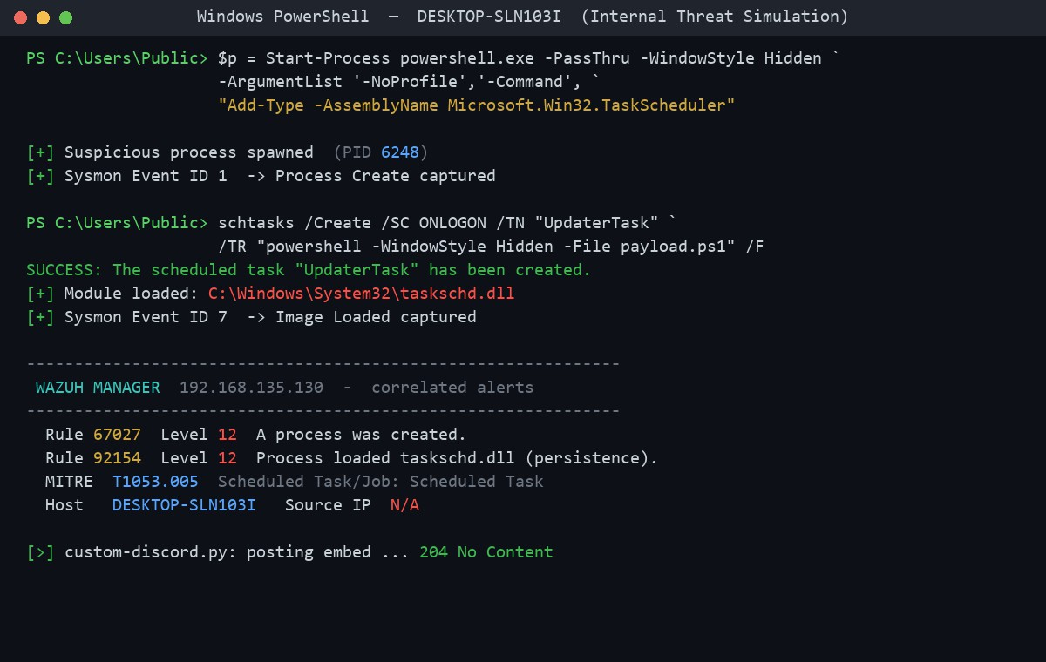
Figure 5.3: Internal malware simulation on DESKTOP-SLN103I: suspicious process creation and taskschd.dll load.

Version Control & Deployment Strategy
The implementation follows a reproducible, version-controlled deployment strategy:
    - Version Control: All custom artifacts — localrules.xml, the ossec.conf inte-gration block, and custom-discord.py — are hosted on GitHub for change tracking and team collaboration. The live <hookurl> is excluded from the repository and injected only on the Manager to avoid leaking the webhook secret.
    - Rule Portability: To prevent XML corruption when injecting large rule blocks into the terminal, a “Here Document” with the tee command is used, bypassing interactive buffer limits and keeping a crash-proof master copy of localrules.xml.
    - Agent Deployment: Endpoints are provisioned with pre-configured ossec.conf files so Sysmon operational channels (process and image-load events) are monitored immediately on enrollment.
    - Scaling Considerations: The Wazuh Indexer is a NoSQL document store that scales horizontally as endpoints are added, while granular agent-side filtering keeps raw log noise from overwhelming the Manager.

Chapter 6
Testing & Quality Assurance

This chapter verifies the functionality and reliability of the SOC pipeline, focusing on detection accuracy, correct rule triggering, and the fidelity of the automated Discord alerting. Testing spans unit-level component checks, integration of the full event-to-alert-to-Discord workflow, and a live internal-threat simulation.

Testing Overview & Success Metrics
The system was validated end to end by executing the internal endpoint persistence / DLL-injection simulation on DESKTOP-SLN103I and observing the resulting detections on the Threat Hunting dashboard. During the simulation phase the system achieved 1,089 total hits and 420 direct hits, confirming high detection fidelity and accurate rule parsing for Rules 67027 and 92154. These metrics form the primary quality benchmark for the project.

Test Cases
Table 6.1 details the executed test cases covering the endpoint threat simulation, Wazuh rule correlation, the Python parsing logic, and the dynamic Discord color coding.
Table 6.1: Test Cases and Results

ID Test case Expected result Actual result Status

TC01 | Spawn | sus- | Sysmon Event ID 1 | Process | create | Pass
 | picious | back- | captured; Rule 67027 | logged; | Agent
ground process on (process created) forwarded stream.
 | DESKTOP-SLN103I. |  | triggered.
TC02 | Process loads |  | Sysmon Event ID 7 | Rules fired; 1,089 |  | Pass
 | taskschd.dll |  | captured; Rule 92154 | total / 420 direct
 | (persistence). |  | triggered at high | hits recorded.
 |  |  | severity.
TC03 | MITRE ATT&CK |  | Alert mapped to | Correctly mapped |  | Pass
 | mapping. |  | T1053.005 (Sched- | on the MITRE ma-
 |  |  | uled Task). | trix.
continued on next page

ID | Test case | Expected result | Actual result | Status
TC04 | custom-discord.py | Source IP resolves to | IP reported as | Pass
 | JSON parsing & | N/A for internal OS | N/A; endpoint
 | graceful IP han- | event; endpoint = | correct.
 | dling. | DESKTOP-SLN103I.
TC05 | Discord dynamic | Embed border Red | Red embed deliv- | Pass
 | color — high | for Level 10+. | ered for persistence
 | severity. |  | alert.
TC06 | Discord dynamic | Orange (Level 5–9) / | Correct colors ren- | Pass
 | color — medi- | Green (Level 1–4). | dered per level.

um/low severity.
TC07 Discord Webhook delivery.
TC08 Pipeline stability under event burst.

HTTP 204 (No Con-
tent) on POST.
No dropped alerts or crash loop during burst.

204 returned; card shown in SOC channel.
Pipeline stable across the event burst.

Pass Pass

Evidence & Validation Screenshots
The Threat Hunting timeline (Figure 6.1) shows the spike in alert volume during the simulation, while Figure 6.2 captures the color-coded Discord alerts triggered by the detected endpoint activity.
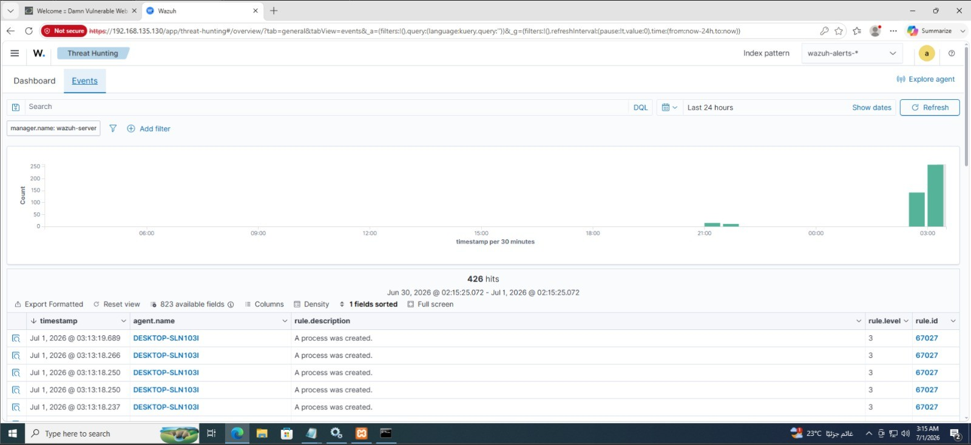
Figure 6.1: Wazuh Threat Hunting timeline showing the alert-hit spike during the simu-lation.

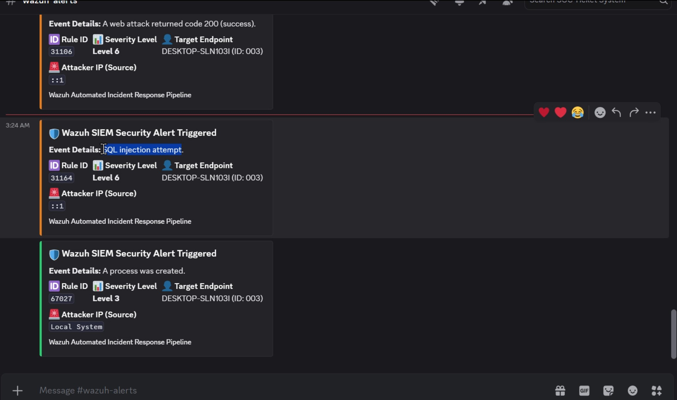
Figure 6.2: Color-coded incident embed evidence in the Discord SOC channel.

Chapter 7
Final Presentation & Reports

User Manual: Reading the Discord SOC Alerts
The Discord channel functions as a lightweight, always-on SOC dashboard. Each detected incident arrives as a graphical embed (card). SOC analysts interpret an alert as follows:
    - Border Color (Severity at a glance): The left border color is set by the Wazuh severity level — Green for Level 1–4 (low risk), Orange for Level 5–9 (medium risk), and Red for Level 10+ (high/critical). Red cards demand immediate triage.
    - Title (Rule ID): Identifies the triggered Wazuh rule (e.g., Rule 67027 for a process creation, or Rule 92154 for a taskschd.dll persistence load).
    - Description: A plain-text summary of what the rule detected.
    - Severity Level field: The numeric Wazuh level, provided as a redundant text label so severity is clear without relying on color alone.
    - Source IP field: The source IP extracted by custom-discord.py. For internal OS events (such as process creation or a DLL load) this reads N/A, signalling a host-based rather than network-based detection.
    - Target Endpoint field: The endpoint that produced the telemetry (e.g., DESKTOP-SLN103I)
— the first pivot point for investigation.
Recommended analyst workflow: (1) scan for Red cards first; (2) read the Rule ID and description to classify the threat; (3) note the Target Endpoint (and Source IP, if not N/A); (4) pivot to the Wazuh Dashboard for the full MITRE mapping and raw event details; and (5) execute the appropriate incident response (e.g., isolate the host and kill the offending process).

Conclusion
This project delivered a complete, validated SOC pipeline on an isolated VMware VMnet8 network (192.168.135.0/24): a Wazuh Manager (192.168.135.130) ingesting Sysmon telemetry from a Windows 10 endpoint (DESKTOP-SLN103I, 192.168.135.131), custom MITRE-mapped detection rules, an internal malware simulation exercising native process

creation (Rule 67027) and taskschd.dll persistence (Rule 92154), and an automated custom-discord.py integration delivering dynamic, color-coded incident alerts — with the source IP gracefully reported as N/A for host-based events — to a Discord SOC dashboard. The measured outcome of 1,089 total hits and 420 direct hits confirms the accuracy and reliability of the detection and alerting workflow.

