Top UI Templets:
1) EasyDev :

Link:- http://previews.aspirity.com/easydev/dashboard_default

EasyDev is a modern dashboard template based on React Components and Bootstrap 4 Framework. We’ve used modern technologies and best practices that’s why you can easily work with our product. It’s the most convenient template for developers, because of React Components, clean code and detailed documentation, which allows you to build any projects easily! Use it for e-commerce, analytics, sports and other types of web or mobile applications.

Screen:-
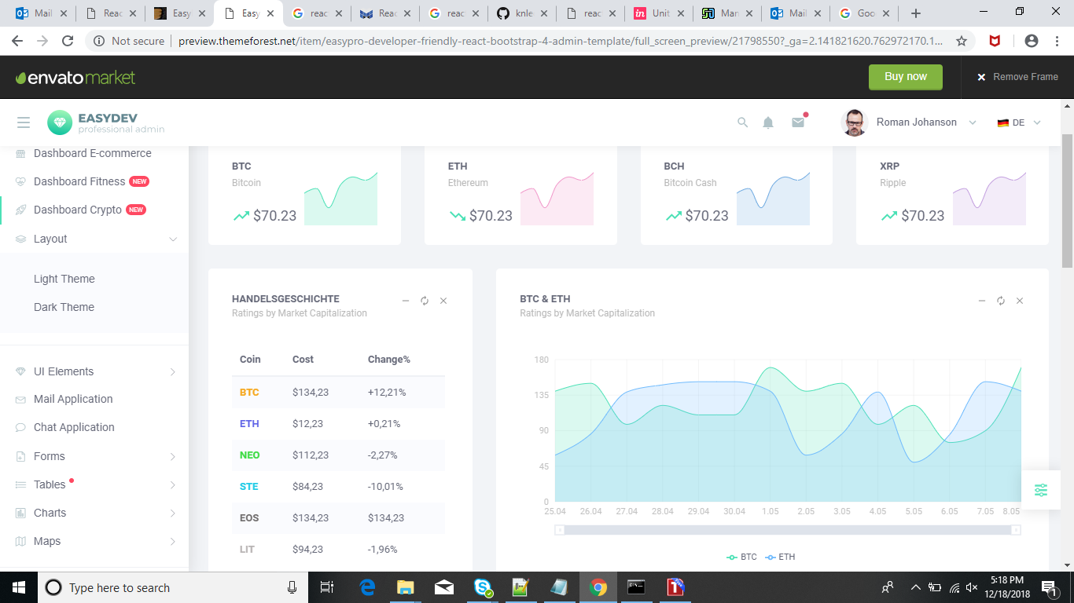

License:-

No, our Regular License is for a free end product (whether or not the item is used in the end product in an editorial way). And our Extended License is for an end product that's sold (whether or not the item is used in the end product in an editorial way). If you want to use an item in an editorial way in your end product, choose the Regular License if your end product is distributed for free, and choose the Extended License if your end product is sold to the end customer.

Price:-

Regular License :- $26(Single user) + 6 month Support from Aspirity
+ $8.25(Extend support to 12 months)

Extended License:- $400(Multiple user) + 6 month Support from Aspirity
+ $75(Extend support to 12 months)

Advantages:

- Bootstrap 4 Stable (4.0.0)
- Fully Responsive Layout
- SASS Powered
- 100+ Pages
- Free Icon Fonts
- 200+ UI Elements
- Dashboard Cards & Widgets
- Shop and Listing Cards & Widgets
- Responsive Navbar Menu
- 3 Kinds of Charts (Recharts, Chart.js, React-vis)
- Form Validation
- Form Wizards
- React WYSIWYG Editor
- Material-ui
- Redux
- Redux Form
- React Router 4
- React-smooth-scrollbar
- Reactstrap (Bootstrap 4 components)
- React-slick
- React-big-calendar
- Colored Tables and DataTables
- Google and Vector Maps
- Two Color Themes
- Unlimited Theme Possibilities
- FREE Lifetime Updates

Disadvantages:

Unfortunately, this template doesn’t include firebase.

2) Isomorphic:

Link: https://isomorphic.redq.io/

A react-redux powered single page admin dashboard. Used progressive web application
pattern, highly optimized for your next react application.

Screen:
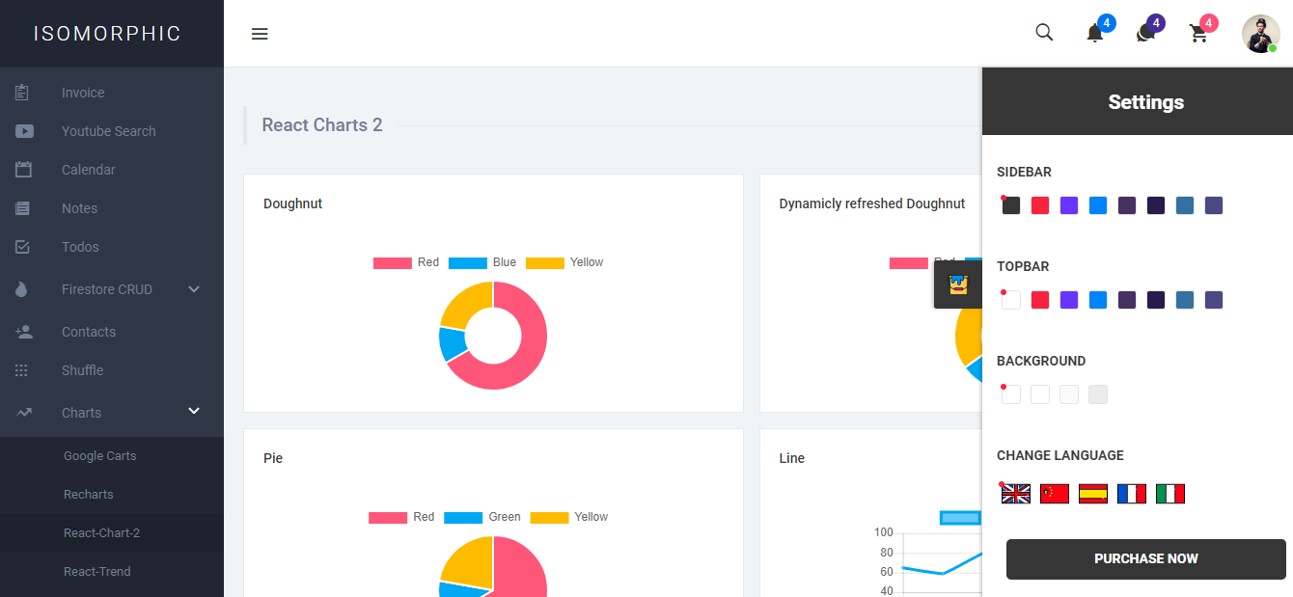

License:

The majority of our items (themes, code, graphics, 3D and flash) are covered by our Standard Licenses. If your end product including the item is going to be free to the end user, then a Regular License is what you need. An Extended License is required if the end user must pay to use the end product.

Price:

Regular License: - $24(Single user) + 6 month Support from Redqteam
+ $7.50(Extend support to 12 months)

Extended License: - $800(Multiple user) + 6 month Support from Redqteam
+ $225(Extend support to 12 months)

Advantages:

- Redux
- Redux-Saga
- Webpack 4
- React Router 4
- Async Loading
- Code Splitting.
- Flexbox Grid.
- Ant design
- RTL supported
- Multilingual supported
- Styled Component
- Ionicons
- Firebase
- Algolia
- Auth0
- Babel, ES6 & Prettier
- JWT implementation Included [ Express, Laravel, Spark, Flask, Django ]
- Firebase firestore CRUD.
- Separate Next JS implementation.
- multiple charts and tables

Disadvantages:

- Pricing: Paid
- Need to re-design few components and layout
- May have to create supporting components for UI

3) React-Admin

Link: https://marmelab.com/react-admin-demo/#/

A frontend Framework for building admin applications running in the browser on top of REST/GraphQL APIs, using ES6, React and Material Design. Previously named admin-on-rest. Open sourced and maintained by marmelab.

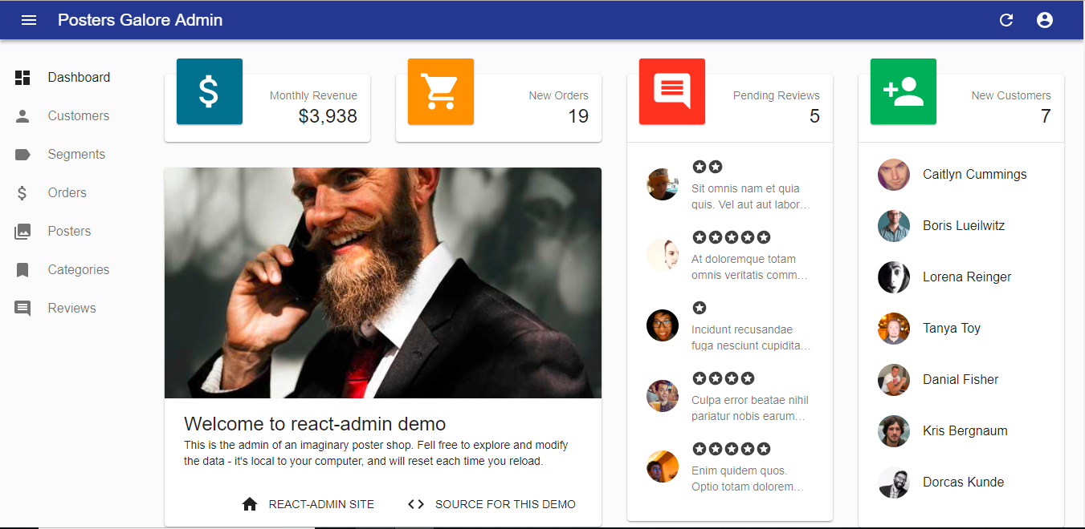

License:
React-admin is licensed under the MIT Licence, sponsored and supported by marmelab.

Permissions
- Commercial use
- Modification
- Distribution
- Private use
Limitations
- Liability
- Warranty
Conditions
- License and copyright notice

Support: At Stack overflow Support

Features:

- Adapts to any backend (REST, GraphQL, SOAP, etc.)
- Complete documentation
- Super-fast UI thanks to optimistic rendering (renders before the server returns)
- Undo updates and deletes for a few seconds
- Supports relationships (many to one, one to many)
- Internationalization (i18n)
- Conditional formatting
- Themeable
- Supports any authentication provider (REST API, OAuth, Basic Auth, …)
- Full-featured Datagrid (sort, pagination, filters)
- Filter-as-you-type
- Supports any form layout (simple, tabbed, etc.)
- Data Validation
- Custom actions
- Large library of components for various data types: boolean, number, rich text, etc.
- WYSIWYG editor
- Customize dashboard, menu, layout
- Super easy to extend and override (it’s just React components)
- Highly customizable interface
- Can connect to multiple backends
- Leverages the best libraries in the React ecosystem (Redux, redux-form, redux-saga, material-ui, recompose)
- Can be included in another React app

Disadvantages:
- No Graph or Chart components have to use 3rd party: D3, Ant V, Chart.js
- Only one default theme we have to create other themes as per client requirement.
- Contains only basic components which works as container.
- Need to spend time on modifying the default behavior of existing components.
- Some of the UI components have stringent behavior, it may require to look for a workaround.

