Planetary Purchasing
CST336 Final Project

A Node based website to purchase planets and stars

By: Alejandro Caicedo
Ivan Alejandre
Randy Son
Matthew Chan

Introduction
This project consists of a Login Page which requires the user to enter credentials which will be compared against a MySQL database. The user will be welcomed to a welcome page which will have the most recent space based news as well as a navigation bar that updates depending on the user. From this page the user can search for planets to purchse, if they are an admin they can go to the admin page and edit the tables that make up the MySQL back end. The search page houses the item catalogs and allows the user to query the available items. Here the user is able to add items they like to the cart which is stored in the database. The shopping cart displays the user’s cart, gives the user the ability to change any of their item’s quantity as well as giving them the ability to remove items. A subtotal is displayed at the bottom for the user and a checkout button to lead them to the next step. IVAN AND MATTHEW SUMMARY HERE

Login Page
The login page requires the user to enter a user name and password which are then POSTed to the appropriate route. In this case the “ac_login” route. In this route a DB connection is created, then a query is formed to return the users credential information. If the user name matches what is in the DB then the password hash is compared to the hash of the password that was entered. If those match then the “authenticated” boolean turns true. The isAdmin boolean is then parsed to determine if the user is an admin. These booleans along with the user name are saved in an express session for use in the other routes. If the user was authenticated in the previous step the welcome page is loaded, to it are passed API information on space news and the NASA picture of the day along with other user specific relevant information for rendering. Image shown below.

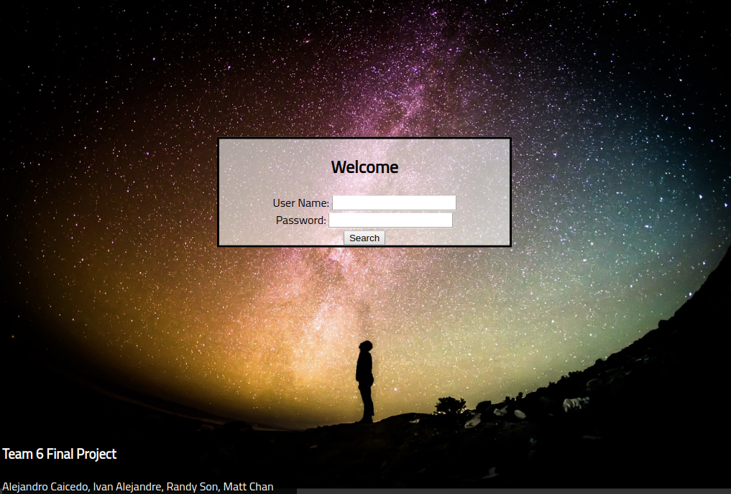

Welcome Page
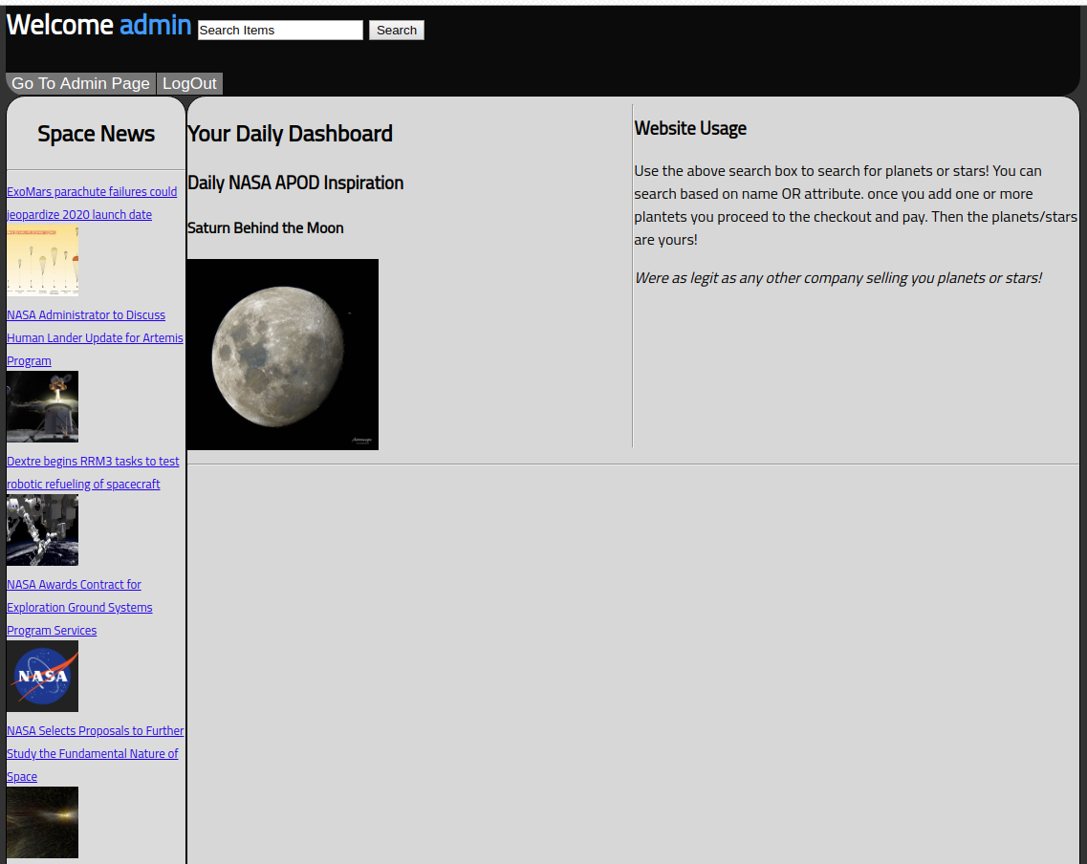
The welcome page shows the information passed to it from the “/ac_login” route. This includes 8 of the top space news stories from the “spaceflightnews.new” API as well as the NASA Picture of the day. The news is displayed in a column aptly called “Space News”, and the NASA picture of the day is in a section called Daily Inspiration. The buttons at the top of the admin page load based on the users “isAdmin” boolean. If the user is an admin then the “Go To Admin Page” button loads, if not then this does not load. The logout button loads irrespective of the users “isAdmin” status.

Search
The search page details the products available. It utilizes AJAX to fetch product information and can search the database using three criteria: the item’s name, the item’s price and the item’s description. This data is sent to the /api/querySearch route. Here the SQL query is generated based on the checked filters and search query. Upon query success, each row from the query generates a product card containing details about the item. At the bottom of each product card is a quantity input and an “Add to Cart” button. Another API, /api/cartAction handles adding, updating and removing items from the shopping cart, (cst336_project.usercart). The API first checks if the userID and itemID combination exists. If it doesn’t, it will insert a new row with that combination along with the item quantity. If the userID and itemID combination exists, then it will update that row with the newly calculated total item quantity.

The schema for usercart is as follows:
CREATE TABLE `usercart` (
`userID` int(11) NOT NULL,
`itemID` int(11) NOT NULL,
`itemQuantity` int(11) NOT NULL
);

The cartAction API utilizes req.session.userID which is set upon login for the user’s ID. The last two parameters, itemID and itemQuantity are passed as arguments and into the generated SQL query.

Search utilizes Bootstrap for design and a toast library (https://kamranahmed.info/toast) to display information to the user upon interacting with cart API.
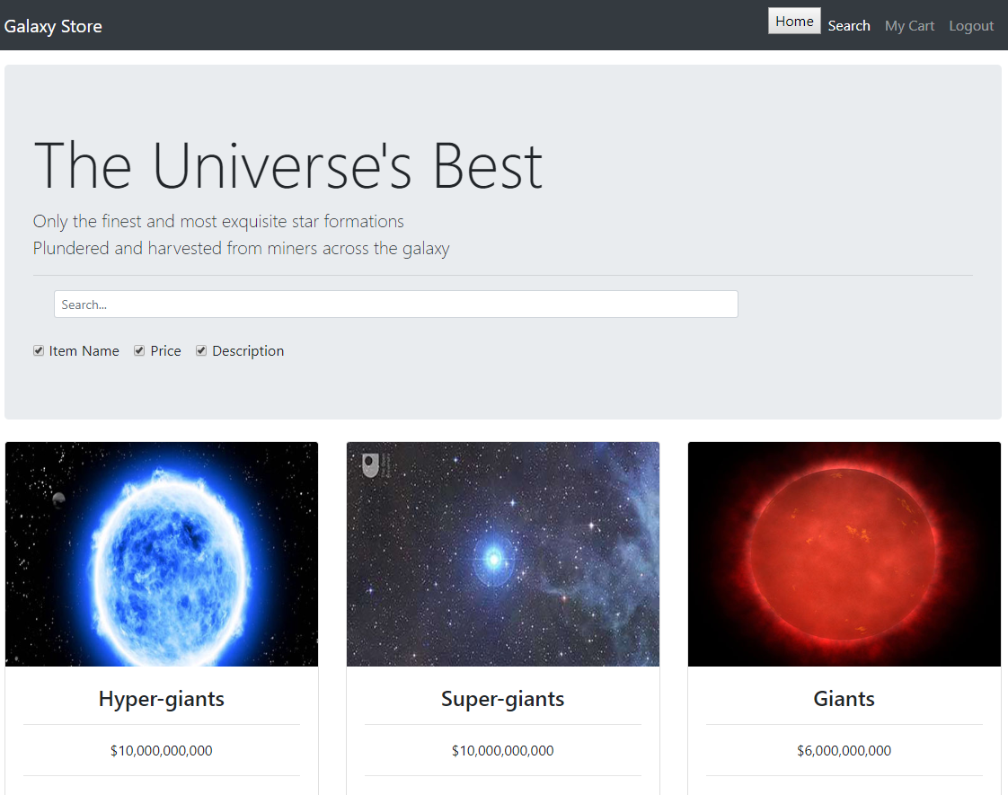
Shopping Cart
The shopping cart page displays the items for the user which the user had added into the table usercart. On this page, jQuery and AJAX calling the cartAction API handle the main functionality. Increasing or decreasing the quantity input updates the values in database. In addition, the trash can button deletes the userID and itemID combination from the usercart table. The subtotal at the bottom is calculated using a query that multiplies the quantity and the price of items together. AJAX calls this query and displays it. Two buttons exist: one to send the user back to the item catalog and the other to head to check out.

