

***Vacation Rental***

***SRS document***

*TA:* ***Dr. Noha Medhat***

|  |  |  |
| --- | --- | --- |
| محمد عادل أبو الفتوح حسين | 2017170347 | 14 |
| عمر محمد السيد حسن البهوتي | 2017170263 | 11 |
| محمد زكي حسين السعيد | 2017170337 | 14 |
| منه الله ابراهيم غريب حماده | 2017170446 | 17 |
| ميار خالد صابر فرغلي | 2017170464 | 17 |
| محمود شريف عبدالقادر أبو صالح | 2017170398 | 15 |

**1. Introduction**

* + - * **1.1 Purpose of this document**  
        This document lays out the description of the software that is to be developed as well as set the requirements (functional and non-functional).

1. **1.2 Overview**  
   This system automates the processes and activities of a travel and tourism agency.

**2. General Description**

1. **2.1 Product Functions**  
   The system helps travelers to plan a trip, and perform all operations related to traveling and sight-seeing
2. **2.2 Similar System Information**  
   This system simulates the “tripadvisor” system in a simple way. 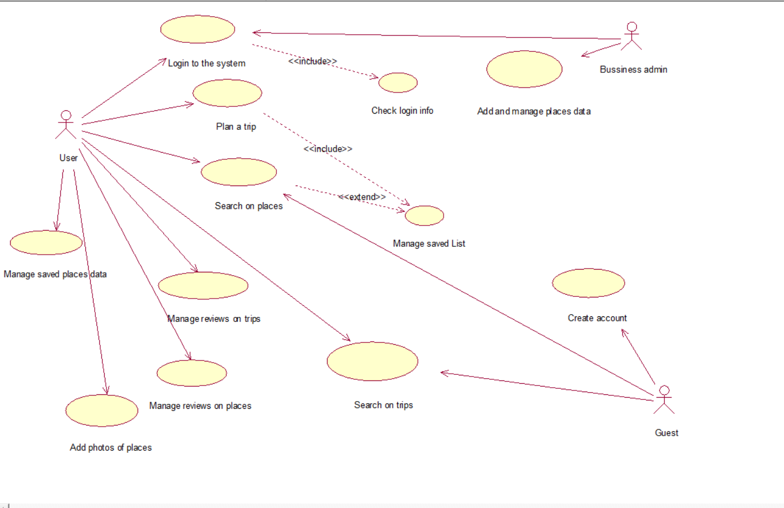
3. **2.3 User Problem Statement**  
   In the present system a customer has to approach various agencies to find details of places and to book tickets. This often requires a lot of time and effort.
4. A customer may not get the desired information from these offices and often the customer may be misguided.
5. **2.4 User Objectives**

* Help managing a trip & itinerary.
* Help finding a nearby place, touristic, hotels and restaurants...etc.
* Easily access the relevant information and make necessary travel arrangements.

**3. Functional Requirements**

1. **The system should have detailed information about places.**
   * **Description:** The system should have the contact info of every place , location ,Ratings,photos,menu , price range ,rank , category and type of every place that it contains.
   * **Criticality:** This is the most important requirement.
   * **Risks:** The information provided from hotels and restaurants can be poor and can be updated frequently.
2. **User should be able to search for places and trips.**
   * **Description:** The user should be able to search a specific place by entering its name and should be able to add filters to his search.
   * **Technical issues:** The user cannot find a specific place or trip.
3. **User should be able to plan a trip.** 
   * **Description:** The user should be able to choose the trip city, start date and end date..etc and he can also view the reviews and rates.
   * **Risks:** The user must have network access to save his trip successfully.
4. **User should be able to register / login to his account.**
   * **Description:** Users must have an account to use the application.
   * **Criticality:** This an important step to what the user has to do.
   * **Technical issues:** The data the user entered isn’t valid.
5. **User should be able to add/ remove the places to his account.**
   * **Description: T**he user can browse the available places and pick his favorite ones and save them for future trips.
   * **Dependencies with other requirements:** The user must be logged in.
6. **User should be able to add / remove / update a place to his trip.**
   * **Description:** The user can add the places he liked to his trip,Update his list of places or remove from it.
   * **Dependencies with other requirements:** Must have a trip reserved.
7. **User should be able to add / remove / update reviews about trips or places.**
   * **Description:** The user can go to the review page where he can write his review about a specific place or a trip then he can remove, update it.
   * **Dependencies with other requirements:** The user must be logged in.
8. **User should be able to add photos of the places of their trip.**
   * **Description :** User can add photos of his trip on his profile.
   * **Dependencies with other requirements:** The user must be logged in.
9. **Business admin should be able to add / update places to the program.**
   * **Description :** The admin can add new places to the application or update the information of current ones.
   * **Dependencies with other requirements:** Must have logged in with an admin account.
   * **Criticality:** Very important because places information must be up to date.
   * **Technical issues:** Check if the place is already added to avoid duplicates.