**Faculty of Information Technology**

**IN1900-Hardware Project**

**Mosquito Repellent and Air Freshener Rover**

Group No: 23

Index Numbers and Names of group members

|  |  |
| --- | --- |
| **RAJAPAKSHA**  **R.A.D. P** | **184136D** |
| JAYARATHNE  H.M.D. T | 184060M |
| MARAPANA  T. N | 184101R |
| KUMARASIRI  N.K.Y. S | 184086X |
| FERNANDO  B.H.S.M | 184041G |

Supervisor’s Name: Date of Submission:

Mr.B.H.SUDANTHA 20/01/2020

***Table of Contents***

**1.Introduction** 3

**2.Literature survey** 4

**2.1** **Wall following robot** 4

**2.2 Autonomous sprinkler system with object avoidance** 4

**3. Aim & Purpose** 7

**3.1 Aim** 7

**3.2 Objectives** 7

**4.System Description** 8

**4.1 System diagram** 8

**4.2 3D diagram views of proposed system** 9

**5. Testing & Implementation** 10

**7.Cost Estimation** 13

**Appendix A** 14

**8. Design of PCB**………………………………………………………………………………………………………………………………15

# **1.Introduction**

These days, there is an increasement in the number of insect-borne diseases in the world. Among these insect, flies and mosquitos are prominent. Mosquito can cause sickness and death through the diseases the carry. According to the world health organization mosquitos infect over 300 million people a year with malaria and dengue, just two of the life-threatening diseases mosquitoes can carry. Hose flies are strongly suspected of transmitty at least 65 diseases to humans including typhoid fever, dysentery, poliomyelitis, anthrax and tuberculosis. Flies regurgitate and excrete whenever they come to rest and thereby mechanically transmit disease organism. To help prevent these hazards, automatic device will be introduced here.

Using different kind of fresheners in different bottles can create an affliction and also a lot of time-consuming task. So here we are going to introduce a system to automated that also.

# **2.Literature survey**

## **Wall following robot**

The wall following robot must be capable of detecting and avoiding obstacles. The design of such a robot requires the integration of different sensors, such as bump sensors, infrared sensors, ultrasonic sensors, etc. By mounting these sensors on the robot, it can get information about the surrounding area. An ultrasonic sensor is suitable for obstacle detection for a slow-moving autonomous robot, as it has a low cost and relatively high range.

An ultrasonic sensor detects objects by emitting a short ultrasonic burst, and then listening for the echo. Under the control of a host microcontroller, the sensor emits a short 40 kHz pulse. This pulse travels through the air until it hits an object, and then is reflected back to the sensor. The sensor provides an output signal to the host that terminates when the echo is detected. This way, the width of the returned pulse is used to calculate the distance to the object.

## **2.2 Autonomous sprinkler system with object avoidance**

Most if not all home sprinkler systems are open-loop, mechanical-based systems that are adjusted manually to output constant water flow that does not take into consideration the current state of the system’s surroundings.

Without checking whether the lawn is moist already from rain, if the weather conditions are appropriate for watering, or if an object is passing the water jet or not, the sprinkler remains active.

With the usual sprinkler parts employed by these products as the base and an attached hose to supply the water, the proposed sprinkler system makes use of valves to control the flow rate in order to avoid objects. When an obstruction approaches the sprinkler within its sensing range, the sprinkler will hinder the water flow in the direction of the object.

The proposed product is an autonomous, weather-controlled sprinkler system utilizing an obstruction sensing and avoidance method. A PIC16F57 microcontroller embedded in a Parallax BASIC Stamp chip will be the CPU of the product. Sensors capable of detecting weather conditions such as a soil moisture, temperature, and light will be interfaced in order for the system to decide when it is appropriate to initiate sprinkling.

Along with a timer integrated circuit, this system will autonomously employ both weather and time control. A series of push buttons and an LCD will also be exploited with a remote controller to allow for human interaction and manual control. Upon completion, the autonomous sprinkler system with object detection and avoidance will prevent what has irritated so many of us for so long in the form of a practical, easy to afford mechatronics solution. Due to slight errors in circuitry and programming, the release of this product is delayed.

**3. Aim & Purpose**

## 

## **3.1 Aim**

To repel mosquitos, flies and freshen the air of a home with maximum effectiveness, without the use of toxic chemicals.

## 

## **3.2 Purpose**

* Using a wall following robot we can make a mobile device that can make a mobile device that can move around the house and carrying the spraying system with it.
* Design it such a way that solution should be feasible.
* To study about all necessary technologies including Atomizer, Motors, Microcontroller programming and basic mechanics.
* Need to make a mechanical parts to mimic the manual process unless otherwise it is impossible to replace that relevant process by machines.
* Have to design and implement new technics in order to obtain a mosquito free and refreshed environment around the user.
* Using Atomizer relevant liquid will spray out to the backward.
* Mini fan helps to spread it out
* Using keypad we can control the selection of spraying system manually.
* Have to make this machine smaller and handy which will suitable for household use.
* Thinking about the safety and easier way to repellent mosquitos and keep an incense environment after use is must .
* End product should carry high market potential.
* The user of this system might not need to consume more time on this regard (get rid of mosquitos and flies), hence user can save time for another task.

**4. System Description**

## 

## **4.1 System diagram**

Temperature & Humidity sensor

Check the humidity and temperature

To find the diffusion rate in order to keep that in a relevant constant

Activate wheel actuators & control

Tracks the wall and the distance

Ultrasonic sensor

Turn on or turn off the LED pannel

Detect the Daylight

LDR

Stimulate the relevant Atomizer

Generate the signals for relevant mode

Keypad

**5. Testing & Implementation**

Constructing the rover and motor testing

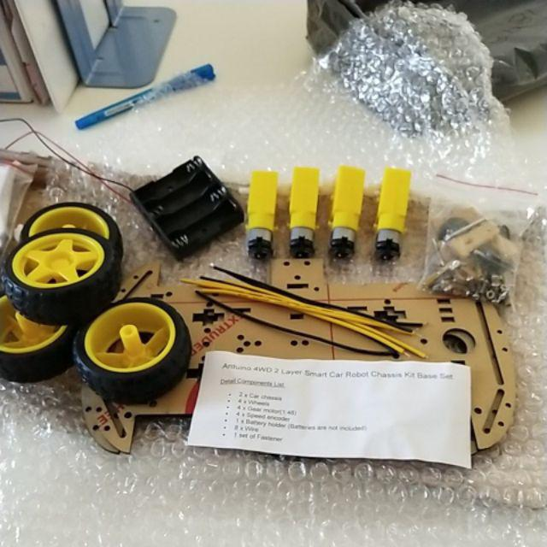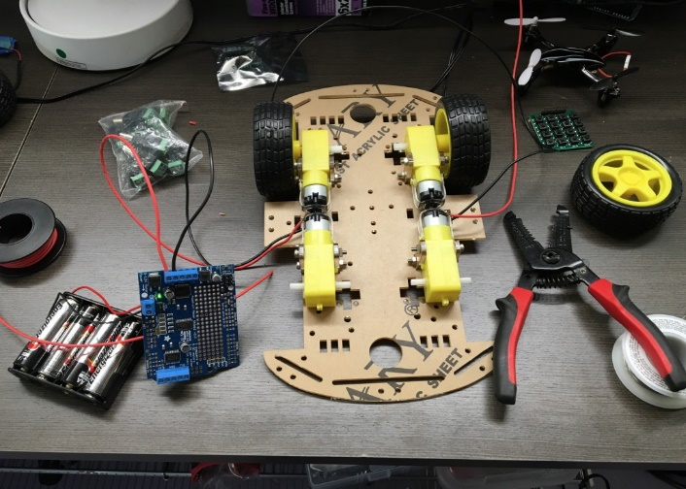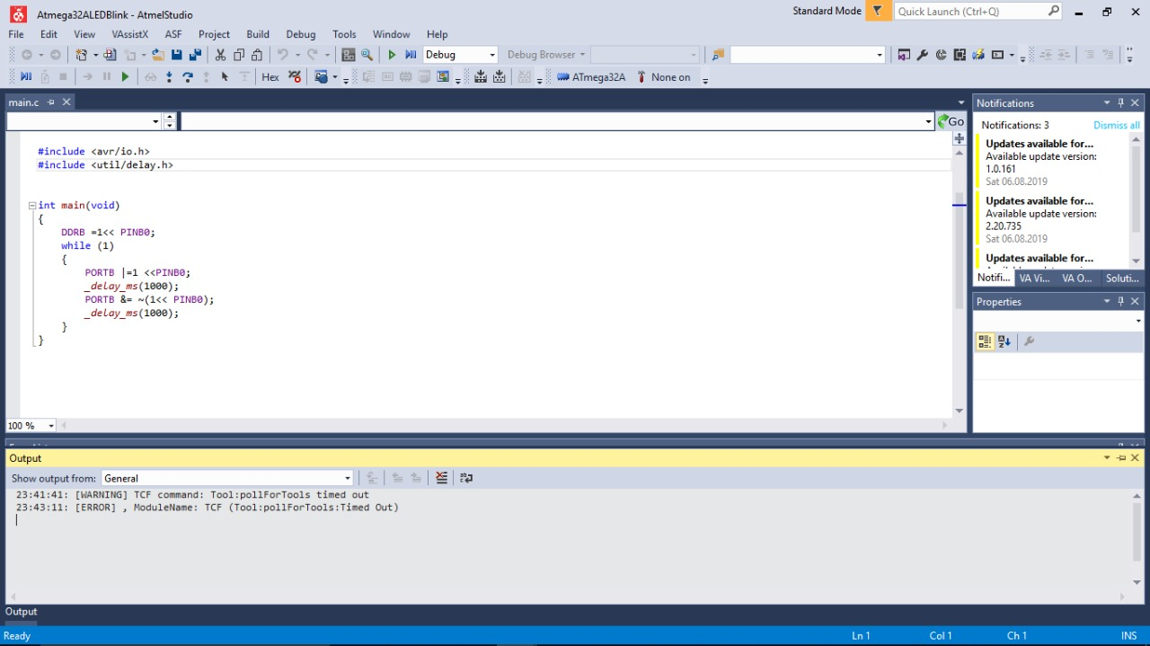

LED Blinking

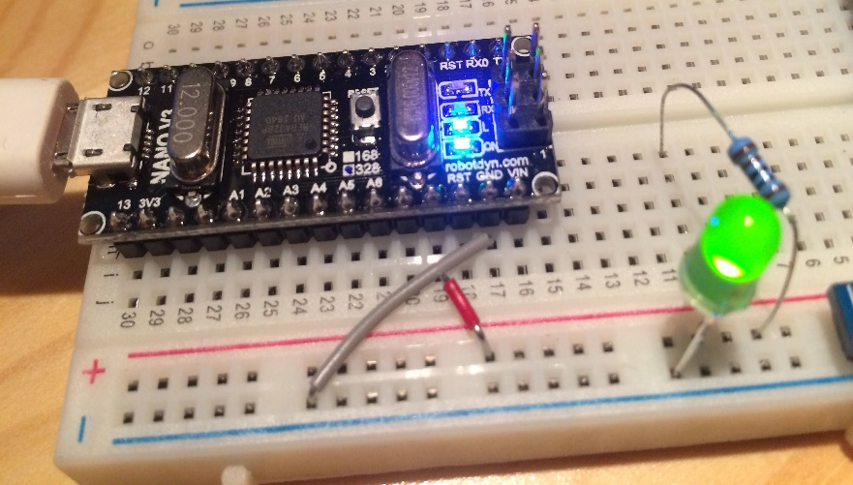

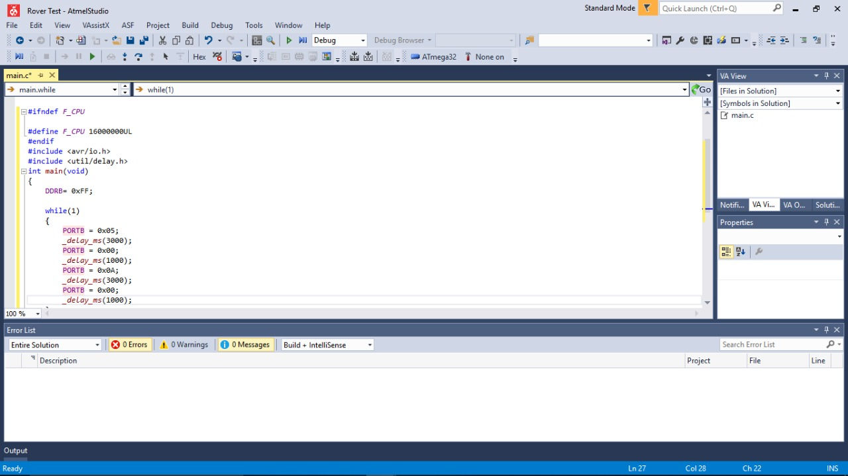

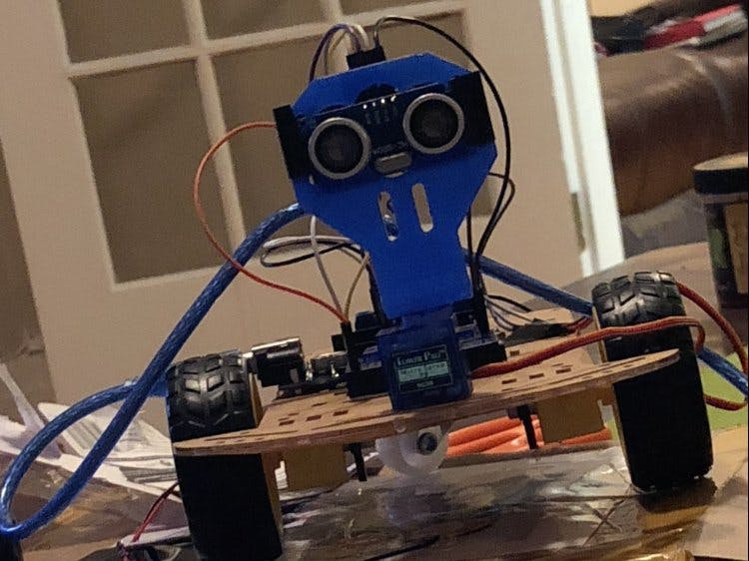Ultrasonic sensor testingand measuring distances

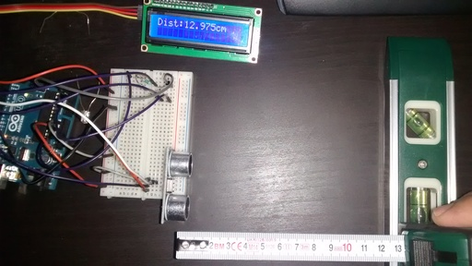

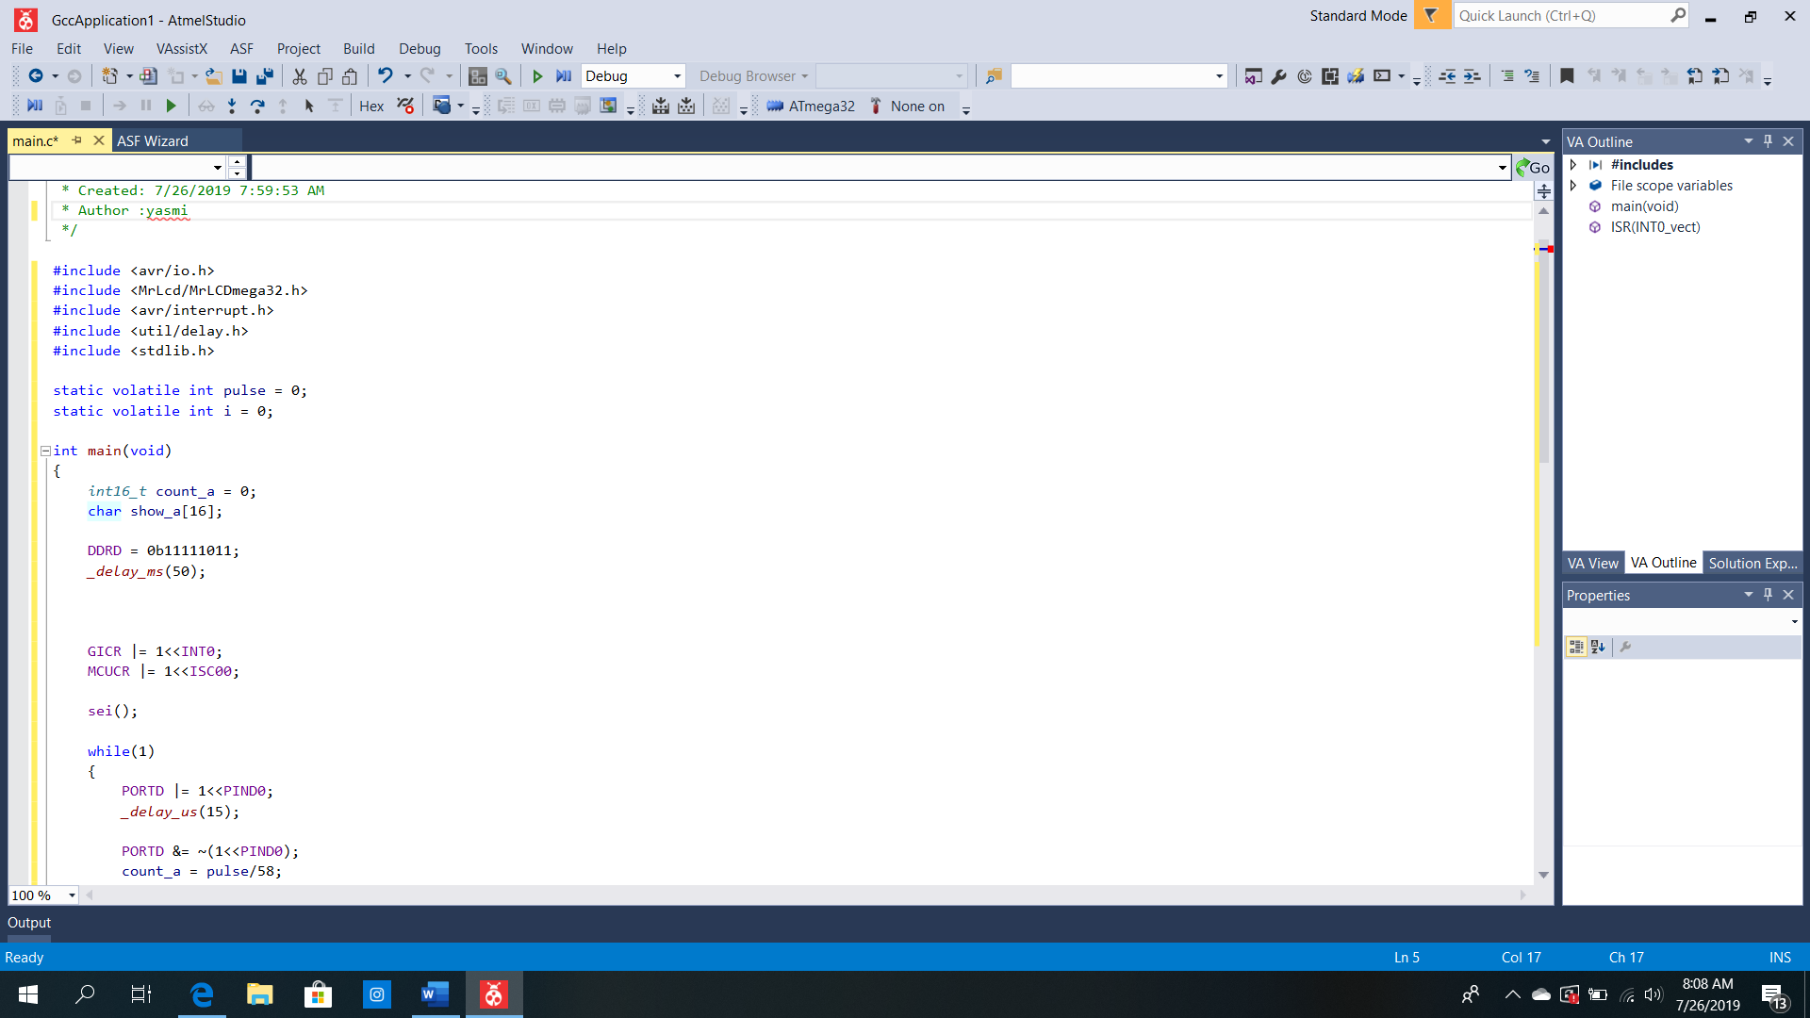

# **7. Cost Estimation**

|  |  |  |  |
| --- | --- | --- | --- |
| **Component** | **Unit price** | **Quantity** | **Price** |
| Microcontroller | 450 | 2 | 900 |
| Battery pack | 1200 | 1 | 1200 |
| Battery power adapter | 310 | 1 | 310 |
| 40 pin header m/m | 20 | 2 | 40 |
| 40 pin header m/f | 15 | 3 | 45 |
| I2C connector | 120 | 1 | 120 |
| Ultrasonic sensors | 200 | 2 | 400 |
| Bread board | 250 | 1 | 250 |
| 7805 regulator | 15 | 1 | 15 |
| 4 wheel chassis | 1500 | 1 | 1500 |
| Relay Module | 380 | 1 | 380 |
| 4 Key metric keypad | 125 | 1 | 125 |
| Rocker switches | 15 | 2 | 30 |
| Copper Board | 200 | 1 | 200 |
| Atomizer | 890 | 2 | 1780 |
| Fecl3 Liquid | 120 | 1 | 120 |
| 5v mini Fan | 160 | 2 | 320 |
| Developing board | 400 | 1 | 400 |
| Wires | 360 |  | 360 |
| Cover boards | 90 | 1 | 90 |
| 9v Battery | 65 | 1 | 65 |
| **Total** |  |  | **8650** |

# **Appendix A**

**Individuals Contribution to the Project**

**Student Name:** RAJAPAKSHA R.A.D.P (184136D)

I am allocated for researching about ultrasonic sensors.

Powering up ultrasonic sensors and detect the distance with the wall and get the input. when ultrasonic sensors detect any obstacle, it takes as the input and then relevant signal output are send to wheel motors.

**Student Name:** JAYARATHNE H.M.D.T (184060M)

I’m allocated for research about and design the moving process of the rover. Design the changings of DC motors along with the ultrasonic sensor output signal further more. Ultrasonic sensor output catch up by DC motors and rover will create its own path.

|  |  |  |  |
| --- | --- | --- | --- |
| **Front Sensor** | **Left Sensor** | **Situation** | **Action** |
| **Off** | Off | Robot is driving near the wall | Come back to wall, turn left. |
| **Off** | On | Robot is following the wall. | Drive forward. |
| **On** | On | The robot is at the corner. | Turn hard right |

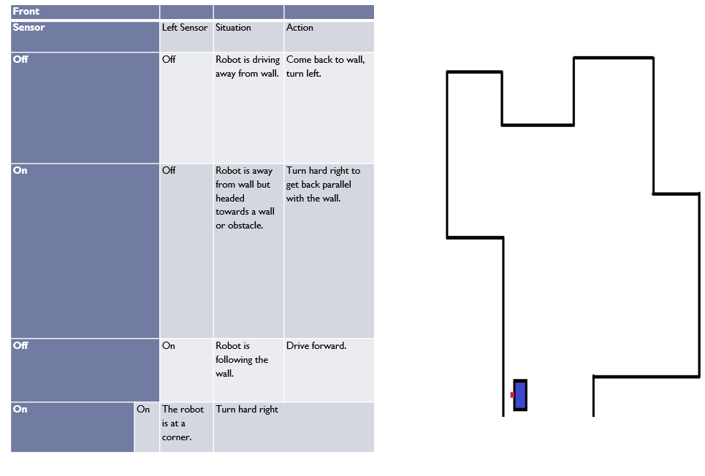

**Student Name:** MARAPANA T.N (184101R)

I am allocated for researching about spraying system .

We hope to use separate Atomizers for each liquids. Keypad is using to select the atomizer which should be activate. In each 10 seconds Atomizer gets signals from humidity and temperature sensors through microcontroller to spray out relevant liquid to control the spraying time. When rover moving forward liquid will spray out backward.

Mini fans are using to spreadout the vapour

**Student Name:** KUMARASIRI N.K.Y.S (184086X)

I’m allocating for research about Temperature , humidity sensors and get the inputs of those sensors.

When temperature is above a given level the speed of spraying will be increased. And when humidity is above a given level the speed of spraying will be decreased. And we hope to show that using temperature and humidity sensor.

**Student Name**: FERNANDO B.H.S.M (184041G)

When it comes to dark background, with the help of LDR, led will light-up, it helps to identify the rover in dark and also here basic chassis structure and later develop its’ components for our further convenience. In chassis allocated separate areas for particular components.

Also arrange a relay module to switch the relevant mode of the machine , and make this machine finished smaller and handy which will suitable for household use .

**Appendix B**

**References**

https://www.instructables.com/id/Wall-Following-Robot-Obstacle-Avoiding-Robot/

<http://npic.orst.edu/factsheets/citronellagen.html>

<https://github.com/acss-io/atomizer/issues/352>

**Structure of PCB**

