Team Ramen: 3/5/2020
Dan Kim
Julian Grabowsky
Man Hin Kwong

Bachelor of Creative Software
CS103
App Proposal & IDD Report

Contents
Proposal
Propose 2
Target Audience & Stakeholders 2

IDD
Key Features 3
Wireframes 5
Production Schedule 8
Branding 10

Proposal
Purpose (Julian)
This app will be made for these who have problems with sticking to what they were supposed to do. Or for those that usually want to do a task but the doing something else and forgetting about it. In short it will be a time and task managing app.
But most people are to lazy to open a app just to check what they where supposed to do. So we also include a second feature, a pet. The pet will be the reason why you will keep opening the app.

Target Audience & Stakeholders (Man)
The target audience of this app are casual gamers and animal lovers who want to manage their time more effectively, focus on important tasks and stick to goals. This app will provide tools to help them meet these needs while also entertaining and engaging users for long term retention.
The stakeholders of this app include users (who may become customers through in app purchases), investors and the developers (us).

IDD
Key Features
Task Management and Productivity Tracking (Man)
The app will handle task management with a todo list where tasks can be added, cancelled, edited and marked as completed.
When a task is selected for execution it will be passed onto the time management features.
Each completed task will award points to the user that can be used to buy items at the shop.
The tasks may be set to repeat on specified days of the week, assigned deadlines and can be organized into different categories by colour coding. Tasks may be sorted into multiple categories.
Categories will include whether the task is important, urgent, to be done in the morning, afternoon or evening. The user can also add their own custom categories and assign colours to that as well.
The app will track productivity by recording the tasks completed and the time spent executing tasks daily. This record will be displayed as a line graph..
Timer (Dan)

Pet (Julian)
The pet (together with the time management feature) wil be the main reason why you would pick up this app, after all, opening an app just to cross off another task is more work then just cross off a task on a sheet of paper.
For the start we will only make ONE pet, later on we might change that to multiple pets and if possible even inplement a “petcreator” where one can create their own pet from multiple different assets.
The pet will react on how well you do in your tasks. If you do less of them the pet will become unhappy and when a task, you currently work on, is uncomplete the pet will be obscured by it, making it more or less unnable to interact with it. Finishing the task will be essential to interact with said pet.
Also on the pet screen will be your next upcoming task and every (up to 3) tasks upcoming in the next 2 hours.
In the upper right corner you will have a number showing you how many task you have upcomming for today, and how many you have already done.
The upper left corner will show the calender, for quick access to the Task manager.
Your current task will also have 3 more buttons, a denied button, if unnable to finish, a done button, if finished and a button wich may stop current task.
Pet will have animations, but since they are time intensive to make, this will be the main factor why we will only make one pet for the now. Including will be idle animation, sad, happy, questioning, eating, toying and leaving.
Shop (Julian)
The shop will be accesable by pressing the coresponding button on the navbar.
The shop will provide a variety of items that can be accesed by using the currency gained by completing tasks (occasionaly also by caring for the pet). Some items can be bought multiple times, others only once. Items available will be accesoirs, clothes or food.
The shop will also have a description for most items and a pre-show feature allowing you to view how the item looks like on your pet.
Once an item is bought it can be accessed in the pet screen by pressing the pouch/backpack button, the icon will then move to the right of the screen and open up, displaying your aquired items wich you then can drag an drop onto your pet.
Speciffic items will have different interactions with your pet and may also increase or decrease how much it likes you.
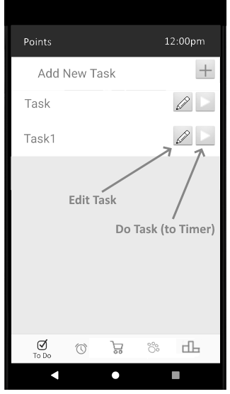
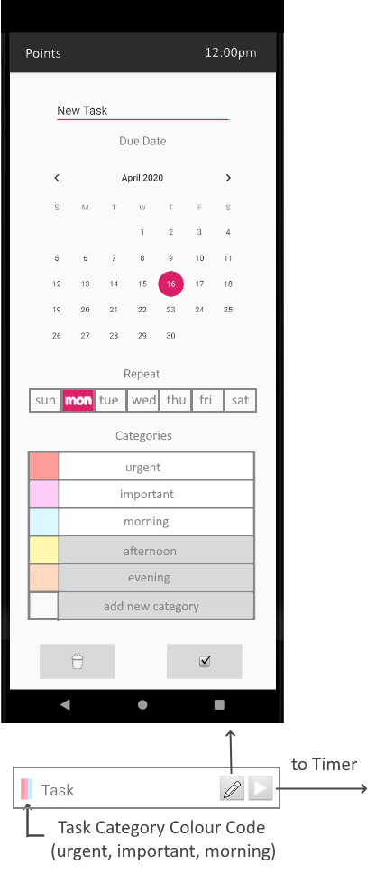
Wire Frames
Todo List (Man) | New/Edit Task Pop Up (Man)
Timer (Dan)  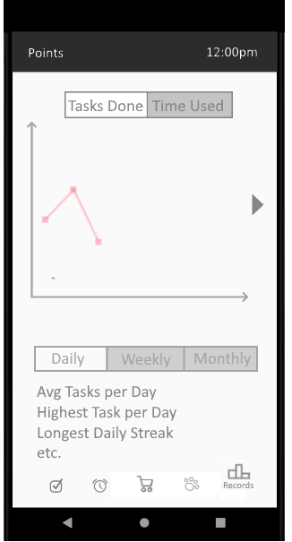  Productivity Tracker (Man) | Pet Interaction (Julian)  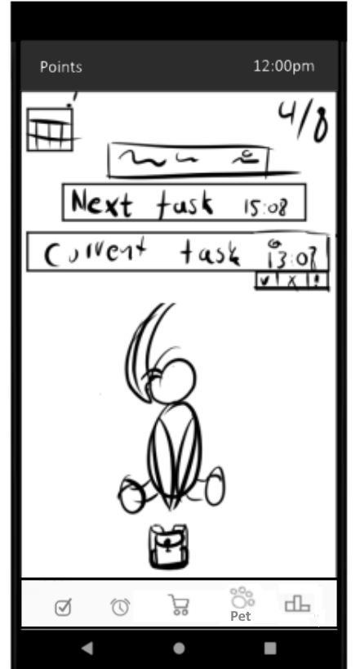  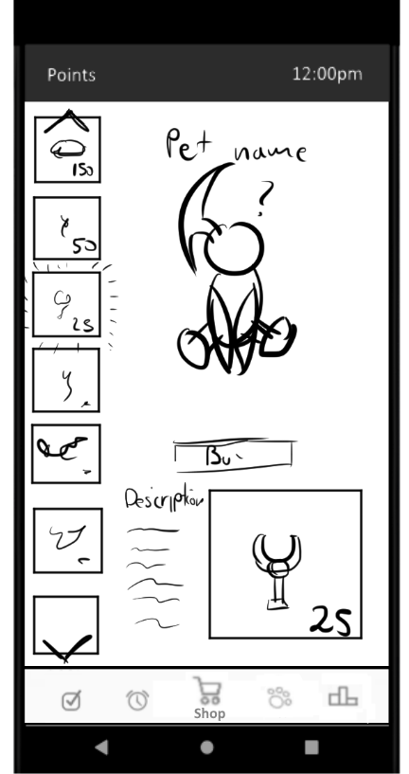  Shop (Julian)

Production Schedule
Week 9

Project Backlog | Sprint Backlog
Todo List | Tasks (add, cancel, do, done)
 | Repeat
 | Colour Code
 | Deadlines
 | Award points
Pet | Pet status (health, affection)
 | Feed pet
 | Petting
 | Basic pet animation
Timer | Set duration, start, pause, stop
 | Schedule breaks
 | Set alarm

Week 10

Project Backlog | Sprint Backlog
Productivity Tracker | Count tasks completed
 | Record time working
 | Colour Code
 | Display weekly histogram
 | Display monthly histogram
Shop | Base Item class
 | Store items in database
 | Display items
 | Buy items
Pet | Use item from shop
 | Animation
Timer | Calendar
 | Deadlines notification
 | Alarm

Week 11

Project Backlog | Sprint Backlog
Shop | Foods
 | Toys
 | Modifications
Pet | Use purchased items
 | Reactions to items
 | Extra animations
Branding | Refine UI
 | Aesthetics

Week 12

Project Backlog | Sprint Backlog
Report | Post mortem
 | Testing
 | Publishing
Presentation (Slides and speech) | Features
 | Market research
 | What makes app stand out

Branding (Dan)

