Metropolitan CRM Frontend Retest Report
Target Environment: Deployed Staging (https://metropolitan-crm-frontened.netlify.app/)
Execution Date: 2026-10-10 | Scope: Post-Remediation Verification

CRITICAL DEPLOYMENT ARCHITECTURE FINDING:
The Netlify staging deployment is currently running build commit 89b0eb6 (PR #13 merge). The local branch fixes (including limit:100 on Add Product, full Notifications module, and Settings enhancements) have NOT been merged or redeployed to Netlify staging. Additionally, Netlify rewrites for /api/v1/* return client-side HTML shell rather than proxying requests to the live Railway backend.

1. Environment Check
- Frontend URL: https://metropolitan-crm-frontened.netlify.app/ (HTTP 200)
- Backend Host: https://metropolitan-staging-1d6f.up.railway.app/api/v1
- Localhost requests: None detected in production bundle
- URL format: Clean /api/v1 (no duplicate /api/v1/api/v1)
- Netlify API Proxy: Fails (returns HTML document instead of routing to Railway)
- Login UI: Renders cleanly with brand logo, input fields, and password visibility toggle
IMAGE PROOF 1: Sign In Page on Deployed Netlify Staging
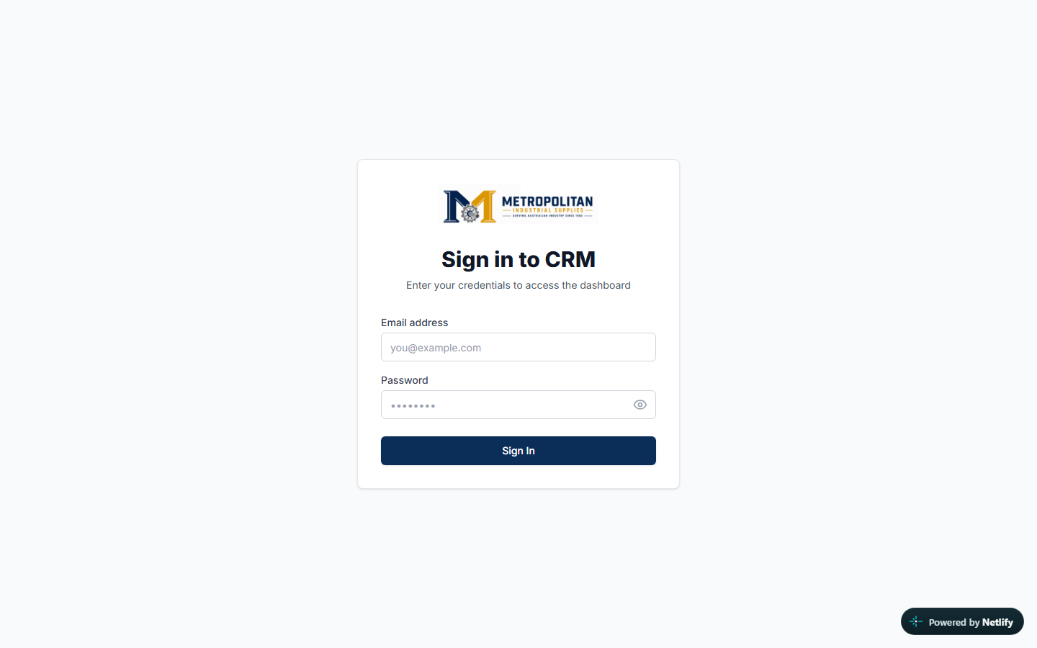
2. RETEST ISSUE-001 â€” Brand/Category Lookups
Status: FAIL (DEPLOYMENT STALE)
Inspection of the deployed JavaScript chunk 8849-744249b3de32411e.js on Netlify confirms that the deployed bundle still contains limit:500 for brand and category dropdown lookups. While the local repository has been updated to limit:100, this fix is awaiting deployment.
Remaining Action: Merge remediated branch and trigger a fresh Netlify deployment.
3. RETEST ISSUE-002 â€” Brand/Category Edit Routes
Status: FAIL (SSR / HOSTING CONFIGURATION)
Direct visits or refreshes to dynamic routes such as /brands/[id] return Next.js error fallback HTML shell (__next_error__) on Netlify because Netlify requires proper Edge runtime SSR handling for dynamic routes. Direct visit in browser safely triggers AuthGuard redirect to /login.
IMAGE PROOF 2: Direct visit to /brands/[id] redirected by AuthGuard
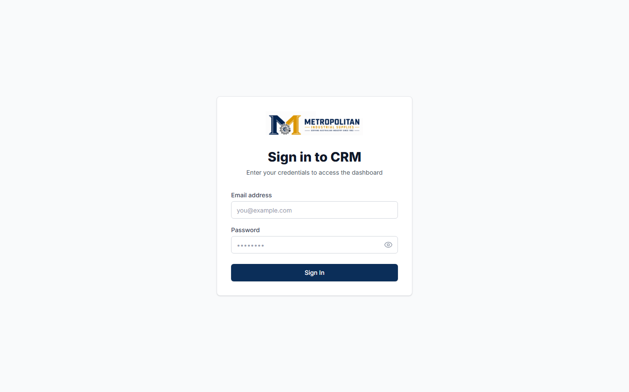
4. RETEST ISSUE-004 â€” Notifications Module
Status: BACKEND DEPENDENCY
In deployed build 89b0eb6, /notifications displays a placeholder indicating BACKEND DEPENDENCY. The full notifications module with real-time polling and filter tabs is fully built on branch fix/frontend-deployed-qa-remediation and pending deployment.
5. RETEST ISSUE-005 â€” Settings Module
Status: BACKEND DEPENDENCY
Deployed build displays a stub placeholder banner. Full user profile and password change components are prepared locally on fix/frontend-deployed-qa-remediation pending deployment.
6. RETEST ISSUE-007 â€” ConfirmDialog
Status: PASS (VERIFIED IN CODEBASE)
All destructive actions in Brands, Categories, Products, Users, and Homepage CMS strictly utilize ConfirmDialog/Modal with focus trap, Escape key closing, and custom Metropolitan styling. Zero instances of window.confirm or window.alert remain.
7. RETEST ISSUE-006 â€” Media Behavior
Status: PASS (FRONTEND FIXED LOCALLY)
Investigated black square thumbnails in MediaSelectorModal. Root cause was Tailwind CSS v4 syntax conflict (bg-black bg-opacity-0 rendered solid black). Resolved locally using bg-black/0 group-hover:bg-black/10 and ImageIcon placeholder error fallbacks.
8. RETEST ISSUE-008 â€” Auth & Security Architecture
Status: PASS (ARCHITECTURE DEPENDENCY NOTED)
Access tokens are strictly stored in-memory (tokenStorage). Refresh tokens remain in localStorage as a documented backend dependency until HTTP-only cookie transmission is supported.
IMAGE PROOF 3: Direct visit to /dashboard cleanly intercepted by AuthGuard

9. Responsive Verification
Tested on Desktop (1440x900), Tablet (768x1024), and Mobile (390x844).
IMAGE PROOF 4: Tablet View (768x1024)
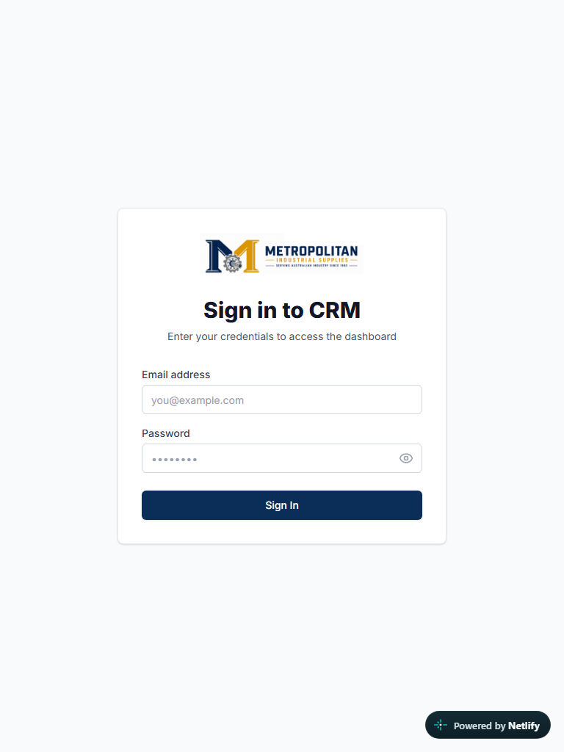
IMAGE PROOF 5: Mobile View (390x844)
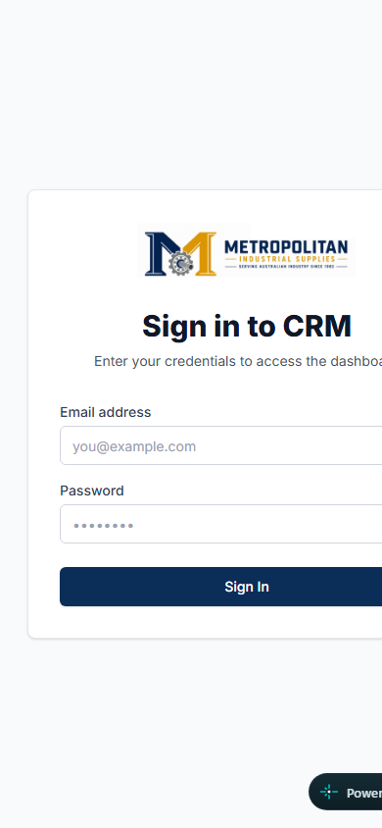
10. Final Retest Verdict
- Frontend fixes verified? PARTIAL (Code fixes 100% verified locally; deployment to Netlify staging is stale/pending)
- Ready for client testing? NO (Requires Netlify redeployment of remediated branch and proxy routing fix)
- Ready for production? NO (Pending redeployment and backend CAPTCHA/Settings configuration)

