Student 1
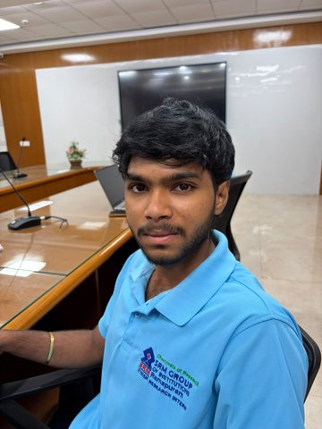 | Name | Dummy Student 1
 | Register Number | 22ECE1001
 | Date of Birth | 10 June 2004
 | Department | Electronics & Communication
 | Year | III
 | Batch | 2022–2026
 | Institute | Easwari Engineering College
 | Accommodation Type | Hosteller
 | Hostel Name | Cauvery Hostel
 | Room Number | C-207

Student 2
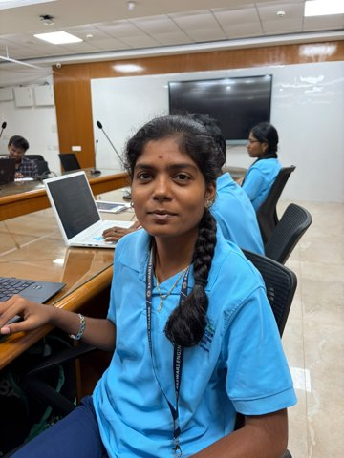 | Name | Dummy Student 2
 | Register Number | 22ECE1002
 | Date of Birth | 11 June 2004
 | Department | Electronics & Communication
 | Year | III
 | Batch | 2022–2026
 | Institute | Easwari Engineering College
 | Accommodation Type | Hosteller
 | Hostel Name | Ganga Hostel
 | Room Number | G-214

Student 3
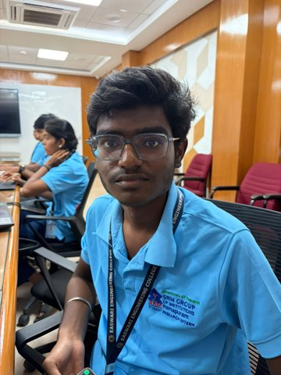 | Name | Dummy Student 3
 | Register Number | 22ECE1003
 | Date of Birth | 12 June 2004
 | Department | Electronics & Communication
 | Year | III
 | Batch | 2022–2026
 | Institute | Easwari Engineering College
 | Accommodation Type | Day Scholar
 | Hostel Name | -
 | Room Number | -

Student 4
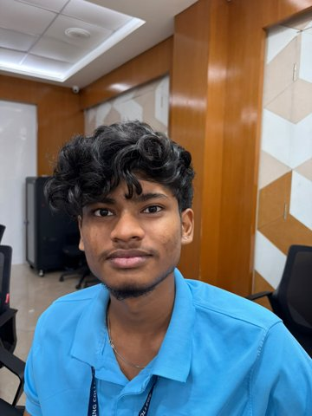 | Name | Dummy Student 4
 | Register Number | 22ECE1004
 | Date of Birth | 13 June 2004
 | Department | Electronics & Communication
 | Year | III
 | Batch | 2022–2026
 | Institute | Easwari Engineering College
 | Accommodation Type | Hosteller
 | Hostel Name | Ganga Hostel
 | Room Number | G-228

Student 5
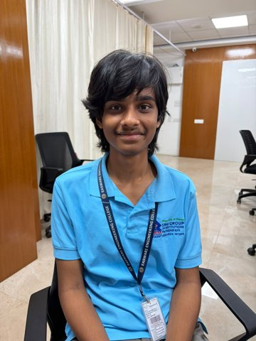 | Name | Dummy Student 5
 | Register Number | 22ECE1005
 | Date of Birth | 14 June 2004
 | Department | Electronics & Communication
 | Year | III
 | Batch | 2022–2026
 | Institute | Easwari Engineering College
 | Accommodation Type | Hosteller
 | Hostel Name | Cauvery Hostel
 | Room Number | C-235

Student 6
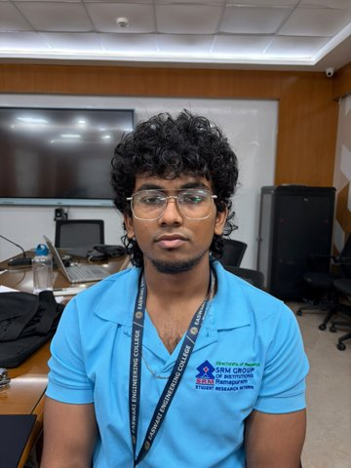 | Name | Dummy Student 6
 | Register Number | 22ECE1006
 | Date of Birth | 15 June 2004
 | Department | Electronics & Communication
 | Year | III
 | Batch | 2022–2026
 | Institute | Easwari Engineering College
 | Accommodation Type | Day Scholar
 | Hostel Name | -
 | Room Number | -

Student 7
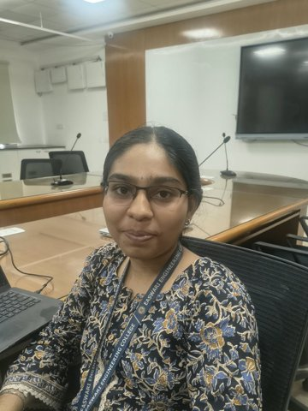 | Name | Dummy Student 7
 | Register Number | 22ECE1007
 | Date of Birth | 16 June 2004
 | Department | Electronics & Communication
 | Year | III
 | Batch | 2022–2026
 | Institute | Easwari Engineering College
 | Accommodation Type | Hosteller
 | Hostel Name | Cauvery Hostel
 | Room Number | C-249

Student 8
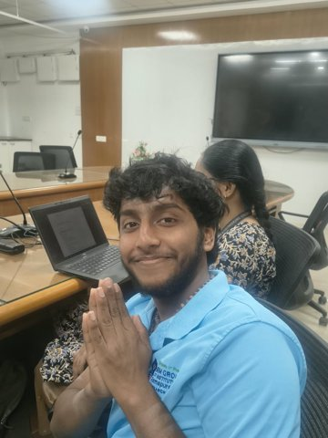 | Name | Dummy Student 8
 | Register Number | 22ECE1008
 | Date of Birth | 17 June 2004
 | Department | Electronics & Communication
 | Year | III
 | Batch | 2022–2026
 | Institute | Easwari Engineering College
 | Accommodation Type | Hosteller
 | Hostel Name | Ganga Hostel
 | Room Number | G-256

Student 9
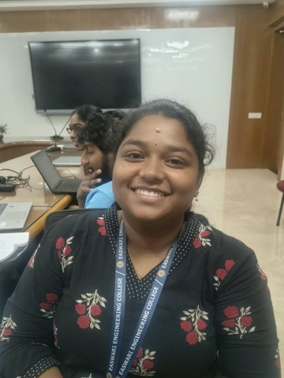 | Name | Dummy Student 9
 | Register Number | 22ECE1009
 | Date of Birth | 18 June 2004
 | Department | Electronics & Communication
 | Year | III
 | Batch | 2022–2026
 | Institute | Easwari Engineering College
 | Accommodation Type | Day Scholar
 | Hostel Name | -
 | Room Number | -

Student 10
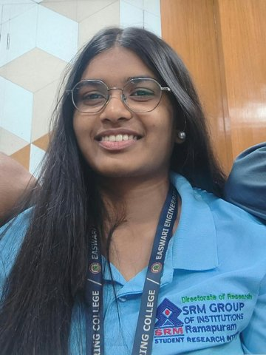 | Name | Dummy Student 10
 | Register Number | 22ECE1010
 | Date of Birth | 19 June 2004
 | Department | Electronics & Communication
 | Year | III
 | Batch | 2022–2026
 | Institute | Easwari Engineering College
 | Accommodation Type | Hosteller
 | Hostel Name | Ganga Hostel
 | Room Number | G-270

Staff 1
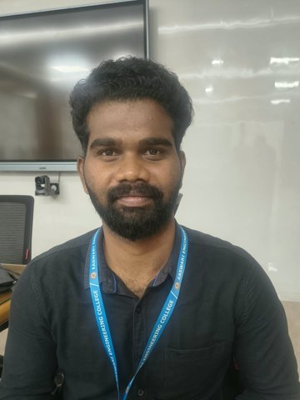 | Name | Dummy Staff 1
 | Employee ID | EEC-STF-001
 | Date of Birth | 15 March 1990
 | Department | Electronics & Communication
 | Designation | Assistant Professor
 | Institute | Easwari Engineering College
 | Phone Number | +91 90000 00001
 | Email | dummy.staff1@example.com

