About the game

Don’t Crash is a casual game that aims to loosely simulate the role of an air traffic controller, managing flights passing through, and, when extended as part of a future assessment, taking-off and landing, within a given airspace. Team BHD developed the game, as part of the second year SEPR module.

Running the game

The easiest way to play the game is simply to visit <http://bhd.waterson.co> in your favourite web browser. The version on that site is identical to that available for download on the team website.

Alternatively, to run the game using the downloaded source code (for development, or for marking the submission) you can follow the instructions below:

* Open a terminal (command prompt) window. On Windows you can press Win + R and then type cmd and press enter. On a Mac open Terminal.app within the Applications folder. On the department Linux install, you can press Alt + F2 and then type xterm and press enter, users of other desktop environments probably already know what to do!
* Run cd [path], where [path] is the path to the unzipped Game2 directory.
* Run python server.py. This sometimes causes a Windows Firewall message to appear, that box can safely be ignored.
* Open your favourite web browser (we've tested Safari, Chrome and Firefox; recent versions of Opera probably also work) and go to <http://localhost:8000>. Windows users may have to use <http://127.0.0.1:8000> if the first address gives an error.

The Main Menu

The first screen you will see upon launching the game is the main menu, which is pictured below. From here there are several options:

Clicking on **Play Now** will start a new game session. Information on game play is given later on in this user manual.

Clicking **Options** will open the Options screen, from which various game settings (as set out below) can be configured.

**User Manual** will open this document.

Selecting the **Team Website** item will open our marketing website, which contains more information about why your team should adopt our codebase for Assessment 3.

The **About** item will open a screen giving details of open-source and creative-commons resources used in the game. It also provides access to our suites of automated tests.

The Options Menu



The options menu offers four settings that govern difficulty, and one that is useful for game debugging.

**max flights** is the maximum number of flights are allowed within the airspace at any given time. While the game engine theoretically supports an infinite number of flights, this version only has 4 entry points, so congestion in those areas will be a problem with a very large number of flights.

**number of waypoints** will change the number of intermediate waypoints generated at random locations within the airspace.

**horizontal separation distance** and **vertical separation distance** set the minimum distances (in metres) which must be maintained between flights. If two planes are within both the horizontal and vertical separation distances then a separation violation has occurred.

Turning on **debug mode** will cause more information (such as accurate position co-ordinates) about flights and waypoints to be displayed. You shouldn’t need to activate this setting unless you are involved in game development or testing.

In order to save your configuration, you have to click on the **Save Changes** button before leaving the screen.

Clicking **Reset to Defaults** will return all settings to their default values, which are as follows:

max flights: 2 horizontal separation distance: 9000

number of waypoints: 15 vertical separation distance: 300

debug mode: unchecked

Finally, after you are tweaking the game to your liking, you need to click **Back to Main Menu** in order to go back and play the game. Remember to always save first!

The Game Screen

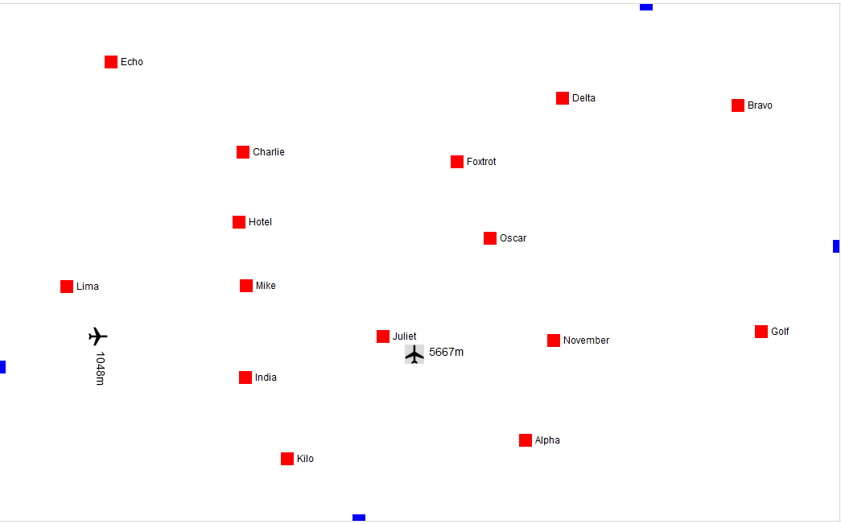

This is the randomly generated airspace that is created for you in the beginning of each game. As you can see, it currently contains two aircraft. One of them is heading north (it has a bearing of 0 degrees) at an altitude of 5997 metres. The other is heading due east (or 90 degrees) and has an altitude of 1048 metres.

The aircraft you have currently selected is highlighted in grey on the map. On the screenshot above, it is the flight travelling northwards that is selected. Selecting a flight causes various controls to appear on the right-hand side of the screen, the functions of which will be covered further on in this manual.

When aircraft are too close, they will be highlighted in orange to indicate that the separation rules have been violated. Should the aircraft get so close as to make collision inevitable, the game will end.

There are three types of airplanes, each with its specific qualities. Larger aircraft are generally faster, and have more fuel, than smaller models.

The red dots on the screen are your waypoints. Flying an aircraft near a waypoint that is on its list of designated targets will score you points. The distance you need to achieve to the waypoint is the same as the distance required for horizontal separation.

Aircraft Controls

This is the navigation panel that opens up on the right of the map when you select an aircraft. It is separated, as follows:

**1. The aircraft’s controls**. Turning left or right will cause you to decrement or increment the aircraft’s target heading by 15 degrees. Descending and climbing alter its target altitude by 500 metres. Setting heading and setting altitude allows you to manually tune the heading and altitude of an aircraft, up to a single degree and a single metre. The game will pause while it waits for you to enter a value.

**2**

**2. The aircraft’s data**. This part of the panel gives you important information about the aircraft, such as name, altitude, speed and heading.

**3**

**4**

**3. Fuel gauge**. If an airplane runs out of fuel it will crash. Planes enter the airspace with enough fuel to cover twice the minimum flight path between their target waypoints, so this should not be a major problem!

**4. The aircraft’s flight plan**. The next waypoint on the plane’s flight plan is given in bold. Flying through that waypoint will cross it off, and, in a later version of this game, may also perhaps award you points. Planes will enter the airspace pointing towards their first waypoint but it is up to you to guide them the rest of the way to their destination.

**1**

**5.** Finally, below the navigation panel, you are presented with the game’s timer and some options. Here, you can pause the game, restart it (which will generate a new airspace) or quit back to the main menu.

**5**

We hope that you all have fun playing our game!

Cheers,

Team BHD