**PRACTICAL NO 1**

**AIM: To study DDL, DML & Constraints.**

**A) Data Definition Language: Create, Alter, Drop, Rename, Truncate**

**1. Create tables for students & course**

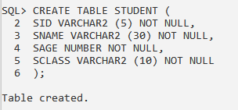

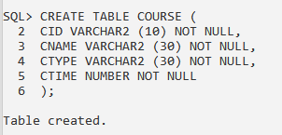

**2. Describe the structure of each table**

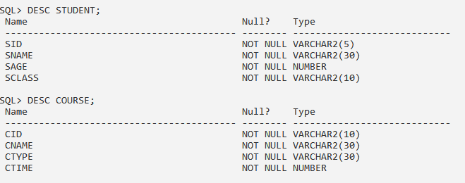

**3. Adding the attribute to first table**

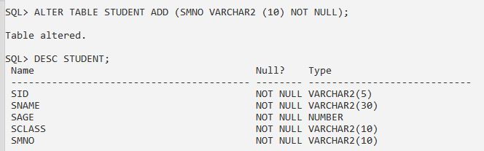

**4. dropping the attribute from second table**

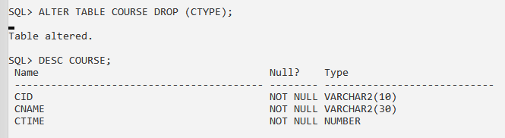

**5. Modify the data types of any one attribute**

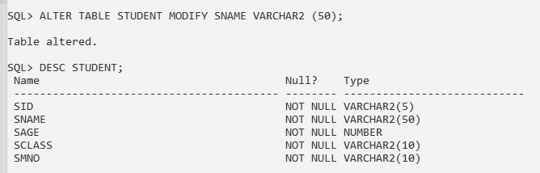

**6. Change the names of attributes in first table**

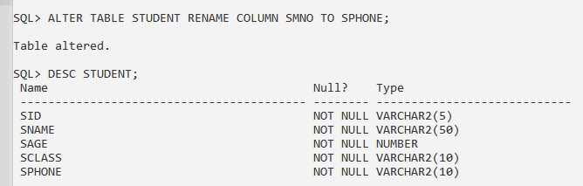

**7. Changes the table name of second table using rename command.**

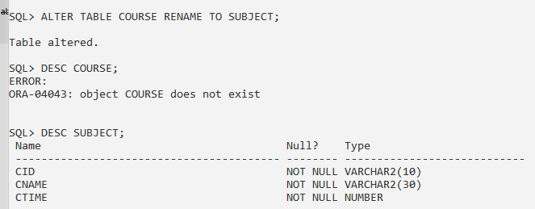

**8. Truncate table**

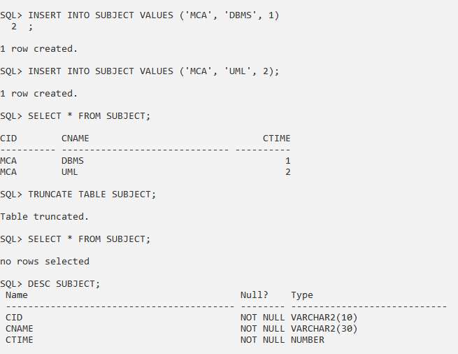

**B)** **Data Manipulation Language: Insert, Update, Delete, Select.**

**1. Insert minimum 5 records in each table in student and course table**

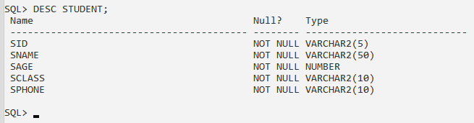

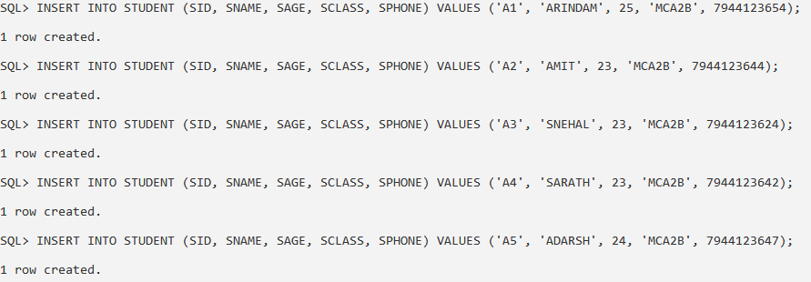

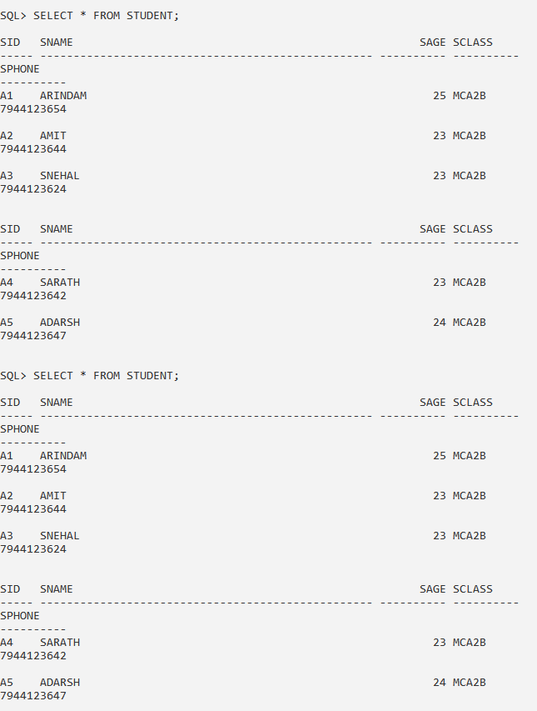

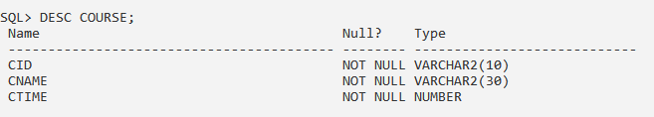

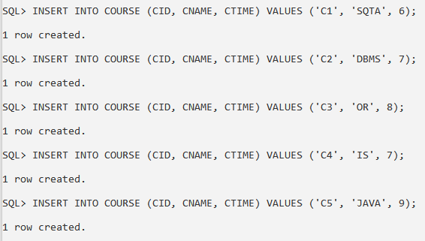

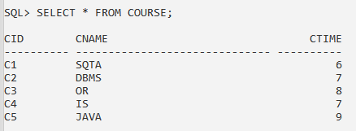

**2. Update any two rows of course table tables**



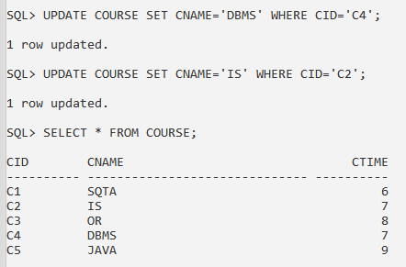

**3. Delete record from student table**

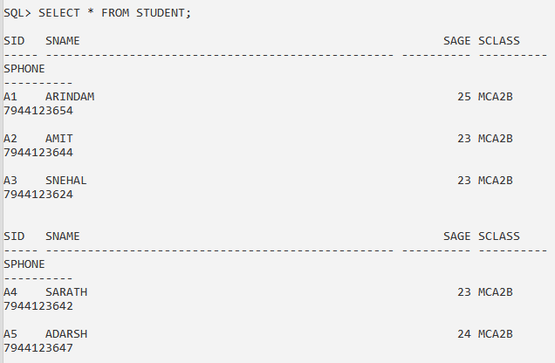

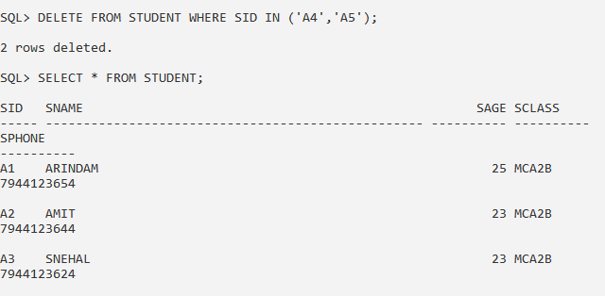

**C) Constraints: Not Null, Unique Key, Primary Key, Foreign Key, Check, adding and Dropping a Constraint**

**1. Create department table (department_name, course, building)**

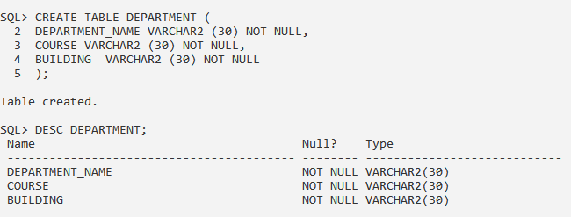

**A. Department name as primary key.**

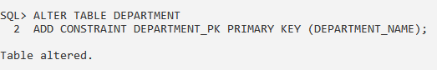

**2. Create a student table with attributes student id, student first name, middle name, last name, phone_number, age, department id**

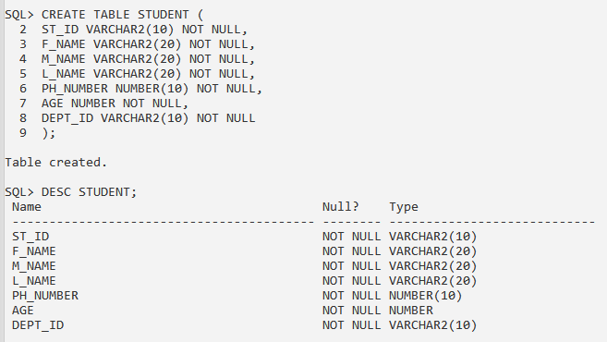

**A. Student_id primary key**

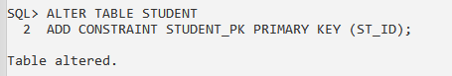

**B. Department id foreign key**

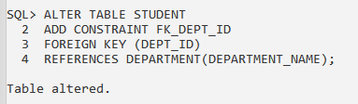

**C. Students fname, middle name and last name not null**

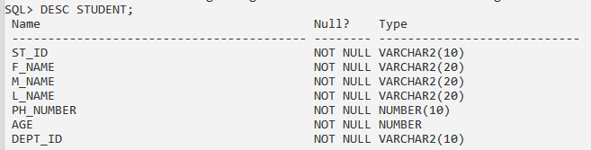



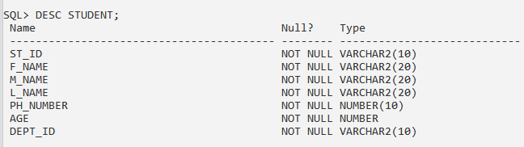

**D. Age greater than zero**

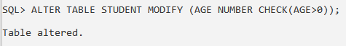

**E. Drop constraint middle name not null**

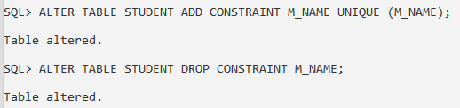

**F. Make phone number as unique key**

