**PRACTICAL NO 1**

**AIM: To study DDL, DML & Constraints.**

**Theory:**

**1) DDL (Data Definition Language):**

Structured Query Language (SQL) as we all know is the database language by the use of which we can perform certain operations on the existing database and also, we can use this language to create a database. SQL uses certain commands like Create, Drop, Insert etc. to carry out the required tasks.

These SQL commands are mainly categorized into four categories as:

1. DDL – Data Definition Language
2. DQl – Data Query Language
3. DML – Data Manipulation Language
4. DCL – Data Control Language

DDL or Data Definition Language actually consists of the SQL commands that can be used to define the database schema.

It simply deals with descriptions of the database schema and is used to create and modify the structure of database objects in the database.

**Examples of DDL commands:**

* [CREATE](https://www.geeksforgeeks.org/sql-create/) : is used to create the database or its objects (like table, index, function, views, store procedure and triggers).
* [DROP](https://www.geeksforgeeks.org/sql-drop-truncate/) : is used to delete objects from the database.
* [ALTER](https://www.geeksforgeeks.org/sql-alter-add-drop-modify/) : is used to alter the structure of the database.
* [TRUNCATE](https://www.geeksforgeeks.org/sql-drop-truncate/) : is used to remove all records from a table, including all spaces allocated for the records are removed.
* [COMMENT](https://www.geeksforgeeks.org/sql-comments/) : is used to add comments to the data dictionary.
* [RENAME](https://www.geeksforgeeks.org/sql-alter-rename/): is used to rename an object existing in the database.

**A) Data Definition Language: Create, Alter, Drop, Rename, Truncate**

**1. Create tables for students & course**

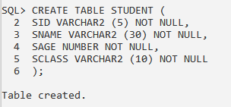

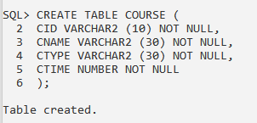

**2. Describe the structure of each table**

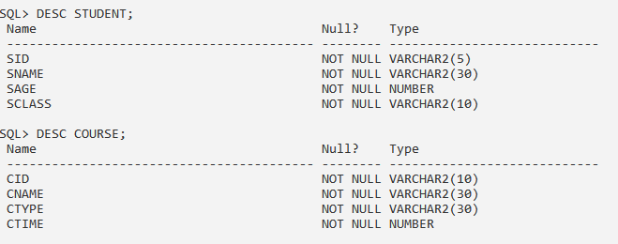

**3. Adding the attribute to first table**

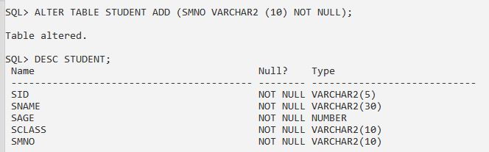

**4. dropping the attribute from second table**

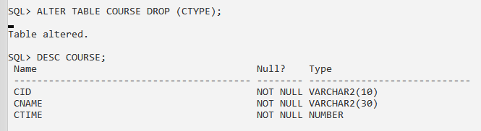

**5. Modify the data types of any one attribute**

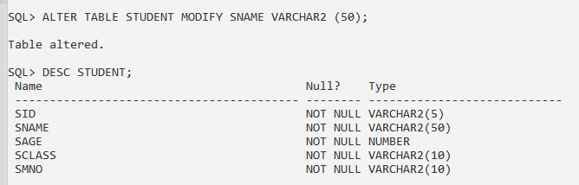

**6. Change the names of attributes in first table**

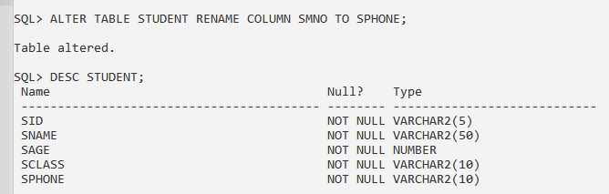

**7. Changes the table name of second table using rename command.**

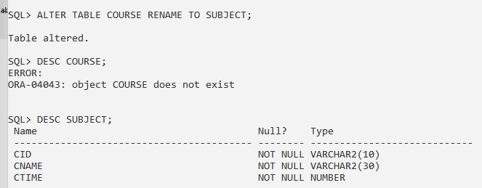

**8. Truncate table**

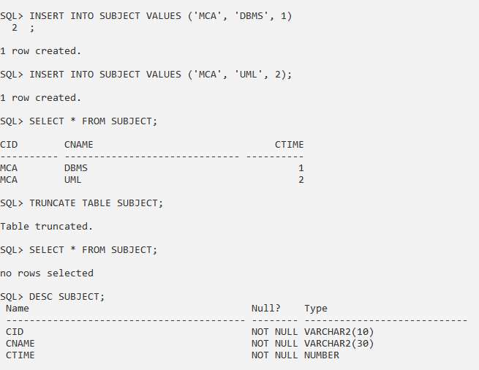

**2) DML (Data Manipulation Language):**

A data manipulation language (DML) is a computer programming language used for adding (inserting), deleting, and modifying (updating) data in a database. A DML is often a sublanguage of a broader database language such as SQL, with the DML comprising some of the operators in the language. Read-only selecting of data is sometimes distinguished as being part of a separate data query language (DQL), but it is closely related and sometimes also considered a component of a DML; some operators may perform both selecting (reading) and writing. A popular data manipulation language is that of Structured Query Language (SQL), which is used to retrieve and manipulate data in a relational database. Other forms of DML are those used by IMS/DLI, CODASYL databases, such as IDMS and others.

**Examples of DML:**

* [**INSERT**](https://www.geeksforgeeks.org/sql-insert-statement/)**: is used to insert data into a table.**
* [**UPDATE**](https://www.geeksforgeeks.org/sql-update-statement/)**: is used to update existing data within a table.**
* [**DELETE**](https://www.geeksforgeeks.org/sql-delete-statement/)**: is used to delete records from a database table.**

**B)** **Data Manipulation Language: Insert, Update, Delete, Select.**

**1. Insert minimum 5 records in each table in student and course table**

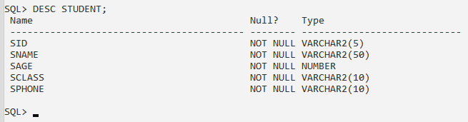

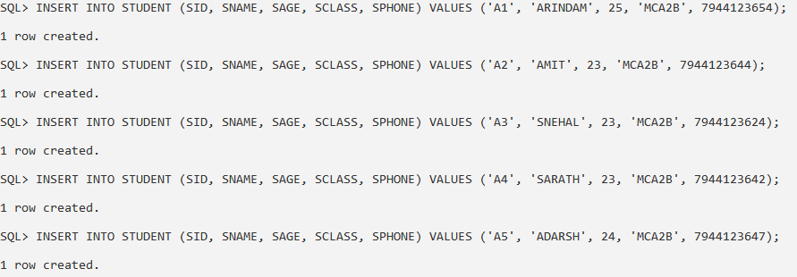

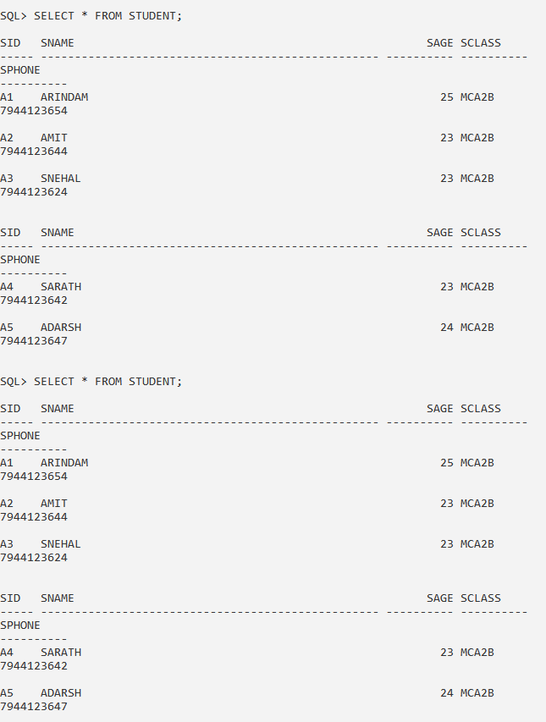

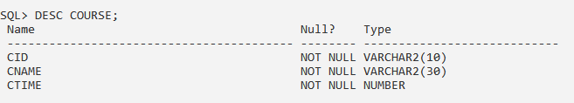

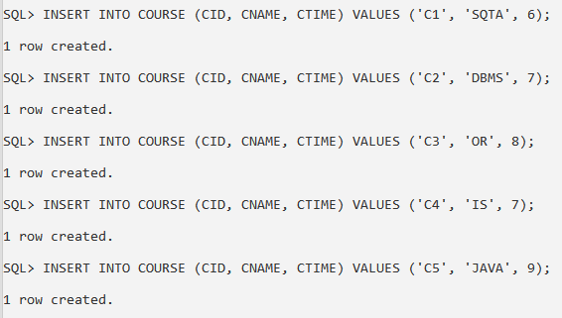

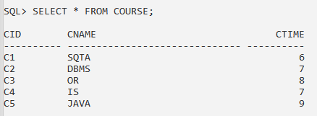

**2. Update any two rows of course table tables**



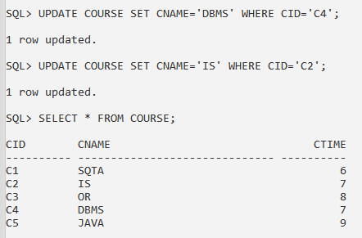

**3. Delete record from student table**

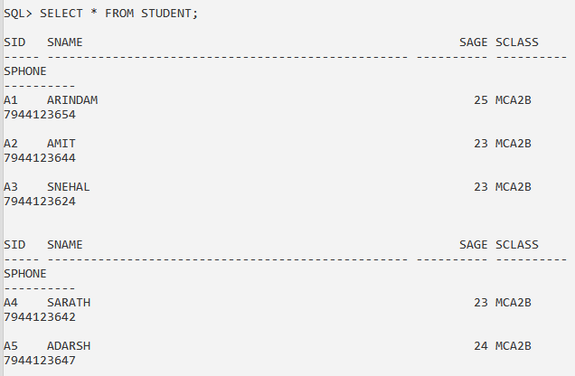

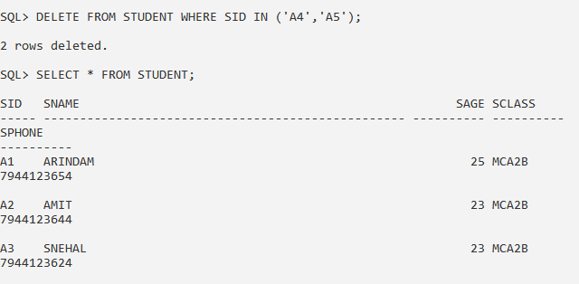

**3) CONSTRAINTS:**

Use a constraint to define an integrity constraint--a rule that restricts the values in a database. Oracle Database lets you create six types of constraints and lets you declare them in two ways.

The six types of integrity constraint are described briefly here and more fully in "Semantics":

i. A NOT NULL constraint prohibits a database value from being null.

ii. A unique constraint prohibits multiple rows from having the same value in the same column or combination of columns but allows some values to be null.

ii. A primary key constraint combines a NOT NULL constraint and a unique constraint in a single declaration. That is, it prohibits multiple rows from having the same value in the same column or combination of columns and prohibits values from being null.

iv. A foreign key constraint requires values in one table to match values in another table.

v. A check constraint requires a value in the database to comply with a specified condition.

**C) Constraints: Not Null, Unique Key, Primary Key, Foreign Key, Check, adding and Dropping a Constraint**

**1. Create department table (department_name, course, building)**

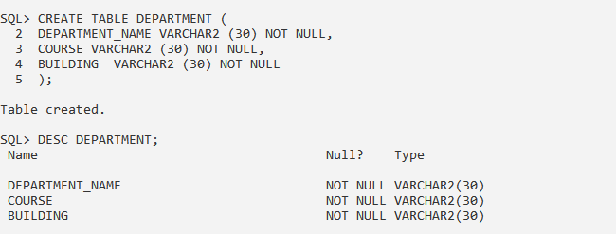

**A. Department name as primary key.**

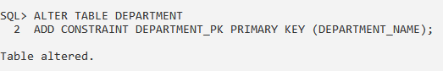

**2. Create a student table with attributes student id, student first name, middle name, last name, phone_number, age, department id**

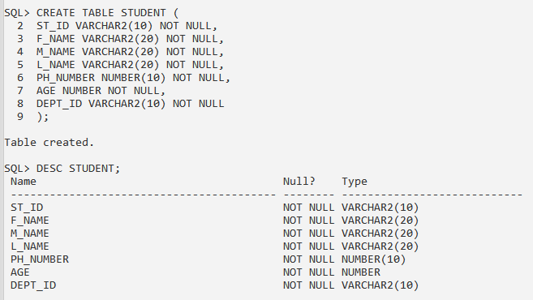

**A. Student_id primary key**

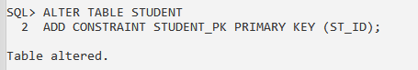

**B. Department id foreign key**

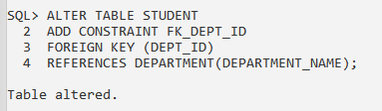

**C. Students fname, middle name and last name not null**

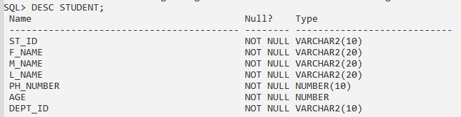



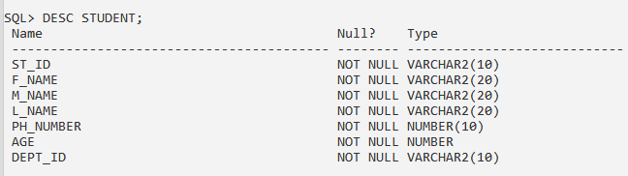

**D. Age greater than zero**

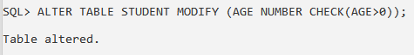

**E. Drop constraint middle name not null**

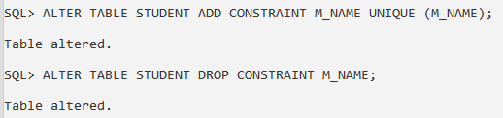

**F. Make phone number as unique key**

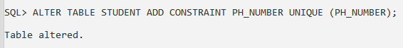

**CONCLUSION:** We have studied DDL, DML & Constraints in detail.