**PRACTICAL NO 10**

**AIM: To study of Object-Oriented Database.**

**Theory:**

An object-oriented database is a collection of object-oriented programming and relational database. There are various items which are created using object-oriented programming languages like C++, Java which can be stored in relational databases, but object-oriented databases are well-suited for those items.

An object-oriented database is organized around objects rather than actions, and data rather than logic. For example, a multimedia record in a relational database can be a definable data object, as opposed to an alphanumeric value.

The object-oriented database model ties related packages together. In other words, a data set and all its attributes are combined with an object. In this way, all of the information is directly available. Instead of distributing everything across different tables, then, the data can be retrieved in one package. Alongside the attributes, methods are also stored in the objects. This is where the databases’ proximity to object-oriented programming languages becomes clear. As in programming, each object has certain activities that it can carry out.

In turn, objects are brought together in classes. Or, to put it more accurately: an object is a concrete unit in an abstract class. This generates a hierarchy of classes and subclasses. Within such a construct, subclasses assume the properties of higher-level classes and expand on these with their own attributes. At the same time, objects in one class can also be connected with other classes. This breaks up the strict hierarchy and makes sure that the objects are interlinked. Simple objects can be combined with complex objects.

To address the various objects, the corresponding database management system automatically assigns a one-off identification to each unit. In this way, objects can be easily retrieved again after they have been saved.

**Advantages of Object-Oriented Database**

* Complex data sets can be saved and retrieved quickly and easily.
* Object IDs are assigned automatically.
* Works well with object-oriented programming languages.

**Disadvantages of Object-Oriented Database**

* Object databases are not widely adopted.
* In some situations, the high complexity can cause performance problems.

**1. Create Abstract data type name (Fname, M Name, Lname).**

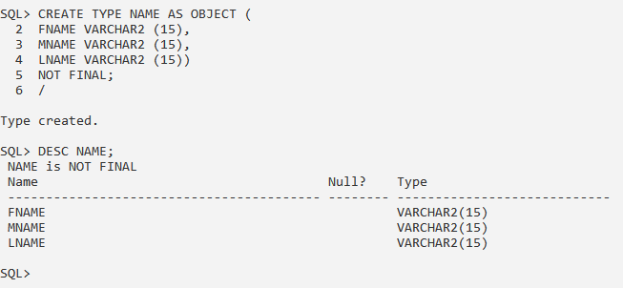

**2. Create abstract data type Address (AppNo., Building, Street).**

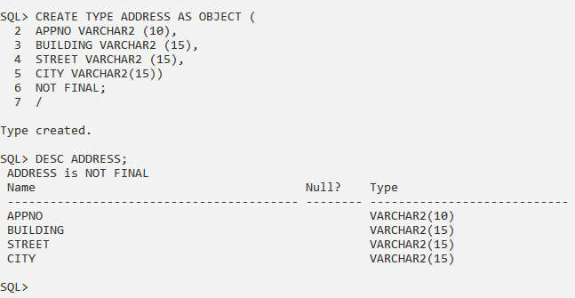

**3. Alter address type add attribute PIN.**

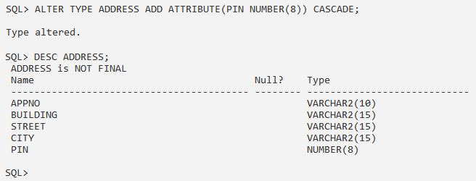

**4. Create abstract datatype Specialization (Sub1, Sub2, Sub3).**

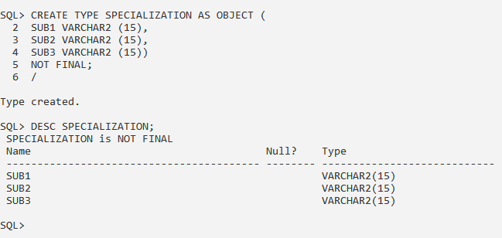

**5. Create table with attribute id, name, address, Specialization, Phone, use created abstract data type wherever necessary.**

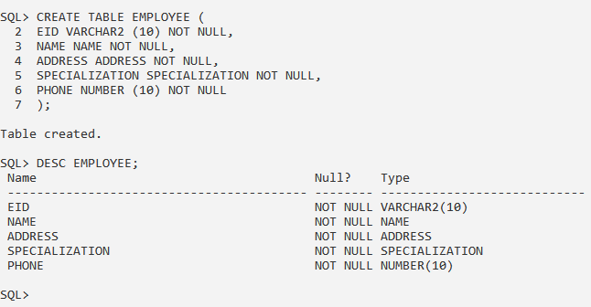

**6. View table description in all level.**

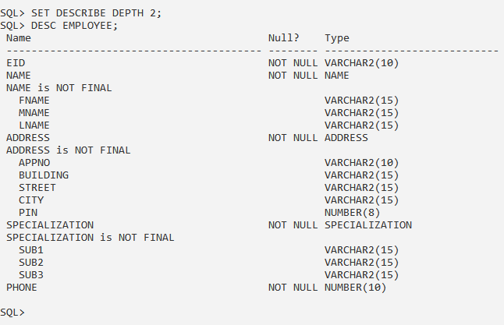

**7. Insert 5 records.**

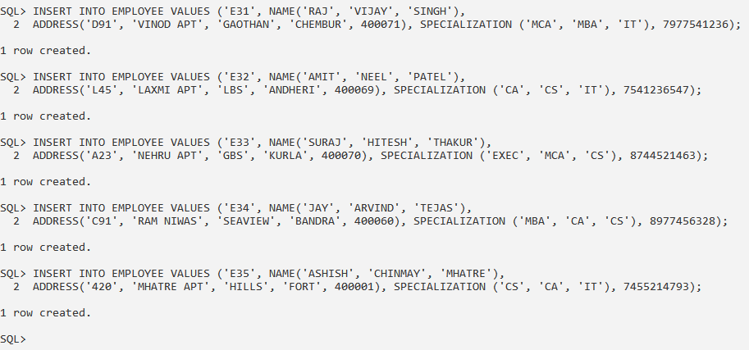

**8. Select data of different levels.**

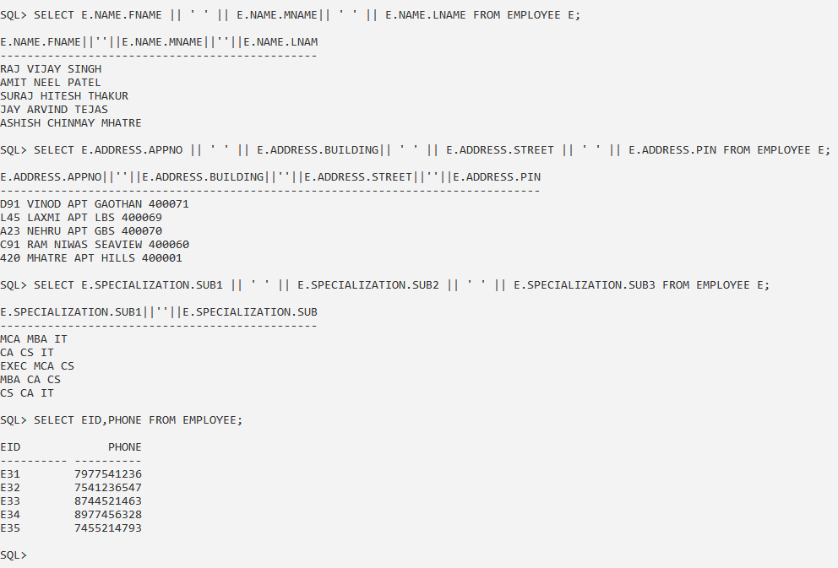

**9. Delete one record from the table.**

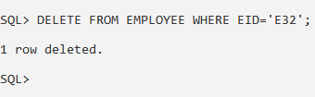

**10. Modify size of Lname in nametype.**

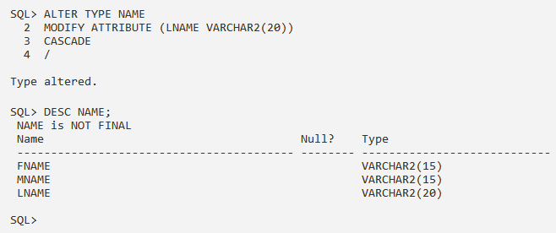

**11. Select data of employee lives in city=Chembur.**



**CONCLUSION:** We have studied the Object-Oriented Database in details.