**PRACTICAL NO 2**

**AIM: To study of Data Control Language and Transaction Control Language.**

**Theory:**

**A) Data Control Language:**

Data Control Language is used to control the access of the data which is stored in the Database. The DCL becomes very useful in the case where the database is exposed to multiple users who might update or make changes to the Database which in turn might create many issues.

DCL includes commands such as GRANT and REVOKE which mainly deals with the rights, permissions and other controls of the database system.

* **GRANT**: This command is used to grant permission to the user to perform a particular operation on a particular object. If you are a database administrator and you want to restrict user accessibility such as one who only views the data or may only update the data. You can give the privilege permission to the users according to your wish.
* **REVOKE**: This command is used to take permission/access back from the user. If you want to return permission from the database that you have granted to the users at that time you need to run REVOKE command.

**B) Transaction Control Language:**

Transaction Control Language (TCL) commands are used to manage transactions in the database. These are used to manage the changes made to the data in a table by DML statements. It also allows statements to be grouped together into logical transactions. TCL commands deals with the [transaction within the database](https://www.geeksforgeeks.org/sql-transactions/). The Transaction Control Language is used to maintain the integrity and consistency of the data stored in the database.

**Examples of TCL commands:**

* **COMMIT**: This command is used to permanently save any transaction into the database.
* [**ROLLBACK**](https://www.geeksforgeeks.org/sql-transactions/)**:** This command is used to get the data or restore the data to the last savepoint or last committed state.
* **SAVEPOINT:** This command is used to save the data at a particular point temporarily, so that whenever needed can be rollback to that particular point.

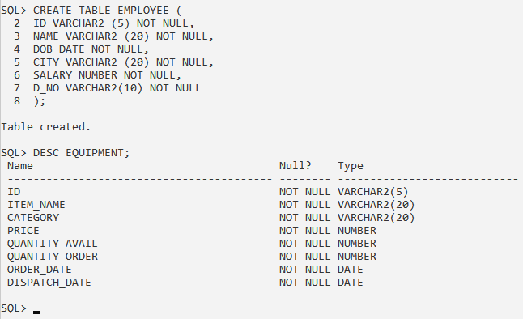

**1. Write a query to insert two records in the ‘Employee’ table and execute commit. Again, insert two more records in the table and logout then login and view the ‘Employee’ table contents.**

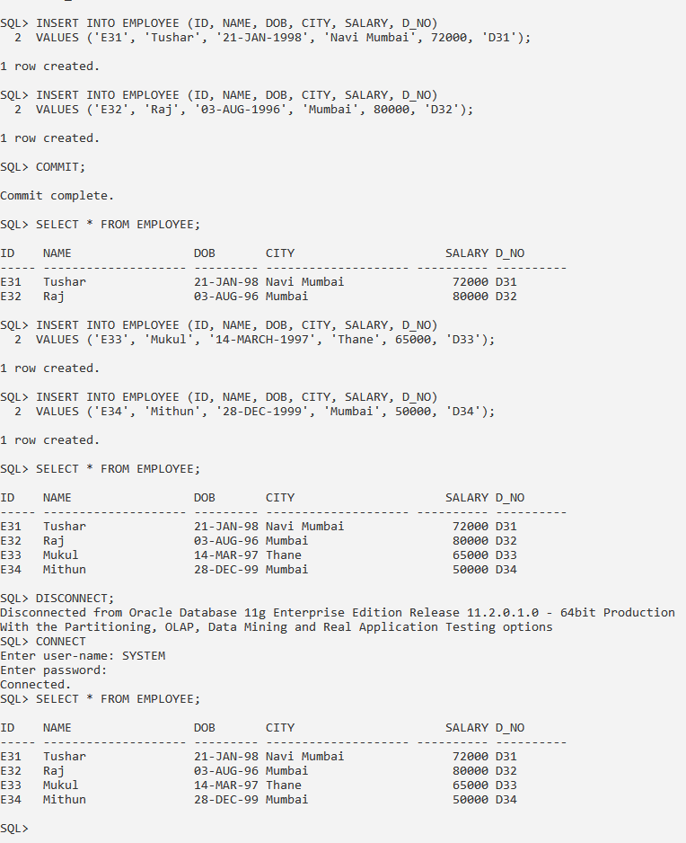

**2. Write a query to insert two records in the ‘Employee’ table and execute commit. Again, insert one more record in the table and execute rollback and view the ‘Employee’ table contents.**

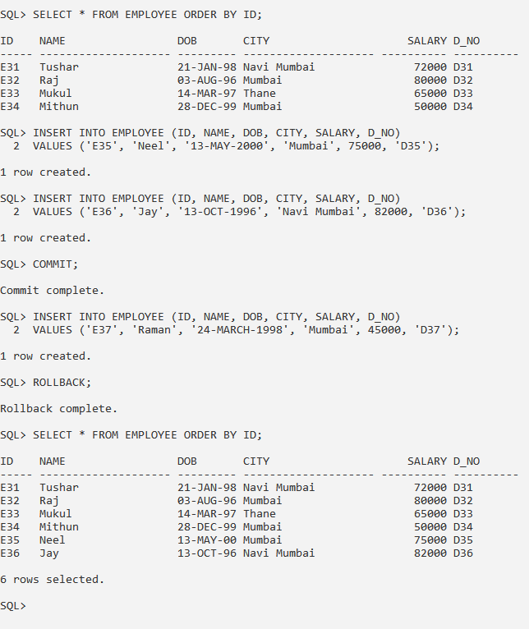

**3. Write a query to insert a record in the ‘Employee’ table and execute savepoint A. Update two rows and execute savepoint B and savepoint C after each update and then execute rollback to B. Now view the ‘Employee’ table contents.**

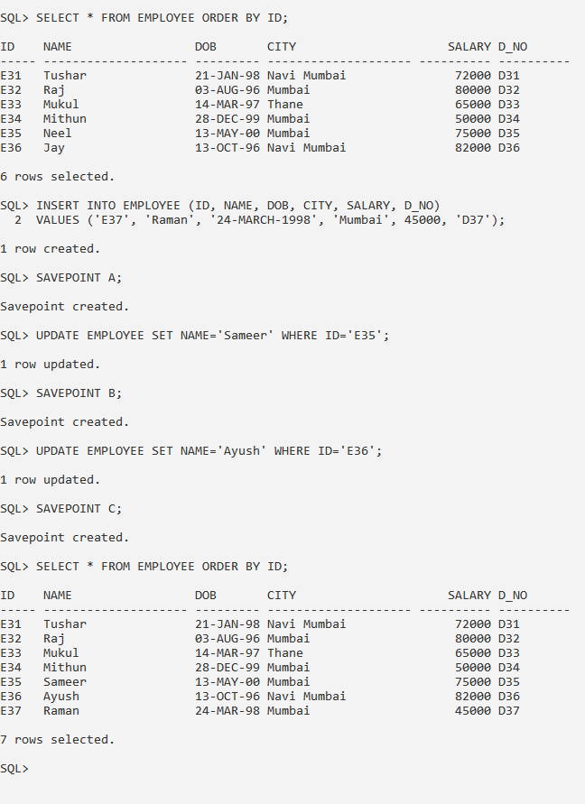



**4. Create a user ‘user03’ and connect to SQL using same user id. If connection fails write a query to grant ‘connect’ privilege to ‘user03’.**

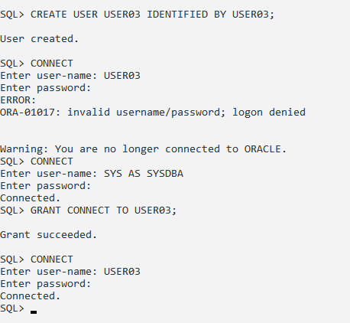

**5. Write a query to create a table from ‘user03’ id and if permission is denied grant ‘create table’ privilege to ‘user03’.**

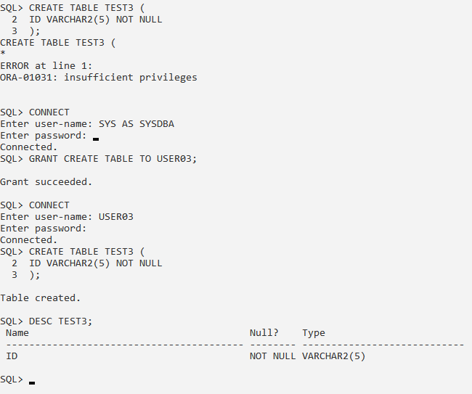

**6. Write a query to insert values in ‘test3’ table from ‘user03’ id and if permission is denied grant ‘unlimited tablespace’ privilege to ‘user03’. Also rename ‘ID’ as ‘Test_ID’ in ‘test3’ table.**

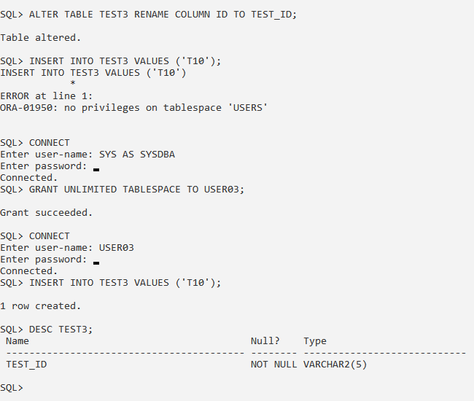

**7. Write a query to grant all privileges to ‘user03’.**

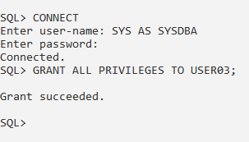

**8. Create a user ‘user03_2’ and write a query to grant ‘connect, create table and unlimited tablespace’ privileges to ‘user03_2’ using roles.**

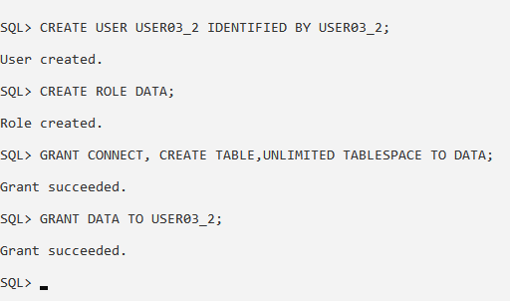

**9. Write a query to display all rows of ‘test3’ from ‘user03_2’ id. If permission is denied or error occurs grant ‘select’ privilege on table ‘test3’ to ‘user03_2’.**

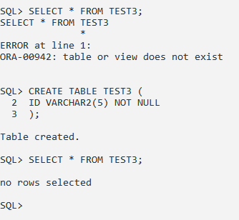

**10. Write a query to insert a row in ‘test3’ from ‘user03_2’ id. If permission is denied or error occurs grant ‘insert’ privilege on table ‘test3’ to ‘user03_2’.**

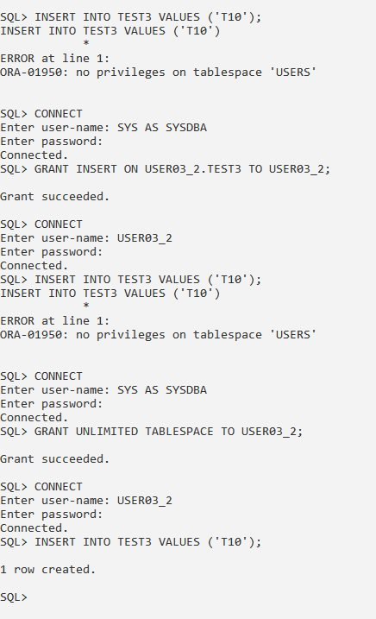

**11. Write a query to add Name, City and Salary column to ‘test3’ table and display all records.**

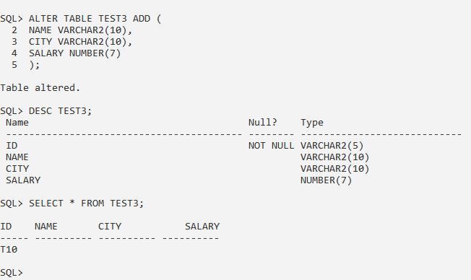

**12. Write a query to grant ‘update’ privilege on ‘Name’ column in table ‘test3’ to ‘user03_2’ and insert a row. Display all records of ‘test3’ and update ‘Name’ of any row. Also try to update any other column in the table.**

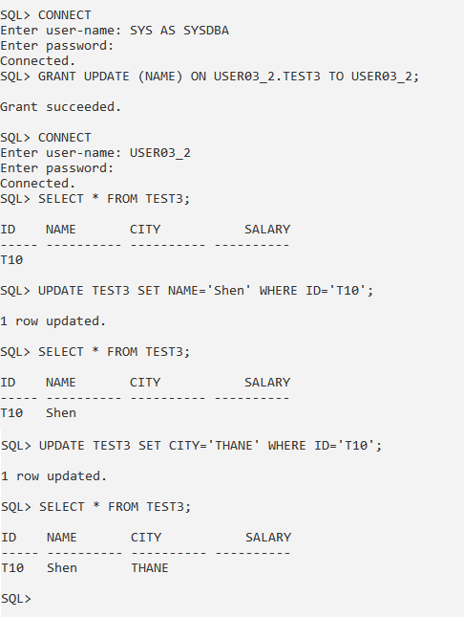

**13. Write a query to revoke ‘update’ privilege on ‘test3’ from user ‘user03_2’ and then try to use update statement.**

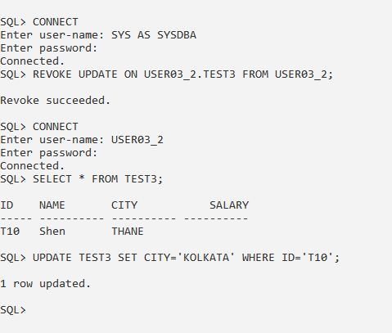

**CONCLUSION:** We have studied the SQL Data Control Language and Transaction Control Language in details.