**PRACTICAL NO 3**

**AIM: To study SQL SELECT Statements.**

**A) Select QUERY, Column Alias Concatenation, Comparison Condition**

**1. Create a table ‘Customer’ with attributes as Id, F_Name, L_Name, Street, City, Pin, Category (Silver, Gold, and Platinum) and Credit.**

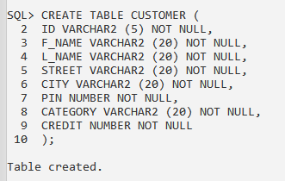

**2. Write a query to insert five rows in ‘Customer’ table.**

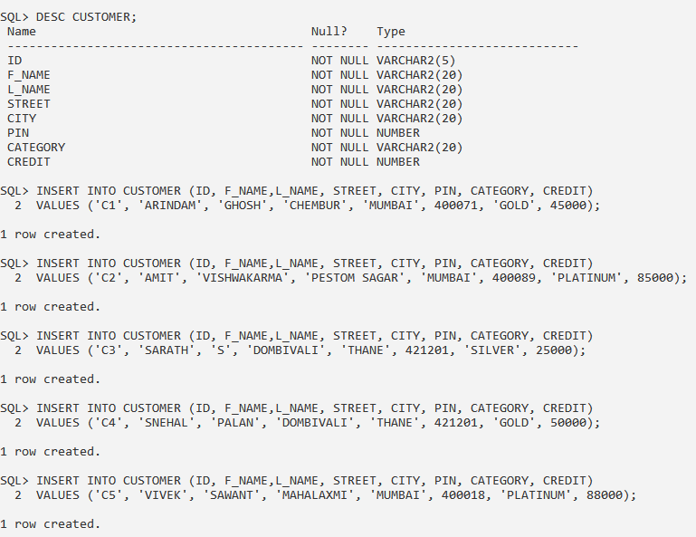

**3. Write a query to display all records in ‘Customer’ table.**

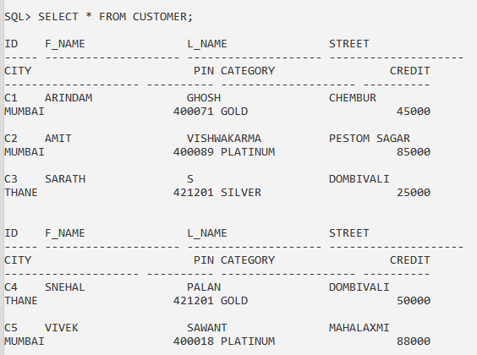

**4. Write a query to display all details of customer from ‘Customer’ table whose Id is 2.**

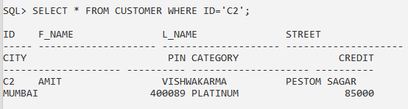

**5. Write a query to display F_Name, L_Name and Category of a customer from ‘Customer’ table whose name is ‘Vivek‘.**

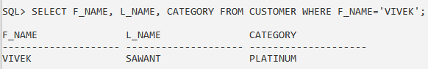

**6. Write a query to display all customers from ‘Customer’ table whose ‘Category’ is ‘Platinum’.**

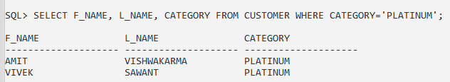

**7. Write a query to display ‘Id’ and ‘Category’ from ‘Customer’ table with column name as**

**‘Customer_ID’ and ‘Customer_Category’ using column alias.**

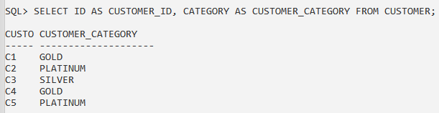

**8. Write a query to display ‘F_Name’ and ‘L_Name’ as Name from ‘Customer’ table using**

**concatenation operator and column alias.**

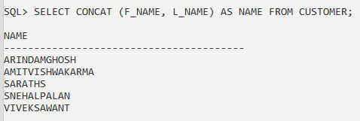

**9. Write a query to display ‘Street’, ‘City’ and ‘Pin’ as ‘Customer_Address’ from ‘Customer’ table using concatenation operator and column alias.**

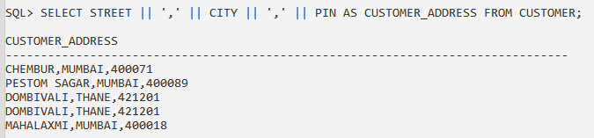

**10. Write a query to display names of customer from ‘Customer’ table whose Credit is greater than 50,000.**

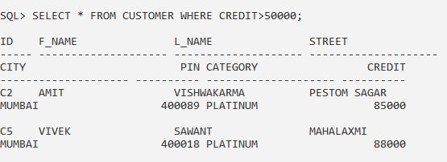

**11. Write a query to display all records of customer from ‘Customer’ table whose Credit is less than 20,000.**

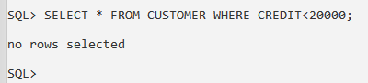

**B) Select QUERY, Column Alias Concatenation, Comparison Condition Arithmetic Operation**

**12. Create a table ‘Emp’ with attributes as Id, Name, Basic, DA and DOB.**

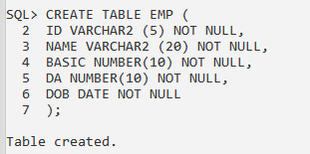

**13. Write a query to insert five records in ‘Emp’ table.**

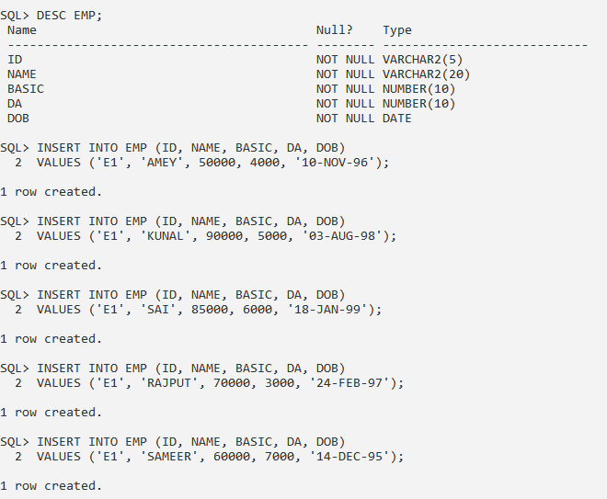

**14. Write a query to calculate Total Salary (Basic + DA = Total Salary) from ‘Emp’ table.**

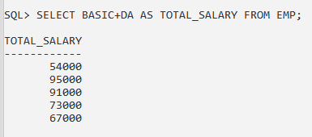

**15. Write a query to display Name with Tax ((Basic + DA + HRA) * 0.2 = Tax) from ‘Emp’ table.**

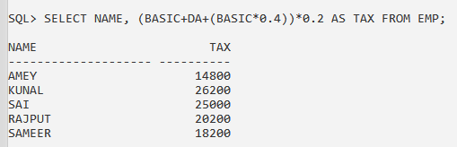

**16. Write a query to display Name, Basic, Gross (Basic + DA + HRA), Tax and Net Salary (Gross – Tax) from ‘Emp’ table.**

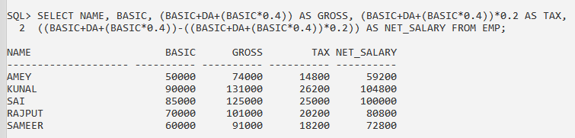

**17. Write a query to display all records of employee from ‘Emp’ table whose Basic is less than equal to 50,000.**

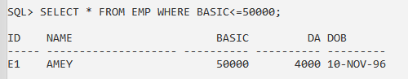

**18. Write a query to display all names of employee from ‘Emp’ table whose Age is greater than or equal to 59.**

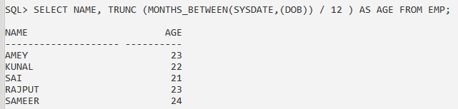

**C) Logical Condition and Order by clause**

**19. Write a query to display all names from ‘Customer’ table whose City is ‘Mumbai’ and Category is ‘Platinum’.**

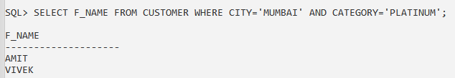

**20. Write a query to display all records of customer from ‘Customer’ table whose L_Name is not ‘Kumar’.**

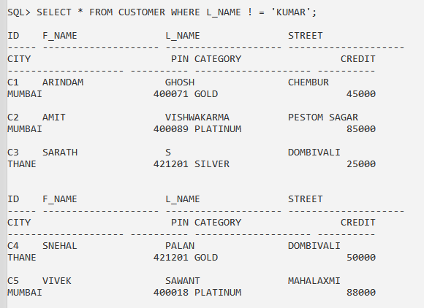

**21. Write a query to display all records of customer from ‘Customer’ table whose City is ‘Mumbai, Chennai, Hyderabad, Bangalore’.**

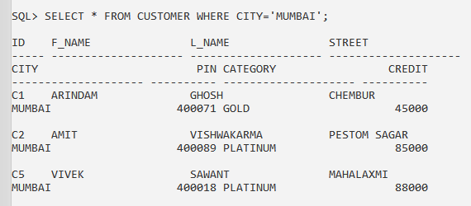

**22. Write a query to display all records of customer from ‘Customer’ table whose F_Name starts with ‘Ko’.**

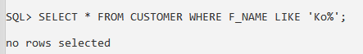

**23. Write a query to display all records of employee from ‘Emp’ table whose Basic is between 50,000 and 1,00,000.**

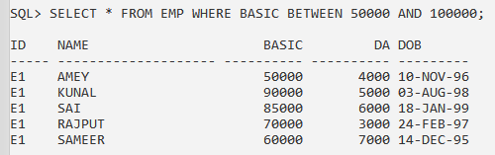

**24. Write a query to display all records of customer with F_Name in ascending order from**

**‘Customer’ table.**

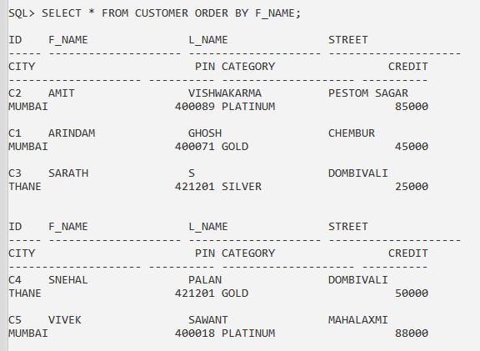

**25. Write a query to display all records of employee with Basic in descending order from ‘Emp’ table.**

