**PRACTICAL NO 3**

**AIM: To study SQL SELECT Statements.**

**Theory:**

**1) SQL SELECT Statements:**

SELECT QUERY is used to fetch the data from the MySQL database. Databases store data for later retrieval. The purpose of MySQL Select is to return from the database tables, one or more rows that match a given criteria. Select query can be used in scripting language like PHP, Ruby, or you can execute it via the command prompt. The SQL SELECT statement returns a result set of records, from one or more tables. A SELECT statement retrieves zero or more rows from one or more database tables or database views. As SQL is a declarative programming language, SELECT queries specify a result set, but do not specify how to calculate it. In most applications, SELECT is the most commonly used data manipulation language (DML) command.

**The SELECT statement has many optional clauses:**

* **FROM** specifies from which table to get the data.
* **WHERE** specifies which rows to retrieve.
* **GROUP BY** groups rows sharing a property so that an aggregate function can be applied to each group.
* **HAVING** selects among the groups defined by the GROUP BY clause.
* **ORDER BY** specifies how to order the returned rows.
* **AS** provides an alias which can be used to temporarily rename tables or columns.

**A) Select QUERY, Column Alias Concatenation, Comparison Condition**

**1. Create a table ‘Customer’ with attributes as Id, F_Name, L_Name, Street, City, Pin, Category (Silver, Gold, and Platinum) and Credit.**

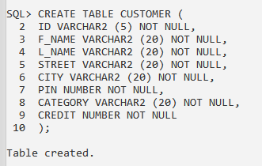

**2. Write a query to insert five rows in ‘Customer’ table.**

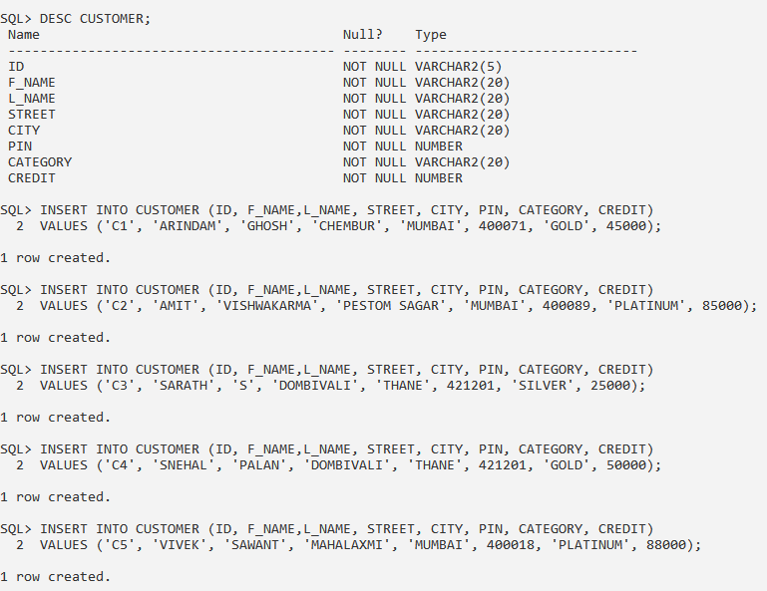

**3. Write a query to display all records in ‘Customer’ table.**

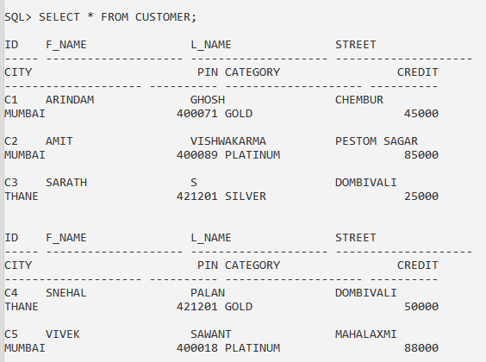

**4. Write a query to display all details of customer from ‘Customer’ table whose Id is 2.**

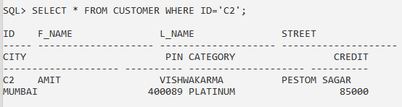

**5. Write a query to display F_Name, L_Name and Category of a customer from ‘Customer’ table whose name is ‘Vivek‘.**

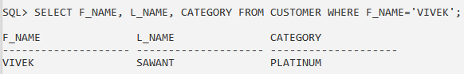

**6. Write a query to display all customers from ‘Customer’ table whose ‘Category’ is ‘Platinum’.**

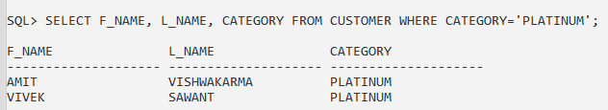

**7. Write a query to display ‘Id’ and ‘Category’ from ‘Customer’ table with column name as**

**‘Customer_ID’ and ‘Customer_Category’ using column alias.**

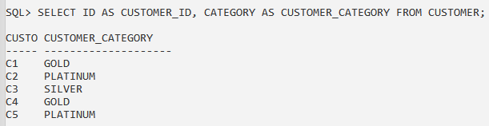

**8. Write a query to display ‘F_Name’ and ‘L_Name’ as Name from ‘Customer’ table using**

**concatenation operator and column alias.**

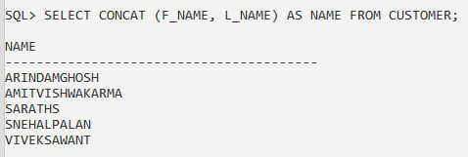

**9. Write a query to display ‘Street’, ‘City’ and ‘Pin’ as ‘Customer_Address’ from ‘Customer’ table using concatenation operator and column alias.**

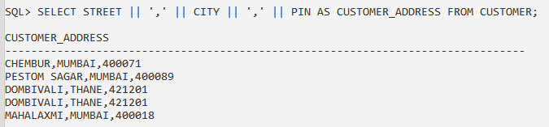

**10. Write a query to display names of customer from ‘Customer’ table whose Credit is greater than 50,000.**

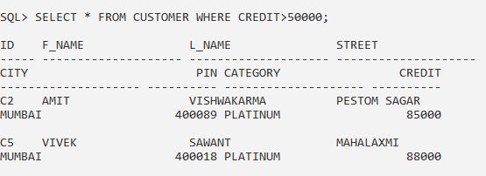

**11. Write a query to display all records of customer from ‘Customer’ table whose Credit is less than 20,000.**

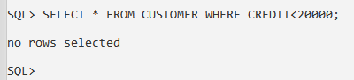

**B) Select QUERY, Column Alias Concatenation, Comparison Condition Arithmetic Operation**

**12. Create a table ‘Emp’ with attributes as Id, Name, Basic, DA and DOB.**

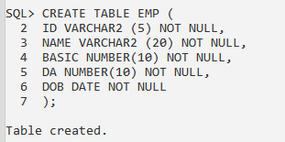

**13. Write a query to insert five records in ‘Emp’ table.**

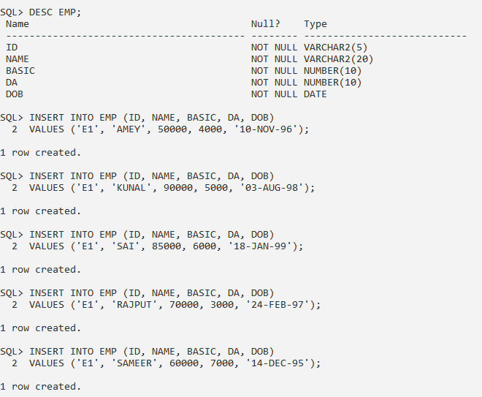

**14. Write a query to calculate Total Salary (Basic + DA = Total Salary) from ‘Emp’ table.**

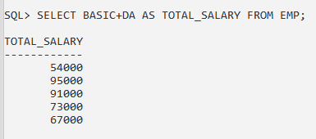

**15. Write a query to display Name with Tax ((Basic + DA + HRA) * 0.2 = Tax) from ‘Emp’ table.**

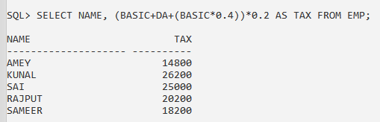

**16. Write a query to display Name, Basic, Gross (Basic + DA + HRA), Tax and Net Salary (Gross – Tax) from ‘Emp’ table.**

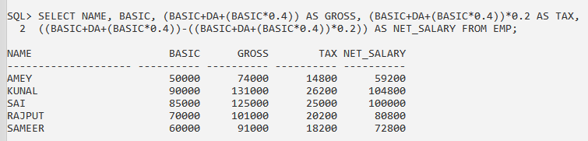

**17. Write a query to display all records of employee from ‘Emp’ table whose Basic is less than equal to 50,000.**

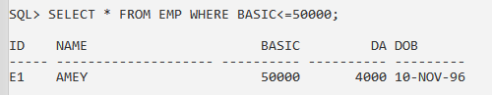

**18. Write a query to display all names of employee from ‘Emp’ table whose Age is greater than or equal to 59.**

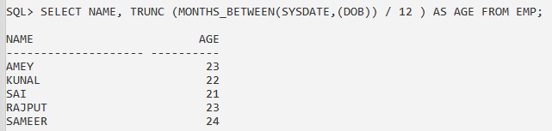

**C) Logical Condition and Order by clause**

**19. Write a query to display all names from ‘Customer’ table whose City is ‘Mumbai’ and Category is ‘Platinum’.**

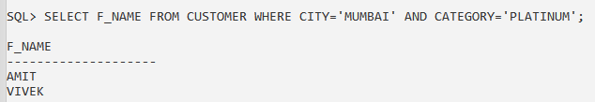

**20. Write a query to display all records of customer from ‘Customer’ table whose L_Name is not ‘Kumar’.**

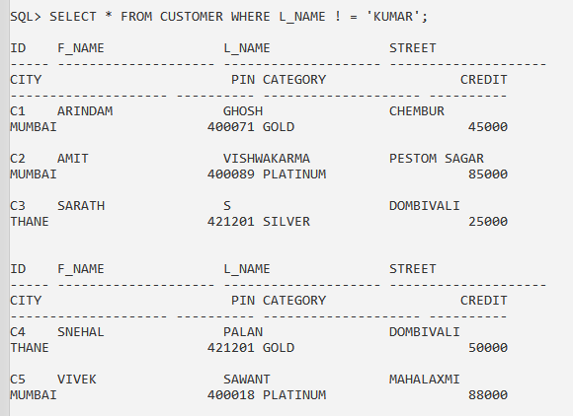

**21. Write a query to display all records of customer from ‘Customer’ table whose City is ‘Mumbai, Chennai, Hyderabad, Bangalore’.**

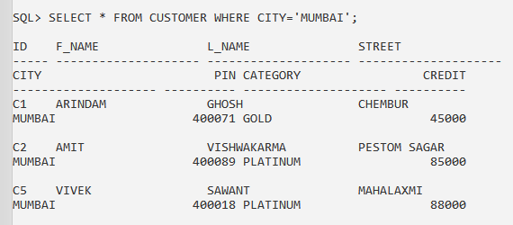

**22. Write a query to display all records of customer from ‘Customer’ table whose F_Name starts with ‘Ko’.**

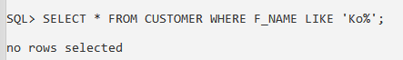

**23. Write a query to display all records of employee from ‘Emp’ table whose Basic is between 50,000 and 1,00,000.**

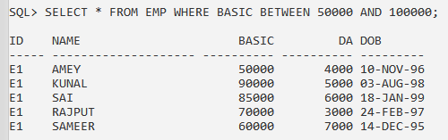

**24. Write a query to display all records of customer with F_Name in ascending order from**

**‘Customer’ table.**

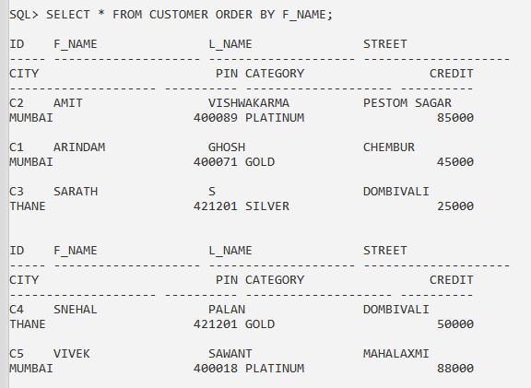

**25. Write a query to display all records of employee with Basic in descending order from ‘Emp’ table.**

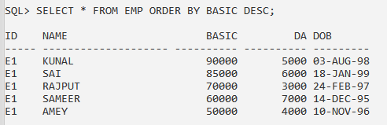

**CONCLUSION:** We have studied the SQL SELECT Statements in details.