**PRACTICAL NO 4**

**AIM: To study of Functions and Subquery.**

**Theory:**

**A) Functions:**

SQL provides many built-in functions to perform operations on data. These functions are useful while performing mathematical calculations, string concatenations, sub-strings etc. SQL functions are divided into two categories:

1. Aggregate Functions: Its return a single value after performing calculations on a group of values
2. Scalar Functions: Its return a single value from an input value.

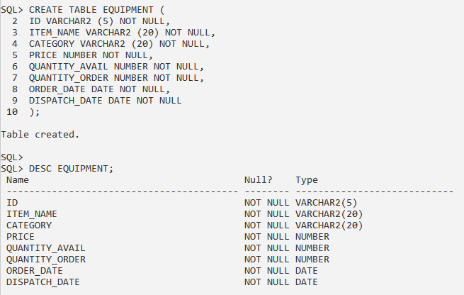



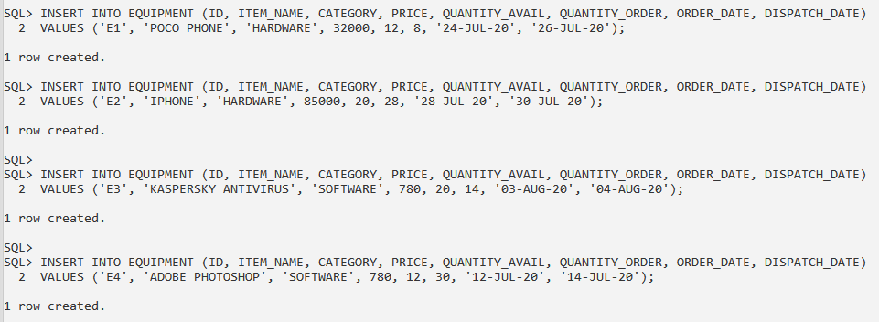

**1. Display the number of orders Pending (quantity ordered- quantity available)**

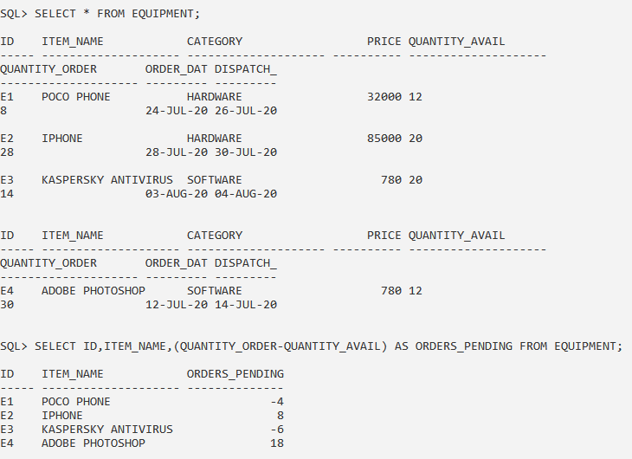

**2. Display the round up price of each item**

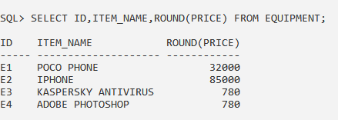

**3. Display the round up price of each item up to 2 decimal point**

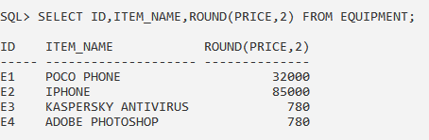

**4. Display whether Number of orders pending is in negative or not**

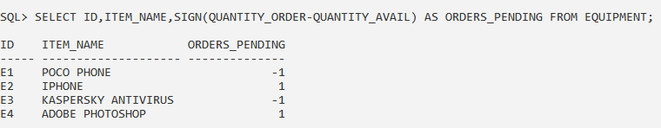

**5. Display if offer Applicable on a particular item (offer given if quantity ordered is three times greater than quantity available.)**

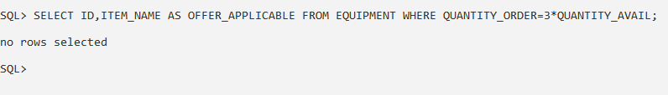

**6. Display all the item name initialized with capital letter**

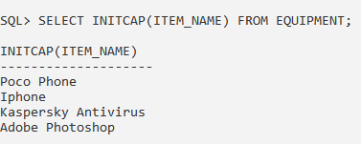

**7. Print item name in ***Itemname pattern**

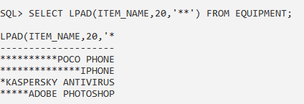

**8. Display Dispatch Date 3 months post order if the category is hardware**

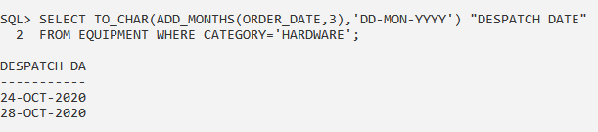

**9. Display the list of items order in year 2018**

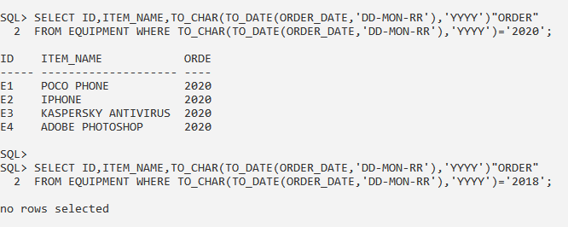

**10. Display items ordered in each month of first quarter of 2019**

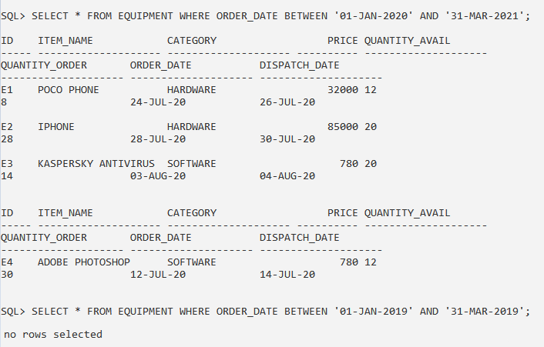

**11. Display the greatest number among (10,20,33,12,45,21)**

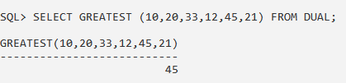

**B) AGGREGATE / GROUP FUNCTIONS**

An aggregate function performs a calculation on a set of values, and returns a single value. Except for COUNT(*), aggregate functions ignore null values. Aggregate functions are often used with the GROUP BY clause of the SELECT statement. All aggregate functions are deterministic.

The GROUP BY statement groups rows that have the same values into summary rows, like "find the number of customers in each country". The GROUP BY statement is often used with aggregate functions (COUNT, MAX, MIN, SUM, AVG) to group the result-set by one or more columns.

**1. Write a query to display average of ‘Credit’ from ‘Customer’ table.**

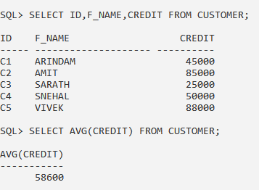

**2. Write a query to display average of ‘Credit’ city wise from ‘Customer’ table.**

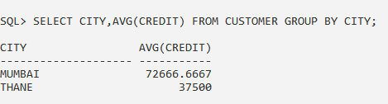

**3. Write a query to display average of ‘Credit’ city wise and ‘F_Name’ starting with ‘A’ from ‘Customer’ table.**

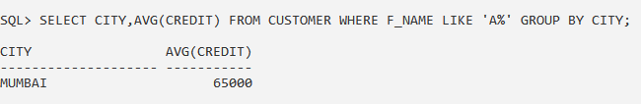

**4. Write a query to display maximum value of credit from ‘Customer’ table.**

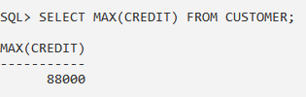

**5. Write a query to display customer details having maximum credit city**

**wise from ‘Customer’ table.**

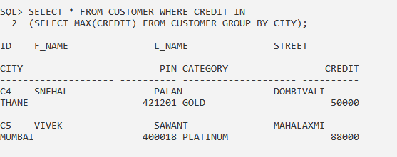

**6. Write a query to display total number of customers of each city from ‘Customer’ table.**

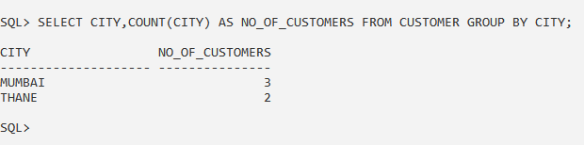

**7. Write a query to display total number of customers whose credit is less than 50,000 and lives in Mumbai from ‘Customer’ table.**

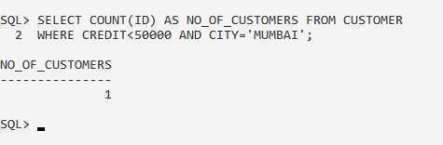

**8. Write a query to display sum of ‘Credit’ city wise from ‘Customer’ table.**

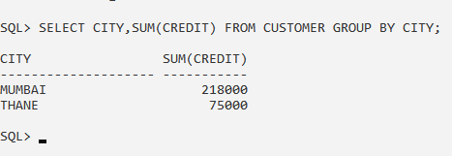

**C) SUBQUERY**

A Subquery or Inner query or a Nested query is a query within another SQL query and embedded within the WHERE clause.

A subquery is used to return data that will be used in the main query as a condition to further restrict the data to be retrieved.

Subqueries can be used with the SELECT, INSERT, UPDATE, and DELETE statements along with the operators like =, <, >, >=, <=, IN, BETWEEN, etc.

**9. Write a query to display the list of customers from ‘Customer’ whose ‘Credit’ is less than 70,000 and lives in the city where ‘Vivek‘ lives.**

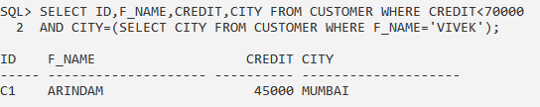

**10. Write a query to display ‘Name’ of employees from ‘Employee’ table whose ‘Salary’ is less than 20,000 and ‘DOB’ is greater than Ram’s DOB.**

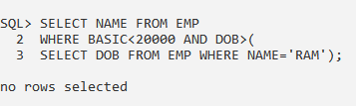

**11. Write a query to display list of customer from ‘Customer’ table whose city is same as ‘Komal’s’ or ‘Nandini’s’ city.**

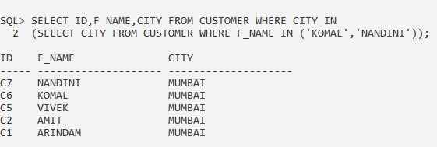

**12. Write a query to display list of customer from ‘Customer’ table who live in Mumbai and credit is same as ‘Vivek’s’ credit.**

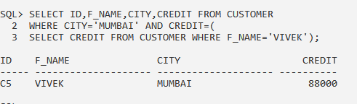

**CONCLUSION:** We have studied the SQL Functions and Subquery Statements in details.