**PRACTICAL NO 5**

**AIM: To study of Joins and other concepts like Views and Indexes.**

**Theory:**

**Joins:**

A SQL Join statement is used to combine data or rows from two or more tables based on a common field between them. Different types of Joins are:

* **Inner Join**: It is the simplest join. The Inner Join keyword selects all rows from both the tables as long as the condition satisfies. This keyword will create the result-set by combining all rows from both the tables where the condition satisfies
* **Left Join**: This join returns all the rows of the table on the left side of the join and matching rows for the table on the right side of join. The rows for which there is no matching row on right side, the result-set will contain null. Left Join is also known as Left Outer Join.
* **Right Join**: Right Join is similar to Left Join. This join returns all the rows of the table on the right side of the join and matching rows for the table on the left side of join. The rows for which there is no matching row on left side, the result-set will contain null. Right Join is also known as Right Outer Join.
* **Full Join**: Full Join creates the result-set by combining result of both Left Join and Right Join. The result-set will contain all the rows from both the tables. The rows for which there is no matching, the result-set will contain NULL values.

**Views:**

In SQL, a view is a virtual table based on the result-set of an SQL statement. A view contains

rows and columns, just like a real table. The fields in a view are fields from one or more real

tables in the database. You can add SQL functions, WHERE, and JOIN statements to a view

and present the data as if the data were coming from one single table.

**Index:**

Indexes are used to retrieve data from the database more quickly than otherwise. The users cannot see the indexes, they are just used to speed up searches/queries. The CREATE INDEX

Statement is used to create indexes in tables.

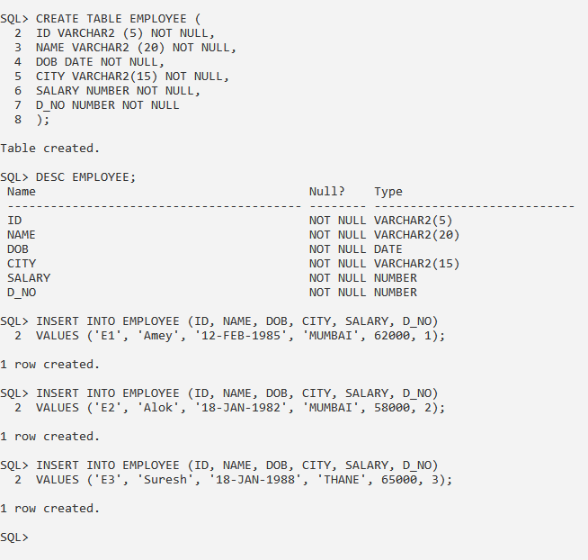

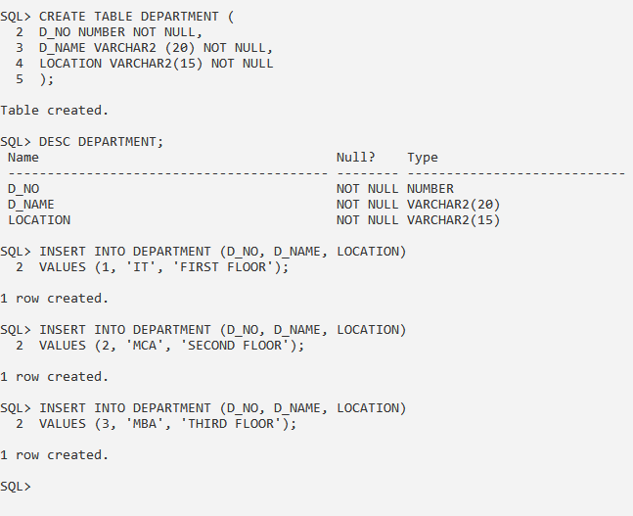

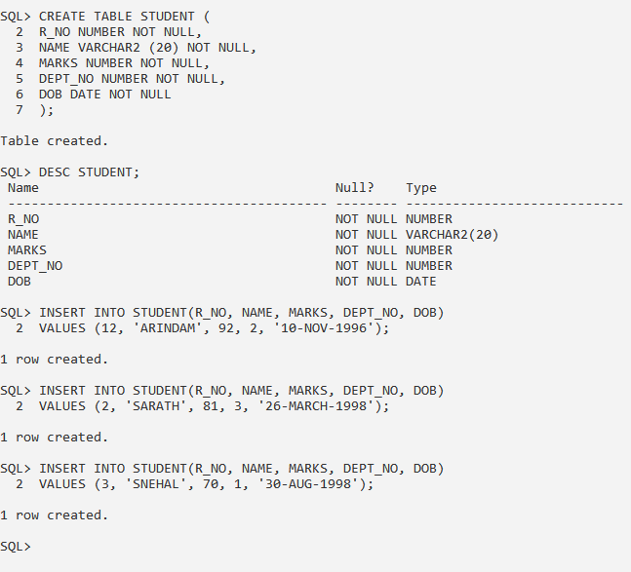

**1. Write a query to perform cross join between ‘Employee’ table and ‘Department’ table.**

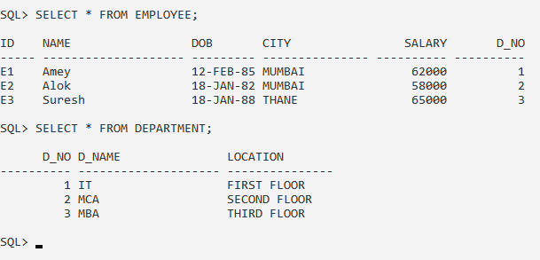

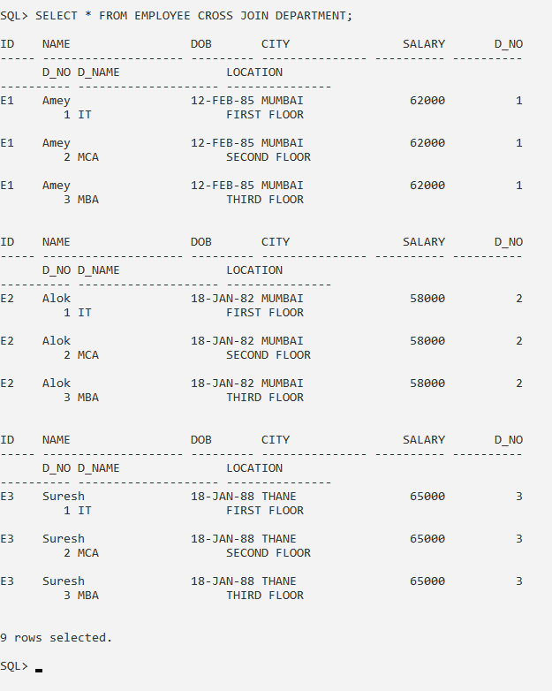

**2. Write a query to perform left outer join on ‘Employee’ table (left) and ‘Department’ table.**

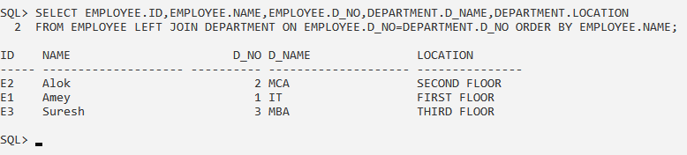

**3. Write a query to perform right outer join on ‘Employee’ table and ‘Department’ table (right).**

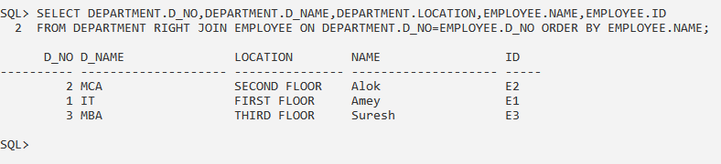

**4. Write a query to perform outer join on ‘Student’ table and ‘Department’ table.**

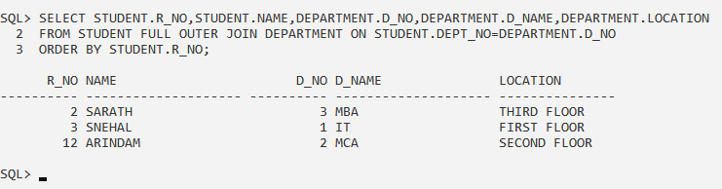

**5. Write a query to perform inner join on ‘Student’ table and ‘Department’ table.**

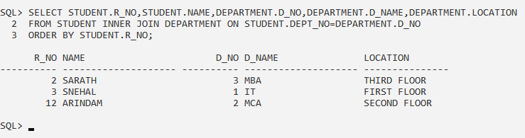

**6. Write a query to display names of students who are registered in MCA department.**

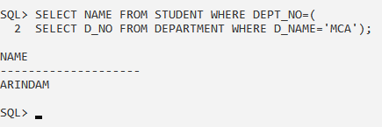

**7. Write a query to display name and date of birth of students registered in MCA department with year of birth less than 1990.**

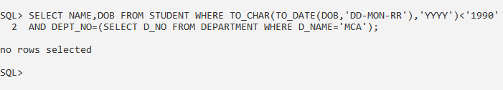

**8. Write a query to display name and marks of students registered in MCA or IT department with marks greater than 80.**

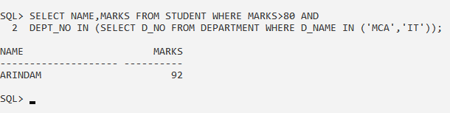

**9. Write a query to display name and marks of students registered in MCA or IT department with marks greater than 80 and year of birth is greater than 1992.**

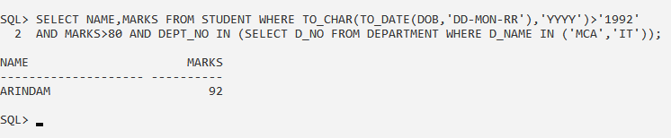

**10. Write a query to display student details who are not assigned any department.**

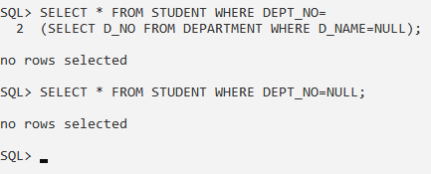

**11. Write a query to display name, marks and department name of students who are assigned MCA department and students who are not assigned to IT department.**

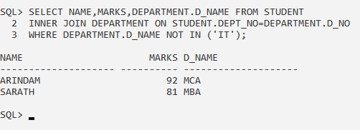

**12. Write a query to display department name where no students have enrolled.**

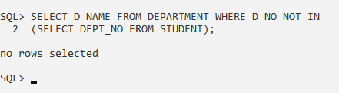

**13. Create a table ‘Employee1’ with attributes as ID, Name, Salary, DOJ and Supervisor. Insert 5 rows in it. Write a query to display the immediate supervisor of each employee.**

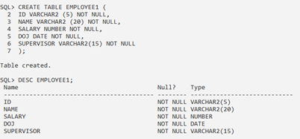

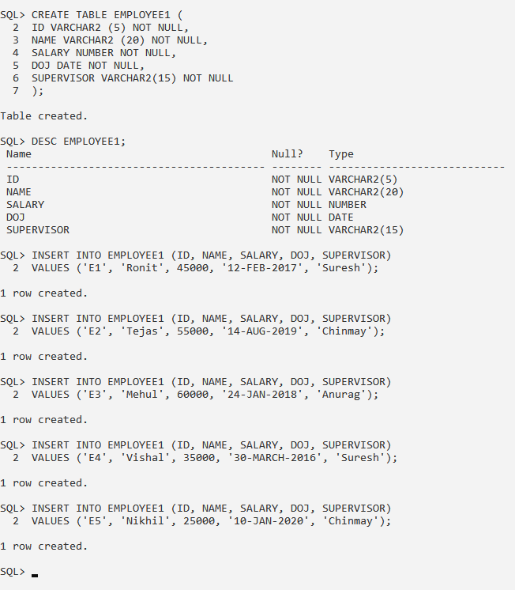

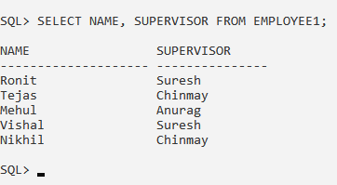

**14. Create a view ‘Emp’ on ‘Employee’ table.**

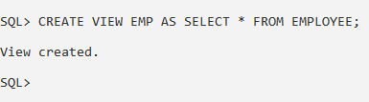

**15. Write a query to update a row in view ‘Emp’ and check if the change is reflected on the original table or not.**

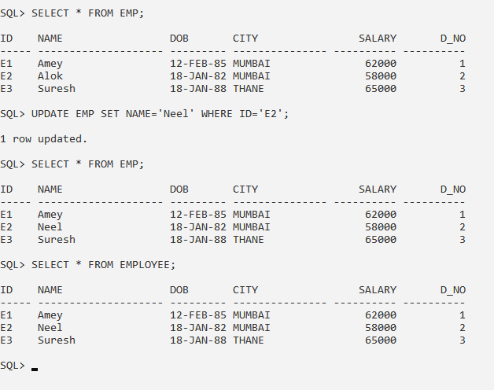

**16. Write a query to delete a row from view ‘Emp’ and check if the change is reflected on the original table or not.**

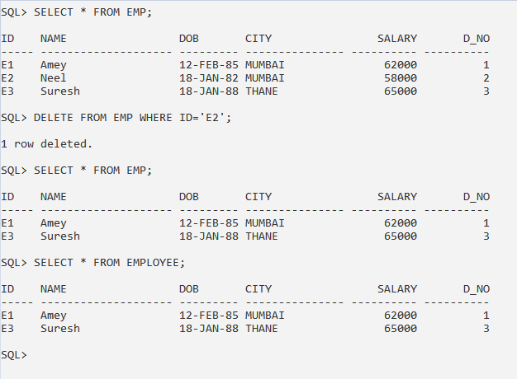

**17. Write a query to drop the view ‘Emp’.**

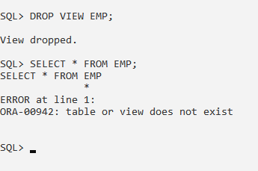

**CONCLUSION:** We have studied the SQL Joins and other concepts live views and indexes in details.